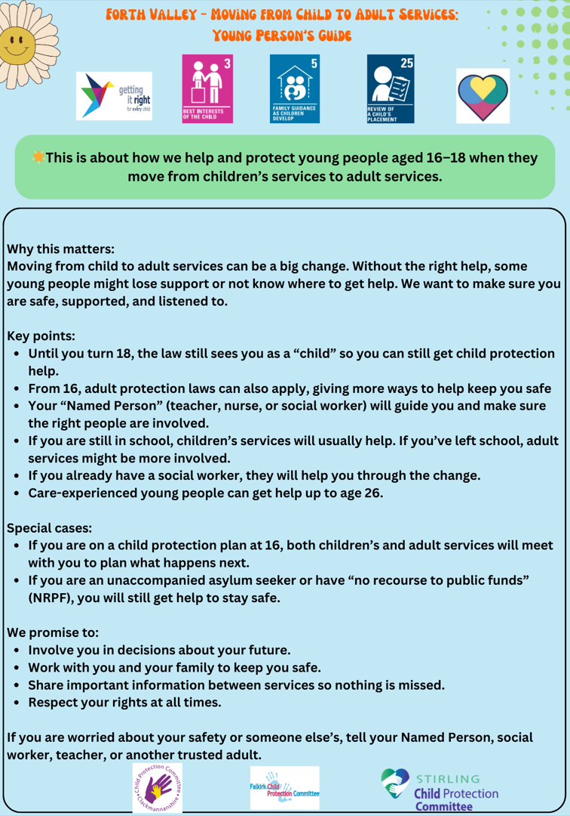

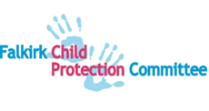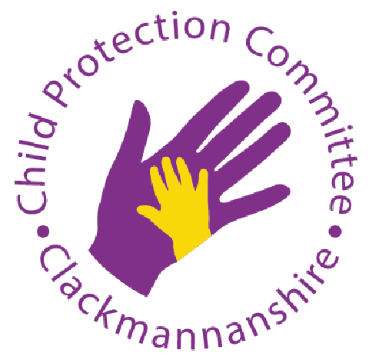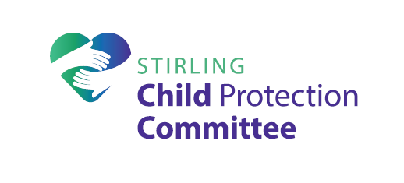

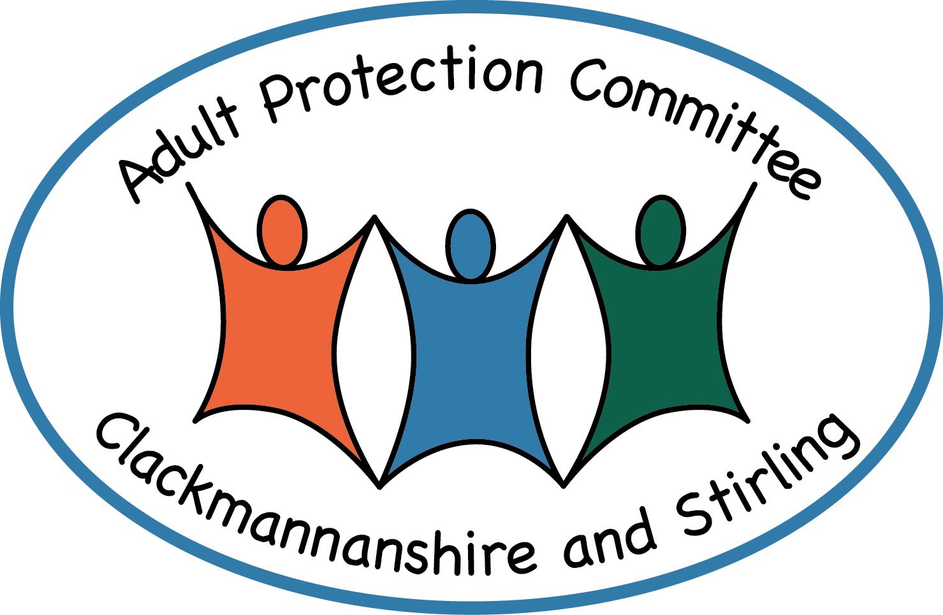
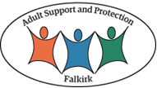

Forth Valley Transition Planning Guidance
for
Staff Supporting
Young People Aged 16 - 18 years
in Areas of Child and Adult Protection Practice

Version | Date | Author | Changes
1.0 | 05.12.16 | FV Policies, Procedures and Protocols Subgroup
2.0 | Dec 2017 | FV Policies, Procedures and Protocols Subgroup | National policy references reviewed
3.0 | 01.04.2019 | FV Policies, Procedures and Protocols Subgroup | No changes- To be updated following publication of National Guidance for Child Protection in Scotland 2021
4.0 | 25.01.25 | FV Child and Adult Protection Lead Officers | Updated with references to new guidance and legislation including links to these and other relevant practice notes.

- Introduction

It is necessary to ensure that there are appropriate operational links between adult and children’s services to address support and protection issues. The move from child to adult services can, if not appropriately managed, present significant risks. Young people at this transition stage can experience drift and/or delay in service provision or may sometimes drop out of services altogether, reducing their access to and contact with services required to ensure continuing support, safety and protection.
The risk is exacerbated by the fact that different agencies and legislation have, at times, established cross cutting criteria for defining when someone becomes an adult, or at what age they can access particular services. The importance of ensuring appropriate planning to support these transitions and protect young people through them is therefore vitally important in order to ensure appropriate access to service provision and preserve continuity of service.
This guidance aims to set out how best to manage transitions considering current policies, procedures and legislation. There are clear planning processes already in place in both child and adult protection, which identify the needs of individual children and young people and the responsibilities of services to consider the interventions they may need to support and, if necessary, protect them. The aim is to maximise the safety and welfare of children and at-risk young adults whilst minimising the impact of any change in service provision associated with age.
Agencies need to be clear about their collective responsibility to manage this transition to ensure that mutual responsibilities are properly reflected in each agency’s practice as well as in multi-agency child protection and adult protection guidance.
This guidance on transition planning should be read in conjunction with Clackmannanshire, Falkirk and Stirling Child Protection and Adult Support and Protection Guidance and Procedures.
In addition to these procedures, Care and Risk Management (CARM) guidance should be considered where a young person meets the criteria set out in this.
These links should ensure communication, fostering a robust process for understanding of risk and safety issues for all age groups. It is recognised that there will on occasion be an overlap between child and adult protection and as such there is a consequent need for professionals within each service area to work well together to prioritise the young person’s safety and protection over debate about individual service responsibility.
Assessment and planning processes, therefore, need to be aligned and some investigations or assessments may be best undertaken jointly, for example, when both child and adult protection issues are identified

- Legislation

Children and Young People
The Children and Young People (Scotland) Act 2014 makes provision and services in relation to children and young people. The provisions in Parts 4 and 5 of the Act refer to the named person and the child’s plan.
A child or young person up to the age of 18 will have an identified Named Person; usually from within Health or Education service to promote, support and safeguard their wellbeing.
The Named Person for the child or young person must ensure a careful and planned transfer of responsibility when another practitioner becomes the Named Person. Similarly, the transition from one Lead Professional to another will need to be planned carefully, particularly when another service becomes the lead agency.

The definition of a child varies across legislation, however, for the purposes of the duties outlined in this Act and in the UNCRC Act 2024; an individual is a child from birth until their 18th birthday. Section 22(2) of the Act introduces the term young person which applies only to individuals who have attained their 18th birthday and continue to attend school. For the period they remain on the school roll beyond their 18th birthday, they are referred to as a young person and the duties within Part 4 only of the Act continue to apply to them.

NB: The Forth Valley Child’s Plan Guidance, based on the legislative requirements, refers to 16–18-year-olds as young people at their request. It is also the case that a young person aged 16 -18 may wish to exercise the right to be considered and treated as an adult.

With the implementation of The Children (Care and Justice) (Scotland) Act 2024 anyone under the age of 18 years can be referred to the Principal Reporter (Scottish Children’s Reporters Association), if appropriate, where there are concerns for the child’s care or welfare, safety and/or protection including the child’s involvement in behaviour that brings them into conflict with the law.

This guidance also acknowledges the United Nations Convention on the Rights of a Child (UNCRC) and the rights of the child and young person.

Adult Support and Protection

The Adult Support and Protection (Scotland) Act 2007 introduced measures which provide additional opportunities to support and protect adults who may be at risk of harm. This is further supported by the Adult Support and Protection (Scotland) Act 2007 Code of Practice published in 2022.

Adults are defined as people aged sixteen and over and therefore includes young people aged sixteen to eighteen who are known to Social Work, Education and Health Services who might also be subject to other legislation, such as UNCRC Act, The Children (Scotland) Act 1995 and the Children and Young People (Scotland) Act 2014.

Adults at risk of harm are those who are unable to safeguard their own well-being, property, rights or other interests; are at risk of harm and who are affected by disability, mental disorder, illness or physical or mental infirmity.

These measures extended the options currently available to those supporting children and young people through a range of duties and powers, particularly for Council employees but this is applicable to employees in all public bodies. The Adult Support and Protection (Scotland) Act 2007 places a duty on all public bodies to report the circumstances of an adult or young person, whom they believe may be at risk of harm, to the Council.

The Act gives Councils lead responsibility for undertaking inquiries into the circumstances of adults or young people at risk of harm. The duties and powers conferred on Councils include the right to visit and interview the adult; request medical examinations; request reports and apply for Protection Orders via the Courts.

Although the differing legal definitions of the age of a child can be confusing, the overriding priority is to ensure that a young person who is, or who may be, at risk of significant harm is offered and provided with access to appropriate support and protection.
No Child should be denied a protective service because of uncertainty about the legal category into which they fit.
The individual young person's circumstances and age will, by default, dictate what legal measures can be applied. For example, the Adult Support and Protection (Scotland) Act 2007 can be applied to over-sixteens where the criteria are met. This further heightens the need for local areas to establish very clear links between their Children & Families and Adult Care Services as well as the Strategic Planning bodies of the Child and Adult Protection Committees.
Guidance on understanding age in child and adult protection is available here
Young people aged between sixteen to eighteen are thus at times potentially vulnerable to falling 'between the gaps' and local services must ensure that processes are in place to enable staff to offer ongoing support and protection as needed, via continuous single planning arrangements for the young person.
KEY POINT: This guidance is designed to include children and young people up to the age of 18. However, as noted above, the protective interventions that can be taken will depend on the circumstances and legislation relevant to that child or young person. The interpretation and application of the law in respect of 16–18 year-olds in particular will be determined by the operational leads in Children's and Adult Services.

- Forth Valley Arrangements

Children and Families Services may provide support and guidance to a young person who has been looked after and meets the requirements of the Children and Young People (Scotland) Act 2014, until they reach the age of twenty-one and up to their twenty sixth birthday in certain circumstances.

The transition requirements of most young people moving on from Secondary School are addressed through the school’s routine arrangements. For some young people, additional planning is required to support a positive and sustainable post-school destination.

Many young people who are or may be at risk of harm, will not previously or recently have received a service from Children and Families Social Work Services.

In determining how best to respond to the young person’s need for support or protection, workers should consider the needs of the young person, the nature of the risks involved and the principle of continuity in relation to knowledge and understanding of the young person’s circumstances.

- If the young person is in full time secondary school education, Children’s Services will receive and respond to the referral.

- If the young person is aged between sixteen and eighteen years has not had previous contact with Social Work services and is not in full time secondary school education, he/she will be considered by Adult Services for appropriate action where there are welfare concerns and/or ‘adult at risk of harm’ concerns.

- If the young person is aged between sixteen and eighteen years and has had recent contact with Children and Families services but no longer has an allocated Social Worker, concerns regarding ‘adult at risk of harm’ matters should be addressed by Adult Support and Protection procedures. Consultation should take place between Adult and Children’s services regarding the individuals known history and current presentation to ensure vital information is not missed when carrying out an assessment of need and risk. If the young person's case has been closed within the last six months Children and Families Services would be expected to support joint inquiry activity.

- If the young person has an allocated Social Worker, either within Children and Families or Adult Services, protection concerns will be responded to by his/her allocated worker.

- Care experienced young people aged up to 26 may still be in receipt of support from children’s services for through care and aftercare. However protective concerns may require a response from either Children (up to 18 years) or Adult Services, this should be this will be negotiated and agreed between the Team Leader/Manager in Children’s services and the Adult Services Team. With consultation with key partner agencies

- The Named Person for the young person aged sixteen to eighteen has to be informed and involved when concerns of possible harm are raised in relation to that young person. (Local authority education)

- In the event of a dispute between Team Leaders/Managers regarding allocation and/or area of service responsibility the matter should be discussed with and promptly resolved by the relevant Service Managers for the locality. Or alternatively the FV escalation policy can be utilised. The primary focus in this should always be the young persons need for support and protection.

- Monitoring of the decision-making process together with the associated rationale must be recorded in service user records. This includes but is not restricted to the chronology, risk assessments, plans and minutes of meetings.

- Some young people are known to services because of their involvement in behaviour that brings them into conflict with the law. Those who present a risk of serious harm to others will be subject to the Care and Risk Management (CARM) policies and procedures. Young People will be subject to formal CARM procedures until their eighteenth birthday. As part of the CARM process when a young person attains seventeen and a half years of age Justice staff will be invited to attend either an initial CARM or review as will other appropriate Adult services such as Mental Health, Community Care and Housing.

- Young Person Already Subject to Child Protection Measures

When a young person is formally subject to child protection measures and is approaching the age of sixteen years a review should be considered, involving both Adult and Children and Families Services, prior to the young person’s sixteenth birthday, when adult protection duties and powers must be considered. It is the responsibility of Children and Families Services to initiate and thereafter facilitate discussions relating to the transition.

It is important to consider that continued support may be provided by either Children and Families or Adult Services on a non-statutory basis. In all cases consideration should be given to other services available to young people in promoting a dynamic approach to meeting individual needs.

The review should include all relevant agencies, and the Named Person involved with the young person and, unless circumstances dictate otherwise, engage with and involve the young person and their family.

The review must consider all other relevant adult legislation, including the Mental Health Care and Treatment (Scotland) Act 2003 and the Adults with Incapacity (Scotland) Act 2000.

- Unaccompanied Asylum-Seeking Children (UASC)/No Recourse to Public Funds (NRPF) Children & Young People

UASC are children up to the age 18 who have fled their country of origin for varying reasons but who are separated from their families. UASC will be accommodated by the local authority and are the responsibility of children’s services.

They will often be in need and/or at riskdue to their unaccompanied status and perhaps their experiences in their home countries, as well as during their journey to the United Kingdom. They may also not carry or have access to any identifying documents to help establish or validate age. In such circumstances services should operate to “best interests” and “benefit of doubt” principles to determine the most appropriate service route applicable to best support and protect the person. If child protection concerns arise, they should be addressed in the same way as though the child was a UK national, bearing in mind differences in culture and experiences the child may have endured.

The Scottish Guardianship Service is a partnership between Aberlour Childcare Trust and Scottish Refugee Council. It works to help young asylum seekers to feel supported and empowered throughout their journey whilst their asylum claim is assessed, and their status determined.

The Human Trafficking & Exploitation (Scotland) Act 2015 provides a statutory obligation upon Ministers to provide guardianship for every eligible child and furthermore that relevant authorities will be under a duty to refer any eligible child to a guardian referred to as the Independent Child Trafficking Guardian.

The guardian will:
- act as a point of contact and continuity as the child progresses through the asylum and immigration system
- make the child aware of their rights
- explain to the child the aspects of the asylum, trafficking and welfare system
- introduce the child to social opportunities and begin to integrate them into community life

Further information may be found at https://beta.gov.scot/policies/refugees-and-asylum-seekers/unaccompanied-children/

If not already confirmed, contact should be made with the United Kingdom Border Agency, to establish the child’s current status as to whether they have been given leave to stay in the United Kingdom up to the age of seventeen years and six months.

Particular consideration also needs to be given on the use of interpreters for UASC and to accessing specialist legal advice.

  - No Recourse to Public Funds (NRPF)

Some people with NRPF can experience prolonged periods of financial insecurity and homelessness. This is because restricted access to public funds removes the safety net which would normally help people in crisis to cope with short term periods of financial stress. When children & young people are impacted by being in this situation their needs and emerging risks can, as with other families in poverty, grow. That said, destitution in and of itself does not preclude Services from their remit and responsibilities to address need and ensure children and young people's safety and protection.

The child or young person's profile may also be fractured and incomplete as with UASC children and young people. Similarly, in such circumstances services should operate to “best interests” and “benefit of doubt” principles to determine the most appropriate service route applicable to best support and protect the person. If child protection concerns arise, they should be addressed in the same way as though the child was a UK national, bearing in mind differences in culture and experiences the child may have endured

Child Protection Committees (CPC) Scotland Principles for SAFE Transitions from Childhood to Adulthood

Forth Valley acknowledges Child Protection Committees Scotland Guiding Principles for Safe Transitions from Childhood to Adulthood.

The principles have been developed to ensure we are:
- Embedding a young persons rights throughout
- Taking a trauma informed and trauma responsive approach
- Building on existing models of good practice
- Providing good continuity of access to service provision be it within Children's or Adult's Services for those in need or at risk
- Learning from good practice both nationally and internationally
- Exploring the interface, legislation and practice issues faced during transitions.

REFERENCES

- Children and Young People (Scotland) Act 2014
- Principles of Good Transitions 3 – ARC ScotlandEnding Destitution Together: A Strategy to Improve Support for People with No Recourse to Public Funds Living in Scotland 2021-2024 (www.gov.scot)
- Scottish Government (2022), GIRFEC Policy Statement
- Scottish Government (2022), Adult Support and Protection Act (Scotland) 2007: A Code of Practice
- Scottish Government (2022), Role of Named Person GIRFEC
- Scottish Government (2023), Getting it Right for Everyone
- Scottish Government (2023), National Guidance for Child Protection in Scotland 2021 - updated 2023
- Understanding age in Child Protection guidance and Adult Support and Protection legislation (iriss.org.uk)
United Nations Convention on the Rights of the Child (Incorporation) (Scotland) Act 2024 (legislation.gov.uk)
- UNCRC (Incorporation) (Scotland) Act 2024 - part 2: statutory guidance - gov.scot

