
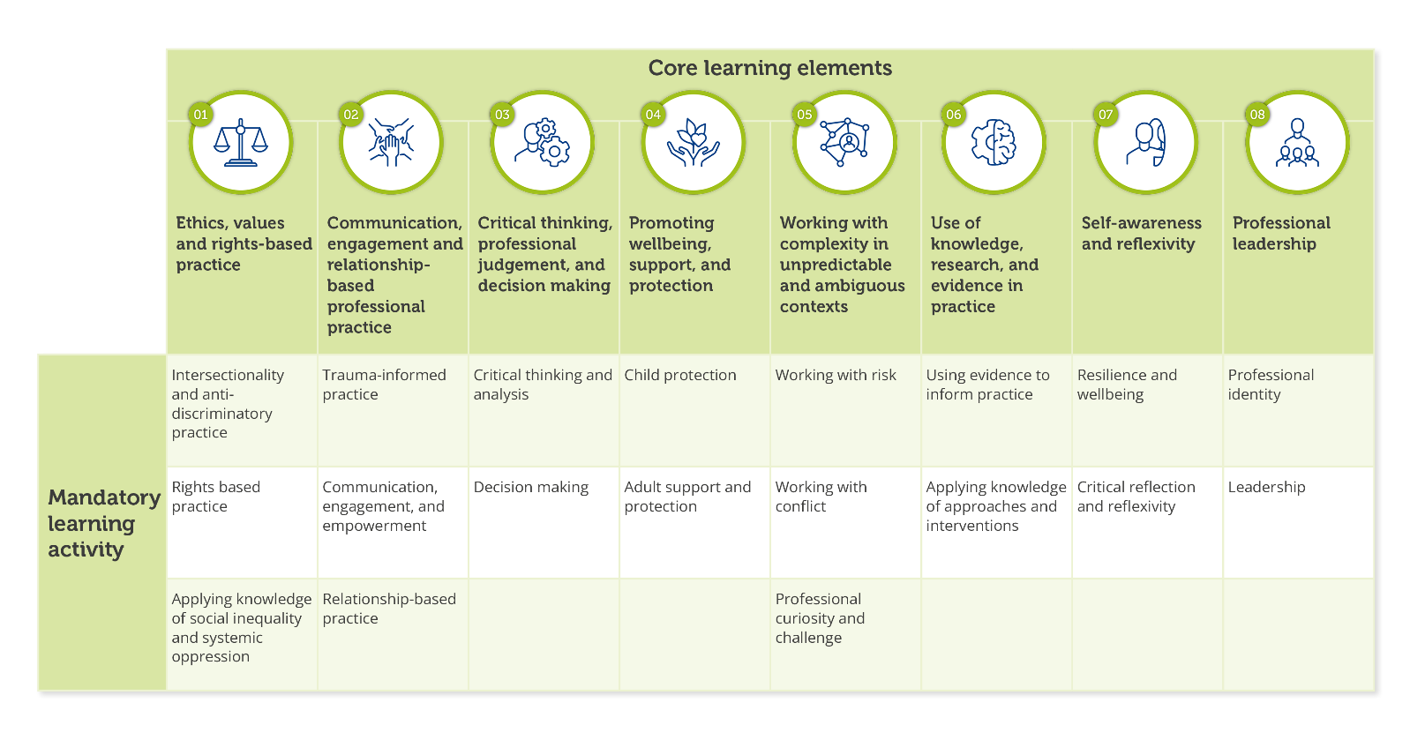
Mandatory Learning Activities Workbook



Learning Element 1 - Ethics, values, and rights-based practice
Intersectionality and anti-discriminatory practice. | Explore relevant research and evidence about intersectionality and relate this to the work of your team. Present information to your team about the importance of understanding intersectionality for social work services.
Intersectionality and anti-discriminatory practice. | Evidence an understanding of cultural competence and what it means in relation to your practice.
Intersectionality and anti-discriminatory practice. | Consider what you know about unconscious bias and racism in social work. Write a personal reflection on your commitment to anti-racism in social work practice and discuss this in supervision.
Intersectionality and anti-discriminatory practice. | Consider the barriers to inclusive practice experienced by both workers and people who use a service which exist in your workplace. Explore how these can be addressed and removed. Identify actions that you will take to promote inclusivity.
Rights-based practice | Reflect on how your social work practice is grounded in the principles of human rights and the United Nations Convention on the Rights of the Child, embedded in Scottish legislation. Provide an example from your practice where you have taken action to protect and advocate for human rights and social justice.
Rights-based practice | Evidence, through discussion in supervision or an example from your practice, how you have ensured that people, including families and carers, are aware of and understand their rights and can act on them.
Rights-based practice | Discuss your understanding and ability to manage the complex balance of rights with risk and protection.
Rights-based practice | Evidence, through discussion in supervision, ethical practice in the recording and sharing of sensitive information about people, including families and carers. Identify actions that you will take to ensure ethical practice in handling sensitive information.
Applying knowledge of social inequality and systemic oppression. | Create a map of local services that support an anti-poverty approach or provide welfare support. Reflect on how you and your team engage with them. Identify any implications for practice and actions that can be taken to support engagement.
 | Review three of your previous assessments or reports and audit how you have included analysis of the impact of social inequality and oppression on a person or family when developing a plan for support.
 | Explain how you would identify systemic oppression and inequality in your setting and how you would respond to or challenge this.
 | Evidence how you use a social justice approach in your practice and manage the authority and powers associated with your social work role.

Learning Element 2 - Communication, engagement, and relationship-based professional practice
Trauma-informed practice. | Using the national trauma training resource, complete the level appropriate to your role.
Trauma-informed practice. | Reflect on how you use trauma informed approaches in your practice, considering how you actively involve and support the participation of individuals, families and carers.
Trauma-informed practice. | Explore the links between the impacts of social inequality and systemic oppression and trauma. Identify any implications and actions for your practice.
Communication, engagement and empowerment. | Demonstrate how you understand people who use services as experts in their own lives.
Communication, engagement and empowerment. | Identify the different communication and engagement approaches, including digital capabilities you require for your role to ensure engagement is inclusive, culturally responsive and challenges stigma. Reflect on areas of strength and areas for development.
Communication, engagement and empowerment. | Provide an example from your practice where you have empowered individuals, families or carers in the planning, implementation and evaluation of an intervention or service.
Communication, engagement and empowerment. | Review your organisation’s policies and procedures for recording, assessment and report writing and consider any implications for your practice.
Relationship-based practice. | Review three of your previous assessments or reports and audit how you have included analysis of the impact of social inequality and oppression on a person or family when developing a plan for support.
Relationship-based practice. | Give an example of how you are developing your ability to use your professional authority as a social worker and working collaboratively with colleagues and professionals across different agencies.
Relationship-based practice. | Critically reflect on a practice situation that has challenged your professional boundaries and relationship with an individual, family, carer or colleague. Identify what worked well and what you might do differently next time.

Learning Element 3 - Critical thinking, professional judgement and decision making
Critical thinking and analysis. | Complete the activities in IRISS course ‘Writing analysis in social care.’
Critical thinking and analysis. | Critically reflect on report writing comparing one of your own reports with one completed by an experienced practitioner. Compare how information has been analysed and presented in the reports and identify best practice and points of learning.
Critical thinking and analysis. | Identify how you ensure that your writing reflects the interests and perspectives of the people about whom you are writing. Discuss with a colleague or supervisor.
Critical thinking and analysis. | Read practitioner guidance on chronologies. Complete a chronology, review it with a colleague or supervisor and reflect on the importance of this tool in your practice.
Critical thinking and analysis. | Reflect on a situation where you have shared your thinking and analysis in a formal setting. Explore your feelings about undertaking this task. Identify actions you can take next time you are in this situation.
Decision making. | Reflect on the process of gathering information when undertaking an assessment. Consider what you found helpful in the process of gathering information and how you decided what was relevant to the assessment.
Decision making. | Describe how a piece of research helped to inform your decision making in a practice situation.
Decision making. | Discuss with a supervisor a decision-making process from your practice. Identify the skills you used when communicating the decision and rationale with individuals, families, carers and professionals. Reflect on areas you found difficult and identify actions you can take to improve your practice confidence.
Decision making. | Consider a significant case review that has been undertaken in children or adult services. Reflect on the use of professional judgement and decision making. Identify actions you can take to incorporate learning from the review, to develop your professional judgement and decision-making capabilities.
Decision making. | Evidence how you use a social justice approach in your practice and manage the authority and powers associated with your social work role.

Learning Element 4 - Promoting wellbeing, support and protection
Child protection. | Familiarise yourself with national and local child protection guidance and procedures including the role of the local child protection/ public protection committee. Identify your key responsibilities as a social worker and what your role is in your organisation and on a multi-agency level to act on concerns about a child.
Child protection. | Access child protection training within your organisation or local area and discuss your key learning with your supervisor or colleague(s).
Child protection. | Provide evidence of a reflective discussion with your supervisor/mentor about the thresholds of risk in child protection.
Child protection. | Create a mind map or equivalent that demonstrates your understanding of the intersections between child protection and the vulnerability, trauma and risk experienced by adults.
Adult support and protection. | Familiarise yourself with national and local adult support and protection guidance and procedures including the role of the local adult protection/public protection committee. Identify your key responsibilities as a social worker and what your role is in your organisation and on a multi-agency level to act on concerns about an adult.
Adult support and protection. | Access adult support and protection training within your organisation or local area and discuss your key learning with your supervisor or colleague(s).
Adult support and protection. | Read the principles of the Adults with Incapacity (Scotland) Act 2000 and identify when and how you would use these when considering rights, risk and protection of adults.
Adult support and protection. | Learn how you would make effective use of local advocacy services. Identify your role in supporting people involved in adult support and protection proceedings and consider how you can support them to participate and communicate in decisions and forums.
Adult support and protection. | Create a mind map or equivalent that considers the intersectional nature of risk, trauma and harm. Reflect on the challenges of accessing support and the impact of structural disadvantage which may impact on adult protection.

Learning Element 5 - Working with complexity in unpredictable and ambiguous contexts
Working with risk. | Explore concepts of risk assessment, risk management and risk tolerance. Reflect on your organisation’s approach to risk and discuss with a supervisor or colleague how this influences your practice.
Working with risk. | Evidence discussion with your supervisor/team/other professionals on personal and organisational thresholds to risk. Compare this with other professional thresholds, and how you will manage ethical dilemmas in your practice.
Working with risk. | Reflect on an example from practice in which you had to identify risk, the levels of risk and protective factors. Consider what informed your approach, how decisions were reached, and how challenges were addressed. Identify what you learned and how you will use this learning in the future.
Working with conflict. | Reflect on your understanding of ‘conflict,’ ‘challenge’ and ‘resistance’ and how these present in social work practice. Reflect on whether such terms are used in your organisation and how this influences your practice.
Working with conflict. | Consider how you approach having challenging conversations with individuals, families and others while remaining committed to relationship-based practice. Think about the knowledge, skills and values you can use. Identify any actions for your practice.
Working with conflict. | Engage in reflective discussion with your supervisor, team or mentor about a situation where another professional, an individual or a family you are working with has shown hostile and resistant behaviour. Consider how you responded, and what impact this had on you. Identify what you have learned from this and any actions for your practice.
Professional curiosity and challenge. | Research and reflect on the opportunities and potential barriers to professional curiosity and identify what skills, knowledge and supports you might need to develop an effective approach in your practice. Identify factors that contribute to professional dangerousness.
Professional curiosity and challenge. | Provide evidence of a discussion with your supervisor about a time when you have had to question your own assumptions about an individual or family with which you are working. Consider what you did and identify what you might do differently next time.
Professional curiosity and challenge. | Act as a critical friend for a peer or have a peer act as a critical friend on a complex or uncertain case. Reflect on observations and learning brought about by this process. Identify the actions you will take as a result.

Learning Element 6 - Use of knowledge, research and evidence in practice
Using evidence to inform practice. | Complete the Social Services Knowledge Scotland (SSKS) Knowledge and Evidence Open Badges.
Using evidence to inform practice. | Complete the Iriss Navigating Evidence reflective tool.
Using evidence to inform practice. | Evaluate a piece of research relevant to your role and share information with others. Discuss its strengths and limitations and demonstrate how it contributed to outcomes.
Using evidence to inform practice. | Review how you have used feedback from people who use services and carers to inform your practice and service delivery. Create a plan to ensure that this remains at the centre of your practice.
Using evidence to inform practice. | Evidence a situation where you identified a gap in your knowledge and reflect on how you took responsibility to fill that gap.
Applying knowledge of approaches and interventions. | Identify and list local and national legislation, policy and guidance that underpins your role. Discuss with a colleague or supervisor and identify any gaps in your knowledge.
Applying knowledge of approaches and interventions. | Evidence your understanding of how Self-directed Support (SDS) is relevant to your role.
Applying knowledge of approaches and interventions. | Reflect on your application of an evidence informed approach in a complex situation. Consider why you adopted this approach, what it involved, how you applied it and what impact it had on outcomes.
Applying knowledge of approaches and interventions. | Lead a 5-minute informal team discussion on a piece of research, theory or framework relevant to your role.
Applying knowledge of approaches and interventions. | Demonstrate how you have related a theory to a practice situation.

Learning Element 7 - Self-awareness and reflexivity
Resilience and wellbeing. | Identify your organisation's responsibilities to support staff wellbeing and understand your own responsibilities within these.
Resilience and wellbeing. | Develop the use of reflective and reflexive practice in your professional development and explore how this can contribute to your wellbeing.
Resilience and wellbeing. | Identify and discuss with your manager/supervisor the professional actions that will support your wellbeing and contribute to the wellbeing of your wider team.
Resilience and wellbeing. | Consider your own emotional responses when coping with a variety of difficult situations. Explore how you recognise and respond to the signs of vulnerability in yourself and others. Identify what supports you might need to help you when working and responding in these situations.
Resilience and wellbeing. | Research national initiatives and resources available to support wellbeing in the sector such as the National Wellbeing Hub. Share learning with colleagues.
Critical reflection and reflexivity. | Provide evidence of how you have used supervision or advice from a mentor to critically reflect on your own practice and development.
Critical reflection and reflexivity. | Critically reflect on your awareness of how your use of self, impacts on developing and sustaining effective relationships with individuals, families, carers and other professionals.
Critical reflection and reflexivity. | Use a tool or map to demonstrate how you use critical reflection when managing complex situations. Demonstrate how you have developed competence and confidence in critical reflection when managing complex situations in your practice.

Learning Element 8 - Professional leadership
Professional identity. | Reflect on the SSSC Code of Practice for Social Service Workers and discuss any ethical dilemmas this raises for you as a registered social worker.
Professional identity. | Roleplay or rehearse how you will explain your social worker role in a variety of settings.
Professional identity. | Use a reflective model, framework, tool or journal to examine your professional identity. Consider how you see your role as a social worker; what kind of social worker you are; what values you believe you have and how you demonstrate them.
Professional identity. | Seek feedback on your practice from people who use services, colleagues, and other stakeholders to help you understand yourself, and your role.
Professional identity. | In supervision explore the tension between organisational, legal and professional requirements and social work values.
Leadership. | Map your professional network of colleagues, supervisors, and other professionals.
Leadership. | Reflect on the ways in which you think you have a leadership role as an NQSW and how you can influence professional, ethical and rights-based responses in social work practice.
Leadership. | Explore the SSSC Step into Leadership website. Complete the SSSC Frontline Worker Leadership Capability Feedback Tool and leadership capabilities workbook.
Leadership. | Contribute to the learning and development of others through activities such as peer reviewing a report, giving feedback to a co-worker or undertaking a practice audit.

