Pre-Placement Checklist & Induction Template for Occupational Therapists
Please use this as a guide for Student joining Falkirk Council and the relevant departments needed to give them access to essential systems and areas relevant to their role:
Arrange | Notes | Complete
Falkirk Council ID Badge | Email access.control@falkirk.gov.uk with:  - Employee Name  - Employee Number (NI Number):  - Work Location  - Service  - Suitable passport style photograph  - Start Date  Collect from Foundry or posted via internal mail. Badges will be actioned within 10 working days.
Olle | Email Emilia.Stepien@falkirk.gov.uk to generate an account. She'll need email address & start date.  Olle - Login (tessello.co.uk)
CPD Manager | Email socialservices.training@falkirk.gov.uk with:  - Employee Number (NI Number):  - Name:  - Job Title:  - E-mail:  - Dept:  - Based:  - Line Manager:  Falkirk Social Work Services CPD (cpdservice.net)
Pool Cars | New system for accessing pool cars - Intranet (falkirk.gov.uk)

Equipment
Arrange | Notes | Complete
Laptop & Mobile | Use existing equipment where possible - Request via Service Desk
IT Systems | System Access Request, Liquid Logic, & Mailbox - Request via Service Desk
Kneeling pads | Universities requested to arrange these prior to placement but some teams have a pool.
Tape Measure | Universities requested to arrange these prior to placement but some teams have a pool.
Allen Keys | Universities requested to arrange these prior to placement but some teams have a pool.
Multi-Head Screwdriver | Universities requested to arrange these prior to placement but some teams have a pool.

Induction
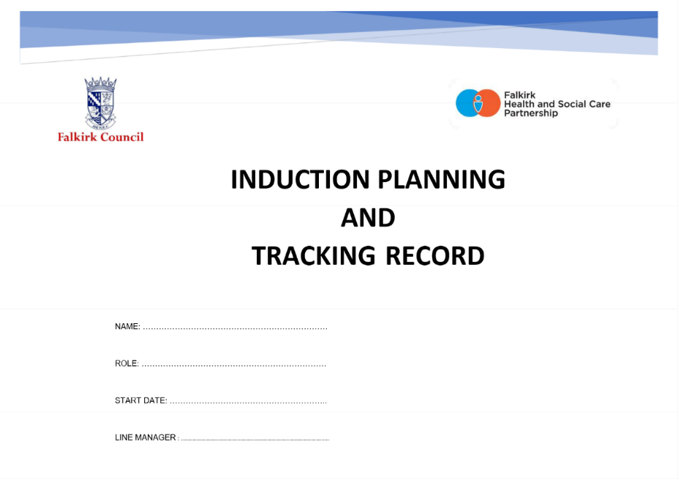
Falkirk Council’s Induction Process can be found on the Practitioner’s Pages under the Recruitment, Induction and Retention tab. The Induction Planning and Tracking Record should be used as a baseline for students to ensure they can access key policy and timescales related to their placements with Falkirk Council. There are key timescales related to their placements with Falkirk that need to be completed within a specific time.

Please amend as needed!

Week 1
Date |  | Morning | Lunch | Afternoon | Notes
Monday |  | Arriving for 9am.  Show layout of offices, workspaces, fire safety arrangements, toilets and changing areas, identify personal spaces |  | Arrange worker safety arrangements with Admin, including personal contact information, management team and link worker.  Spend time with colleagues.
Tuesday |  | Setting up on laptop and encourage to begin familiarising themselves with the workplace.  Completing Induction Planning and Training Record from Practitioners Pages. |  | Shadowing / Policies / Olle Learning / Visiting services
Wednesday |  | Shadowing / Policies / Olle Learning / Visiting services  Access CPD Manager and book in for Training. |  | Shadowing / Policies / Olle Learning / Visiting services
Thursday |  | Shadowing / Policies / Olle Learning / Visiting services |  | Shadowing / Policies / Olle Learning / Visiting services
Friday |  | Shadowing / Policies / Olle Learning / Visiting services |  | Shadowing / Policies / Olle Learning / Visiting services

Week 2
Date |  | Morning | Lunch | Afternoon | Notes
Monday |  | Shadowing / Policies / Olle Learning / Visiting services. |  | Shadowing / Policies / Olle Learning / Visiting services.
Tuesday |  | Shadowing / Policies / Olle Learning / Visiting services. |  | Shadowing / Policies / Olle Learning / Visiting services.
Wednesday |  | Shadowing / Policies / Olle Learning / Visiting services. |  | Shadowing / Policies / Olle Learning / Visiting services.
Thursday |  | Shadowing / Policies / Olle Learning / Visiting services. |  | Shadowing / Policies / Olle Learning / Visiting services.
Friday |  | Shadowing / Policies / Olle Learning / Visiting services. |  | Shadowing / Policies / Olle Learning / Visiting services.

