UNCRC (Incorporation) (Scotland) Act 2024
1
The United Nations Convention on the Rights of the Child (Incorporation) (Scotland) Act 2024 is a landmark piece of legislation that embeds children’s rights into Scots law.
What does it mean for us?
- Legal Protection: The Act makes it unlawful for Public Authorities to act in a way that is incompatible with the UNCRC requirements, ensuring that children’s rights are respected and protected in all areas of life.
- Empowerment: Children and young people can now challenge decisions by public authorities in Scottish courts if they believe their rights under UNCRC have been breached.
- Accountability: Public authorities are required to take proactive steps to ensure their policies and practices are compatible with UNCRC.

3
Identify Relevant Rights

- Focus Areas: Children’s Rights
are indivisible, but pay particular attention
to core articles such as:

  - Article 3: Best Interests of the child
  - Article 12: The child’s right to be heard
  - Article 19: Protection from harm
  - Article 39: recovery from trauma
  - Summary of the full act UNCRC_summary-1.pdf

- Application: Use these rights as the foundation for decision-making and service planning.

2
Understanding the UNCRC and the Act

- Overview: Familiarise yourself with the United Nations Convention on the Rights of the Child (UNCRC) and the legal obligations under the 2024 Act.
- Key Point: It is unlawful for Children’s Service’s and our partner agencies to act in ways that conflict with children’s rights.

7-minute briefing
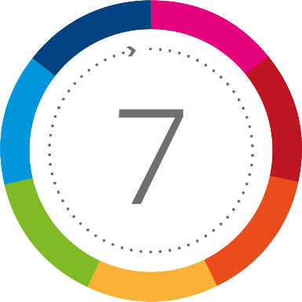
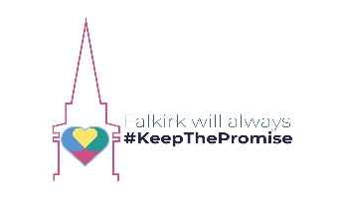
6
Use Statutory Guidance
and Resources

- Resources: Consult the Scottish Government’s statutory guidance and related training materials. Here are some links to these –
- UNCRC (Incorporation) (Scotland) Act 2024 - part 2: statutory guidance
- Resources | Improvement Service
- Children's Rights Skills and Knowledge Framework | Together Scotland
- summary of UNCRC statutory guidance
- UNCRC Guidance summary
- Support: These resources are designed to assist you in navigating at times, complex situations and ensure the Act in implemented properly.

5
Listen and Involve Children

- Participation: Actively engage children
in conversations about matters that affect their lives.
- Voice: Children have the right to express their views in matters that affect them.
- Build child participation into your practice
by meaningfully consulting them in the decision making process.

4
Act Compatibly

- Policy Alignment: Ensure that all your policies, procedures and service delivery methods are fully compatible with UNCRC principles.
- Everyday Practice: Embed a rights-based approach in both formal and informal interactions.
- Documentation: Maintain detailed records that highlight how children’s rights have been integrated into your practice.
- Self-Audit: Regularly review your decisions and actions to ensure they reflect what is in
the child’s best interests, individually and collectively as a Team Around the Child.

7
Know Your Accountability

- Legal Responsibility: Be aware that children, families and advocates have the right to challenge decisions in court if they believe a child’s rights have been compromised.
- Transparency: Maintain clear and transparent practices to uphold accountability.

