Good Conversations – Make it Happen

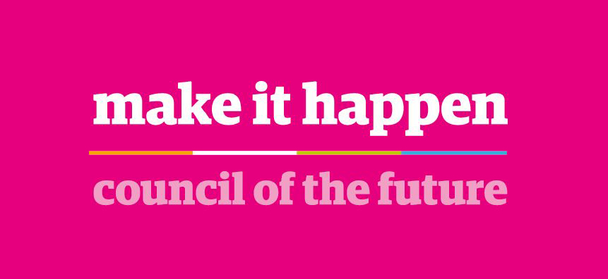

1
WHAT ARE GOOD CONVERSATIONS?
It is about a line manager having regular conversations with their employee(s) which focus on clarifying work related objectives for the year ahead, providing feedback and agreeing any support or development needed for employees and teams to be the best they can be. The ethos is all employees have the opportunity of talking about their job and the process should be adapted to make that happen in the most appropriate manner.


THE PURPOSE OF GOOD CONVERSATIONS
The purpose is to enable meaningful conversations which help build relationships, provide support and keep individuals feeling valued, motivated and engaged. They should help boost confidence and morale as well as help produce high performing individuals and teams. High performance and successfully delivering outcomes is achieved when managers consider the task, individuals and the team.
2
GOOD CONVERSATIONS – WHAT IS IT?
It is a relaxed but focussed conversation between the line manager and their employees / teams to discuss their progress and how they can be the best they can be at work.
There will be 3 stages of the conversation:
- Annual conversation
- Regular 1-2-1 check-ins
- Team check-ins

3

GOOD CONVERSATIONS – WHAT IS INVOLVED?
Stage 1 - Annual Conversation
Every employee will attend an annual conversation which will centre around 3 areas for discussion with the focus being on having a conversation and not about filling in a form or sitting around a computer.
It is a chance to step back and take stock by reflecting on the year that’s been and what has been accomplished and to get prepared for the year ahead.

The 3 areas for discussion are:

What might have gone even better?
What do you want to achieve / focus on for the year(s) ahead?

What has gone well over the last year?

1
3
2

SUPPLEMENTARY QUESTIONS FOR THE ANNUAL CONVERSATION
Below are a list of supplementary questions which can be used to aid conversations during the annual review between manager and employee.

What do you want to achieve / focus on for the year(s) ahead?
What might have gone even better?
What has gone well in the last year?
- What has been challenging or had you feeling out of your comfort zone?
- What have you taken or learned from this experience?
- What support could help you achieve your goals easier?
- What do you think your objectives should be?
- What is your plan for achieving these objectives?
- What barriers / challenges might get in the way of achieving these objectives?
- What are your thoughts on the best way to overcome these barriers / challenges?
- How can I help you? What other support do you need?
- How are you hoping to develop in the next 12 months?
- Where do you see your career in the future?
- What do you feel the most proud of in the last 12 months
- What have you enjoyed working on most over the last year?
- What sense of achievement did you gain in the last year?
- Did you feel your achievement was recognised?

Stage 2 - Regular 1-2-1 Check-in

ANNUAL CONVERSATION FORM
What’s gone well this year?  (Achievements) | What might have gone even better this year?  (Barriers)
(Record brief bullet points only – goals can be short & long term)
Employee Name: |  | Employee Number:
Job Title: |  | Date:
Commitments
(What do you want to achieve / focus on in the future?)

Objectives | Development


RITA
This topic focuses on the role modelling of the values. Using a coaching style work through the values with the employee finding out where they think they model the values and where they struggle to model the values.

Life and wellbeing
This topic will focus on both the employees health and well being. It should cover areas like resilience and dealing with change. The conversation should discuss anything that you as their manager can do to support them in the workplace.

Stage 2 - Regular 1-2-1 Check-ins
In addition to the annual conversation it is best practice that managers carry out regular 1-2-1 check-ins with their employees throughout the year covering specific topics. The topics covered below are the typical conversations that managers should be having with their employees. Research illustrates that regular and strengths based conversations lead to more productive and motivated team members.
These are conversations that can easily be incorporated into scheduled supervision or 1-2-1 meetings or simply be standalone quick check-ins in their own right. The frequency of check-ins and which topics should be discussed is entirely flexible and up to each manager and employee to discuss and agree. It would be good practice to hold more regular 1-2-1 check-ins with employees you don’t see as often e.g. Mobile Flexible Workers.

Objectives and performance measures
Review of the objectives and performance measures agreed at the beginning of the year. This conversation should happen regularly throughout the year.

Personal development
This topic should cover any development that was planned and any future development needs that have been identified.








Improvements
This topic focusses on what the employee thinks about improvements that can be made within the team or service.


Feedback
This conversation and all of the conversations within this process should be focussing on the employee’s strengths and building on these. The manager should start the conversation by asking the employee what they believe their main strengths are and then present their views on the employee’s main strengths. If there are areas of concern with the employees performance feedback should be given. More regular 1-2-1’s would be expected where performance was an issue.

1-2-1 Check-Ins Supplementary Questions
IMPROVEMENTS
- What, if any, improvements to your job have you identified since we last met?
- What impact would the suggested improvements make?
- What organisational improvements would you like to see implemented?

LIFE & WELLBEING
- How do you feel about your work / life balance?
- What worries or concerns do you have right now?
- How resilient do you feel at present?

- What impact is Mobile Flexible Work having on your wellbeing?
RITA
- How well do you think you role model the values?
- What value do you find easiest to role model?
- Which value challenges you when role modelling it?
- What can I do to support you role model the values?

PERSONAL DEVELOPMENT
- Have you organised or completed any of your agreed development needs?
- What did you find most useful?
- What might be an area of development that might help you further in your job?
OBJECTIVES & PERFORMANCE MEASURES
- How are you progressing with your objectives?
- Which objectives are you able to progress the best?
- Do you have objectives that you are concerned might not be met?
- How do you think you could meet those objectives?
- What support do you need to meet those objectives?



FEEDBACK
- What has been your biggest achievement so far this year?
- What has been your biggest challenge so far this year?
- What feedback would you like to give me?

1-2-1 Check-In Form
(optional)
Employee Name: |  | Employee Number:
Job Title: |  | Date:

Personal Development
Objectives & performance measures
Life and wellbeing
Improvements
Feedback
Team Learning
A chance to share what we have learned; from events we have attended, articles we have read or what we have learned on the job.
5
6
Challenges and Ideas
Gives the team the opportunity to discuss the challenges and the tensions the team are facing. It is a chance to explore solutions and ways forward and ways of supporting each other.
Current Performance
This is an opportunity for the team to review their performance against actions plans and targets.
Celebrating Achievements
This is an opportunity to celebrate what the team are doing well, where they have gone the extra mile and reflect on the impact the team is having.
3
4
Council of the Future
This allows a conversation to take place about what is happening across the Council and within your Service regarding Council of the Future projects and workstreams.
1
Employee Engagement
Every 2 years employees will participate in an engagement survey and this conversation allows managers to communicate with the findings from the survey.

2
Stage 3 - Team Check-ins
Managers should have regular check-ins which focus on ensuring the team is working well together. It is acknowledged that the frequency of team check-ins will vary across the Council; however a minimum of 2 check-ins per year should take place. The following are suggested topics that can be used for team check-in conversations. (If you already hold regular team meetings then please continue to do so just ensure you cover certain topics like Council of the Future.)

Team Check-In Form
(Optional) Managers may continue to use existing recording process (if in place)
Date of Meeting:
Topic of Conversation | Key Discussion | Actions
Schedule an annual conversation before the end of June each year or at a time that suits the best needs of the service. The annual conversation is dual purpose as it allows the manager and the employee the opportunity to participate in a good conversation.

1

2

Good conversations should take place discussing achievements, providing feedback, identifying areas for development and clarifying goals for the following year.

3

Plan and organise any agreed development.

6

Organise future team check-ins and continue to monitor progress.
GOOD CONVERSATIONS FLOW CHART

4

Organise 1st team check-in (around April to June or at a time that suits the needs of the service best).

5

Schedule and hold regular 1-1 check-ins and continue to monitor progress.

