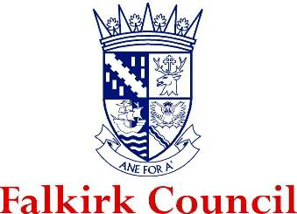

The Newly Qualified Social Worker Supported Year in Falkirk
Guidance for NQSWs & Supervisors



Contents
Background 3
Outline of the NQSW Supported Year in Falkirk 3
Key Roles and Responsibilities 6
Role of Falkirk Council as an employer 6
Role of the NQSW 7
Role of the Supervisor 7
Role of the Advanced Practitioner 8
Falkirk’s Learning & Development Framework 9
Continuous Professional Learning (CPL) Framework 10
Individual Learning Plan (ILP) 11
Supported Year Induction 12
Individual Development Plan (IDP) 15
Key dates 16
Protected Learning Time 19
Protected Workload 20
Reflective Supervision 20
Peer Mentoring 21
Advanced Practitioners 21
NQSW Peer Learning Forum 21
Core Learning Elements 23
Mandatory Learning Activities 25
Learning Element 1 - Ethics, values, and rights-based practice 25
Learning Element 2 - Communication, engagement, and relationship-based professional practice 27
Learning Element 3 - Critical thinking, professional judgement and decision making 28
Learning Element 4 - Promoting wellbeing, support and protection 29
Learning Element 5 - Working with complexity in unpredictable and ambiguous contexts 30
Learning Element 6 - Use of knowledge, research and evidence in practice 31
Learning Element 7 - Self-awareness and reflexivity 32
Learning Element 8 - Professional leadership 33
Feedback 34
Extension Requests 36
Changing Supervisor or Employer 37
Validation and Endorsement 38
Good Conversations 39

Continuous Professional Learning (CPL) Framework
The following guidance provides information on the framework of the Supported Year’s implementation across Falkirk, including the documentation and processes in place to support NQSWs, Supervisors and supporting professionals. The purpose of this document is to enhance knowledge and familiarity of the Supported Year but should not be used in isolation. It is important for Supervisors and NQSWs to take time to attend the SSSC’s suite of information sessions available throughout 2024.
Please make sure to access the SSSC’s NQSW website for more context. This is also the centralised location of all the documents NQSWs need as part of their Supported Year and can be accessed via this link.
There will be further guidance in this document about the stages of the Supported Year. Here is an overview of the timeline that NQSWs will go through from their registration date with the SSSC until the end of their Supported Year:

Individual Learning Plan (ILP)
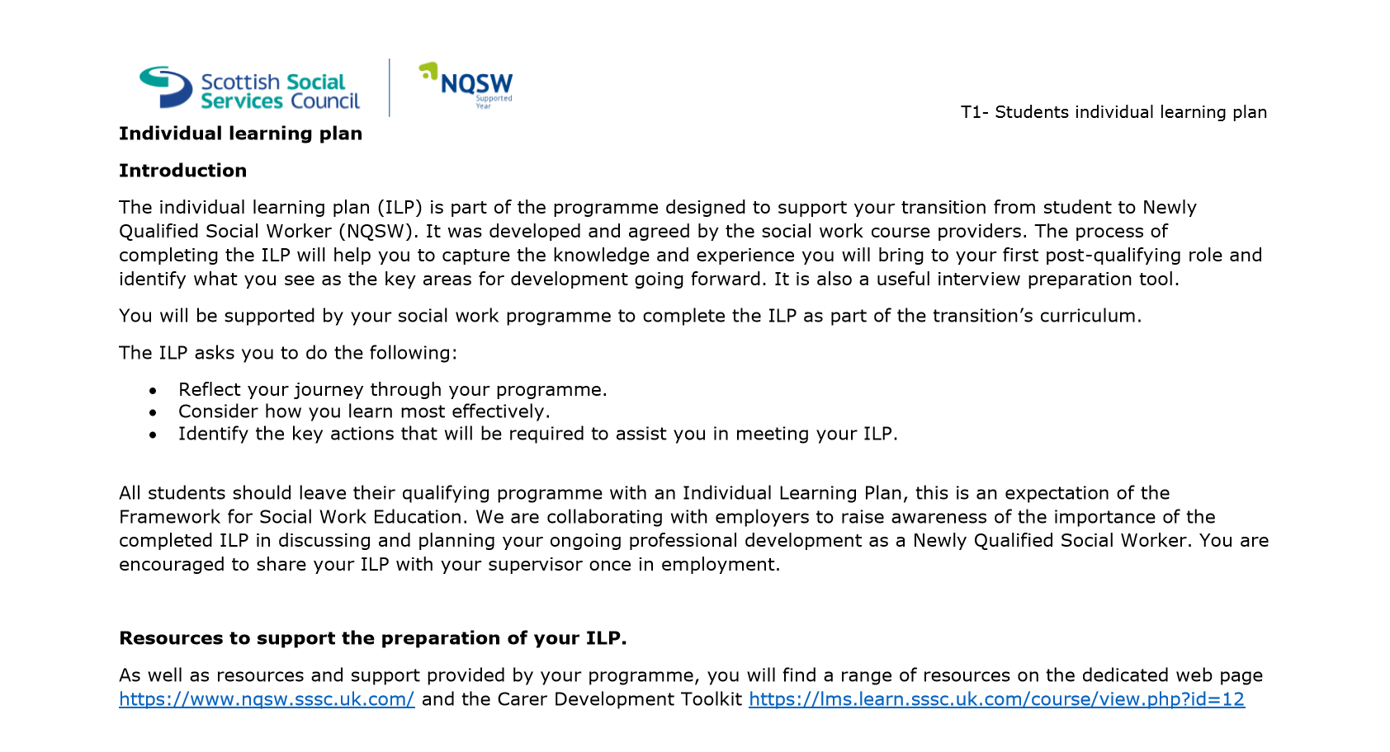
NQSWs joining Falkirk Council will be supported by their University Tutors to produce an ILP which outlines their strengths, experience, and areas for further development. This document should be used to reference the starting point of NQSWs professional learning journey as they begin working with Falkirk Council. There may be occasions where a NQSW does not have this, and we would encourage the NQSW to reach out to their university or take time to reflect and take stock of their learning needs as they begin their new post in the Supported Year. The ILP document can be found on the SSSC NQSW site.

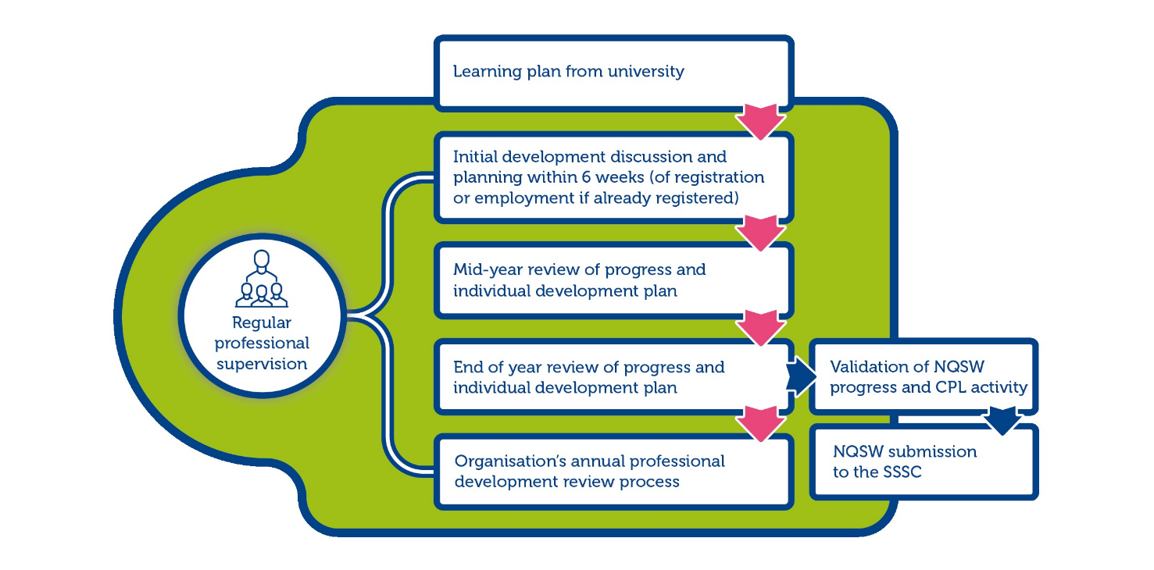
The SSSC have produced the following overview to show how the ILP fits into the NQSWs professional learning journey:

Supported Year Induction
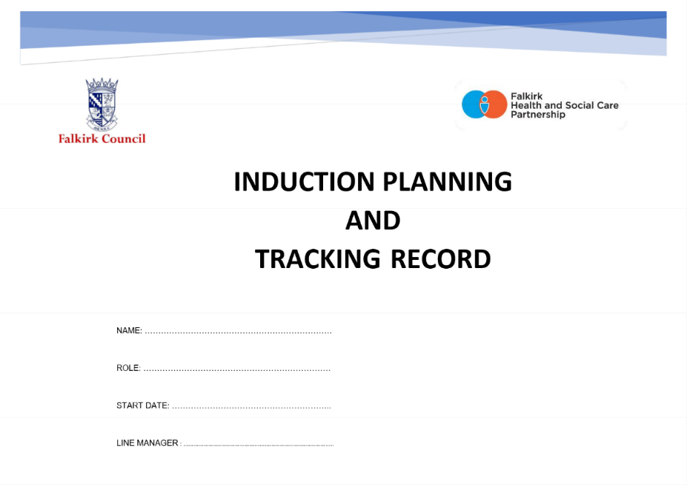
Falkirk Council’s induction process can be found on the Practitioner’s Pages. The Induction Planning and Tracking Record should be used as a baseline for NQSWs to ensure they can access key policy and timescales related to their employment with Falkirk Council. The document can be found under the Recruitment, Induction and Retention subheading.

At the induction stage it is recommended that NQSW and Supervisors begin populating the Continuous Professional Learning (CPL) Review Template as this will outline the NQSWs understanding of supervision arrangements, peer support & mentoring, protected learning time, and workload arrangements. Please ensure NQSWs and Supervisors become familiar with this document prior to the start date for NQSWs.
Within the induction period, the NQSWs should also be encouraged to familiarise themselves with the Core Learning Elements they will work towards within their Supported Year.
It is good practice to encourage NQSWs to create a secured shared space where they can record their reflections on key themes within their Supported Year. This may be a shared folder on the ‘W’ drive, a OneNote document, Teams folder, or a physical file where information can be stored. NQSWs can also records their reflections using CPD Manager, Olle, and can use the SSSC’s MyLearning App and Open Badges.
It is good practice for Supervisors to establish a tailored induction framework that supports NQSWs to become familiar with the service and agency partners. See the below example of an Induction Plan that can be used by Supervisors, but should be tailored to each service’s needs:

Week 1
Date |  | Morning | Lunch | Afternoon | Notes
Monday |  | NQSW arriving for 9am.  Show layout of offices, workspaces, fire safety arrangements, toilets and changing areas, identify personal spaces. |  | Arrange worker safety arrangements with Admin, including personal contact information, management team and link worker.  Spend time with colleagues.
Tuesday |  | Set up laptop and encourage NQSW to begin familiarising themselves with the workplace.  Complete Induction Planning and Training Record from Practitioners Pages. |  | Shadowing/policies/Olle learning/visiting services.
Wednesday |  | Shadowing/policies/Olle learning/visiting services.  Access CPD Manager and book in for training. |  | Shadowing/policies/Olle learning/visiting services.
Thursday |  | Shadowing/policies/Olle learning/visiting services. |  | Shadowing/policies/Olle learning/visiting services.
Friday |  | Shadowing/policies/Olle learning/visiting services. |  | Shadowing/policies/Olle learning/visiting services.
Week 2
Date |  | Morning | Lunch | Afternoon | Notes
Monday |  | Shadowing/policies/Olle learning/visiting services. |  | Shadowing/policies/Olle learning/visiting services.
Tuesday |  | Shadowing/policies/Olle learning/visiting services. |  | Shadowing/policies/Olle learning/visiting services.
Wednesday |  | Shadowing/policies/Olle learning/visiting services. |  | Shadowing/policies/Olle learning/visiting services.
Thursday |  | Shadowing/policies/Olle learning/visiting services. |  | Shadowing/policies/Olle learning/visiting services.
Friday |  | Shadowing/policies/Olle learning/visiting services. |  | Shadowing/policies/Olle learning/visiting services.

Individual Development Plan (IDP)
Throughout the Supported Year there is an emphasis on the continuous professional development (CPD) of NQSWs to ensure they have time and space to fully integrate themselves into their new role. A key component of this process is to have specific meetings throughout the Supported Year to ensure that NQSWs are meeting their Core Learning Elements and capturing this on their IDP.
There is an emphasis on Supervisors and APs being a ‘Critical Friend’ throughout the Supported Year (and beyond). The purpose of the Critical Friend is to encourage the relationship between the NQSWs, mentors and Supervisors as being nurturing, honest, open, transparent, and focused on the professional development of NQSWs. It may mean giving feedback that is welcome, and feedback that can be tough to hear. However, it is ultimately to support the NQSW to be as skilled and competent as possible. It also means that the NQSW supports their Supervisor to understand their learning style and take steps to reflect and analyse feedback so it is meaningful for their development.
Throughout the Supported Year there will be key meetings held between Supervisor and NQSWs to monitor progress of their development, identify opportunities for further learning, and address delays in key learning elements that need to be met as part of the Supported Year. There will be a six-week Individual Development Planning Meeting which will incorporate the ILP produced by the NQSWs and their university tutor, a Mid-Point Development Review and an End of Year Development Review. Once the NQSWs have completed their CPL Review Template this will be endorsed by their Supervisor and a Falkirk Council endorser; after which, NQSWs can submit their CPL Review Template to the SSSC.
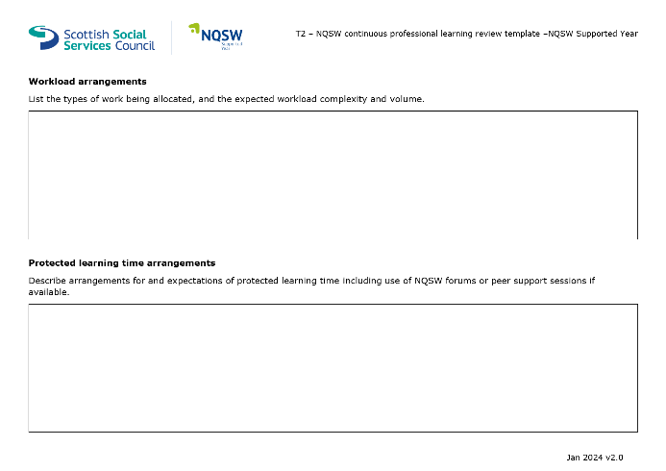
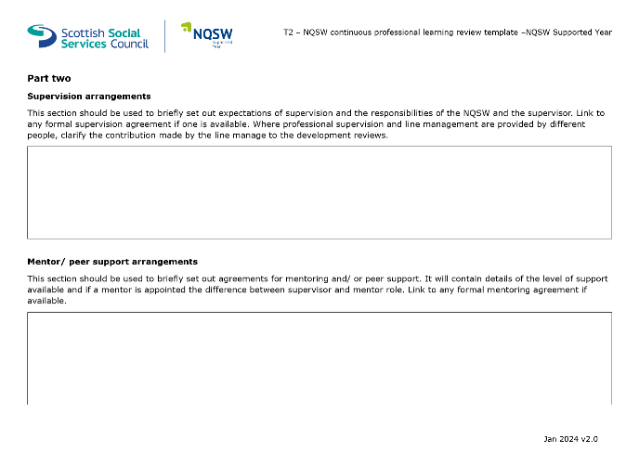
From the outset of their employment with Falkirk Council, it is important that NQSWs and Supervisors take time to fill in the first few pages of the CPL Review Template. This outlines supervision arrangements, peer support, protected workload, and Protected Learning Time.

Key dates
The Supported Year takes place from the point of registration as a social worker with the SSSC. There are three meetings that take place at key points of the Supported Year alongside supervision.

Six-Week Initial Development Discussion
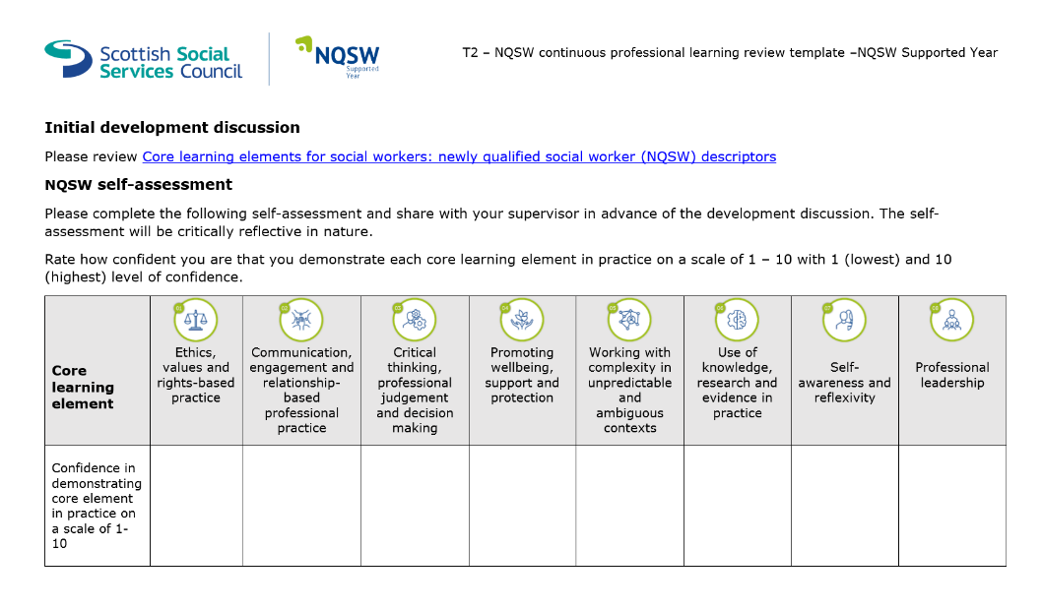
By the first six weeks as a registered social worker, the NQSW will meet with their Supervisor to discuss their Individual Development Plan (IDP) and how this will work towards their CPL Review Template being completed. NQSWs will take time before their meeting to complete a reflective self-assessment demonstrating on a score from 1-10 (low to high) how confident they feel with each of the eight Learning Elements. There is no word count on this, but NQSWs should take time to reflect on each of the elements as this will both encourage meaningful reflection and will provide good evidence for their commitment to their registration requirements.

NQSWs should also provide evidence of their relevant learning so they can evidence this to their Supervisor. There is no set format for how NQSWs record their critical reflection, learning and development but the SSSC will need this to be an auditable process, as sampling will be required to ensure a high quality of tailored learning and development. As noted in the Induction section there are a number of ways NQSWs can record their learning and this should be tailored to each NQSW to ensure it is meaningful to their learning.
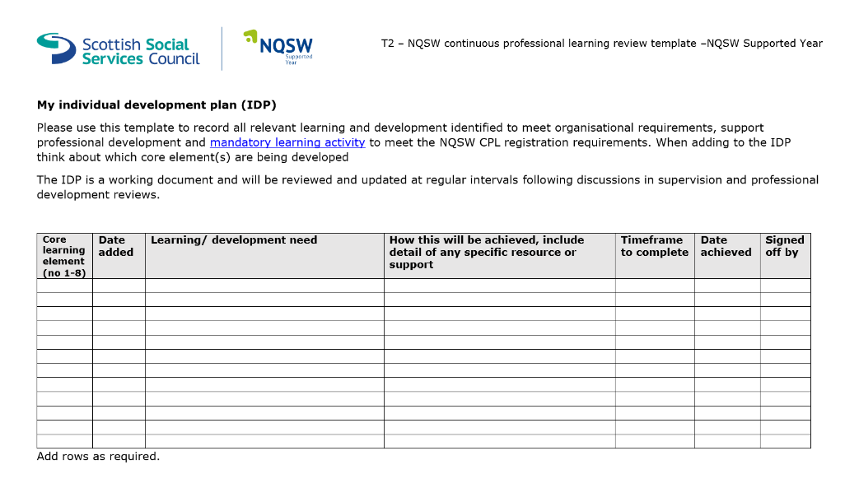
Together, the Supervisor and NQSW will create an IDP (see appendix of CPL Review Template), outlining the important learning opportunities that can help the worker meet these learning elements. Note: if there is sufficient learning and analysis, this document can be used to supplement evidence of the eight core learning elements needed.

Mid-year review
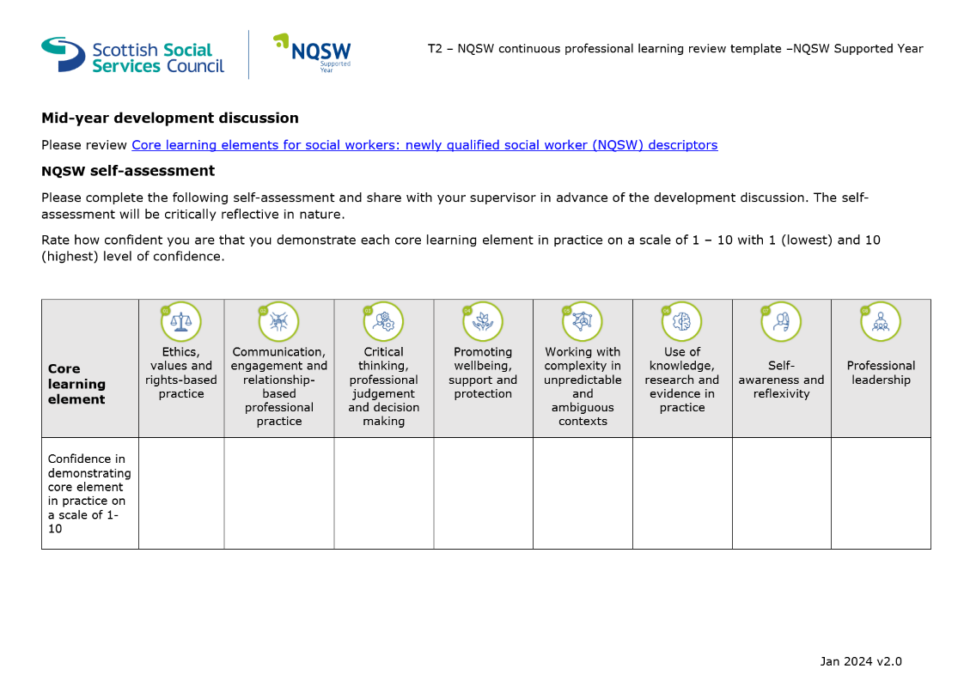
NQSWs will complete a mid-year review with their Supervisors. NQSWs are required to complete a self-assessment prior to this, as well as populate the document with evidence of their learning in line with the Mandatory Learning Activities.

If there are concerns noted about a NQSWs ability to meet the registration requirements under the Supported Year all steps should be taken to support the NQSW to address unmet learning needs. There may be occasions where external support is required. Should this be the case, the Supervisor should first discuss this with their own line manager and Workforce Development.
Some aspects of the Supported Year have to account for the variable ways that some people learn, but Supervisors should also be mindful of Falkirk’s own performance management policies to support NQSWs in ways that the Supported Year may not be able to. This may include HR processes such as absence management, professional conduct, etc.
Feedback should be requested from a range of sources prior to the mid-point meeting to evidence the NQSWs learning and unmet learning at this stage of their Supported Year.

End of Year Review
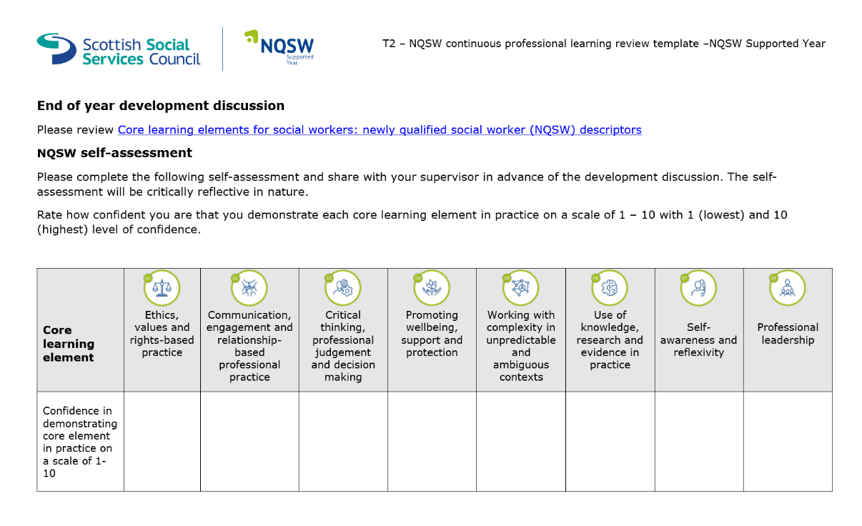
The end of year development review should take place at 12 months for full-time employees and 18 months for part-time employees. The format follows the same as the six-week and mid-point reviews but should be the at point where NQSWs have completed their Mandatory Learning Activities to evidence their Core Learning Elements.

To supplement this the SSSC have created an end of year development discussions tool to record professional development and capture any other learning elements that may be outstanding by the end of the Supported Year.

Protected Learning Time
Protected learning time is provided to support NQSWs to reflect upon their social work practice, consolidate learning and gathering evidence of the Core Learning Elements for CPL Review Template submission. NQSWs are entitled to a half-day protected work time per week during your first year in practice. There may be circumstances where this can be negotiated as one-day per fortnight but should be arranged with Supervisors.
Protected learning time should be used for a range of work-related developmental activities such as critical reflection, meeting with APs, shadowing colleagues and/or other professionals, observing meetings, research, etc. Attendance at mandatory training should not be included as part of protected learning time.
Many NQSWs initially join the Council in other posts until their registration is approved by the SSSC. During this time they will complete essential training and learning in order for them to be an employee of Falkirk council. NQSWs can now capture this learning within the Supported Year and may wish to use their protected learning time to reflect upon what they have learned over the preceding time and how this will inform/ influence/be integrated into their future social work practice.
There is no stipulation as to where protected work time takes place; this should be negotiated between the NQSW and their Supervisor. Consideration should be given to choosing a suitable location, but this will likely depend upon the activity taking place, i.e., choosing somewhere free from interruption and distraction when reading an article or writing a reflective account.

Protected Workload
NQSWs will have a protected caseload during the Supported Year with workloads gradually increasing in volume and complexity, determined and informed by the NQSWs developing competence and confidence in their social work role.
As the social work role and complexity of cases varies significantly, there is no defined suitable number of cases. However, in all circumstances there is an expectation that Supervisors will ensure a protected caseload and NQSWs should not be expected to undertake the same complexity and volume of cases as an experienced social worker.
Protected caseload also means that NQSWs should not take a lead role in child protection, adult protection or permanence cases during the Supported Year. However, it will be expected that they shadow colleagues, undertake supporting (second worker) roles, attend agency training, familiarise themselves with agency protocol and policy, and develop a working understanding of these more complex processes.
It is possible that any client NQSWs are working with may need child protection or adult support and protection input. NQSWs should be made aware that they will remain the allocated worker but will be paired with an experienced colleague or AP who will take the lead with Child or Adult Protection etc.

Reflective Supervision
The Supported Year requires Supervisors having a greater role in the CPD of NQSWs and their learning as they complete their CPL Review Template. It is hoped that supervision will be an opportunity to check in on progress of Core Learning Elements and provide feedback and guidance to NQSWs to ensure they remain on track to maintain their registrations with the SSSC.
During the Supported Year, NQSWs will have supervisions on a monthly basis and should be ringfenced to ensure that there is good oversight of NQSW progress and performance.
The SSSC have provided a number of materials for supervisors and NQSWs to use during their supervisions, encouraging critical reflection and paying attention to the individual needs of the workers. There is also information further within this guidance which outlines some of the means by which NQSWs and Supervisors can engage in good, meaningful critical reflection.

Peer Mentoring

Advanced Practitioners
As part of the commitment to support NQSWs development within their first year in qualified practice, they will be encouraged to work alongside Advanced Practitioners (APs) who will have a key role in sharing best practice and encouraging learning and development outwith the supervisory relationship. APs work throughout the council and if there are no APs within the NQSWs team Supervisors should explore other APs from other services to assist with shadowing, learning and development opportunities.
The purpose of the APs is to provide a peer mentoring support during the Supported Year. This will be a more informal relationship and should be used to share examples of best practice, practice wisdom, informal support, case discussions, and specialist knowledge.
APs are very experienced workers who have (or are in the process of gaining) further qualifications regarding their professional practice. This may include Mental Health Officers, Child Protection, Adult Support and Protection, Practice Education, Self-Directed Support, and many others. Some APs have gained further qualifications related to Mindfulness, Leadership, and other specialist subjects. It is very important that we recognise the valuable learning that APs can share with NQSWs.

NQSW Peer Learning Forum
Falkirk Council has an established NQSW Peer Learning Forum where NQSWs have a chance to network and build relationships with other workers who have just qualified and joined Falkirk.
The NQSW Peer Learning Forum takes into account Falkirk’s Planning Partnership Learning and Development Strategy and Framework. The Learning and Development Strategy is supported by the pillars of leadership, culture, collaboration, and reflective practice and is closely linked to the core learning elements needed within the Supported Year.
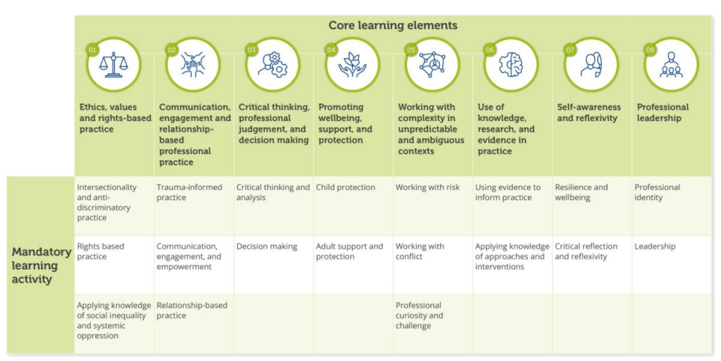
The NQSW Peer Learning Forums will reflect the Core Learning Elements and will draw on the expertise of NQSWs, APs, ATMs and TMs to facilitate learning around key areas. See the chart below for further information:

Feedback
NQSWs will be required to gather feedback at various stages of their Supported Year in order to evidence their learning, their professional development, and support their Supervisor to have greater insight into the NQSWs relationship-based practice. It is hoped that Feedback will be fair and balanced to promote learning, but we also need to recognise the experiences, values, expectations, and limitations when working with people using services.
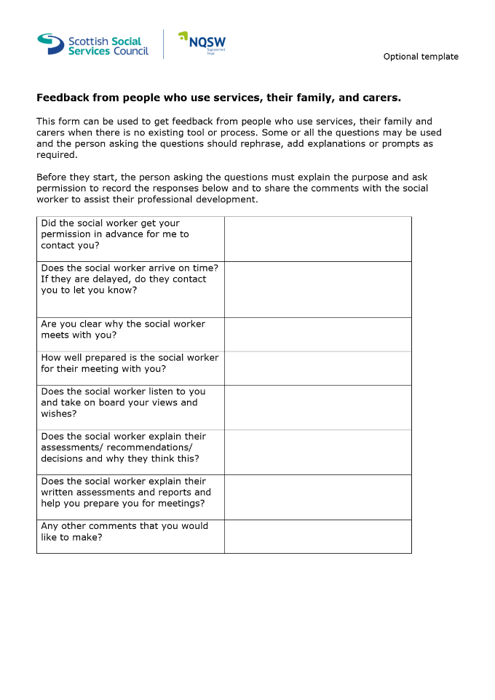
The following is an example of a feedback form the SSSC has provided (available here) as a template for people accessing services, their family, and carers:

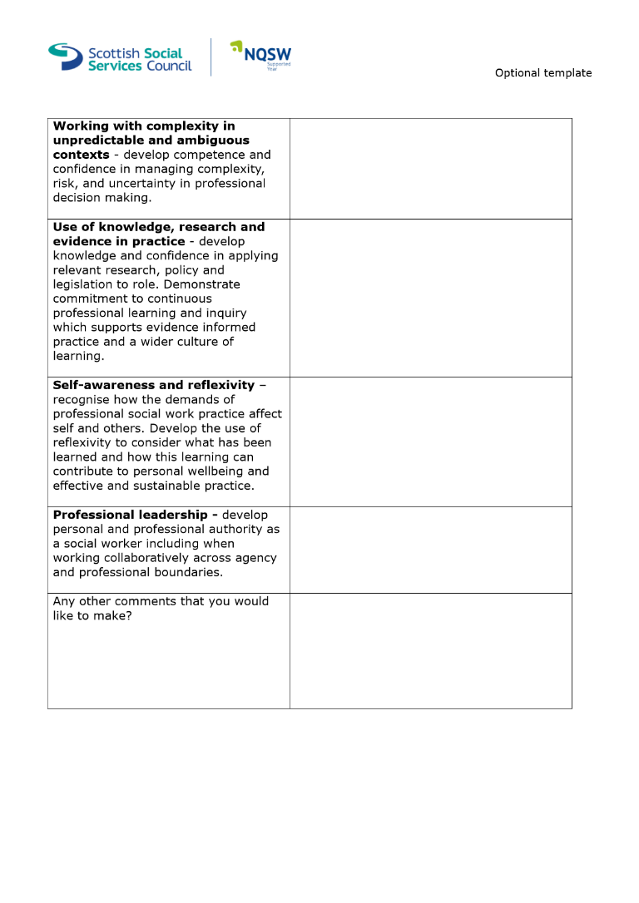
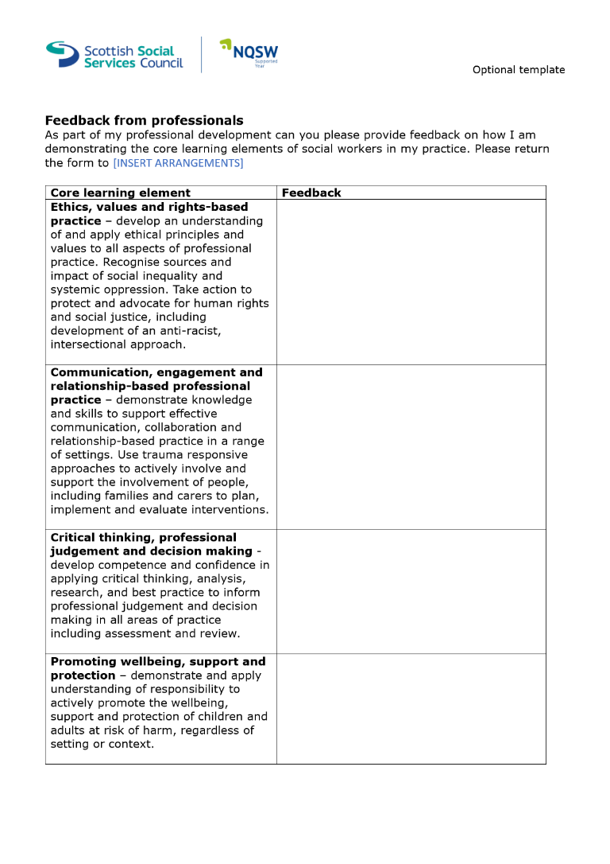
It is also important to collate feedback from professionals who have been working alongside NQSWs to be able to identify areas of strength and development, to help facilitate further learning during their Supported Year. The SSSC have provided the following document (which can be accessed here) to support this:

Extension Requests
There are a number of different life events and circumstances that may necessitate an extension request being submitted by NQSWs to the SSSC. It is essential that the NQSW keep in touch with their Supervisor and Team Manager to ensure that they get the help and attention they need during their Supported Year.
Extension Requests should be completed by the NQSW then passed to their manager before submitting to the SSSC for approval.
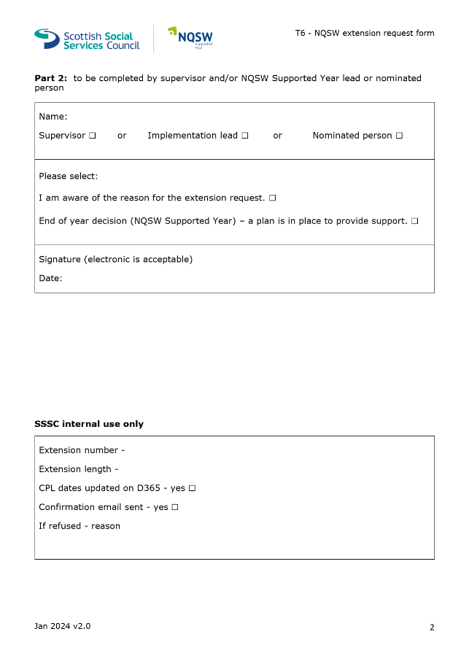
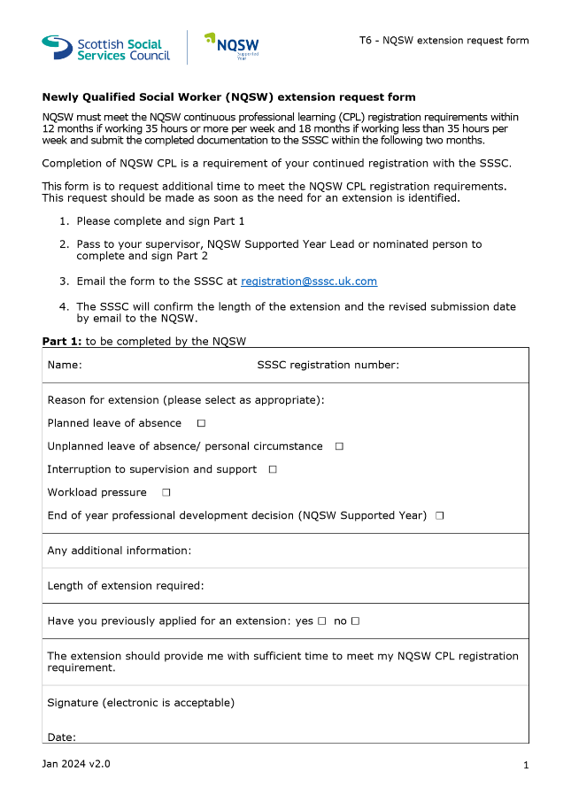
Please note that there may be circumstances where the SSSC refuse an extension request. There is a section which identifies workload pressures as a possible reason for needing an extension request so it is important that NQSWs have their CPL Review Template as up to date as possible as the SSSC may ask to sample the NQSWs progress through the Mandatory Learning Activities.

Under the previous PRTL and new Supported Year there is possibility that continued Registration may not be approved if there is not sufficient evidence for a need for an extension. There may be workers who do not maintain their registration, and this may affect their employability as a Social Worker with Falkirk Council. It is important that we avoid these circumstances and work collaboratively to ensure the NQSWs meet their registration requirements during the Supported Year.

Changing Supervisor or Employer
There may be occasions during the Supported Year where a NQSW either changes their workplace or there is a change in Supervisor. NQSWs require a level of continuity with their learning and development, which is why they should keep their CPL Review Template as a source of evidence of their mandatory learning activities.
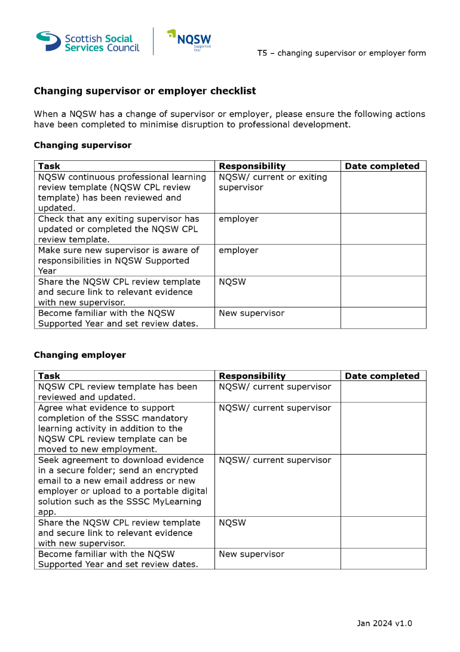
Should there be a change in supervisor, this evidence will enable them to see NQSWs achievements to date. The form can be accessed here on the SSSC website.

Validation and Endorsement
Once the NQSWs end of year development review has been completed and their CPL Review Template has been populated with evidence of Core Learning Elements being met, the document should be sent to their Supervisor to Validate (below, page 2). The CPL Review Template and accompanying endorsement form (below, page 3) should be shared with either the Supported Year lead or a nominated team manager for random sampling before being endorsed.
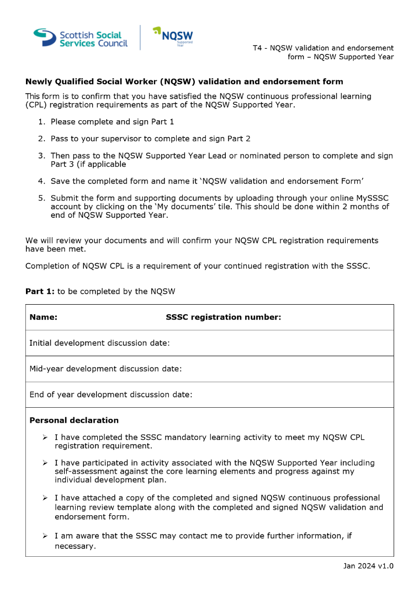
Once endorsed, the document should be returned to the NQSW and they should submit this to the SSSC within 2 months of the end of their Supported Year. This is one year & two months after the exact calendar date that they had been registered as a Social Worker.

It is possible that the SSSC may ask for further information to evidence sufficient learning during the Supported Year.
There is a recognition by the SSSC that NQSWs registered between the 1st of February and 1st of October will be working towards the Supported Year model before this is implemented in full, and it has been agreed that some degree of leniency will be afforded to the workers providing they use the same in-depth critical reflection of their learning needed in the PRTL requirements.

