

The Newly Qualified Social Worker Supported Year in Falkirk
Guidance for NQSWs & Supervisors



Contents
Background 3
Outline of the NQSW Supported Year in Falkirk 3
Key Roles and Responsibilities 6
Role of Falkirk Council as an employer 6
Role of the NQSW 7
Role of the Supervisor 7
Role of the Advanced Practitioner 8
Falkirk’s Learning & Development Framework 9
Continuous Professional Learning (CPL) Framework 10
Individual Learning Plan (ILP) 11
Supported Year Induction 12
Individual Development Plan (IDP) 15
Key dates 16
Protected Learning Time 19
Protected Workload 20
Reflective Supervision 20
Peer Mentoring 21
Advanced Practitioners 21
NQSW Peer Learning Forum 21
Core Learning Elements 23
Mandatory Learning Activities 25
Learning Element 1 - Ethics, values, and rights-based practice 25
Learning Element 2 - Communication, engagement, and relationship-based professional practice 27
Learning Element 3 - Critical thinking, professional judgement and decision making 28
Learning Element 4 - Promoting wellbeing, support and protection 29
Learning Element 5 - Working with complexity in unpredictable and ambiguous contexts 30
Learning Element 6 - Use of knowledge, research and evidence in practice 31
Learning Element 7 - Self-awareness and reflexivity 32
Learning Element 8 - Professional leadership 33
Feedback 34
Extension Requests 36
Changing Supervisor or Employer 37
Validation and Endorsement 38
Good Conversations 39

Background
The first year in practice is widely acknowledged as being crucial for social workers (Grant et al, 2014). It is recognised that a more consistent approach is required to support Newly Qualified Social Workers (NQSW) in their first year of practice. The purpose of this programme is to provide structured support for NQSW in meeting their continuous professional learning (CPL) requirements over their first year in post as a qualified Social Worker. This is an evidence-based approach which seeks to improve the recruitment and retention of NQSWs, as well as recognise the need for tailored learning to support them in their new roles.

Outline of the NQSW Supported Year in Falkirk
The following is a broad outline of the NQSW Supported Year in Falkirk. Further information will be shared during development events, in follow-up workshops and in the written documentation provided.
The model of this programme has been developed in partnership with other local authorities and universities. It was informed by a scoping exercise and literature review and is cognisant of the Scottish Social Services Council (SSSC) Core Learning Elements for NQSWs.
- NQSWs will work towards completing a Continuous Professional Learning (CPL) Review Template that consolidates their learning and development throughout their Supported Year. This is an evidenced-based document that will contain details of the NQSWs Core Learning Elements and a tailored plan that will identify how to meaningfully engage with learning in the workplace.

- CPL no longer focuses on hours of training/learning completed and uses a wide variety of sources to evidence learning. These will be discussed later in this guidance.

- Your supported CPL programme will consist of the following key participants:
- NQSWs
- Supervisors (Assistant Team Manager or Team Manager)
- Advanced Practitioners
- Workforce Development
- University Tutors

- NQSWs will be supported by their Supervisors to develop an Individual Development Plan (IDP) to co-produce a learning plan that reflects their learning style and provides a foundation for them to develop their social work practice within Falkirk. NQSWs will be responsible for maintaining a record of their learning throughout their Supported Year and Supervisors will support the NQSW to verify learning elements have been met.

- Falkirk’s Supported Year will last for 12 months from the period that a NQSW is registered with the SSSC for full-time employment and 18 months for part-time employment.

- Some NQSWs will be employed within their teams as social care officers, social work assistants etc. until their SSSC registration is approved. The Supported Year allows workers to account for their induction and learning during the period between employment and registration using reflective journals.

- NQSWs will receive monthly supervision. In the first 3-6 months NQSWs should expect supervision to be more frequent (typically two-weekly). The focus of supervision will be to work towards Core Learning elements and there should be a strong emphasis on reflection and analysis. NQSWs and their Supervisor will review whether monthly supervision is sufficient or whether this should be increased.

- NQSWs will be matched by their Supervisors with an advanced practitioner (AP) — an experienced social worker — where possible from within the team they are working in. However, occasionally they may be from another part of the service. NQSWs should be encouraged to shadow their AP to explore specific themes and topics to facilitate learning. APs have a wide range of skills and knowledge, and it is good practice for workers to spend time with different APs at different points of their Supported Year to maximise learning.

- NQSWs and their Supervisors will work out their workplace arrangements. It is expected that NQSWs will be office-based within their Supported Year so that they can develop relationships with colleagues and collaborate. There may be occasions where hybrid working is needed but this should be considered in the context of the NQSWs learning and development.

- NQSWs will have a protected caseload during their Supported Year, with their workload gradually increasing in volume and complexity based on capabilities and competency. There will be occasions where NQSWs need to take on more work, which should be reflected on and discussed in supervisions.

NQSWs will not take a lead role in child, adult protection or permanence cases during their Supported Year. They may shadow experienced colleagues and contribute to these assessments if it is a supported part of their professional development.

- NQSWs will have Protected Learning Time (PLT). This will be a half day per week, or full day per fortnight, during core business hours to undertake study, reflection, shadowing, etc. There is no set time for this but should be balanced with the NQSWs learning needs and the service’s needs. NQSWs and their Supervisors will arrange where PLT takes place; within the office, other Falkirk Council workplaces, or at home.

Essential training such as Child Protection, Adult Protection, Trauma etc. should not considered part of their protected learning time.

- The Supported Year will more broadly encourage, contribute to, and facilitate learning within teams and localities in which NQSWs are based. NQSWs will be expected to contribute to the professional learning of others.

This should be negotiated and planned within formal supervision. Examples of this may include the sharing of dissertation findings, theory and research evidence explored to apply/ integrate to social work practice, or mentoring Social Work Students undertaking placements.

- NQSWs will be offered a monthly NQSW Peer Learning Forum to explore and consolidate learning, and to network with peers across the local authority.

- All those involved in the Supported Year programme (NQSW, Supervisors and APs) will be expected to contribute to the overall programme evaluation to make sure it meets the needs of Falkirk’s Social Work staff.

Key Roles and Responsibilities

Role of Falkirk Council as an employer
Falkirk Council plays a critical role in the successful implementation and delivery of the Supported Year alongside other Local Authorities. NQSWs should consult the SSSC website to find out more about the roles and responsibilities placed on Falkirk to make sure they get the best opportunities to develop and thrive.
Falkirk Council is an Early Adopter of the Supported Year and will be supporting NQSWs to meet their registration requirements with the appropriate structures and supports in place to facilitate good learning, so workers feel capable in their new roles.
Falkirk Council have employed a NQSW Supported Year coordinator to support with the transition from Post Registration Training and Learning (PRTL) to the Supported Year. The coordinator will support with establishing and rolling out the Employer Support. Further guidance on Employer Support is discussed later in this guidance.
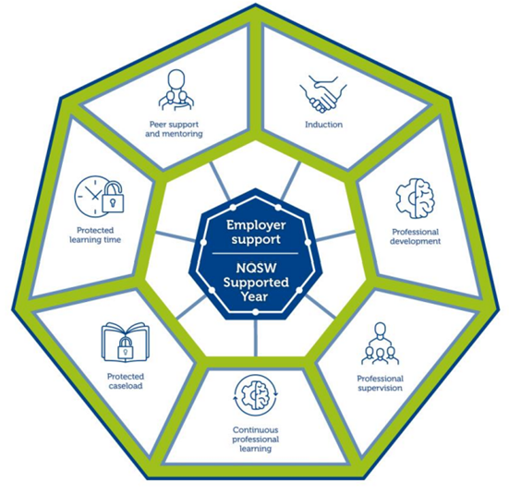

Role of the NQSW
NQSWs have a responsibility to their learning and development within the Supported Year, to engage meaningfully with the process and to ensure that they work in partnership with their Supervisors. There is an emphasis on co-production of learning to support the NQSW move on from being a Social Work Student to a Social Worker.
NQSWs are responsible for ensuring that they complete the Mandatory Learning Activities so that they can evidence the Core Learning Elements within their CPL Review Template. This means ongoing critical reflection and analysis of each of the Core Learning Elements and what role they have, or will have, in professional practice.
NQSWs are responsible for keeping a record of their learning and where this should be stored so they and their Supervisor can coordinate CPL actions. NQSWs should take time to familiarise themselves with the Supported Year by visiting the SSSC Website.
NQSWs should contribute to the learning and development of their team, service, colleagues and other professionals.

Role of the Supervisor
Supervisors are Assistant Team Managers (ATMs) or Team Managers (TMs) who are registered as Social Workers with the SSSC.
Supervisors are responsible for supporting NQSWs through their Supported Year to achieve their Core Learning Elements and record this in their CPL Review Template. There is an emphasis on the need for Supervisors to build good working relationships with their NQSW colleagues to support them to maximise their learning as this will have a positive impact on their resilience, competence and capability.
Supervisors will arrange a minimum of monthly supervision. It is best practice for the Supervisor and NQSW to arrange a Supervision Contract to establish roles and responsibilities.
Supervisors have case allocation responsibility and will become more attuned to the NQSWs capacity to manage increasingly complex cases as time goes on. Supervisors should be clear that NQSWs will have a protected caseload during their Supported Year and allocations should be dependent on capability and learning needs. Note: this is not about numbers, but rather supporting NQSWs to understand complexity and give them the opportunity to develop their competence.
Supervisors are responsible for ensuring that NQSWs have their Protected Learning Time. This includes supporting them by directing them to areas of further study/research, facilitating shadowing opportunities, making sure they understand the importance of their protected learning time, etc.
Supervisors will support their NQSWs to request and collate feedback from people who use the service and professional colleagues. Feedback is invaluable to NQSWs learning and development. Supervisors may also observe NQSWs in the initial stages to provide professional feedback. This may be something that happens in a naturally occurring way, for instance, a phone call in relation to an individual, or in a meeting or group forum. This is something that can be discussed throughout the supervision process.
Supervisors will play an active part in NQSWs development towards becoming an autonomous, professional social work practitioner. It is important to remember that this is all about the NQSWs own learning, therefore, they themselves are accountable for ensuring their own learning and development needs are being met.

Role of the Advanced Practitioner
NQSWs should be encouraged to work alongside APs as they have a key role in sharing best practice and encouraging learning and development out-with the supervisory relationship. APs work throughout the council so if there are no APs within the NQSWs team, Supervisors should explore APs from other services to assist with shadowing and learning opportunities.
The purpose of the APs is to provide peer mentoring support during the Supported Year with the purpose of sharing examples of best practice, practice wisdom, informal support, case discussions, and specialist knowledge.
APs are very experienced workers who have (or are in the process of gaining) further qualifications regarding their professional practice. This may include Mental Health Officers, Child Protection, Adult Support and Protection, Practice Education, Self-Directed Support, and many others. Some APs have gained further qualifications related to Mindfulness, Leadership, and other specialist subjects. It is important that we recognise the valuable learning that APs can share with NQSWs.
APs will not have managerial responsibilities such as performance management of NQSWs and should consult with Supervisors if they have feedback about the NQSWs development.

Falkirk’s Learning & Development Framework
Falkirk Council’s Learning and Development Framework includes valuable critically reflective practice techniques to facilitate learning and development across services.
Throughout their time as a social work students NQSWs should have developed a solid foundation from which to build on and support them in becoming ongoing reflective practitioners. NQSWs are expected to continue demonstrating those critical reflection skills well into their professional practice and will record their reflections.
NQSWs can use a variety of tools to encourage critical reflection, including the models encouraged within the Learning and Development Strategy (Driscoll’s So What? Model; 4D Cycle; Reflection-on/in-Action). It is also useful for NQSWs to consider the reflective techniques that best suit their learning styles and may use Critical Incident Analysis, Gibbs’ Reflective Cycle (example below), or something completely different. The Supported Year does not ask NQSWs to use a specific model, but rather encourages a tailored learning experience so workers may use one, some, a combination of models, or none of them – they may use something completely different that works for them.

Gibbs’ Reflective Cycle encourages NQSWs to think methodically about the sequence of an experience or social work activity and the headings/ framework can be helpful in structuring the content of your reflection.
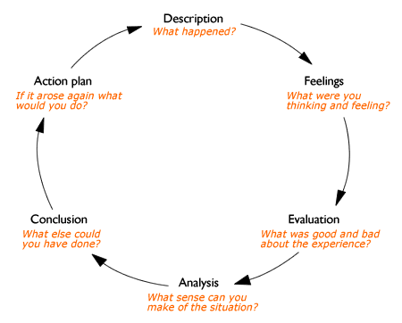

Continuous Professional Learning (CPL) Framework
The following guidance provides information on the framework of the Supported Year’s implementation across Falkirk, including the documentation and processes in place to support NQSWs, Supervisors and supporting professionals. The purpose of this document is to enhance knowledge and familiarity of the Supported Year but should not be used in isolation. It is important for Supervisors and NQSWs to take time to attend the SSSC’s suite of information sessions available throughout 2024.
Please make sure to access the SSSC’s NQSW website for more context. This is also the centralised location of all the documents NQSWs need as part of their Supported Year and can be accessed via this link.
There will be further guidance in this document about the stages of the Supported Year. Here is an overview of the timeline that NQSWs will go through from their registration date with the SSSC until the end of their Supported Year:

Individual Learning Plan (ILP)
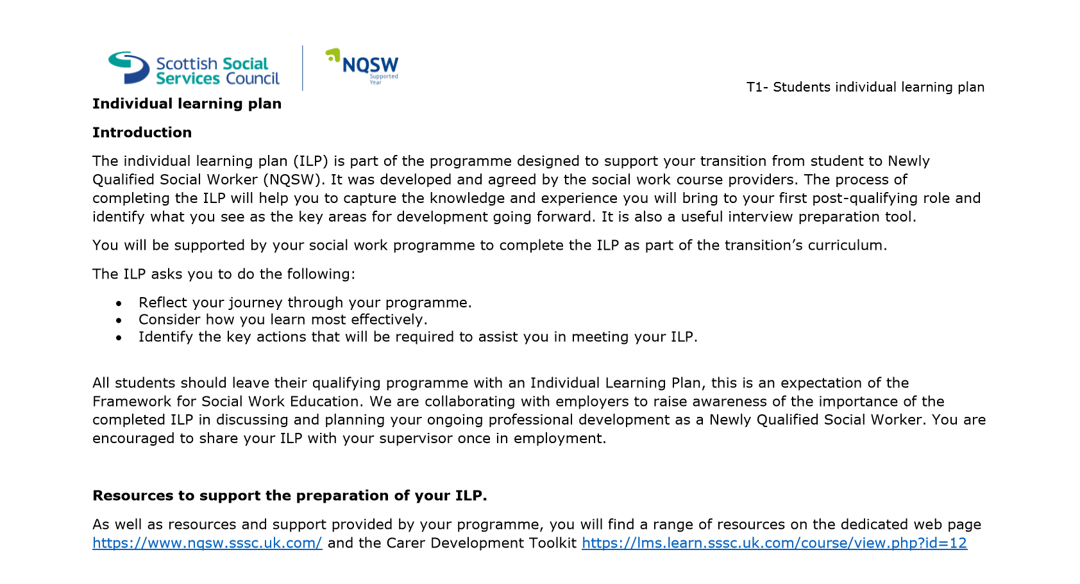
NQSWs joining Falkirk Council will be supported by their University Tutors to produce an ILP which outlines their strengths, experience, and areas for further development. This document should be used to reference the starting point of NQSWs professional learning journey as they begin working with Falkirk Council. There may be occasions where a NQSW does not have this, and we would encourage the NQSW to reach out to their university or take time to reflect and take stock of their learning needs as they begin their new post in the Supported Year. The ILP document can be found on the SSSC NQSW site.

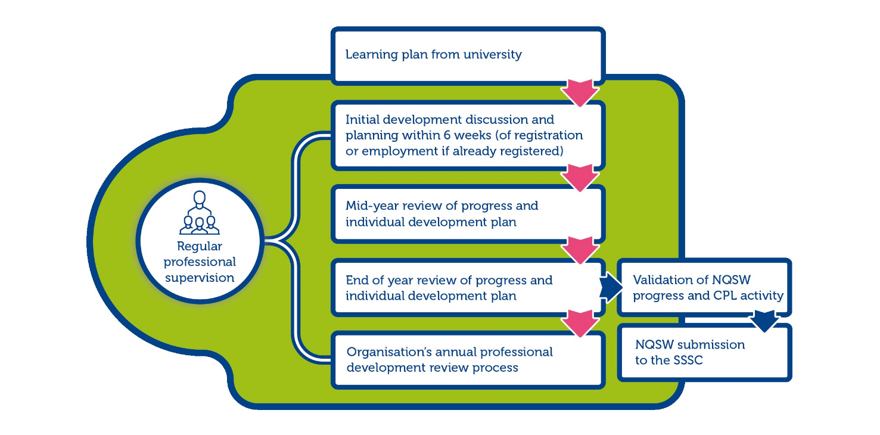
The SSSC have produced the following overview to show how the ILP fits into the NQSWs professional learning journey:

Supported Year Induction
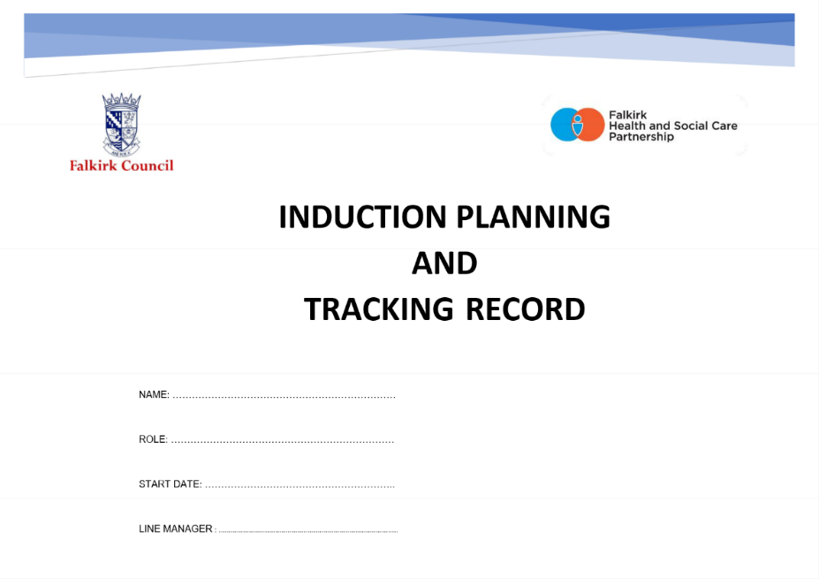
Falkirk Council’s induction process can be found on the Practitioner’s Pages. The Induction Planning and Tracking Record should be used as a baseline for NQSWs to ensure they can access key policy and timescales related to their employment with Falkirk Council. The document can be found under the Recruitment, Induction and Retention subheading.

At the induction stage it is recommended that NQSW and Supervisors begin populating the Continuous Professional Learning (CPL) Review Template as this will outline the NQSWs understanding of supervision arrangements, peer support & mentoring, protected learning time, and workload arrangements. Please ensure NQSWs and Supervisors become familiar with this document prior to the start date for NQSWs.
Within the induction period, the NQSWs should also be encouraged to familiarise themselves with the Core Learning Elements they will work towards within their Supported Year.
It is good practice to encourage NQSWs to create a secured shared space where they can record their reflections on key themes within their Supported Year. This may be a shared folder on the ‘W’ drive, a OneNote document, Teams folder, or a physical file where information can be stored. NQSWs can also records their reflections using CPD Manager, Olle, and can use the SSSC’s MyLearning App and Open Badges.
It is good practice for Supervisors to establish a tailored induction framework that supports NQSWs to become familiar with the service and agency partners. See the below example of an Induction Plan that can be used by Supervisors, but should be tailored to each service’s needs:

Week 1
Date |  | Morning | Lunch | Afternoon | Notes
Monday |  | NQSW arriving for 9am.  Show layout of offices, workspaces, fire safety arrangements, toilets and changing areas, identify personal spaces. |  | Arrange worker safety arrangements with Admin, including personal contact information, management team and link worker.  Spend time with colleagues.
Tuesday |  | Set up laptop and encourage NQSW to begin familiarising themselves with the workplace.  Complete Induction Planning and Training Record from Practitioners Pages. |  | Shadowing/policies/Olle learning/visiting services.
Wednesday |  | Shadowing/policies/Olle learning/visiting services.  Access CPD Manager and book in for training. |  | Shadowing/policies/Olle learning/visiting services.
Thursday |  | Shadowing/policies/Olle learning/visiting services. |  | Shadowing/policies/Olle learning/visiting services.
Friday |  | Shadowing/policies/Olle learning/visiting services. |  | Shadowing/policies/Olle learning/visiting services.
Week 2
Date |  | Morning | Lunch | Afternoon | Notes
Monday |  | Shadowing/policies/Olle learning/visiting services. |  | Shadowing/policies/Olle learning/visiting services.
Tuesday |  | Shadowing/policies/Olle learning/visiting services. |  | Shadowing/policies/Olle learning/visiting services.
Wednesday |  | Shadowing/policies/Olle learning/visiting services. |  | Shadowing/policies/Olle learning/visiting services.
Thursday |  | Shadowing/policies/Olle learning/visiting services. |  | Shadowing/policies/Olle learning/visiting services.
Friday |  | Shadowing/policies/Olle learning/visiting services. |  | Shadowing/policies/Olle learning/visiting services.

Individual Development Plan (IDP)
Throughout the Supported Year there is an emphasis on the continuous professional development (CPD) of NQSWs to ensure they have time and space to fully integrate themselves into their new role. A key component of this process is to have specific meetings throughout the Supported Year to ensure that NQSWs are meeting their Core Learning Elements and capturing this on their IDP.
There is an emphasis on Supervisors and APs being a ‘Critical Friend’ throughout the Supported Year (and beyond). The purpose of the Critical Friend is to encourage the relationship between the NQSWs, mentors and Supervisors as being nurturing, honest, open, transparent, and focused on the professional development of NQSWs. It may mean giving feedback that is welcome, and feedback that can be tough to hear. However, it is ultimately to support the NQSW to be as skilled and competent as possible. It also means that the NQSW supports their Supervisor to understand their learning style and take steps to reflect and analyse feedback so it is meaningful for their development.
Throughout the Supported Year there will be key meetings held between Supervisor and NQSWs to monitor progress of their development, identify opportunities for further learning, and address delays in key learning elements that need to be met as part of the Supported Year. There will be a six-week Individual Development Planning Meeting which will incorporate the ILP produced by the NQSWs and their university tutor, a Mid-Point Development Review and an End of Year Development Review. Once the NQSWs have completed their CPL Review Template this will be endorsed by their Supervisor and a Falkirk Council endorser; after which, NQSWs can submit their CPL Review Template to the SSSC.
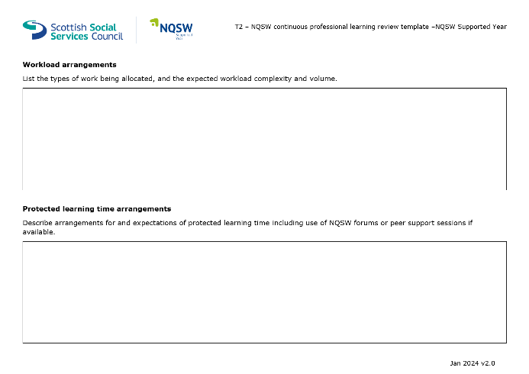
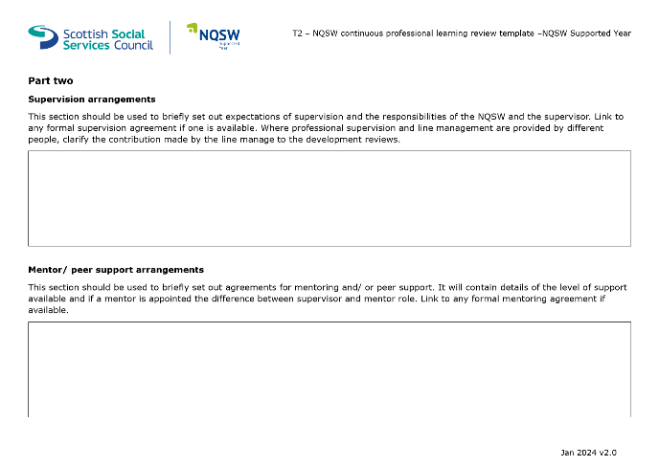
From the outset of their employment with Falkirk Council, it is important that NQSWs and Supervisors take time to fill in the first few pages of the CPL Review Template. This outlines supervision arrangements, peer support, protected workload, and Protected Learning Time.

Key dates
The Supported Year takes place from the point of registration as a social worker with the SSSC. There are three meetings that take place at key points of the Supported Year alongside supervision.

Six-Week Initial Development Discussion
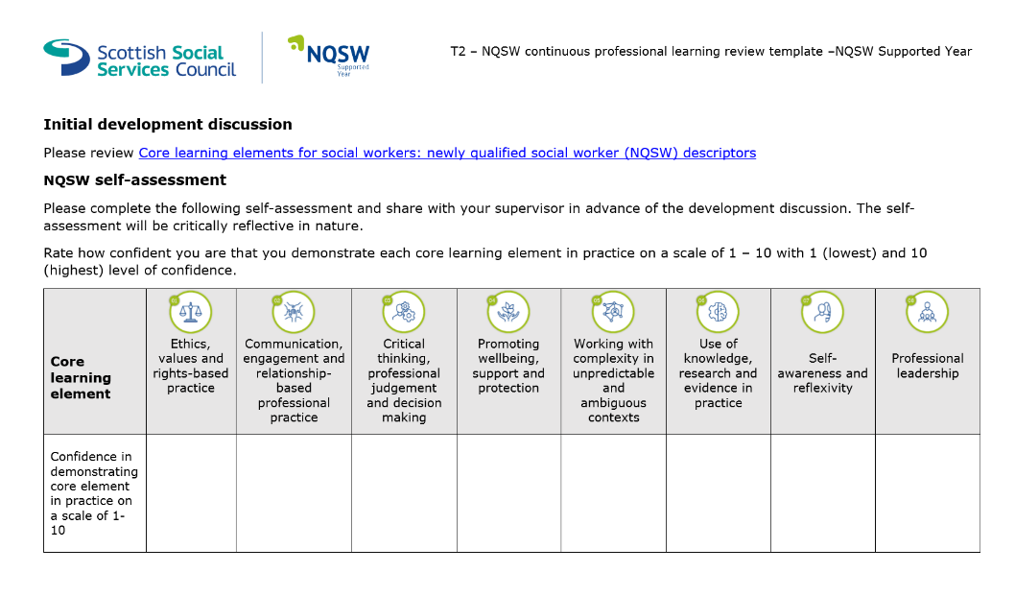
By the first six weeks as a registered social worker, the NQSW will meet with their Supervisor to discuss their Individual Development Plan (IDP) and how this will work towards their CPL Review Template being completed. NQSWs will take time before their meeting to complete a reflective self-assessment demonstrating on a score from 1-10 (low to high) how confident they feel with each of the eight Learning Elements. There is no word count on this, but NQSWs should take time to reflect on each of the elements as this will both encourage meaningful reflection and will provide good evidence for their commitment to their registration requirements.

NQSWs should also provide evidence of their relevant learning so they can evidence this to their Supervisor. There is no set format for how NQSWs record their critical reflection, learning and development but the SSSC will need this to be an auditable process, as sampling will be required to ensure a high quality of tailored learning and development. As noted in the Induction section there are a number of ways NQSWs can record their learning and this should be tailored to each NQSW to ensure it is meaningful to their learning.
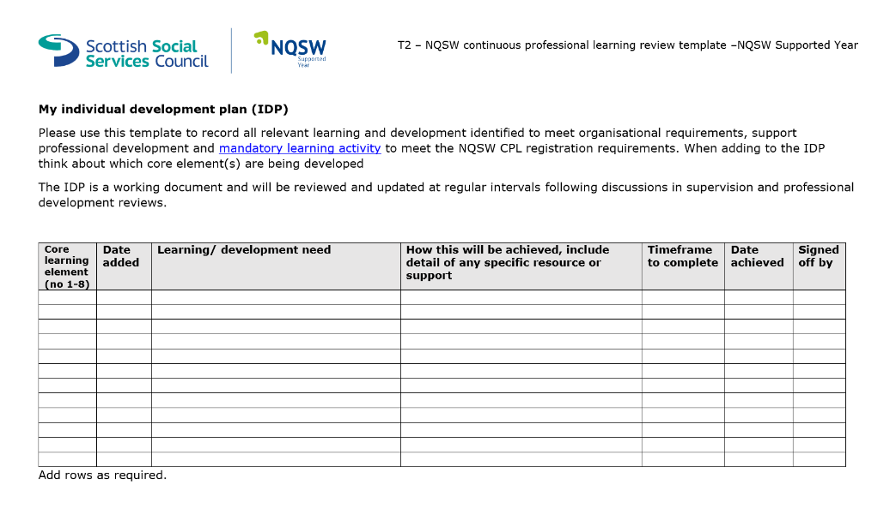
Together, the Supervisor and NQSW will create an IDP (see appendix of CPL Review Template), outlining the important learning opportunities that can help the worker meet these learning elements. Note: if there is sufficient learning and analysis, this document can be used to supplement evidence of the eight core learning elements needed.

Mid-year review
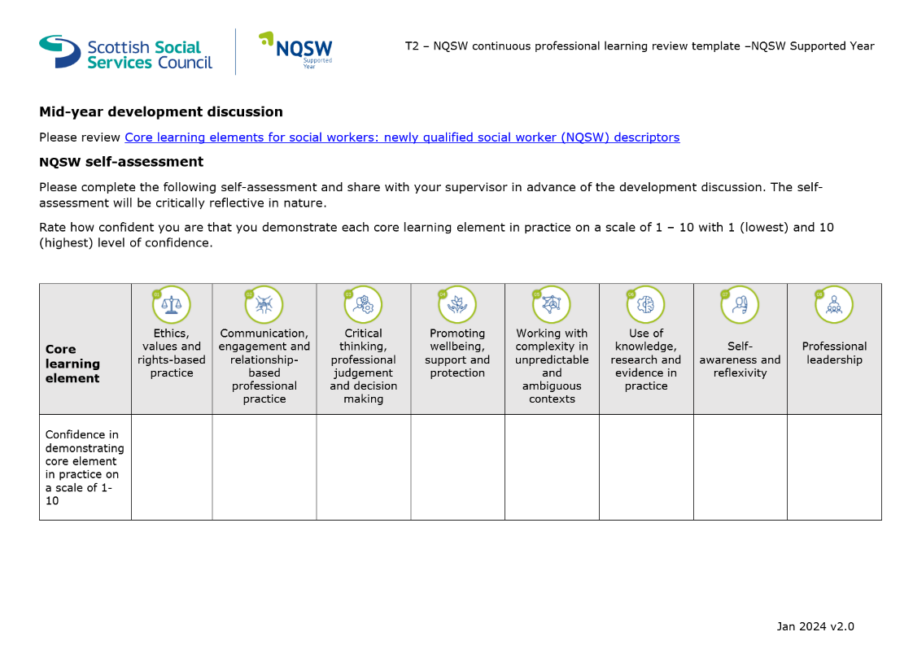
NQSWs will complete a mid-year review with their Supervisors. NQSWs are required to complete a self-assessment prior to this, as well as populate the document with evidence of their learning in line with the Mandatory Learning Activities.

If there are concerns noted about a NQSWs ability to meet the registration requirements under the Supported Year all steps should be taken to support the NQSW to address unmet learning needs. There may be occasions where external support is required. Should this be the case, the Supervisor should first discuss this with their own line manager and Workforce Development.
Some aspects of the Supported Year have to account for the variable ways that some people learn, but Supervisors should also be mindful of Falkirk’s own performance management policies to support NQSWs in ways that the Supported Year may not be able to. This may include HR processes such as absence management, professional conduct, etc.
Feedback should be requested from a range of sources prior to the mid-point meeting to evidence the NQSWs learning and unmet learning at this stage of their Supported Year.

End of Year Review
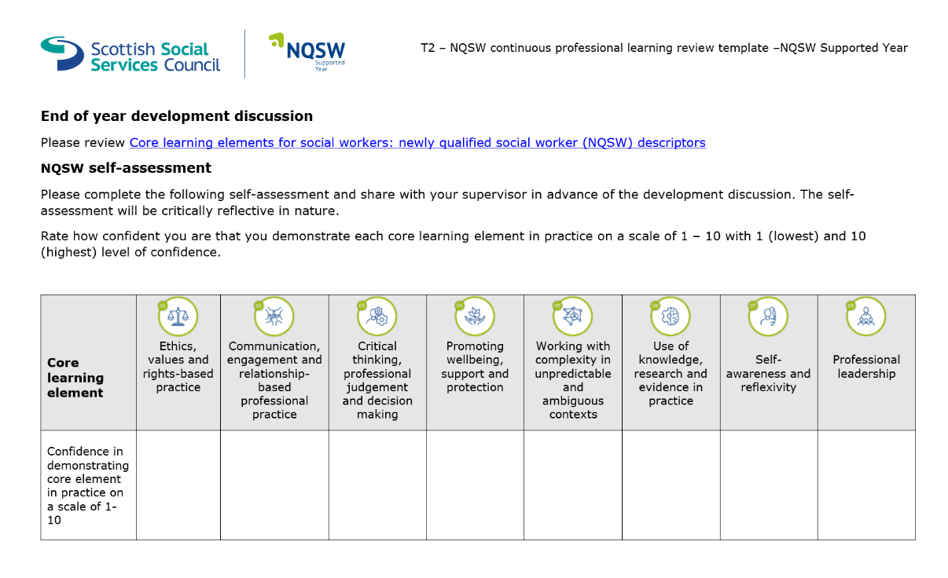
The end of year development review should take place at 12 months for full-time employees and 18 months for part-time employees. The format follows the same as the six-week and mid-point reviews but should be the at point where NQSWs have completed their Mandatory Learning Activities to evidence their Core Learning Elements.

To supplement this the SSSC have created an end of year development discussions tool to record professional development and capture any other learning elements that may be outstanding by the end of the Supported Year.

Protected Learning Time
Protected learning time is provided to support NQSWs to reflect upon their social work practice, consolidate learning and gathering evidence of the Core Learning Elements for CPL Review Template submission. NQSWs are entitled to a half-day protected work time per week during your first year in practice. There may be circumstances where this can be negotiated as one-day per fortnight but should be arranged with Supervisors.
Protected learning time should be used for a range of work-related developmental activities such as critical reflection, meeting with APs, shadowing colleagues and/or other professionals, observing meetings, research, etc. Attendance at mandatory training should not be included as part of protected learning time.
Many NQSWs initially join the Council in other posts until their registration is approved by the SSSC. During this time they will complete essential training and learning in order for them to be an employee of Falkirk council. NQSWs can now capture this learning within the Supported Year and may wish to use their protected learning time to reflect upon what they have learned over the preceding time and how this will inform/ influence/be integrated into their future social work practice.
There is no stipulation as to where protected work time takes place; this should be negotiated between the NQSW and their Supervisor. Consideration should be given to choosing a suitable location, but this will likely depend upon the activity taking place, i.e., choosing somewhere free from interruption and distraction when reading an article or writing a reflective account.

Protected Workload
NQSWs will have a protected caseload during the Supported Year with workloads gradually increasing in volume and complexity, determined and informed by the NQSWs developing competence and confidence in their social work role.
As the social work role and complexity of cases varies significantly, there is no defined suitable number of cases. However, in all circumstances there is an expectation that Supervisors will ensure a protected caseload and NQSWs should not be expected to undertake the same complexity and volume of cases as an experienced social worker.
Protected caseload also means that NQSWs should not take a lead role in child protection, adult protection or permanence cases during the Supported Year. However, it will be expected that they shadow colleagues, undertake supporting (second worker) roles, attend agency training, familiarise themselves with agency protocol and policy, and develop a working understanding of these more complex processes.
It is possible that any client NQSWs are working with may need child protection or adult support and protection input. NQSWs should be made aware that they will remain the allocated worker but will be paired with an experienced colleague or AP who will take the lead with Child or Adult Protection etc.

Reflective Supervision
The Supported Year requires Supervisors having a greater role in the CPD of NQSWs and their learning as they complete their CPL Review Template. It is hoped that supervision will be an opportunity to check in on progress of Core Learning Elements and provide feedback and guidance to NQSWs to ensure they remain on track to maintain their registrations with the SSSC.
During the Supported Year, NQSWs will have supervisions on a monthly basis and should be ringfenced to ensure that there is good oversight of NQSW progress and performance.
The SSSC have provided a number of materials for supervisors and NQSWs to use during their supervisions, encouraging critical reflection and paying attention to the individual needs of the workers. There is also information further within this guidance which outlines some of the means by which NQSWs and Supervisors can engage in good, meaningful critical reflection.

Peer Mentoring

Advanced Practitioners
As part of the commitment to support NQSWs development within their first year in qualified practice, they will be encouraged to work alongside Advanced Practitioners (APs) who will have a key role in sharing best practice and encouraging learning and development outwith the supervisory relationship. APs work throughout the council and if there are no APs within the NQSWs team Supervisors should explore other APs from other services to assist with shadowing, learning and development opportunities.
The purpose of the APs is to provide a peer mentoring support during the Supported Year. This will be a more informal relationship and should be used to share examples of best practice, practice wisdom, informal support, case discussions, and specialist knowledge.
APs are very experienced workers who have (or are in the process of gaining) further qualifications regarding their professional practice. This may include Mental Health Officers, Child Protection, Adult Support and Protection, Practice Education, Self-Directed Support, and many others. Some APs have gained further qualifications related to Mindfulness, Leadership, and other specialist subjects. It is very important that we recognise the valuable learning that APs can share with NQSWs.

NQSW Peer Learning Forum
Falkirk Council has an established NQSW Peer Learning Forum where NQSWs have a chance to network and build relationships with other workers who have just qualified and joined Falkirk.
The NQSW Peer Learning Forum takes into account Falkirk’s Planning Partnership Learning and Development Strategy and Framework. The Learning and Development Strategy is supported by the pillars of leadership, culture, collaboration, and reflective practice and is closely linked to the core learning elements needed within the Supported Year.
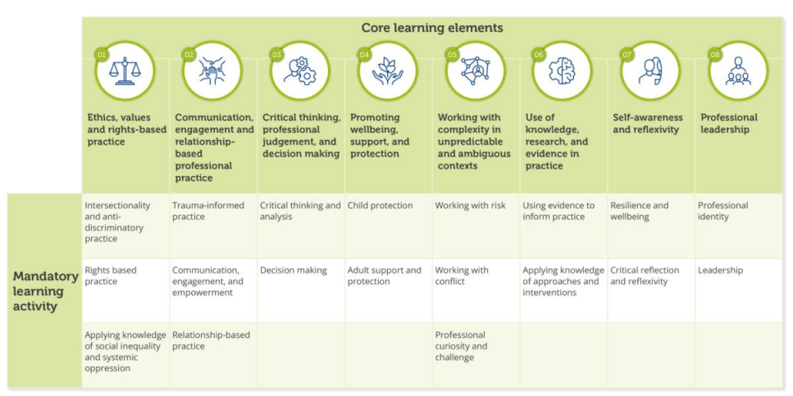
The NQSW Peer Learning Forums will reflect the Core Learning Elements and will draw on the expertise of NQSWs, APs, ATMs and TMs to facilitate learning around key areas. See the chart below for further information:

Core Learning Elements
The Supported Year aims to support NQSWs to develop and demonstrate their continuous professional development using evidence-based benchmarks. NQSW learning in their Supported Year will take account of the eight Core Learning Elements and workers will provide evidence of their learning within their CPL Review Template.
These core learning elements that NQSWs need to achieve are as follows:

 | Ethics, values, and rights-based practice  Develop an understanding of, and apply, ethical principles and values to all aspects of professional practice. Recognise sources and impact of social inequality and systemic oppression. Take action to protect and advocate for human rights and social justice, including development of an anti-racist, intersectional approach.
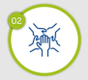 | Communication, engagement, and relationship-based professional practice  Demonstrate knowledge and skills to support effective communication, collaboration, and relationship-based practice in a range of settings. Use trauma responsive approaches to actively involve and support the involvement of people, including families and carers to plan, implement and evaluate interventions.
 | Critical thinking, professional judgement and decision making  Develop competence and confidence in applying critical thinking, analysis, research, and best practice to inform professional judgement and decision making in all areas of practice including assessment and review.
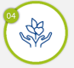 | Promoting wellbeing, support, and protection  Demonstrate and apply understanding of responsibility to actively promote the wellbeing, support and protection of children and adults at risk of harm, regardless of setting or context.
 | Working with complexity in unpredictable and ambiguous contexts  Develop competence and confidence in managing complexity, risk, and uncertainty in professional decision making.
 | Use of knowledge, research and evidence in practice  Develop knowledge and confidence in applying relevant research, policy and legislation to role. Demonstrate commitment to continuous professional learning and inquiry which supports evidence informed practice and a wider culture of learning.
 | Self-awareness and reflexivity  Recognise how the demands of professional social work practice affect self and others. Develop the use of reflexivity to consider what has been learned and how this learning can contribute to personal wellbeing and effective and sustainable practice.
 | Professional leadership  Develop personal and professional authority as a social worker including when working collaboratively across agency and professional boundaries.

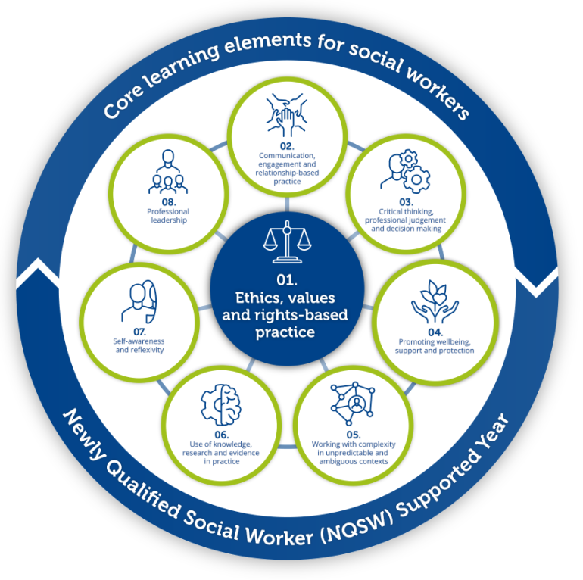

Mandatory Learning Activities
The following information outlines each of tasks NQSWs can complete to evidence their learning towards the Core Learning Elements. Each Learning Element has a series of Mandatory Learning Activities NQSWs must achieve within their Supported Year. These should be planned out between NQSWs and their Supervisor, and Advanced Practitioners can be utilised to support with achieving these for the learning and development of NQSWs.
It is expected that learning will be incremental and NQSWs should be supported to achieve their Learning Elements gradually over the course of their Supported Year to maximise their learning and reflection. It is likely that rushing to complete their Learning Elements will not support the NQSW to meaningfully engage with their learning so Supervisors will be required to monitor progress of Learning Elements throughout the Supported Year.
NQSWs will achieve the Mandatory Learning Activities by completing different learning tasks to evidence for their CPL Review Template. There is no set formula for evidencing learning. These may include online resources; reflective journals; shadowing; training; sharing and disseminating information; reading policy, research and legislation; OpenBadges, etc.
It should be noted that the Core Learning Elements are interconnected and can be considered holistically, and multiple Elements can be captured within specific pieces of work that demonstrate the NQSWs learning.

Learning Element 1 - Ethics, values, and rights-based practice
 | Intersectionality and anti-discriminatory practice. | Explore relevant research and evidence about intersectionality and relate this to the work of your team. Present information to your team about the importance of understanding intersectionality for social work services.
 | Intersectionality and anti-discriminatory practice. | Evidence an understanding of cultural competence and what it means in relation to your practice.
 | Intersectionality and anti-discriminatory practice. | Consider what you know about unconscious bias and racism in social work. Write a personal reflection on your commitment to anti-racism in social work practice and discuss this in supervision.
 | Intersectionality and anti-discriminatory practice. | Consider the barriers to inclusive practice experienced by both workers and people who use a service which exist in your workplace. Explore how these can be addressed and removed. Identify actions that you will take to promote inclusivity.
 | Rights-based practice | Reflect on how your social work practice is grounded in the principles of human rights and the United Nations Convention on the Rights of the Child, embedded in Scottish legislation. Provide an example from your practice where you have taken action to protect and advocate for human rights and social justice.
 | Rights-based practice | Evidence, through discussion in supervision or an example from your practice, how you have ensured that people, including families and carers, are aware of and understand their rights and can act on them.
 | Rights-based practice | Discuss your understanding and ability to manage the complex balance of rights with risk and protection.
 | Rights-based practice | Evidence, through discussion in supervision, ethical practice in the recording and sharing of sensitive information about people, including families and carers. Identify actions that you will take to ensure ethical practice in handling sensitive information.
 | Applying knowledge of social inequality and systemic oppression. | Create a map of local services that support an anti-poverty approach or provide welfare support. Reflect on how you and your team engage with them. Identify any implications for practice and actions that can be taken to support engagement.
 |  | Review three of your previous assessments or reports and audit how you have included analysis of the impact of social inequality and oppression on a person or family when developing a plan for support.
 |  | Explain how you would identify systemic oppression and inequality in your setting and how you would respond to or challenge this.
 |  | Evidence how you use a social justice approach in your practice and manage the authority and powers associated with your social work role.

Learning Element 2 - Communication, engagement, and relationship-based professional practice
 | Trauma-informed practice. | Using the national trauma training resource, complete the level appropriate to your role.
 | Trauma-informed practice. | Reflect on how you use trauma informed approaches in your practice, considering how you actively involve and support the participation of individuals, families and carers.
 | Trauma-informed practice. | Explore the links between the impacts of social inequality and systemic oppression and trauma. Identify any implications and actions for your practice.
 | Communication, engagement and empowerment. | Demonstrate how you understand people who use services as experts in their own lives.
 | Communication, engagement and empowerment. | Identify the different communication and engagement approaches, including digital capabilities you require for your role to ensure engagement is inclusive, culturally responsive and challenges stigma. Reflect on areas of strength and areas for development.
 | Communication, engagement and empowerment. | Provide an example from your practice where you have empowered individuals, families or carers in the planning, implementation and evaluation of an intervention or service.
 | Communication, engagement and empowerment. | Review your organisation’s policies and procedures for recording, assessment and report writing and consider any implications for your practice.
 | Relationship-based practice. | Review and reflect on your strengths and areas of development in undertaking relationship-based practice.
 | Relationship-based practice. | Give an example of how you are developing your ability to use your professional authority as a social worker and working collaboratively with colleagues and professionals across different agencies.
 | Relationship-based practice. | Critically reflect on a practice situation that has challenged your professional boundaries and relationship with an individual, family, carer or colleague. Identify what worked well and what you might do differently next time.

Learning Element 3 - Critical thinking, professional judgement and decision making
 | Critical thinking and analysis. | Complete the activities in IRISS course ‘Writing analysis in social care.’
 | Critical thinking and analysis. | Critically reflect on report writing comparing one of your own reports with one completed by an experienced practitioner. Compare how information has been analysed and presented in the reports and identify best practice and points of learning.
 | Critical thinking and analysis. | Identify how you ensure that your writing reflects the interests and perspectives of the people about whom you are writing. Discuss with a colleague or supervisor.
 | Critical thinking and analysis. | Read practitioner guidance on chronologies. Complete a chronology, review it with a colleague or supervisor and reflect on the importance of this tool in your practice.
 | Critical thinking and analysis. | Reflect on a situation where you have shared your thinking and analysis in a formal setting. Explore your feelings about undertaking this task. Identify actions you can take next time you are in this situation.
 | Decision making. | Reflect on the process of gathering information when undertaking an assessment. Consider what you found helpful in the process of gathering information and how you decided what was relevant to the assessment.
 | Decision making. | Describe how a piece of research helped to inform your decision making in a practice situation.
 | Decision making. | Discuss with a supervisor a decision-making process from your practice. Identify the skills you used when communicating the decision and rationale with individuals, families, carers and professionals. Reflect on areas you found difficult and identify actions you can take to improve your practice confidence.
 | Decision making. | Consider a significant case review that has been undertaken in children or adult services. Reflect on the use of professional judgement and decision making. Identify actions you can take to incorporate learning from the review, to develop your professional judgement and decision-making capabilities.
 | Decision making. | Evidence how you use a social justice approach in your practice and manage the authority and powers associated with your social work role.

Learning Element 4 - Promoting wellbeing, support and protection
 | Child protection. | Familiarise yourself with national and local child protection guidance and procedures including the role of the local child protection/ public protection committee. Identify your key responsibilities as a social worker and what your role is in your organisation and on a multi-agency level to act on concerns about a child.
 | Child protection. | Access child protection training within your organisation or local area and discuss your key learning with your supervisor or colleague(s).
 | Child protection. | Provide evidence of a reflective discussion with your supervisor/mentor about the thresholds of risk in child protection.
 | Child protection. | Create a mind map or equivalent that demonstrates your understanding of the intersections between child protection and the vulnerability, trauma and risk experienced by adults.
 | Adult support and protection. | Familiarise yourself with national and local adult support and protection guidance and procedures including the role of the local adult protection/public protection committee. Identify your key responsibilities as a social worker and what your role is in your organisation and on a multi-agency level to act on concerns about an adult.
 | Adult support and protection. | Access adult support and protection training within your organisation or local area and discuss your key learning with your supervisor or colleague(s).
 | Adult support and protection. | Read the principles of the Adults with Incapacity (Scotland) Act 2000 and identify when and how you would use these when considering rights, risk and protection of adults.
 | Adult support and protection. | Learn how you would make effective use of local advocacy services. Identify your role in supporting people involved in adult support and protection proceedings and consider how you can support them to participate and communicate in decisions and forums.
 | Adult support and protection. | Create a mind map or equivalent that considers the intersectional nature of risk, trauma and harm. Reflect on the challenges of accessing support and the impact of structural disadvantage which may impact on adult protection.

Learning Element 5 - Working with complexity in unpredictable and ambiguous contexts
 | Working with risk. | Explore concepts of risk assessment, risk management and risk tolerance. Reflect on your organisation’s approach to risk and discuss with a supervisor or colleague how this influences your practice.
 | Working with risk. | Evidence discussion with your supervisor/team/other professionals on personal and organisational thresholds to risk. Compare this with other professional thresholds, and how you will manage ethical dilemmas in your practice.
 | Working with risk. | Reflect on an example from practice in which you had to identify risk, the levels of risk and protective factors. Consider what informed your approach, how decisions were reached, and how challenges were addressed. Identify what you learned and how you will use this learning in the future.
 | Working with conflict. | Reflect on your understanding of ‘conflict,’ ‘challenge’ and ‘resistance’ and how these present in social work practice. Reflect on whether such terms are used in your organisation and how this influences your practice.
 | Working with conflict. | Consider how you approach having challenging conversations with individuals, families and others while remaining committed to relationship-based practice. Think about the knowledge, skills and values you can use. Identify any actions for your practice.
 | Working with conflict. | Engage in reflective discussion with your supervisor, team or mentor about a situation where another professional, an individual or a family you are working with has shown hostile and resistant behaviour. Consider how you responded, and what impact this had on you. Identify what you have learned from this and any actions for your practice.
 | Professional curiosity and challenge. | Research and reflect on the opportunities and potential barriers to professional curiosity and identify what skills, knowledge and supports you might need to develop an effective approach in your practice. Identify factors that contribute to professional dangerousness.
 | Professional curiosity and challenge. | Provide evidence of a discussion with your supervisor about a time when you have had to question your own assumptions about an individual or family with which you are working. Consider what you did and identify what you might do differently next time.
 | Professional curiosity and challenge. | Act as a critical friend for a peer or have a peer act as a critical friend on a complex or uncertain case. Reflect on observations and learning brought about by this process. Identify the actions you will take as a result.

Learning Element 6 - Use of knowledge, research and evidence in practice
 | Using evidence to inform practice. | Complete the Social Services Knowledge Scotland (SSKS) Knowledge and Evidence Open Badges.
 | Using evidence to inform practice. | Complete the Iriss Navigating Evidence reflective tool.
 | Using evidence to inform practice. | Evaluate a piece of research relevant to your role and share information with others. Discuss its strengths and limitations and demonstrate how it contributed to outcomes.
 | Using evidence to inform practice. | Review how you have used feedback from people who use services and carers to inform your practice and service delivery. Create a plan to ensure that this remains at the centre of your practice.
 | Using evidence to inform practice. | Evidence a situation where you identified a gap in your knowledge and reflect on how you took responsibility to fill that gap.
 | Applying knowledge of approaches and interventions. | Identify and list local and national legislation, policy and guidance that underpins your role. Discuss with a colleague or supervisor and identify any gaps in your knowledge.
 | Applying knowledge of approaches and interventions. | Evidence your understanding of how Self-directed Support (SDS) is relevant to your role.
 | Applying knowledge of approaches and interventions. | Reflect on your application of an evidence informed approach in a complex situation. Consider why you adopted this approach, what it involved, how you applied it and what impact it had on outcomes.
 | Applying knowledge of approaches and interventions. | Lead a 5-minute informal team discussion on a piece of research, theory or framework relevant to your role.
 | Applying knowledge of approaches and interventions. | Demonstrate how you have related a theory to a practice situation.

Learning Element 7 - Self-awareness and reflexivity
 | Resilience and wellbeing. | Identify your organisation's responsibilities to support staff wellbeing and understand your own responsibilities within these.
 | Resilience and wellbeing. | Develop the use of reflective and reflexive practice in your professional development and explore how this can contribute to your wellbeing.
 | Resilience and wellbeing. | Identify and discuss with your manager/supervisor the professional actions that will support your wellbeing and contribute to the wellbeing of your wider team.
 | Resilience and wellbeing. | Consider your own emotional responses when coping with a variety of difficult situations. Explore how you recognise and respond to the signs of vulnerability in yourself and others. Identify what supports you might need to help you when working and responding in these situations.
 | Resilience and wellbeing. | Research national initiatives and resources available to support wellbeing in the sector such as the National Wellbeing Hub. Share learning with colleagues.
 | Critical reflection and reflexivity. | Provide evidence of how you have used supervision or advice from a mentor to critically reflect on your own practice and development.
 | Critical reflection and reflexivity. | Critically reflect on your awareness of how your use of self, impacts on developing and sustaining effective relationships with individuals, families, carers and other professionals.
 | Critical reflection and reflexivity. | Use a tool or map to demonstrate how you use critical reflection when managing complex situations. Demonstrate how you have developed competence and confidence in critical reflection when managing complex situations in your practice.

Learning Element 8 - Professional leadership
 | Professional identity. | Reflect on the SSSC Code of Practice for Social Service Workers and discuss any ethical dilemmas this raises for you as a registered social worker.
 | Professional identity. | Roleplay or rehearse how you will explain your social worker role in a variety of settings.
 | Professional identity. | Use a reflective model, framework, tool or journal to examine your professional identity. Consider how you see your role as a social worker; what kind of social worker you are; what values you believe you have and how you demonstrate them.
 | Professional identity. | Seek feedback on your practice from people who use services, colleagues, and other stakeholders to help you understand yourself, and your role.
 | Professional identity. | In supervision explore the tension between organisational, legal and professional requirements and social work values.
 | Leadership. | Map your professional network of colleagues, supervisors, and other professionals.
 | Leadership. | Reflect on the ways in which you think you have a leadership role as an NQSW and how you can influence professional, ethical and rights-based responses in social work practice.
 | Leadership. | Explore the SSSC Step into Leadership website. Complete the SSSC Frontline Worker Leadership Capability Feedback Tool and leadership capabilities workbook.
 | Leadership. | Contribute to the learning and development of others through activities such as peer reviewing a report, giving feedback to a co-worker or undertaking a practice audit.

Feedback
NQSWs will be required to gather feedback at various stages of their Supported Year in order to evidence their learning, their professional development, and support their Supervisor to have greater insight into the NQSWs relationship-based practice. It is hoped that Feedback will be fair and balanced to promote learning, but we also need to recognise the experiences, values, expectations, and limitations when working with people using services.
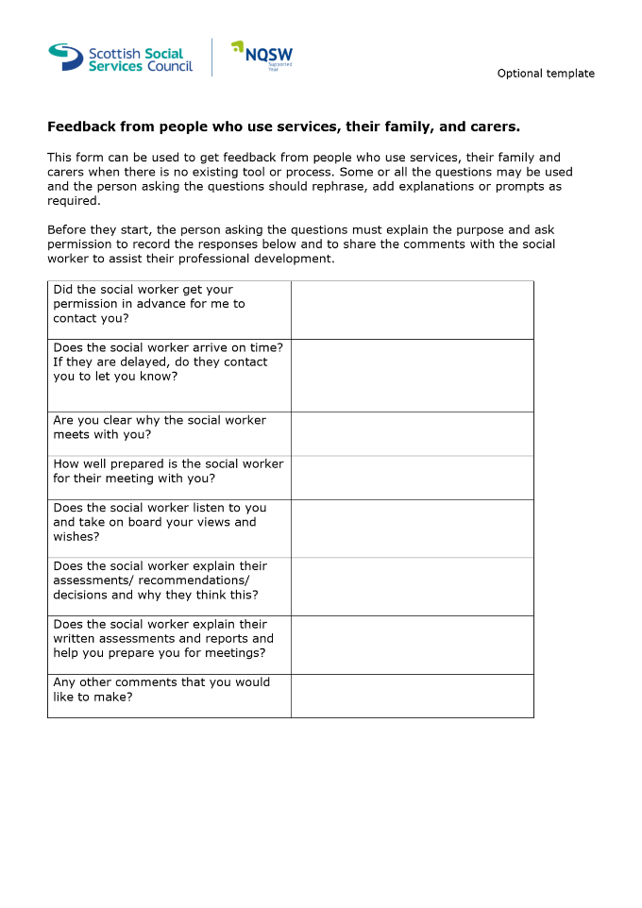
The following is an example of a feedback form the SSSC has provided (available here) as a template for people accessing services, their family, and carers:

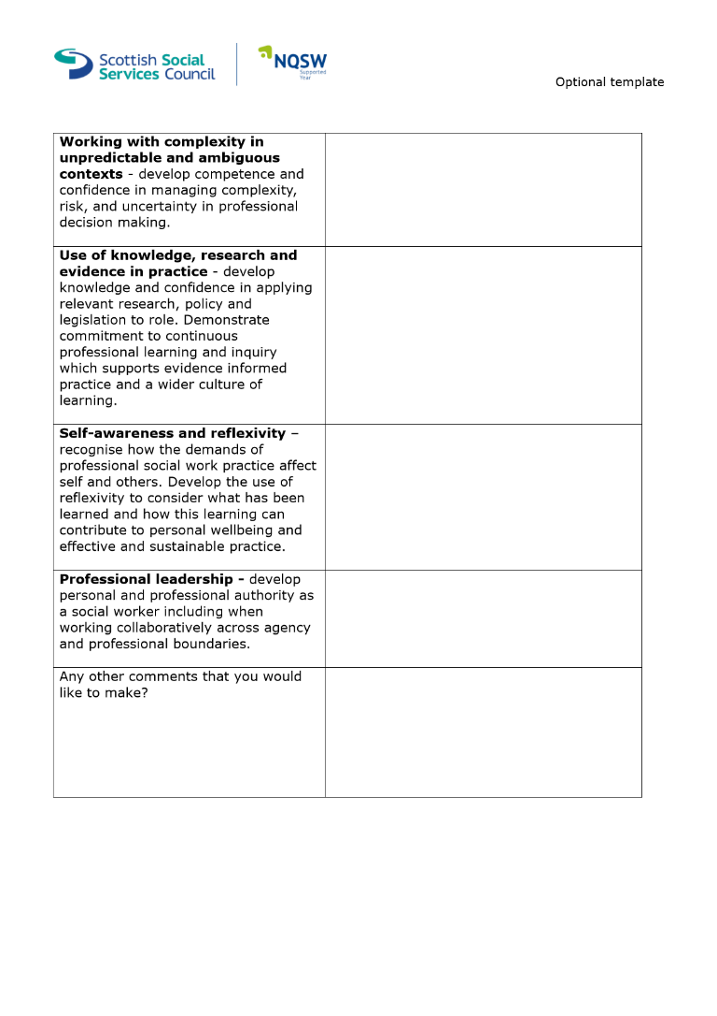
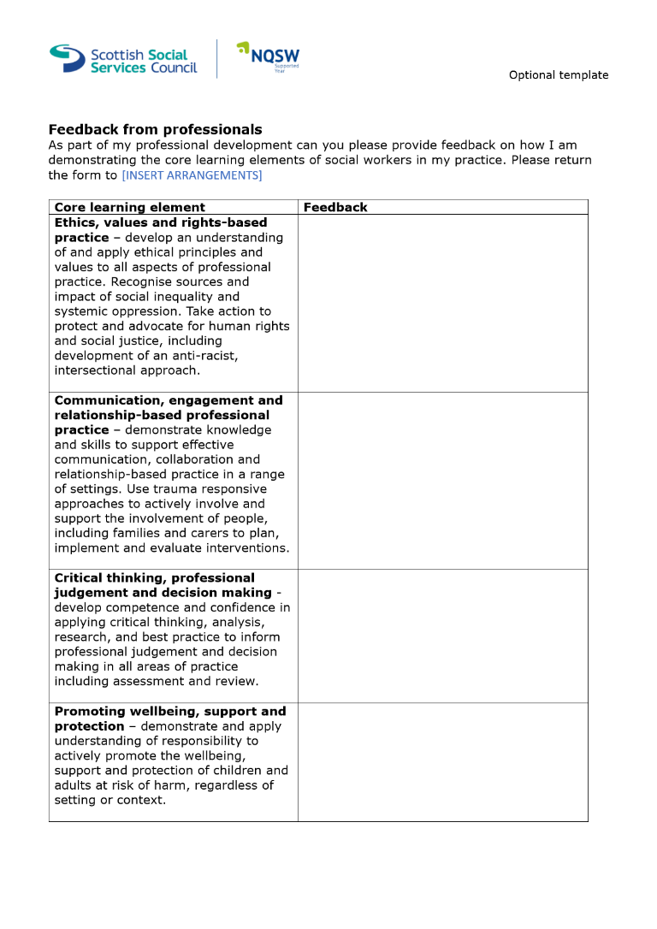
It is also important to collate feedback from professionals who have been working alongside NQSWs to be able to identify areas of strength and development, to help facilitate further learning during their Supported Year. The SSSC have provided the following document (which can be accessed here) to support this:

Extension Requests
There are a number of different life events and circumstances that may necessitate an extension request being submitted by NQSWs to the SSSC. It is essential that the NQSW keep in touch with their Supervisor and Team Manager to ensure that they get the help and attention they need during their Supported Year.
Extension Requests should be completed by the NQSW then passed to their manager before submitting to the SSSC for approval.
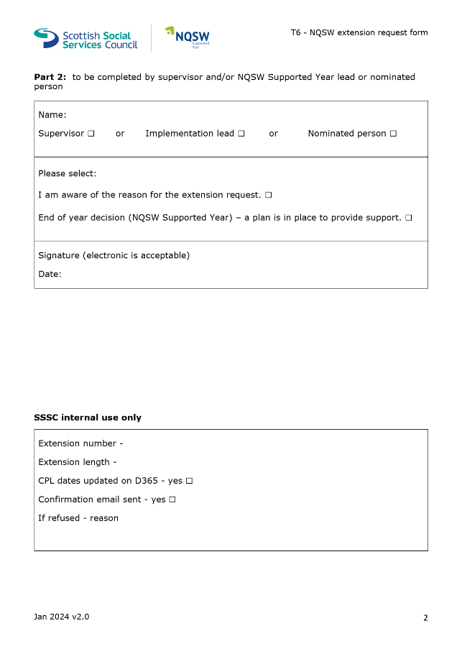
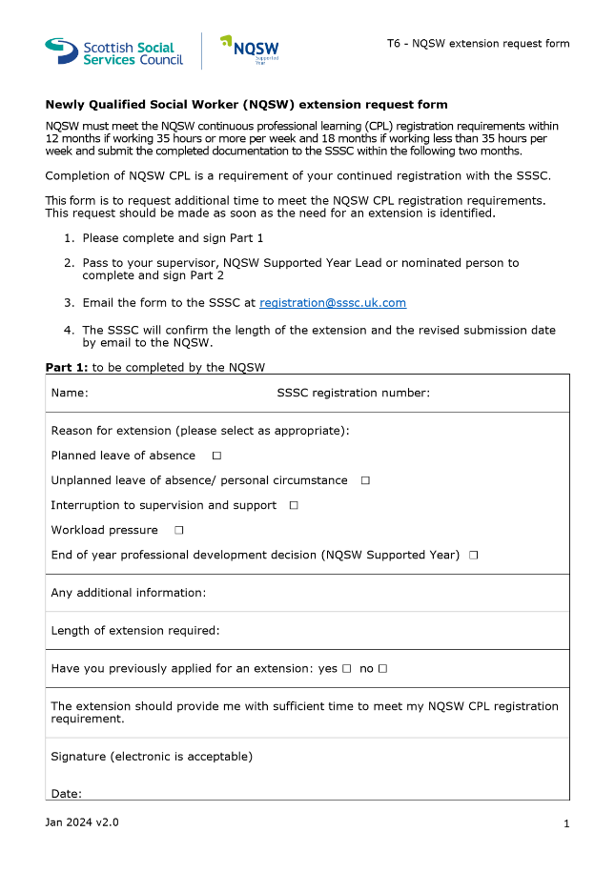
Please note that there may be circumstances where the SSSC refuse an extension request. There is a section which identifies workload pressures as a possible reason for needing an extension request so it is important that NQSWs have their CPL Review Template as up to date as possible as the SSSC may ask to sample the NQSWs progress through the Mandatory Learning Activities.

Under the previous PRTL and new Supported Year there is possibility that continued Registration may not be approved if there is not sufficient evidence for a need for an extension. There may be workers who do not maintain their registration, and this may affect their employability as a Social Worker with Falkirk Council. It is important that we avoid these circumstances and work collaboratively to ensure the NQSWs meet their registration requirements during the Supported Year.

Changing Supervisor or Employer
There may be occasions during the Supported Year where a NQSW either changes their workplace or there is a change in Supervisor. NQSWs require a level of continuity with their learning and development, which is why they should keep their CPL Review Template as a source of evidence of their mandatory learning activities.
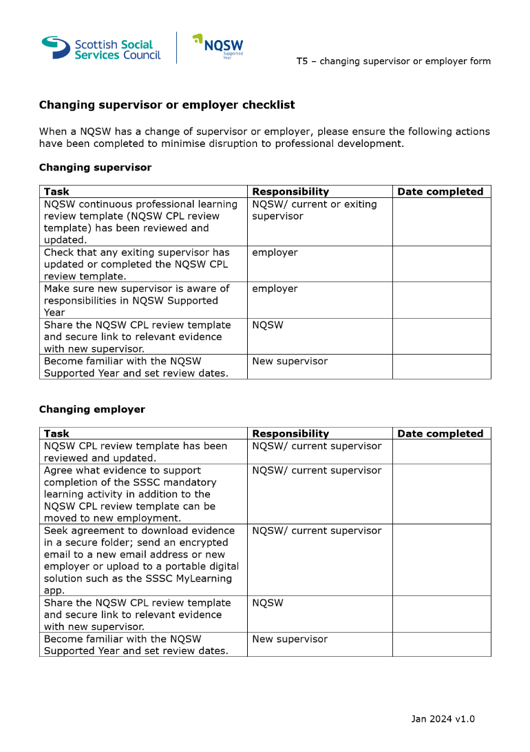
Should there be a change in supervisor, this evidence will enable them to see NQSWs achievements to date. The form can be accessed here on the SSSC website.

Validation and Endorsement
Once the NQSWs end of year development review has been completed and their CPL Review Template has been populated with evidence of Core Learning Elements being met, the document should be sent to their Supervisor to Validate (below, page 2). The CPL Review Template and accompanying endorsement form (below, page 3) should be shared with either the Supported Year lead or a nominated team manager for random sampling before being endorsed.

Once endorsed, the document should be returned to the NQSW and they should submit this to the SSSC within 2 months of the end of their Supported Year. This is one year & two months after the exact calendar date that they had been registered as a Social Worker.

It is possible that the SSSC may ask for further information to evidence sufficient learning during the Supported Year.
There is a recognition by the SSSC that NQSWs registered between the 1st of February and 1st of October will be working towards the Supported Year model before this is implemented in full, and it has been agreed that some degree of leniency will be afforded to the workers providing they use the same in-depth critical reflection of their learning needed in the PRTL requirements.

Good Conversations
Once NQSWs have been approved for their registration by the SSSC, they will move on to the Good Conversations pathway for the continued professional development. This is Falkirk’s model for continuous professional development and should be used to record the successes and professional developmental needs of workers.
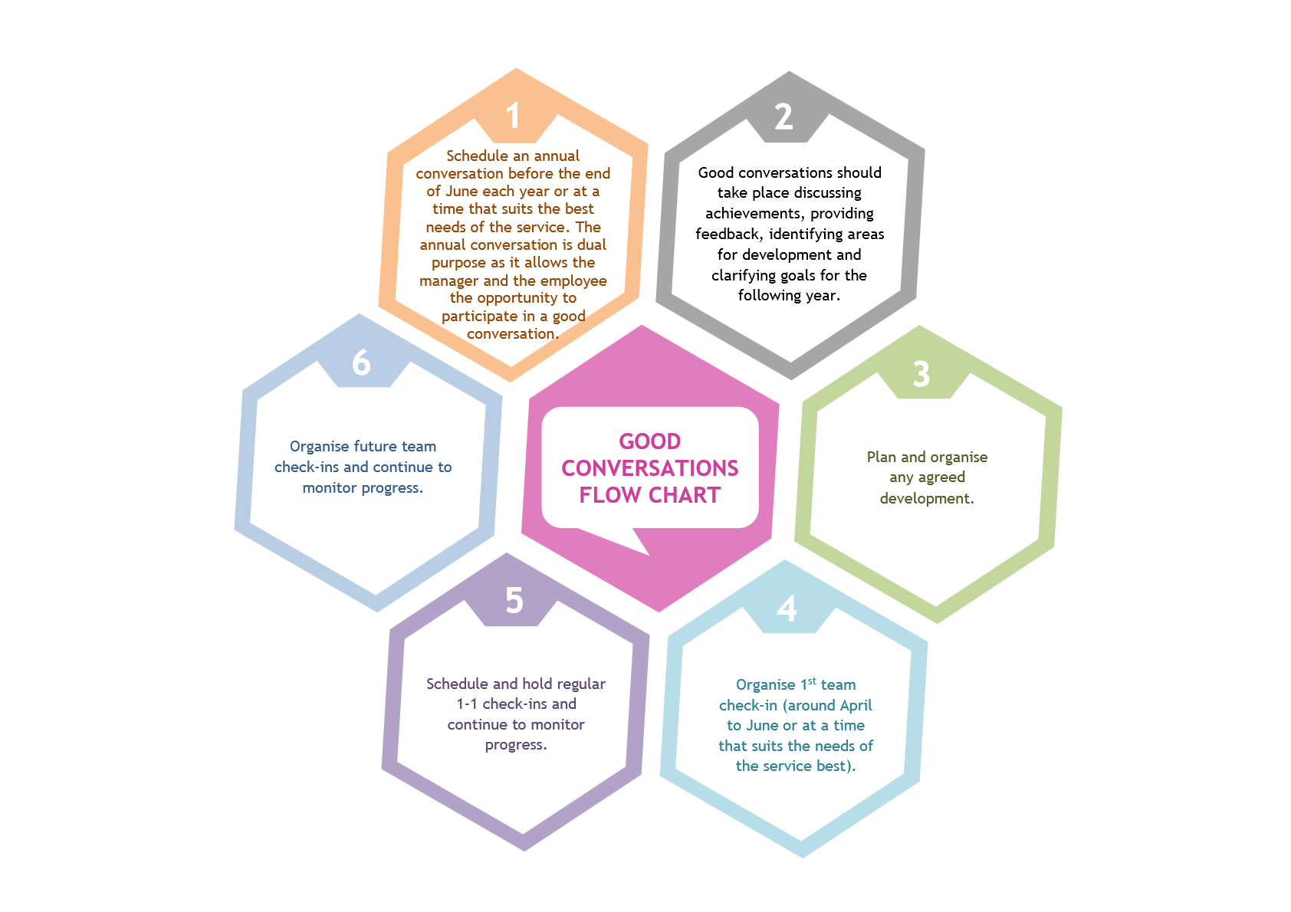
It is important to note that the Good Conversations pathway should be reviewed after 6 months to ensure outcomes are being met as planned, and to amend plans as necessary.
The Good Conversations pathway should also begin building on the continuous professional development of social workers who wish to progress to Post-Graduate studying and becoming an Advanced Practitioner.

Grant, S., Sheridan, L., & Webb, S. A. (2014). Evaluation Study for the Scottish Social Services Council (SSSC): Readiness for Practice of Newly Qualified Social Workers. Scottish Social Services Council.

