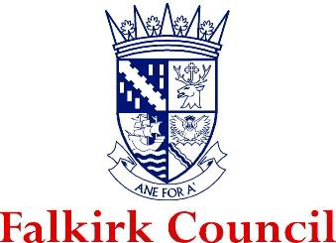

The Newly Qualified Social Worker Supported Year in Falkirk
Guidance for NQSWs & Supervisors



Contents
Background 2
Outline of the NQSW Supported Year in Falkirk 2
Key Roles and Responsibilities 5
Role of Falkirk Council as an employer 5
Role of the NQSW 6
Role of the Supervisor 6
Role of the Advanced Practitioner 7
Falkirk’s Learning & Development Framework 8
Good Conversations 9

Background
The first year in practice is widely acknowledged as being crucial for social workers (Grant et al, 2014). It is recognised that a more consistent approach is required to support Newly Qualified Social Workers (NQSW) in their first year of practice. The purpose of this programme is to provide structured support for NQSW in meeting their continuous professional learning (CPL) requirements over their first year in post as a qualified Social Worker. This is an evidence-based approach which seeks to improve the recruitment and retention of NQSWs, as well as recognise the need for tailored learning to support them in their new roles.

Outline of the NQSW Supported Year in Falkirk
The following is a broad outline of the NQSW Supported Year in Falkirk. Further information will be shared during development events, in follow-up workshops and in the written documentation provided.
The model of this programme has been developed in partnership with other local authorities and universities. It was informed by a scoping exercise and literature review and is cognisant of the Scottish Social Services Council (SSSC) Core Learning Elements for NQSWs.
- NQSWs will work towards completing a Continuous Professional Learning (CPL) Review Template that consolidates their learning and development throughout their Supported Year. This is an evidenced-based document that will contain details of the NQSWs Core Learning Elements and a tailored plan that will identify how to meaningfully engage with learning in the workplace.

- CPL no longer focuses on hours of training/learning completed and uses a wide variety of sources to evidence learning. These will be discussed later in this guidance.

- Your supported CPL programme will consist of the following key participants:
- NQSWs
- Supervisors (Assistant Team Manager or Team Manager)
- Advanced Practitioners
- Workforce Development
- University Tutors

- NQSWs will be supported by their Supervisors to develop an Individual Development Plan (IDP) to co-produce a learning plan that reflects their learning style and provides a foundation for them to develop their social work practice within Falkirk. NQSWs will be responsible for maintaining a record of their learning throughout their Supported Year and Supervisors will support the NQSW to verify learning elements have been met.

- Falkirk’s Supported Year will last for 12 months from the period that a NQSW is registered with the SSSC for full-time employment and 18 months for part-time employment.

- Some NQSWs will be employed within their teams as social care officers, social work assistants etc. until their SSSC registration is approved. The Supported Year allows workers to account for their induction and learning during the period between employment and registration using reflective journals.

- NQSWs will receive monthly supervision. In the first 3-6 months NQSWs should expect supervision to be more frequent (typically two-weekly). The focus of supervision will be to work towards Core Learning elements and there should be a strong emphasis on reflection and analysis. NQSWs and their Supervisor will review whether monthly supervision is sufficient or whether this should be increased.

- NQSWs will be matched by their Supervisors with an advanced practitioner (AP) — an experienced social worker — where possible from within the team they are working in. However, occasionally they may be from another part of the service. NQSWs should be encouraged to shadow their AP to explore specific themes and topics to facilitate learning. APs have a wide range of skills and knowledge, and it is good practice for workers to spend time with different APs at different points of their Supported Year to maximise learning.

- NQSWs and their Supervisors will work out their workplace arrangements. It is expected that NQSWs will be office-based within their Supported Year so that they can develop relationships with colleagues and collaborate. There may be occasions where hybrid working is needed but this should be considered in the context of the NQSWs learning and development.

- NQSWs will have a protected caseload during their Supported Year, with their workload gradually increasing in volume and complexity based on capabilities and competency. There will be occasions where NQSWs need to take on more work, which should be reflected on and discussed in supervisions.

NQSWs will not take a lead role in child, adult protection or permanence cases during their Supported Year. They may shadow experienced colleagues and contribute to these assessments if it is a supported part of their professional development.

- NQSWs will have Protected Learning Time (PLT). This will be a half day per week, or full day per fortnight, during core business hours to undertake study, reflection, shadowing, etc. There is no set time for this but should be balanced with the NQSWs learning needs and the service’s needs. NQSWs and their Supervisors will arrange where PLT takes place; within the office, other Falkirk Council workplaces, or at home.

Essential training such as Child Protection, Adult Protection, Trauma etc. should not considered part of their protected learning time.

- The Supported Year will more broadly encourage, contribute to, and facilitate learning within teams and localities in which NQSWs are based. NQSWs will be expected to contribute to the professional learning of others.

This should be negotiated and planned within formal supervision. Examples of this may include the sharing of dissertation findings, theory and research evidence explored to apply/ integrate to social work practice, or mentoring Social Work Students undertaking placements.

- NQSWs will be offered a monthly NQSW Peer Learning Forum to explore and consolidate learning, and to network with peers across the local authority.

- All those involved in the Supported Year programme (NQSW, Supervisors and APs) will be expected to contribute to the overall programme evaluation to make sure it meets the needs of Falkirk’s Social Work staff.

Key Roles and Responsibilities

Role of Falkirk Council as an employer
Falkirk Council plays a critical role in the successful implementation and delivery of the Supported Year alongside other Local Authorities. NQSWs should consult the SSSC website to find out more about the roles and responsibilities placed on Falkirk to make sure they get the best opportunities to develop and thrive.
Falkirk Council is an Early Adopter of the Supported Year and will be supporting NQSWs to meet their registration requirements with the appropriate structures and supports in place to facilitate good learning, so workers feel capable in their new roles.
Falkirk Council have employed a NQSW Supported Year coordinator to support with the transition from Post Registration Training and Learning (PRTL) to the Supported Year. The coordinator will support with establishing and rolling out the Employer Support. Further guidance on Employer Support is discussed later in this guidance.
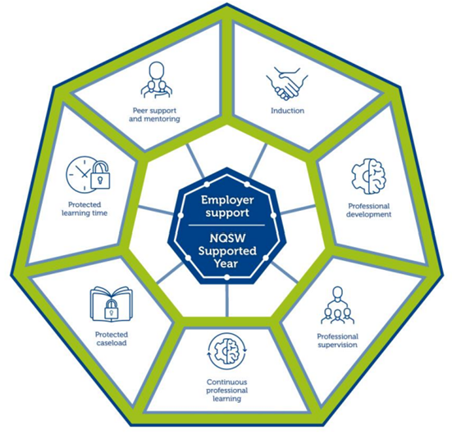

Role of the NQSW
NQSWs have a responsibility to their learning and development within the Supported Year, to engage meaningfully with the process and to ensure that they work in partnership with their Supervisors. There is an emphasis on co-production of learning to support the NQSW move on from being a Social Work Student to a Social Worker.
NQSWs are responsible for ensuring that they complete the Mandatory Learning Activities so that they can evidence the Core Learning Elements within their CPL Review Template. This means ongoing critical reflection and analysis of each of the Core Learning Elements and what role they have, or will have, in professional practice.
NQSWs are responsible for keeping a record of their learning and where this should be stored so they and their Supervisor can coordinate CPL actions. NQSWs should take time to familiarise themselves with the Supported Year by visiting the SSSC Website.
NQSWs should contribute to the learning and development of their team, service, colleagues and other professionals.

Role of the Supervisor
Supervisors are Assistant Team Managers (ATMs) or Team Managers (TMs) who are registered as Social Workers with the SSSC.
Supervisors are responsible for supporting NQSWs through their Supported Year to achieve their Core Learning Elements and record this in their CPL Review Template. There is an emphasis on the need for Supervisors to build good working relationships with their NQSW colleagues to support them to maximise their learning as this will have a positive impact on their resilience, competence and capability.
Supervisors will arrange a minimum of monthly supervision. It is best practice for the Supervisor and NQSW to arrange a Supervision Contract to establish roles and responsibilities.
Supervisors have case allocation responsibility and will become more attuned to the NQSWs capacity to manage increasingly complex cases as time goes on. Supervisors should be clear that NQSWs will have a protected caseload during their Supported Year and allocations should be dependent on capability and learning needs. Note: this is not about numbers, but rather supporting NQSWs to understand complexity and give them the opportunity to develop their competence.
Supervisors are responsible for ensuring that NQSWs have their Protected Learning Time. This includes supporting them by directing them to areas of further study/research, facilitating shadowing opportunities, making sure they understand the importance of their protected learning time, etc.
Supervisors will support their NQSWs to request and collate feedback from people who use the service and professional colleagues. Feedback is invaluable to NQSWs learning and development. Supervisors may also observe NQSWs in the initial stages to provide professional feedback. This may be something that happens in a naturally occurring way, for instance, a phone call in relation to an individual, or in a meeting or group forum. This is something that can be discussed throughout the supervision process.
Supervisors will play an active part in NQSWs development towards becoming an autonomous, professional social work practitioner. It is important to remember that this is all about the NQSWs own learning, therefore, they themselves are accountable for ensuring their own learning and development needs are being met.

Role of the Advanced Practitioner
NQSWs should be encouraged to work alongside APs as they have a key role in sharing best practice and encouraging learning and development out-with the supervisory relationship. APs work throughout the council so if there are no APs within the NQSWs team, Supervisors should explore APs from other services to assist with shadowing and learning opportunities.
The purpose of the APs is to provide peer mentoring support during the Supported Year with the purpose of sharing examples of best practice, practice wisdom, informal support, case discussions, and specialist knowledge.
APs are very experienced workers who have (or are in the process of gaining) further qualifications regarding their professional practice. This may include Mental Health Officers, Child Protection, Adult Support and Protection, Practice Education, Self-Directed Support, and many others. Some APs have gained further qualifications related to Mindfulness, Leadership, and other specialist subjects. It is important that we recognise the valuable learning that APs can share with NQSWs.
APs will not have managerial responsibilities such as performance management of NQSWs and should consult with Supervisors if they have feedback about the NQSWs development.

Falkirk’s Learning & Development Framework
Falkirk Council’s Learning and Development Framework includes valuable critically reflective practice techniques to facilitate learning and development across services.
Throughout their time as a social work students NQSWs should have developed a solid foundation from which to build on and support them in becoming ongoing reflective practitioners. NQSWs are expected to continue demonstrating those critical reflection skills well into their professional practice and will record their reflections.
NQSWs can use a variety of tools to encourage critical reflection, including the models encouraged within the Learning and Development Strategy (Driscoll’s So What? Model; 4D Cycle; Reflection-on/in-Action). It is also useful for NQSWs to consider the reflective techniques that best suit their learning styles and may use Critical Incident Analysis, Gibbs’ Reflective Cycle (example below), or something completely different. The Supported Year does not ask NQSWs to use a specific model, but rather encourages a tailored learning experience so workers may use one, some, a combination of models, or none of them – they may use something completely different that works for them.

Gibbs’ Reflective Cycle encourages NQSWs to think methodically about the sequence of an experience or social work activity and the headings/ framework can be helpful in structuring the content of your reflection.
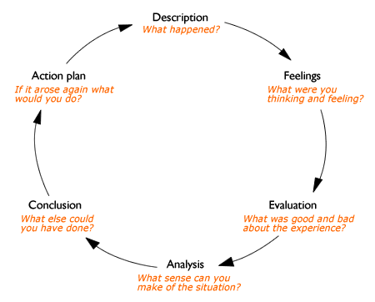

Good Conversations
Once NQSWs have been approved for their registration by the SSSC, they will move on to the Good Conversations pathway for the continued professional development. This is Falkirk’s model for continuous professional development and should be used to record the successes and professional developmental needs of workers.
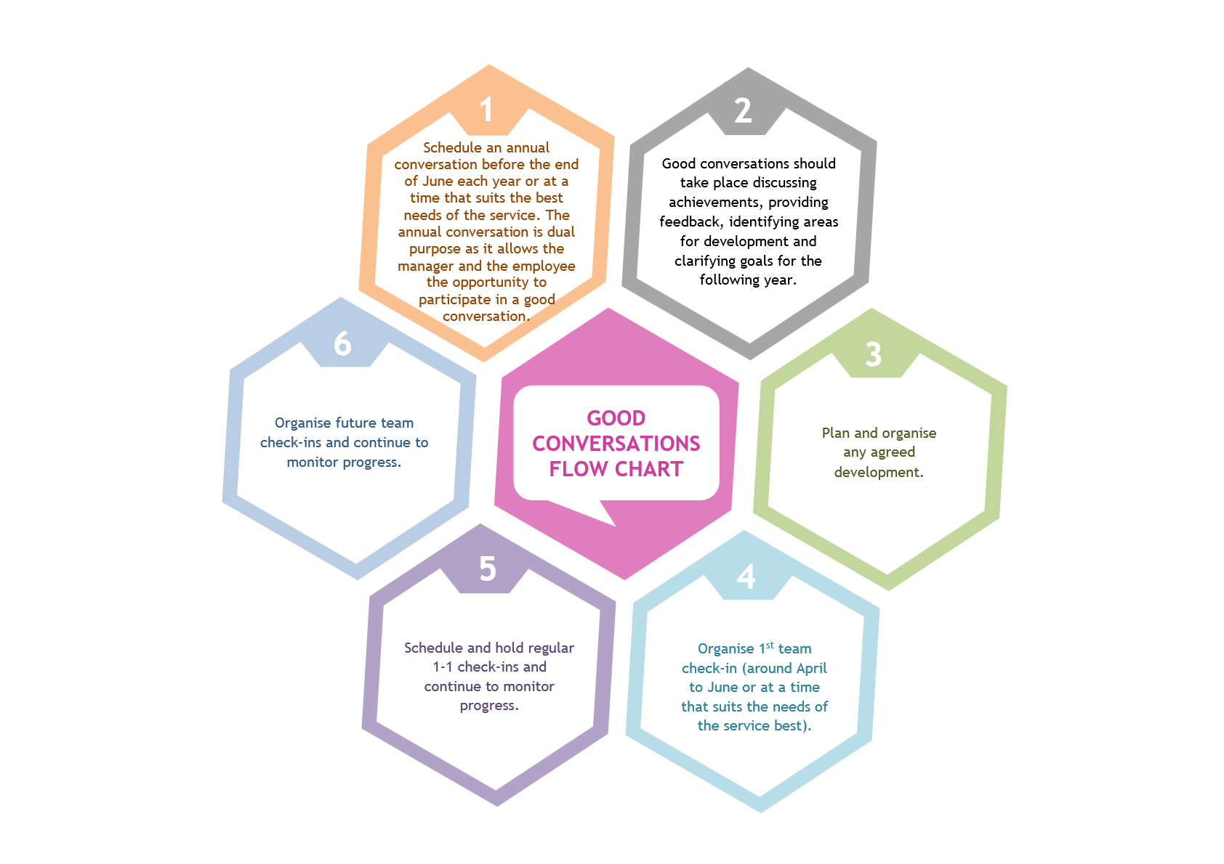
It is important to note that the Good Conversations pathway should be reviewed after 6 months to ensure outcomes are being met as planned, and to amend plans as necessary.
The Good Conversations pathway should also begin building on the continuous professional development of social workers who wish to progress to Post-Graduate studying and becoming an Advanced Practitioner.

Grant, S., Sheridan, L., & Webb, S. A. (2014). Evaluation Study for the Scottish Social Services Council (SSSC): Readiness for Practice of Newly Qualified Social Workers. Scottish Social Services Council.

