

GETTING IT RIGHT FOR EVERY CHILD IN FORTH VALLEY

GIRFEC Guidance – Refreshed March 2025

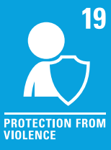
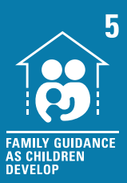
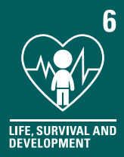
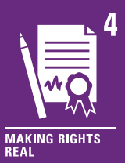

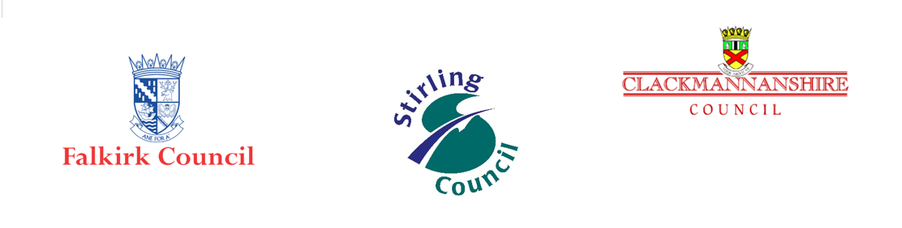

Contents

Section 1 - Introduction
Section 2 – Understanding Children’s Rights
Section 3 – Information Sharing
Section 4 – Role of the named person
Section 5 – Assessment of Wellbeing
Section 6 – Team Around the Child (TAC)
Section 7 – Role of the Lead Professional
Section 8 – Chronologies as a tool for analysis
Section 9 – Appendix

Section 1 - Introduction

This GIRFEC refreshed guidance is for all practitioners across Forth Valley who work with children, young people, and their families. In this context, the term child(ren) used throughout represents unborn babies, infants, children, young people, and young adults up to the age of 18. For some young people who have been Care Experienced or have Additional Support Needs (ASN) this can extend beyond 18.
The term parent is used to represent whoever has legal responsibility for looking after the child, including, parents, carers, foster carers, kinship carers, or adoptive parents.
Getting it Right for Every Child (GIRFEC) should now embedded within everyday practice delivery to engage with children and families to plan and offer additional support at the right time for as long as it is needed.
The GIRFEC refresh national guidance was launched by The Scottish Government in September 2022.

What is GIRFEC?

Getting it right for every child (GIRFEC) is the Scottish Government’s national approach in Scotland to improve outcomes and support the wellbeing of children by offering the right help at the right time from the right people.
The GIRFEC approach underpins both preventative and child protection processes. All practitioners have a role to play in promoting, supporting, and safeguarding the wellbeing of children through their professional expertise and day to day work, individually and in partnership with other practitioners. The approach is underpinned by the United Nations Convention on the Rights of the Child (UNCRC), the Children and Young People (Scotland) Act 2014, and supports The Promise (Independent Care Review, 2020), as evidenced in the 5 foundations of The Promise.
GIRFEC is all about early support and action to meet wellbeing needs and reduce risk. GIRFEC covers everything from early intervention through to when there is a concern that a child may be at risk of harm from abuse, neglect, or exploitation. This is when child protection processes are followed. All practitioners must respond to children and their families when they require or seek assistance, using the GIRFEC key questions and the National Practice Model which advocates wellbeing assessment tools including SHANARRI, My World Triangle, and the Resilience/Vulnerability Matrix. A named person is available for every child. They act as a point of contact to promote, support, and safeguard the child, and begin the wellbeing assessment and plan if one is needed.

GIRFEC is an approach which empowers children and their families by recognising and promoting their rights. This means putting their views and needs at the heart of service development and delivery. It also means Forth Valley’s practitioners following the GIRFEC pathway to ensure effective delivery of the approach. It is expected that practitioners develop meaningful, relationship-based practice that embraces partnership working. The Team Around the Child (TAC) (see Section 6) is the most effective way of improving wellbeing outcomes.

GIRFEC Key Values and Principles

GIRFEC is founded on the following, recently refreshed key values and principles:
- To put the child and family at the centre, by promoting choice, with full participation of children and families in decision-making.
- To work in partnership with families to enable a rights-respecting, strengths-based, inclusive approach; underpinned by the principles of UNCRC and The Promise.
- To understand wellbeing as holistic and interconnected, with a child's developmental experiences understood within the wider context, and influences of family, community, and society.
- Valuing diversity and ensuring non-discrimination.
- To tackle multiple and intersecting forms of inequality.
- To shift resources and support towards providing an early offer of support to improve outcomes for children, young people, and families.
- To promote joint working in a culture of co-operation and communication between practitioners and services, locally and across Scotland.
(Scottish Government 2022)

Child Protection Concerns:
Where there is a child protection concern, relevant information should be shared without consent immediately. Child Protection Processes must be followed. Further information on these can be found in the Forth Valley Inter Agency Child Protection Guidance and the updated Scottish National Child Protection Guidance https://www.gov.scot/publications/national-guidance-child-protection-scotland-2021-updated-2023/documents

Section 2 – Understanding Children’s Rights

The United Nations Convention on the Rights of the Child (UNCRC) underpins everything we do to support children and their families. The UNCRC is an international human rights treaty, that sets out rights which every child is entitled to. UNCRC will be enshrined in Scottish Law (July 2024) so that our role in ensuring children’s rights, and preventing and removing obstacles to those rights, will become a legal requirement for all public authorities.
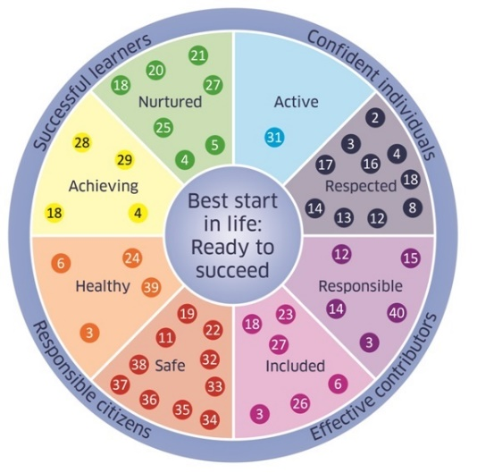

How do Children’s Rights and Wellbeing needs come together?

GIRFEC makes sure that practitioners helping children and their families work in a way that fully embraces and upholds UNCRC. By adopting the GIRFEC values and principles and using the National Practice Model, practitioners will apply a UNCRC approach in day-to-day practice by putting children at the centre.
The UNCRC articles have been linked to SHANARRI in the following report by Jane Aldgate: UNCRC: The foundation of GIRFEC.
Picture 1: UNCRC & Wellbeing Indicators

To grant children equal value and guarantee them the necessary protection, the following four main principles of the convention play a fundamental role in interpretating and guiding implementation:
- Non-Discrimination – Article 2
- Best interests of the child – Article 3
- The right to survival and development – Article 6
- The views of the child – Article 12

This is to make sure rights are being considered in everyday practice and when thinking about children’s wellbeing needs. We need to uphold these rights (and others) keeping them front and centre when working with families, assessing needs, risks, and when planning to meet those needs and reduce risks. To meet children’s rights, Forth Valley have added a sixth GIRFEC Key Question, as shown in Section 5.

Section 3 – Information Sharing

In many cases, practitioners will need to share information with other practitioners, or with other people involved in a child’s life, to meet their needs. Data protection law is not a barrier to information sharing; in fact, it provides a framework for information to be shared effectively, lawfully, securely, and transparently.
Falkirk, Clackmannanshire & Stirling Councils along with NHS Forth Valley have signed an information sharing agreement, which sets out how, why, and when they will share personal about children and young people to support GIRFEC.
Sharing relevant information is an essential part of protecting children from harm. Practitioners and managers in statutory services and the voluntary sector should all understand when and how they may share information.
For more detailed information sharing guidance please see the Practitioner Pages: Forth Valley GIRFEC practitioner pages - Information Sharing

GIRFEC Key Principles for Information Sharing

- Data protection is not a barrier to sharing proportionate information about children and young people and their families. Data protection legislation provides a framework for ensuring that information is shared, used, kept, and disposed of appropriately in line with each service’s information governance policies. You may need to share information within your organisation (for example, between social work and education services) or with another organisation (for example, between the Council and the Health Board). The same principles apply.
- Proportionate information sharing means that you only share information where it is necessary and relevant, and only with those who need to know it. Make sure that any information shared is accurate and shared securely in line with your service’s information governance policies.
- Be open and honest with the child or young person (and their family where appropriate) right from the start about how you will use and share their information. If there is any change to how you will use or share their information, you need to discuss that with them. You should have written privacy notices in place to help explain what you do, but face-to-face discussions are important, and provide the opportunity for questions. There will be cases where you need to share information without discussion (for example, where there are child protection concerns).
- Do not ask for consent to share information if you intend to share that information anyway. Instead, be open with the child or young person, and their family where appropriate, about what you will share and the reasons for that.
- Take advice if you need it. Practitioners are best placed to make professional judgements about whether to share information, based on the particular facts. But take a second opinion from your manager or advice from information governance or legal colleagues where you are unsure.
- Consider safety and wellbeing. Base your information sharing decisions by considering the safety and wellbeing of the child or young person, and others who may be affected by their actions. The consequences of not sharing appropriate information are usually worse than the consequences of sharing too little or no information.
- Keep a record of your decision and the reasons for it, whether or not to share information. If you decide to share, record what you have shared, with whom and for what purpose. Another practitioner may reach a different decision on the same facts, but you are unlikely to be criticised for making a well-reasoned, recorded decision which you consider to be in the best interests of the child.

Section 4 - Role of the Named Person

Access to a named person is a core component of GIRFEC. A named person does not replace parents or carers who have the primary responsibility for bringing up their children.

A named person’s role and responsibilities include the following:
- Listen to children and families, working with them to promote, support and safeguard children’s wellbeing needs.
- Be responsible for a single agency assessment and plan when required.
- Make sure the child’s needs are central to any assessment and plan developed.
- Be a clear point of contact to provide early support, advice, and access to services to children or their parents if required.
- Make sure there is a joined-up approach to meeting needs through integrated assessment and planning.
- Offer direct support from their service or other relevant services offered by the NHS, local authorities and Third Sector or community groups.
- Promote, respect, and protect children’s rights.

Who is the Named Person?
Age of Child | named person
Pre-birth, usually until 10-14 days old | Midwife
Birth until child starts school | Health Visitor or Family Nurse Practitioner
Primary school pupils | Primary Head Teacher or nominated promoted member of staff
Secondary school pupils | Guidance Teacher
Gypsy Traveller and home educated children | For children and young people of school age, but not on a school roll, for example those who are home-educated (e.g. some children and young people from Gypsy/Traveller families), the local authority should identify a suitable named person, such as a local authority officer and inform the child or young person and family of the service and support available.
School leaver until 18 years old | Young people transitioning from school education before the age of 18 should continue to be offered a named person. The local authority for the school the young person was attending is responsible for identifying the new named person as a specific point of contact for the young person. This could be a promoted teacher with whom the young person already has a relationship, or another adult within the local authority. The named person should contact the young person to offer support where this is required.  If a young person leaves school before the age of 18; their family should also be informed who the named person is and how they can contact them in the event they need any support or guidance.
Children Looked After and accommodated/educated out-with the Local Authority area  OR  Children placed within the Local Authority area from a different local authority | The lead professional will have the coordinating role, but the child will also have a named person who will be a key contact person from the local authority area where they live/go to school.  The Key contact in Falkirk is Educational Psychologist or ASN advisor. There will also be close liaison with the original local authority named person/lead professional.
Young person serving a custodial sentence | Representative from Scottish Prison Service

For most children the named person will not need to do anything more than they normally do in the course of their day-to-day job. This is because most children get all the help they need from their families and the universal services of health and education.

The named person can help a child, or their parents, address concerns early and, in some cases, avoid bigger concerns or problems developing. When the child, their parent, or someone who works with them raises a wellbeing concern, a named person will use the wellbeing indicators and carefully consider the situation by asking the GIRFEC key questions.

Children and parents do not need to take the support or assistance offered by a named person. If this could impact the child’s wellbeing or place a child at risk, then the named person should discuss this with parents and encourage them to work with available supports to meet the needs of their child.

Section 5 – Assessment of Wellbeing

What is Wellbeing?

Wellbeing is wider than child protection, which is about protecting children from harm, abuse, neglect, or exploitation. A child or young person’s wellbeing is defined by the eight wellbeing indicators (SHANARRI). These are influenced by everything around them and the different experiences and needs they have at different times in their lives. While each indicator is separately defined, in practice the indicators are connected and overlapping. They give a holistic view of each child and allow the child and the adults supporting them to consider both strengths and barriers to growth and development.
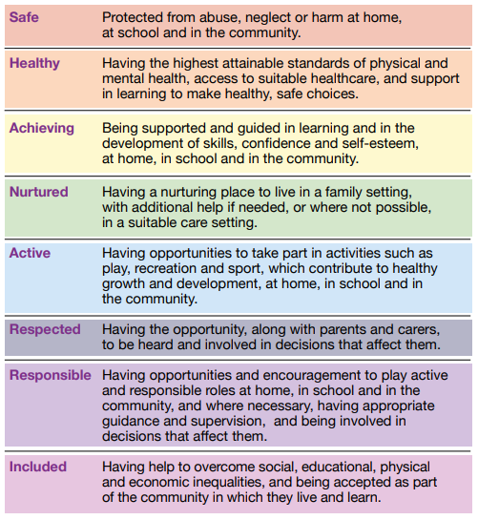
Anything that impacts a child’s wellbeing or might impact it in the future, could develop into an unmet wellbeing need or risk. This could be one single event, or cumulative events. The nature of the need will be specific to the individual child, their age, stage of development and circumstances. So, what represents a wellbeing need for one child may not be judged a need for another child.
Sharing information at the right time often prevents low-level concerns escalating into more serious or entrenched family difficulties and can help to improve outcomes for children (see Section 3).

What is the National Practice Model?

The National Practice Model is the key GIRFEC tool to help all named persons and other practitioners have relevant and appropriate conversations with children and their families. It provides a consistent child and family-centred approach to consider a child’s wellbeing and the need for support. This is done as part of a practitioner’s everyday role. By using this approach, practitioners should develop an understanding of the child’s and parent’s views, their wider environment, network of support, strengths, and challenges.
The national practice model was developed from conversations with families, to ensure they only had to tell their story once and that assessment of needs and plans were co-ordinated.

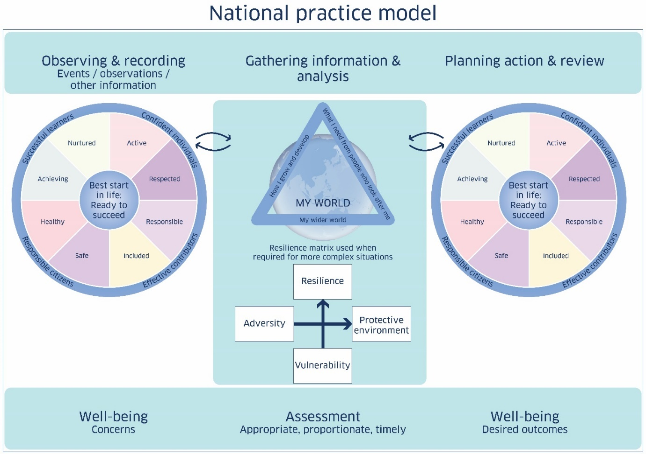
Picture 3: National Practice Model

The National Practice Model consists of the following tools:
• Eight Wellbeing indicators are used to frame practitioners’ relevant observations or recording. They help highlight information to indicate specific areas of strength, need or concern.

• Using the My World Triangle - The Scottish Government.

This framework supports a holistic assessment of a child’s situation by gathering and analysing information in the context of their wider world, in acknowledgement of connections between the different areas in a child’s life. It can be used to explore needs, risks, and strengths.

• How can the Resilience Matrix be used in GIRFEC? The resilience matrix supports the organisation and analysis of assessment information and looks at what impact this has on that individual child, by considering the balance of resilience and strength factors against adversity, vulnerability, and risk. It is used to support workers to figure out what information gathered during an assessment means for a child. It can be used with all assessments but is particularly helpful in more complex situations.
• Revisiting aspects of the National Practice Model helps to focus action planning and review progress. By agreeing desired outcomes for an individual child, practitioners can identify what specific actions are required and by whom, to improve the child or young person’s circumstances.
Where a child or young person needs extra help beyond the support generally available from universal services, and where one or more supports will be in place, a proportionate assessment and plan should be considered. This can be single or multi-agency.

In Falkirk there is one Lead Professional Assessment and Child’s Plan which is used by social work services and can be found at:

Falkirk Child and Young Person's Integrated Assessment and Plan. LP Assessment

In Clackmannanshire and Stirling Councils, the Integrated Assessment Framework paperwork continues to be in use which is located on the Practitioner Pages Forth Valley Practitioner Pages

Guide to completing a Child’s Wellbeing Assessment & Plan

It is important to remember that needs and risks are two sides of the same coin. Where there are unmet needs, risks will emerge in relation to the child’s wellbeing. When a wellbeing need is identified, a wellbeing assessment must be started. Asking the GIRFEC six key questions, as any needs or risks are emerging for a child, is essential to early and preventative practice by practitioners. This will determine what assessment requires to be undertaken to understand and explore these emerging needs or risks further.

Use the following GIRFEC key questions to talk openly and honestly with a child and their family about their needs. This is the start of your assessment of a child’s wellbeing needs.
- What is getting in the way of this child’s wellbeing?
- Do I have all the information I need to help this child?
- What can I do now to help this child?
- What can my agency do to help this child?
- What additional help, if any, may be needed from others?

Forth Valley have added a 6th question
- Are this child’s human rights being met?

While the GIRFEC questions refer to a child or young person, this applies equally to the wellbeing needs of unborn babies. The Forth Valley Pre Birth Planning Pathway Paper 4 - SBAR Update (glowscotland.org.uk)will help you to consider your assessment of needs of an unborn baby.
The following steps should be taken when completing a Child’s Wellbeing Assessment and plan:
- Use the National Practice model to carry out a wellbeing assessment by considering the eight SHANARRI indicators, My World Triangle, and the Resiliency/Vulnerability matrix. What are the strengths/protective factors? What are the needs? What are the risks? Use a Chronology to help collate and analyse key information about significant events in a child’s life and the single or cumulative impact these may have had on their wellbeing.

- Do you have a 360-degree picture of the child that relates to their whole life experiences and circumstances? Do you need more information? Talk with the child and parents about your assessment so far and explain why you need more information, and what you plan to share with any other agencies you need to talk to. Ask the child and parents: “what is the best way we can support you?”

- Using the GIRFEC Key Principles for Information Sharing (Section 3), consider whether the sharing of information could support, promote, or safeguard the wellbeing of the child and could provide additional help, if needed, from others.

- Practitioners providing a service to adults who are parents, adults who are siblings of children, or adults who have regular contact with children, are also required to consider children’s wellbeing. You may need to contact relevant adult services as part of your assessment.

- Reconsider your assessment with any further information you get. Has this changed the needs you have identified? Can you meet the child’s needs from within your service?

- If you have identified needs that your service cannot meet and need to request assistance from another service, talk to the child and family to reach agreement about what information will be shared and why.

- Discuss the assessment with the service of which you are asking for support. If required, arrange a TAC meeting to consider how the child’s wellbeing needs could be best met.

- You may need to go back to any of these steps at any point in the child’s wellbeing assessment. They may not happen in the order above.

- Regular reflection and review on progress should take place to make sure the child’s wellbeing needs are being met, risks are being reduced, and outcomes are improving.

There are five essential questions that TAC needs to be asking at regular intervals:
- What has improved in the child/young person’s circumstances?
- What, if anything, has gotten worse?
- Have the outcomes in the plan been achieved?
- If not, is there anything in the plan that needs to be changed?
- Can we continue to manage the plan within the current environment?

Assessing and Managing Risk

The concept of risk is frequently associated with dangerousness rather than a more holistic approach to working with people’s needs, vulnerabilities, and risk to self. If a child is at risk of harm, then child protection processes must be followed. Our aim is that identification and intervention for needs and risks happens at an earlier stage so that child protection procedures are not required.

Any assessment of risk should reflect the National Risk Assessment Guidance National Risk Framework to Support the Assessment of Children and Young People - gov.scot (www.gov.scot) which aims to support and assist practitioners at all levels, in every agency, to be able to approach the task of risk identification, assessment, analysis and management with more confidence and competence.

Analysis is a critical activity in assessment. It helps families understand needs and risks, informs families’ decisions and professional interventions, and any risk management or safety planning to be set out within the assessment and plan. Making sense of children’s lives and relationships is fundamental to understanding their wellbeing and safety.

Risk analysis is the process of understanding what the information gathered is saying about the actual and potential needs of and risks to the child. Information gathering should be purposeful, systematic, and organised in approach. Practitioners must consistently ask themselves: “what is this information telling me?”

The information should include the following:

- The abilities of the parent to protect their child.
- The known resilience and protective factors, particularly to, and around, the child, that may help to better protect.
- The impact of the identified risk factors on the child’s future safety, or the safety of the child to themselves or others.
- The capacity of the parents/child to affect any necessary changes in the timeframe in line with the child’s age and development.
- Analysis of the information gathered is used to inform the assessment and planning.

Remain responsible for wellbeing and any emerging risks. Passing on information does not mean passing on responsibility. When you raise a wellbeing/child protection concern with another service, you may still have a role in supporting the child at this stage.

Escalation

Learning from significant case reviews and findings from joint inspections of services for children recommend that professional partnership working is essential, so children and families get consistent support and the right help at the right time. Everyone who works with children has a responsibility for keeping them safe.

Professional discussion and differences of opinion about assessment and planning can be healthy. Discussion encourages further exploration about children’s needs and risks and can lead to improved outcomes. On the rare occasion that differences cannot be resolved, or practitioners feel the TAC meeting is not reducing risk or improving outcomes for the Child, then the Forth Valley Multi-Agency Guidance for Escalation can be followed.

Writing a plan that improves Outcomes.

A child’s assessment and plan will support the child and their family by detailing what support is required to improve wellbeing outcomes. The plan is considered and developed in partnership with the child, their parent and TAC.
Outcomes refer to the impact support has on a child’s life and not the outputs of services. Outcomes are the answers to the questions; ‘So, what difference has it made?’ and ‘How do we know?’ In identifying outcomes, we start with a vision of positive, long-term change for children, parents, families, and communities. Long-and short-term outcomes for children are set out in the plan and are linked to the GIRFEC wellbeing indicators.

Planned outcomes must involve the child and family; consider their views about what they want to achieve; and overall be specific, measurable, achievable, realistic, timely, evaluative, and re-adjustable (SMARTER). An outcome is what positive change we expect as a result of the intervention, and it is important to be explicit about what the outcome means to the child. Outcomes should not be too general, too vague, or immeasurable. Tools such as the Wellbeing Web, Talking Mats or Mind Maps will assist workers, children, and their parents to work together to identify the specific outcomes they want to achieve.

Plan Getting it right for every child (GIRFEC): child's plan - practice statement - gov.scot (www.gov.scot)

Section 6 – Team Around the Child (TAC)

Team Around the Child is the term used for the child, family and other services who come together to meet any unmet wellbeing needs or address risks.

When the early assessment of wellbeing is undertaken, any practitioner working with a child and/or their family can request a TAC meeting. If you are not the named person, you should speak with the child and family to share this information with their named person and include them in the TAC meeting.

TAC will review the assessment and develop a plan to meet the wellbeing needs of the child.

Before you call a TAC meeting

When you have used the GIRFEC questions and identified an unmet need that your service cannot meet alone, then you should link with the child’s named person to carry out a wellbeing assessment with the child and their parents using the national practice model. The assessment will identify the strengths and needs and help to identify any additional services that need to be part of a TAC.

Professionals’ meetings are meetings where the child and their parent does not attend and should only be held in rare exceptions if agencies need to resolve operational issues relating to the delivery of wellbeing assessment and plan. Families should be made aware of why a professionals’ meeting needs to happen and be reassured it is not to consider the wellbeing assessment and plan without them.

Where there are child protection concerns, a Core Group meeting is held. A Core Group is a group of identified individuals: the lead professional, the child, and their parents/carers, who have a crucial role to play in implementing and reviewing the Child Protection Plan. The core group is responsible for ensuring that the plan remains focused on achieving better outcomes for the child by reducing the known risks. The initial Core Group meeting should be held within 15 calendar days of the initial Child Protection Planning Meeting. Further information can be found at Forth Valley Inter Agency Child Protection Guidance.

Section 7 - Role of the Lead Professional

When two or more services work together to meet a child’s needs, a lead professional will always be agreed. The lead professional coordinates an integrated assessment and plan and makes sure that the different services provide a network of support around the child in a seamless, timely and proportionate way.
Role of the lead professional:
- Work with the child, family, and other TAC members to discuss the effectiveness and progress of the plan.
- Look out for and respond to changes in circumstances that may affect the assessment, and plan and coordinate ongoing assessment of needs and risks.
- Be a point of contact for all practitioners who are delivering services to the child and highlight where drift or delay from services is getting in the way of the assessment, plan and improving outcomes.
- Make sure that any supports provided are consistent with the assessment and plan.
- Engage with, and coordinate supports from other services, particularly at transition points or if specialist assessment is required.
- Offer to link the child and family with specialist advocacy where appropriate.

Who is the lead professional?

The named person can be the lead professional where most of the support in a plan is delivered by either Health or Education Service.
If the lead professional is not the named person, it could be:
- A Children’s Services social worker, if a child is on the Child Protection Register, or Looked After away from home.
- A specific medical specialist if a child has complex physical or mental health needs.
- A specific education professional if a child has significant education support needs, e.g., additional support needs teacher.

Some children are involved in several planning processes. They may be Care Experienced and have a Child Protection Plan, and/or a Co-ordinated Support Plan. They should experience a co-ordinated process, with their needs met by a single plan and meeting structure.
The lead professional can change as appropriate to support the assessment and plan at any time and should change appropriately as the wellbeing needs of the child change.

When the lead professional cannot be agreed

On rare occasions where lead professional agreement cannot be reached, line management advice should be sought to reach a prompt resolution; the named person remains available as a continued key point of contact for the child, their family, and professionals. Where agreement cannot be reached at the local level, disputes should be escalated to the relevant managers for a service-level decision, never airing any disagreement in the presence of families.

Transition from one lead professional to another lead professional

The lead professional can change over time, typically at times of transition or where a child’s needs change significantly. A lead professional will make sure the child is supported through significant points of transition. They will ensure a planned transfer of responsibility when another practitioner becomes the lead professional.
A new lead professional may be required under the following circumstances:
- The child’s needs change (including when a child no longer needs a coordinated child’s plan but still has unmet needs)
- Transitions form nursery or school
- Transitions from child to adult services
- Child is no longer Looked After or on the Child Protection Register
- The family moves away.

When Social Work is the Lead Professional

The social worker as lead professional will be responsible for ensuring the production of an agreed Integrated Assessment, multi-agency chronology and Child’s Plan. The foundation for this will be the wellbeing assessments completed by other services (See Section 5). This assessment is required when children have complex needs or where the safety of a child is a concern. It will have a particular focus on the risks to the child, and the interventions needed to reduce these risks.

Section 8 - Chronologies as a tool for analysis

Why have a chronology?

The National Practice Model sets out an expectation that as a basic requirement, each agency involved with a child and their family will collate key information into a single-agency chronology. When more than one service is involved, a multi-agency integrated chronology, assessment and plan must be brought together with the child and family.

What is a chronology?

A chronology is a single or multi-agency written record of significant events, in date order in a child’s, adult’s, or family’s life, both positive and negative. It is part of an assessment and should be used with other assessment tools to provide evidence and support for the analysis and planning being undertaken at the time. Chronologies provide structured data to help inform assessment and analysis by examining and identifying patterns. This supports the earlier identification of actual or potential risks and helps in decision making.
A chronology must comply with information sharing guidance and protocols in the way that it is developed, held, shared, and reviewed. It must be accurate, relevant, and proportionate to purpose.
Further reasons for the requirement of a chronology include:

- Important in assessing complex circumstances and/or where children may be a risk to self or others.
- It is regularly updated and analysed for patterns of behaviour or incidents, and for the impact which these behaviours have had on the child’s life.
- It helps everyone to better understand needs and risks, including risk of significant harm to the child which then informs planning and intervening for the future.
- It is a tool which should be used in supervision and/or to reflect on assessment in practice.
- It assists the Children’s Reporter to frame grounds of referral and supporting statement of facts.

What is a Significant Event?

Anything that has or may have a significant positive or negative impact on the wellbeing or future development of the individual. Significant events will not be the same for each child, even within the same family. What determines a significant event will always require professional judgment.
What a chronology is not:
- A comprehensive case record and it cannot substitute for such records.
• A list of exclusively adverse circumstances
When a chronology has been analysed, the subsequent version should, where possible, group similar events together.

What is recorded in a chronology?

The chronology needs to record all significant events and changes in the life of a child, adult or family which have an impact on the child’s wellbeing. The events included must be considered significant to the child or adult. A chronology is factual and evidence-based using professional analysis of the information gathered, to inform the impact and lived experiences of the child.
The types of events below are some examples of what may be included in a chronology but is not exhaustive:
- Significant changes in child’s wellbeing.
- Significant changes in parent/carer’s wellbeing (which impact on the child).
- Significant changes in family, household, housing circumstances.
- Legislative changes (in legal status of child or parents/carers).
- Patterns of failure to attend e.g., appointments, school, school lateness, exclusions.
- Denied/refused entry to family household e.g., cancelled appointments or not answering the door.
- Child protection activity and the impact on the child (not a list of meetings).
- Requests for assistance.
- Changes in professional staff or services that have a significant impact on the child.

What to include in a chronology is a matter of professional judgement. To help you consider if an event is significant you may wish to ask yourself the following questions:
- Is this event likely to impact on the child?
- How is this event likely to make the child feel?
- Has a similar event happened in the past and is there a pattern developing?
- Does this event increase or reduce the risk to the child’s wellbeing?
- Has there been a pattern of significant improvements/positive events impacting on the child?

Who is responsible for producing a chronology?

Single Agency
Named persons will have a single agency chronology. Other services working with a child/ family may also have a single agency chronology.

Health - Maternity Services
A chronology will be created where there is a concern that is having a significant impact on the wellbeing of the unborn/newborn child and will include the impact on the child of any relevant information from the mother’s and sibling’s chronology.

Health - Health Visiting Services/Family Nurse Partnership
A chronology will be continued if started by midwifery or will be created and maintained within every child health record from the first point of contact with a child and family. It will include the impact on the child of any relevant information from the mother’s chronology.

Education
A chronology will be created where there is a concern significantly impacting the child’s wellbeing. Up to the point of deciding that a chronology will be created, education staff will use the electronic pastoral notes system or Wellbeing application on SEEMiS (Education recording system in Falkirk, or others) to record any concerns about the child’s wellbeing. A single agency chronology of significant events can be created through SEEMiS.

Recording a single agency chronology

Health
Health visitors, family nurses and school nurses currently use the chronology template in the MORSE electronic system when compiling a chronology. There may be several different health disciplines working with children and families and each discipline may have their own electronic format for a chronology. Within health if you don’t have an electronic template, please use the template below which replaces the old Child’s Plan V.3/IAF, Form 7 Chronology.
Education, Other services
Please use the chronology template below.

Integrated Chronology

The lead professional will create an integrated chronology for each child from the single agency chronologies provided by other agencies. Contribution to the chronology is a collective responsibility. Forming a chronology will help to assess needs and risks through a shared analysis and understanding of strengths and concerns over time.

An integrated chronology:
  - Draws on single agency chronologies
  - Includes turning points, indications of progress and/or relapse
  - Informs analysis, but is not in itself an assessment
  - May evolve in a flexible way to integrate further necessary detail
  - May highlight further assessment, exploration or support needed
- Is a tool to help to identify themes and patterns of risk and unmet need
  - is a tool which should be used in supervision
  - Should be reviewed regularly and referred to within the assessment and child’s plan
- Can be a tool which assists the Children’s Reporter to frame grounds of referral and supporting statement of facts.

Recording a multi-agency chronology

A multi-agency chronology will be recorded in the integrated assessment and plan using the template below. (See page 8, Falkirk Child and Young Person's Integrated Assessment and Plan. LP Assessment.)

Event Date | Entry Date | Source | Significant Event | Age | Impact | Action
Click or tap to enter a date. | Click or tap to enter a date.

Or in Stirling and Clackmannanshire IAF Form 7

Please record significant events here

Date/Time of Event | Date/Time Event Recorded | Key Event and Brief Explanation of Significance (including category) |  | Action and Outcomes | Source Agency and Agency Contact

Section 9 – Appendix

Information for children, young people, and parents on Team Around the Child Meetings
What is the Team Around my Child?
The Team Around the Child is a group of family members and professionals, who care about a child/young person and are working together to meet the needs of that child/young person. We call the Team Around a Child the TAC.
What is a Team Around the Child Meeting?
A TAC meeting takes place when the child (where age-appropriate), their family and the supporting professionals want to create a plan to help the child/young person.
When will a Team Around the Child happen?
A TAC meeting will be called when we need to make a plan to best support your child, perhaps with the help of other agencies and services.
Will we be invited to the TAC meeting?
You and your child/young person (depending on their age) will be invited to the meeting. It is important that you, and especially your child/young person, are there but you might make the decision for your child/young person only to attend part of the meeting or not at all.
If my child/young person cannot or does not want to attend, how will their views and opinions be shared?
You will have the opportunity to share the thoughts and feelings of your child/young person, along with your own, at the meeting. A member of staff or you may be asked to collect your child/young person’s ideas before the meeting. Resources can be provided for this.

What information will I receive before the meeting?
You will receive an invitation to the meeting telling you when and where the meeting will happen (you may already have agreed a time and date for the meeting with a member of staff from your school) and the purpose of the meeting will be shared.
What can I do if I have questions or need support for the meeting?
You can contact your health visitor, your child’s school, your child/young person’s social worker or one of the other professionals that you know will be attending who you feel comfortable speaking to. You can have a supporter with you in the meeting if that helps.
What will happen at the meeting?
You can expect the following things to happen at the meeting (these will be outlined in the agenda):
- The Chairperson will welcome everyone to the meeting and outline the reason for the meeting.
- Everyone will be asked to introduce themselves and give their role in supporting the young person, including you and your child/young person (where age appropriate).
- Your child/young person, yourself, and the professionals attending will share information and discuss what we should do to support your child/young person.
- The Chairperson will give a summary of the discussion outlining identified strengths and the needs of your child/young person.
- The Chairperson, with the support of the Team Around the Child, will create an action plan – who will do what and by when.
- The Team Around the Child will identify a lead professional - the person who is working closely with your child/young person - if required
- A review date/time will be arranged.

What will happen after the meeting?
You will receive a record of the meeting and a copy of the action plan created as soon as possible after the meeting. The Team Around your Child will work with your child and you to carry out the actions from the plan.

Checklist for holding a Team Around the Child meeting
The following tasks should be considered when planning, facilitating/chairing, and recording a Team Around the Child meeting.

Pre meeting tasks:
☐ Invite child/young person (age appropriate) and family members
☐ Invite professionals working with family
☐ Invite professionals who may have a future role with family (Including duty SW)
☐ Book room / organise online meeting
☐ Organise administrative staff if required/possible for minute taking
☐ Complete child / young person’s view documents (in school or request families complete)
☐ Set agenda and share with family and professionals (example agenda)

At the meeting – facilitating / chairing
☐ Chairperson should follow the agenda
☐ Introductions (including child/young person if appropriate and family)
☐ Review previous action plan if appropriate
☐ Invite input from family and professionals
☐ Invite input or share views and opinions of young person from child / young person’s view documents
☐ Identify or appoint lead professional if appropriate/required
☐ Create action plan identifying actions for professionals, family and child/young person
☐ Set review date for action plan.

After the meeting
☐ Action plan and record of meeting (if required) circulated to family within 5 days of the meeting
☐ Action plan/record of meeting circulated to professionals within 5 days of the meeting

Useful links:
GIRFEC in Falkirk - Forth Valley Practitioner Pages
GIRFEC principles and values - Getting it right for every child (GIRFEC) - gov.scot (www.gov.scot)
Wellbeing (SHANARRI) - Getting it right for every child (GIRFEC) - gov.scot (www.gov.scot)
National Practice Model - Getting it right for every child (GIRFEC) - gov.scot (www.gov.scot)
Named person - Getting it right for every child (GIRFEC) - gov.scot (www.gov.scot)
Lead professional - Getting it right for every child (GIRFEC) - gov.scot (www.gov.scot)
Information sharing - Getting it right for every child (GIRFEC) - gov.scot (www.gov.scot)
Child's plan - Getting it right for every child (GIRFEC) - gov.scot (www.gov.scot)
Whole Family Wellbeing Funding - Getting it right for every child (GIRFEC) - gov.scot (www.gov.scot)
GIRFEC resources - Getting it right for every child (GIRFEC) - gov.scot (www.gov.scot)
GIRFEC Lead Professional Assessment and Plan V8
A short animation written and narrated by Sally Wassel: The Resilience/Vulnerability Matrix South Lanarkshire Council 2016

