Falkirk Family and Friends Plan 2024-2027

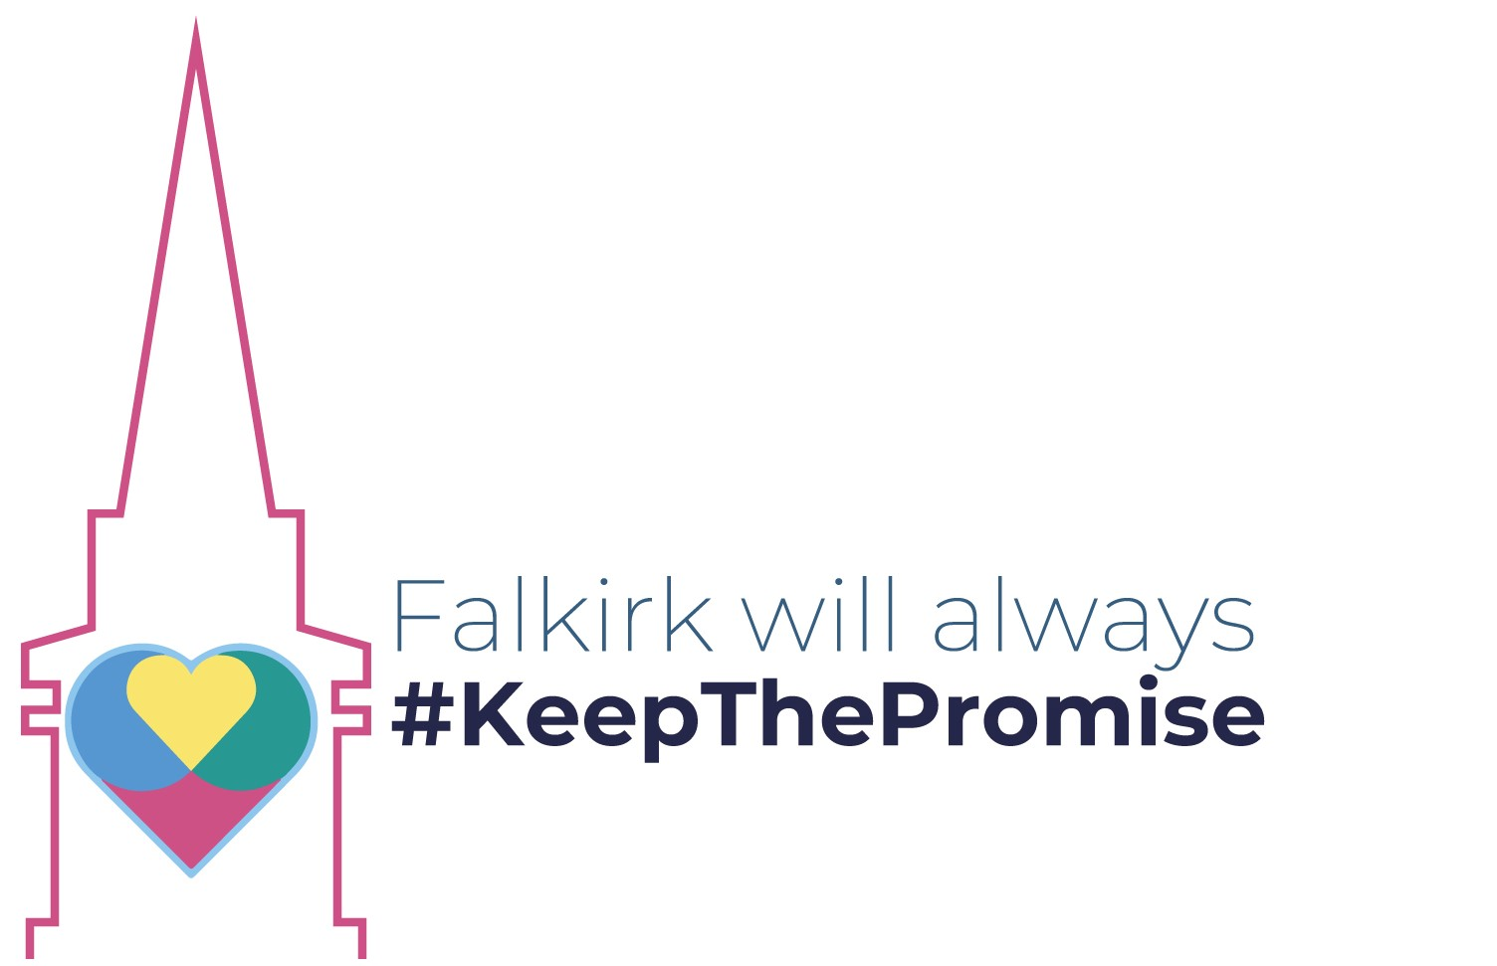

This document explains what Falkirk’s Corporate Parent Plan is. This plan was made by Falkirk Family and Friends who are Falkirk’s Corporate Parents alongside people with lived experience.

Who are Corporate Parents?
A corporate parent is a public organisation with special duties to children and young people with care experience. Some examples of corporate parents include the Council, the NHS and Police Scotland. Every person who works for these organisations is also a corporate parent. This includes teachers, social workers, doctors, nurses and police officers.
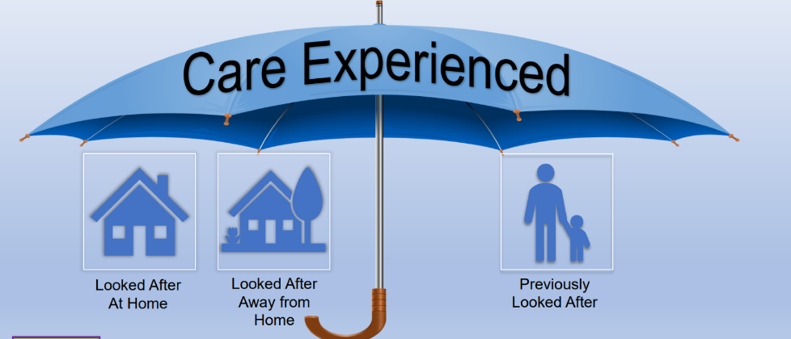
What is Care Experience?



The term care-experienced in Falkirk refers to anyone who has been, is currently in care or from a looked-after background at any stage in their life, including adopted children who were previously looked-after. This care may have been provided in one of many different settings such as in residential care, foster care, kinship care, or through being looked-after at home with social work support.

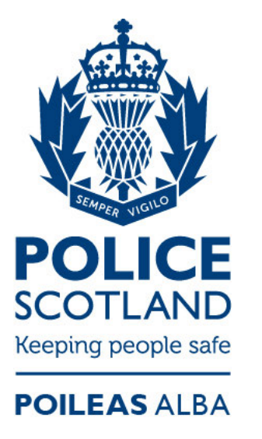



By law, corporate parents must support children and young people with care experience. They are responsible for making sure that young people with care experience are safe, healthy and successful. The law says that corporate parents must:
- Learn about what care experienced young people need and how best to support them.
- Be alert and notice if a care experienced young person needs help.
- Improve how they support care experienced young people.
- Help care experienced young people access opportunities.

Who else is involved?
The priorities below were agreed upon with Falkirk Champs - a group of care experienced young people who work for a better care system.

Get to Focus also agreed on these priorities. They are a group of local parents who have experience of the Care System.

Both Falkirk Champs and Get to Focus are part of Falkirk Family and Friends and were an important part of making this plan.

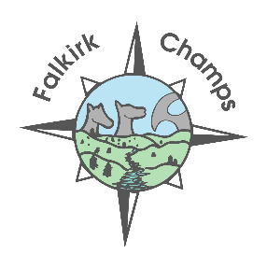

The Plan: 6 priorities

 | - Falkirk will have a workforce that understands people with care experience
 | - Falkirk’s workforce will have caring values
 | - Children and families’ views will be listened to.
 | - All children and young people will be supported to succeed in education and beyond.
 | - All children and young people will have good physical and mental health.
 | - Falkirk Family and Friends will know when a care experienced young person uses their service and what their needs are.
Here is a link to the main Corporate Parent Document if you want to find out more: Children & families - Falkirk Family and Friends | Falkirk Council

