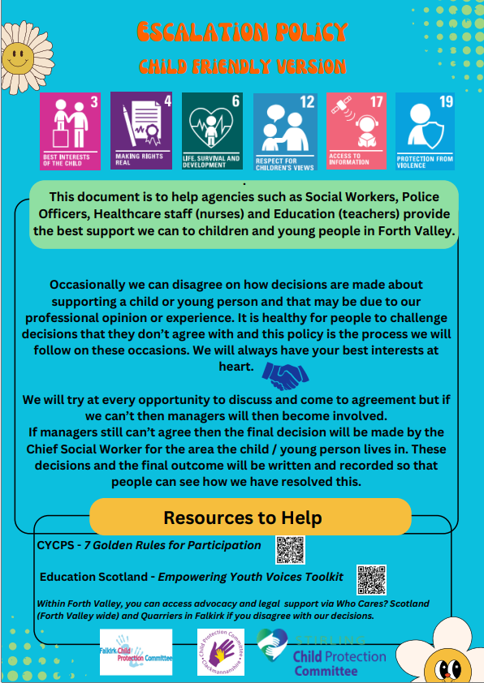

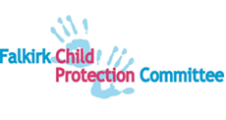 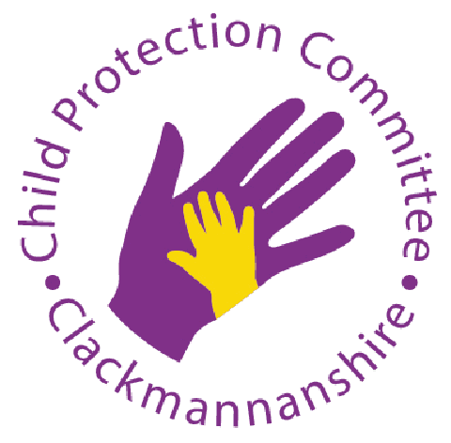 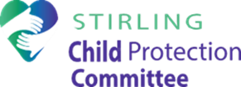

**FORTH VALLEY**

**MULTI-AGENCY GUIDANCE**

**FOR**

**ESCALATION**

|  |  |  |  |
| --- | --- | --- | --- |
| Version | Date | Author | Changes/comments |
| 1.0 | 22.11.19 | FV PPP Group | Draft |
| 1.1 | 28.02.20 | FV PPP Group | Reviewed updated draft |
| 1.2 | 09.07.20 | FV PPP Group- Sue Johnson, Anne Salter | Reviewed updated draft - SCR learning incorporated |
| 1.3 | 06.11.20 | FV PPP Group | Updated to include IRD in flowchart |
| 1.4 | 15.03.24 | FV PPP Group | Updated to reflect change in staff and language as per the National Guidance for Child Protection in Scotland 2021, updated 2024. |

1. **Introduction**

This guidance has been developed by Clackmannanshire, Falkirk and Stirling Child Protection Committees. The Chairs of the Child Protection Committees in Forth Valley acknowledge the shared responsibility that agencies and services have to ensure that GIRFEC and child protection processes improve outcomes for children in acceptable timeframes.

Everyone who works with children has a responsibility for keeping them safe. No single professional can have a full picture of a child’s needs and circumstances and, if children and families are to receive the right help at the right time, everyone who comes into contact with them has a role to play in identifying concerns, sharing information and taking prompt action.

It’s important that staff feel supported in and around the complexity of protecting vulnerable children. It will always be an area of work where there may be differences of opinion about the best course of action. These differences may be healthy as they can encourage further exploration and discussion about what is best for each child and can therefore contribute to better outcomes for children. It is important that all those working with children and families feel able to air their views and constructively challenge the decisions and actions, or lack of actions of others.

During any disagreement, staff must always be focused on the child. The safety of individual children remains the paramount consideration and decisions should always be made in the child’s best interests.

The following are core aspects of a safe multi agency GIRFEC and child protection service:

* Transparency, openness and a willingness to understand and respect individual agency views.
* A culture of listening to and engaging in dialogue within and across agencies.
* All communication is as accurate and detailed as possible. Without accuracy, effective decisions cannot be made and equally inaccurate accounts can lead to children remaining unsafe.
* Supervision can support staff to reflect critically on the impact of their decisions on the child and their family.
* All agencies share a commitment to deal with disagreements at an early stage.

1. **Policy Statement**

Learning from Learning Reviews (previously Significant Case Reviews) and findings from Joint Inspections of services for children, recommend that professional partnership working is essential, so that children and families get consistent support and the right help at the right time. Children must not be left in situations where their needs are not being met in a consistent manner and safe environment. If your assessment of a child’s circumstances suggests progress is not being made to reduce risk or improve children’s outcomes, or you perceive that a child is at additional risk, there are several steps you must take to fulfil your responsibility. This guidance aims to ensure that all multi agency staff have clear steps to follow to promote a consistent approach to escalating concerns.

**3. Scope**

This framework provides additional information which should be adhered to if single and multi-agency children’s plans are not keeping them safe or promoting change that can evidence their wellbeing needs are being met in a safe and consistent manner.

It ensures that staff know where to seek support in exploring concerns identified within their assessment and in the steps required to be taken to escalate these concerns appropriately to ensure the safety of the child. Escalation should be used on the rare occasions where staff have not reached a consensus and one professional/ agency thinks that progress is not being made to improve outcomes for children or perceives that a child is at additional risk.

It may apply in the following situations:

* Referrals (to social work, Reporter, other services);
* Inter-agency Referral Discussions;
* Child Protection Planning Meetings, core groups, looked after reviews, care and risk management meetings;
* Children’s Hearing System;
* Team around the child meetings;
* Case transfers between Local Authorities

1. **Guidance for practice**

Through reflection and gathering of evidence , identify exactly what it is that makes you think progress is not being made with single or multi-agency child’s plans or what is putting this child at **additional** risk of harm. Sharing your concern with the relevant involved colleague is essential and should provide agreement to proceed in the best interest of the child. This is the preferred way to resolve the concern (Step 1).

If escalation is required, further options should be taken (outlined in Steps 2 and 3).

For Child Protection Planning Meetings, there is a formal process if a practitioner wishes to dissent against a child protection registration decision. For further information please refer to Forth Valley Inter-Agency Child Protection guidance available on Practitioner Pages - [CPPM & Dissent.](https://blogs.glowscotland.org.uk/glowblogs/public/fvpp/uploads/sites/9924/2024/01/11204615/Forth-Valley-Inter-Agency-Child-Protection-Guidance-2023-FINAL.pdf)

All relevant discussion must be recorded in information systems at all levels in this Framework.

1. **Senior Manager Contact Details**

**Social Work**

Clackmannanshire Senior Manager –Margaret Lewis, T: 01259 225000, [mlewis@Clacks.Gov.uk](mailto:mlewis@Clacks.Gov.uk)

Stirling Service Manager - Mark Howie, T: 01786 233766, [howiem@stirling.gov.uk](mailto:howiem@stirling.gov.uk)

Falkirk Senior Service Manager - Gayle McIntyre, T: 01324 504644, [gayle.mcintyre@falkirk.gov.uk](mailto:gayle.mcintyre@falkirk.gov.uk)

Stirling Service Manager - Rikki Sneddon, T: 01786 233690 (Ext: 33690), [sneddonr@stirling.gov.uk](mailto:sneddonr@stirling.gov.uk)

**Education**

Clackmannanshire Service Manager –Veronica Cully, Tel 01259 452404, email [vcully@clacks.gov.uk](mailto:vcully@clacks.gov.uk)

Falkirk Service Manager -Kerry Drinnan, Tel 01324 506600, email [Kerry.drinnan@falkirk.gov.uk](mailto:Kerry.drinnan@falkirk.gov.uk)

Stirling Service Manager - ASN, Health & Wellbeing-Morven Graham, T: 01786 237586 grahammo@stirling.gov.uk

**Police**

Detective Chief Inspector PPU – Barry McDaid, Tel 01324 574942, email [Barry.McDaid@scotland.police.uk](mailto:Barry.McDaid@scotland.police.uk)

**Health**

Child Protection Nurse Consultant – Lorna Hood, Tel 01786 477420, email Lorna.hood2@nhs.scot

**Reporter**

**Clacks**

Locality Reporter Manager Central – Lynne Hobbs, Tel 0131 244 3143, Lynne.Hobbs@scra.gov.uk

**Falkirk and Stirling**

Locality Reporter Manager Central – Nicola Crawford, Tel 0131 244 3143, Nicola.Crawford@scra.gov.uk

1. **Appendices**

Appendix 1 Escalation Form (previously NHS FV CP4)

Appendix 2 [National Guidance for Child Protection in Scotland 2021, updated 2023](https://www.gov.scot/binaries/content/documents/govscot/publications/advice-and-guidance/2023/08/national-guidance-child-protection-scotland-2021-updated-2023/documents/national-guidance-child-protection-scotland-2021-updated-2023/national-guidance-child-protection-scotland-2021-updated-2023/govscot%3Adocument/national-guidance-child-protection-scotland-2021-updated-2023.pdf)

Appendix 3 The Scottish Children’s Reporter Administration (SCRA) website provides information that includes The Role of the Reporter, How to Refer and Information for Professionals – see link below:

[www.scra.gov.uk](http://www.scra.gov.uk)

# Appendix 1

# CONFIDENTIAL

**Escalation/Request for Child Protection Planning Meeting or other multi-agency meeting**

**Used as written confirmation of telephone call and email made to escalate concern**

|  |  |
| --- | --- |
| Member of staff escalating concern |  |
| **Name** |  |
| **Designation** |  |
| **Base** |  |
| **Tel. No and email** |  |

|  |  |
| --- | --- |
| For the attention of |  |
| **Name of Chair** |  |
| **Address** |  |

|  |  |  |  |
| --- | --- | --- | --- |
| ***Child/Family details*** | |  | |
| ***Parents/Carers*** | |  | |
| Mother | |  | |
| Father | |  | |
| Significant adult in household | |  | |
| **Address** | |  | |
| **Tel. No.** | |  | |
| **Children** | **Name** | | **CHI** |
| 1. |  | |  |
| 2. |  | |  |
| 3. |  | |  |
| 4. |  | |  |
| 5. |  | |  |

**Reason for request**

* **Current single/multi/child protection plan not improving the outcomes for the child in acceptable timeframe**
* **Change in circumstances that impacts on current risk and assessments**
* **Poor/non engagement/resistance by family with description of impact on child**
* **Increased risk to child identified and described**
* **Other**

REQUEST FOR:

Team Around the Child Meeting (TAC)

Child Protection Planning Meeting

Professional only meeting

Looked After Review

Care and Risk Management Review

***Is the family aware of this request?***

(Please tick as appropriate)

NO

YES

Signature .......................................................... Date: .....................................

(Print) ............................................................... Designation: ...........................

**Copy to Professional record**