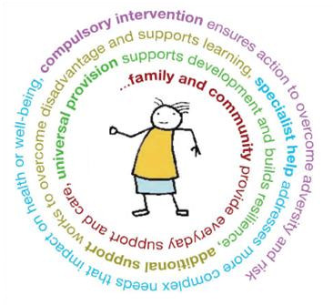
A G E N D A
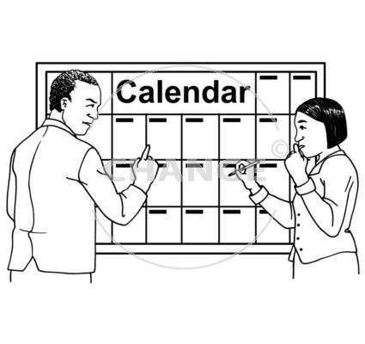
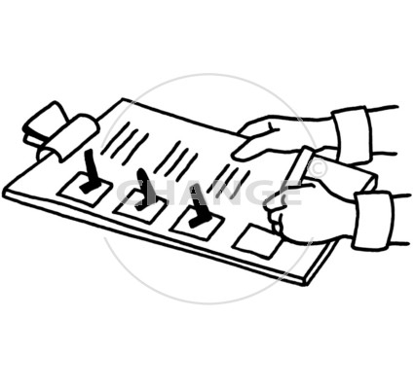
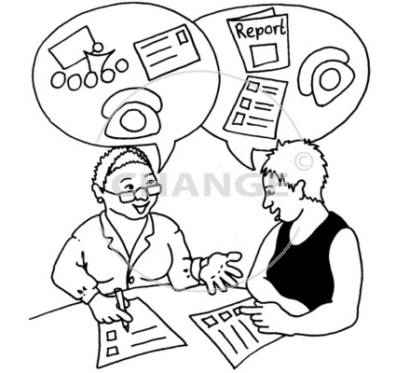
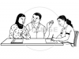
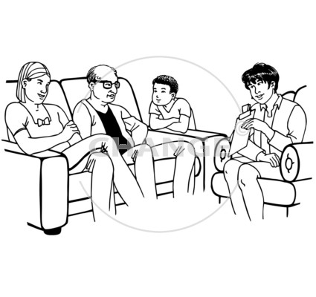
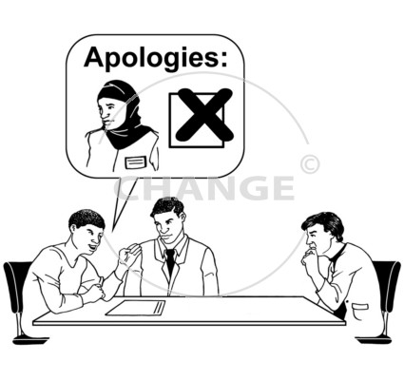
1. | Welcome & Introductions
2. | Apologies
3. | Reason for Meeting
4. | Information Sharing/Discussion
5. | Recommendations that Shape Child/Young Person’s Action Plan  - Who will do what & when  - Including family members
6. | Lead Professional Role – identification, if appropriate
7. | Clarification of Lead Professional Role
8. | Review Date, Time and Venue Arranged

