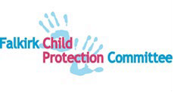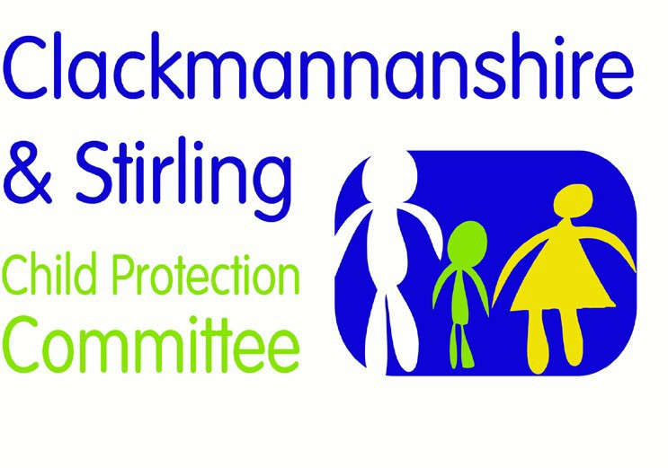

Forth Valley Multi-agency Guidance

Honour-Based Abuse and Forced Marriage

Version | Date | Author | Date Review Due | Changes/comments
1.0 | 01.02.2019 | FV PPP Group | 01.02.2021 | First version
2.0 | 03.11.2021 | FV PPP Group | 03.11.2024 | Reviewed and Honour-Based Abuse incorporated

Page | 1

A forced marriage is a marriage conducted without the full and free consent of both parties, and where duress is a factor. Duress can include physical, psychological, financial, sexual and emotional abuse.
A forced marriage is different from an ‘arranged marriage’. An arranged marriage is one in which the families of both spouses are primarily responsible for choosing a marriage partner for their child or relative, but the final decision as to whether or not to accept the arrangement lies with the potential spouses: both spouses give their full and free consent. The tradition of arranged marriage has operated successfully within many communities for generations.

Forced marriage is both a child protection and adult protection matter. Child protection processes will be considered up to the age of 18.
Forced marriage may be a risk alongside other forms of so called ‘honour-based’ abuse.
Honour based abuse includes practices used to control behaviour within families, communities, or other social groups, to protect perceived cultural and religious beliefs and/or ‘honour’. Such abuse can occur, for example, when perpetrators perceive that a relative has shamed or may potentially shame the family and/or community by breaking their honour code. This abuse can take many forms, including threatening behaviour, emotional blackmail, assault, rape, abduction, forced marriage, confinement and ‘honour killing’.
Perceived transgressions which may trigger “honour based” abuse include: supposedly “inappropriate” makeup or dress; having a boyfriend/girlfriend; forming a relationship with someone of a different faith; showing same-sex attraction or having a same-sex relationship; kissing or intimacy in a public place; pregnancy outside marriage; and rejecting or seeking to escape from a forced/arranged marriage.
Particularly for women, seeking a divorce (regardless of the reasons behind this) is extremely stigmatised and can lead to ostracism and “honour based” abuse.
Those who might identify as LGBT and disabled children may be at increased risk of forced marriage. For LGBT people this is seen as a way of ensuring that their LGBT identity is not made public. Forced marriages are also seen as a way of ensuring that someone who needs care has a spouse who can provide care. Further, immigration can be an aggravating factor towards forced marriage: by arranging a marriage of a UK citizen with someone from overseas, the overseas spouse is guaranteed an easier entry into the UK. An estimated 85% of forced marriage victims are girls and women.
Honour based abuse support work is mainly conducted by women’s organisations. However, boys, especially those who might identify as gay, bi-sexual or transgender are also affected by forced marriage, domestic abuse, coercive control, and other forms of honour-based abuse.
Practitioners should be aware that forced marriage is not restricted to any particular ethnic or religious community.

Forced marriage legislation should be used in conjunction with child and adult protection legislation. In Scotland, a couple cannot be legally married unless both parties are at least 16 on the day of the wedding and are capable of understanding the nature of a marriage ceremony and of consenting to the marriage. Parental consent is not required. The Forced Marriage etc. (Protection and Jurisdiction) (Scotland) Act 2011 came into force in November 2011 and introduced civil remedies for those at risk of forced marriage, and those who have already been forced into marriage. It introduced a civil Forced Marriage Protection Order (FMPO), which can be used to protect those at risk; it is a criminal offence to breach a FMPO. To extend protection for those at risk, the Scottish Government took the decision to criminalise forcing someone into marriage. The relevant legislation is contained in section 122 of the Anti-Social Behaviour, Crime and Policing Act 2014.
The consequences of forced marriage can be devastating for the whole family, but especially to the young people affected. They may become estranged from their families and wider communities, lose out on educational opportunities, or become victims of domestic abuse. Rates of suicide and self-harm within forced marriages are high.
Potential indicators of honour-based abuse and forced marriages include:
- Concerns voiced by child or person in child’s network about going overseas ‘to visit relatives’ or attend a wedding.
- Concerns expressed about a dowry being collected (usually jewelry, clothing, other material possessions).
- A girl undergoing or at risk of undergoing FGM as part of her ‘preparation’ for the marriage.
Education concerns include:
- absence, or persistent absence, from education
- a request for extended leave of absence and failure to return from visits of country of origin
- a decline in behaviour, engagement, performance or punctuality
- being withdrawn from school by those with parental responsibility
- being prevented from attending extra-curricular activities
- being prevented from going onto further/higher education
- sudden changes in appearance or behaviour (especially young girls changing their dress code dramatically to adopt culturally/religiously appropriate clothing

Health concerns include:
- Self-harm
- Attempted suicide
- Depression
- Eating disorders
- Being accompanied to doctors or clinics and prevented from speaking to health practitioners in confidence
- Experience of female genital mutilation (FGM).

Police concerns include:
- Reports of domestic abuse, harassment or breaches of the peace at the family home
- Threats to kill and attempts to kill or harm the potential victim or another family member (emotional blackmail)
- Truancy or persistent absence from school.
Direct engagement with the family is not advised, as it may aggravate and expedite the risk of a child being taken abroad for a marriage. It is always advisable to contact a specialist organisation or community advisor for support.

Resources and References
National guidance for child protection in Scotland 2021 - gov.scot (www.gov.scot)

https://blogs.glowscotland.org.uk/glowblogs/fvpp/

