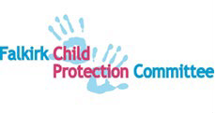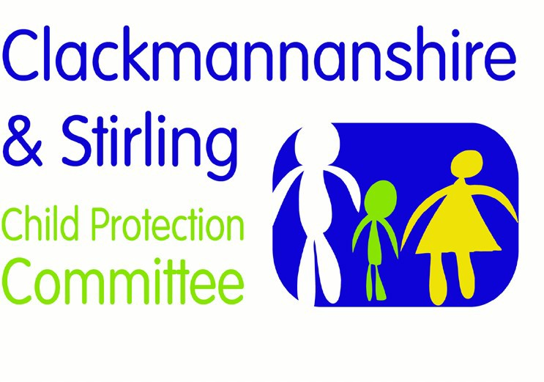

Forth Valley Multi-agency Guidance

Female Genital Mutilation

Version | Date | Author | Date Review Due | Changes/comments
1.0 | 01.02.2019 | FV PPP Group | 01.02.21
1.1 | 02.08.2021 | FV PPP Group | 02.08.24 | Updated in line with National Guidance for Child Protection in Scotland 2021

Forth Valley Multi-agency Child Protection Guidance
Female Genital Mutilation

Female Genital Mutilation (FGM) is child abuse. This traditional practice is an extreme form of gender-based abuse, causing significant and lifelong physical and emotional harm. Cultural considerations and sensitivities should not override the need of professionals to take action to protect a child at risk.
The legal definition of FGM is to excise, infibulate or otherwise mutilate the whole, or any part, of the labia majora, labia minora, prepuce of the clitoris, clitoris or vagina (section 1 of the Prohibition of Female Genital Mutilation (Scotland) Act 2005).
The World Health Organization defines four types of FGM. However, it should be noted that the term FGM is often not recognised by FGM practicing communities, and practitioners should use terms such as cutting or female circumcision instead.
FGM may be a risk from infancy through to adulthood, as the practice can take place in infancy, childhood and also before marriage. Disabled children may also be subjected to the practice. A girl or woman might be subjected to FGM more than once throughout her life. A girl or woman may be taken out of the country by family in order for the procedure to be carried out.
FGM has been illegal in Scotland since 1985. The Prohibition of Female Genital Mutilation (Scotland) Act 2005 made it a criminal offence to have FGM carried out either in Scotland or outside the United Kingdom. The Act also increased the maximum sentence on conviction on indictment from 5 to 14 years imprisonment (section 5 of the 2005 Act). The UK Parliament’s Serious Crime Act 2015 extends the reach of extra-territorial offences in that Act to habitual (as well as permanent) UK residents. The Female Genital Mutilation (Protection and Guidance) Act 2020 makes provision for FGM Protection orders and for Statutory Guidance on FGM. This Bill will strengthen the existing legislative framework for the protection of women and girls from FGM.
FGM can be imposed by families that are in other ways protective.
By contrast it may be associated with other forms of gender-based violence and so called ‘honour-based’ abuse, which can include child and forced marriage. Sometimes FGM can be linked to trafficking. Children affected by FGM experience lifelong psychological trauma
FGM procedures cause severe pain, emotional and physical shock. Complications can cause death. Effects can include haemorrhage, wound infections, urinary retention, injury to adjacent tissues, fracture or dislocation as a result of restraint, and damage to other organs. Long-term health consequences include: chronic vaginal and pelvic infections; difficulties during menstruation; difficulties in passing urine and chronic urine infections; renal impairment and possible renal failure; damage to reproductive system (including infertility); infibulation cysts; neuromas; keloid scar formation; complications in pregnancy; delay in the second stage of child birth; maternal or foetal death; and increased risk of sexually transmitted infections. Surgical interventions during pregnancy and childbirth may be required.
Immediate and long-term emotional impact is further complicated because the decision is usually made by those who are respected, loved and trusted. Adult survivors who experienced FGM as children have reported losing trust in those who forced them to undergo the procedure. Others experience family conflict and/or separation, especially in families when parental attitudes are divided. Women may experience recurrent sexual, psychological and physiological problems. FGM may also cause severe post-traumatic stress and can be associated with subsequent drug and alcohol problems, although this is less likely in cultures where drug and alcohol use is considered ‘shameful’.
FGM or risk of FGM may first come to the attention of education or health professionals. A child can be considered at risk if they come from an FGM practicing community or if a close female relative is a survivor of FGM regardless of whether the community of origin traditionally practices FGM. A strong indicator could be the planning of an extended family holiday.
Every situation should be considered individually, rather than making automatic assumptions about levels of risk within specific communities.
Other child protection concerns may or may not co-exist.
It is relevant to know if the family is from a community in which FGM is practised; if the girl’s mother has experienced FGM; if the girl has a female sibling/cousin who has experienced FGM; and if it is known that the family is as yet not well integrated.
Practitioners should be aware that attitudes within the same family may vary. Some women who have experienced FGM are opposed to their daughters undergoing it. Experience of coercive control and the size of the family/extended family/wider community may limit the protective capacity of some parents.
Consideration should be given to how to give mothers safe and private space in which to talk. As with other forms of child protection work, there should be efforts to engage and seek a shared understanding in partnership with parents/carers, unless there are safety considerations. Survivors of FGM should be given the opportunity to speak with female practitioners.
When it is believed that FGM has been carried out upon a child or when there is cause to believe it may occur, this should trigger an IRD. A strategy discussion may be advised in order to consider the whole situation and tailor the engagement, investigation and support process likely to be in the child’s best interests. The plan should take into account that other female siblings or close relatives may also be at risk.
A multi-agency approach is required. National multi-agency guidance (Scottish Government, 2017) provides indicators of good practice. Wherever possible, female practitioners are recommended for planned assessment. Practitioners will be sensitive to the time and privacy needed by those expressing concerns. Clear and simple language should be used. Those involved also need a clear understanding of the role of practitioners. Some children will not understand what has happened or what may happen. Care should be exercised in the use of interpreters and lay advisors from the same local community as the victim. (The Scottish Translation, Interpretation and Communication Forum Good Practice Guidelines, 2004).
As part of the National Action Plan to Prevent and Eradicate FGM (Scottish Government (2016), the Female Genital Mutilation (Protection and Guidance) (Scotland) Act 2020 was recently enacted. Agencies need to take into account the new Act’s requirements. These include FGM Protection Orders and Statutory Guidance.

