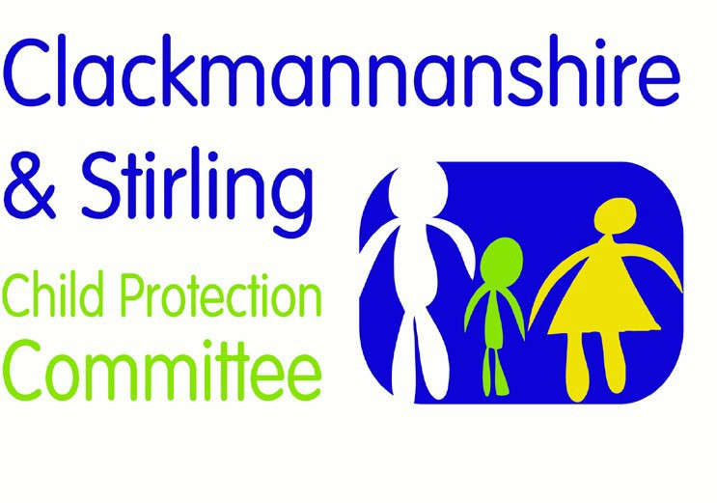

Forth Valley Multi-Agency Guidance

The Unseen Child

Version | Date | Author | Date Review Due | Changes/comments
1.0 | 12.04.2016 | Children’s Commission Improvement Group | 12.04.2018 | First Version
1.1 | 05.12.2016 | FV PPP Group | 05.12.2018 | Changing from Falkirk to Forth Valley Guidance
2.0 | 08.11.2018 | FV PPP Group | 08.11.2020 | Reviewed and working with resistance guidance incorporated
1.0 | 03.11.2021 | FV PPP Group | 03.11.2024 | Reviewed in line with National Guidance for Child Protection 2021

Page | 1

Purpose

The following multi-agency guidance has been produced by Clackmannanshire and Stirling Child Protection Committee and Falkirk Child Protection Committee. The guidance should be used to assist practitioners to determine an appropriate course of action to take in situations where the child is ‘unseen’. The guidance incorporates the core components of Getting It Right for Every Child (GIRFEC).

Children in households in which there is professional involvement need to be seen in order to review and assess their circumstances and needs. If chronologies show that a pattern is emerging in which the child is not seen, concern should be heightened and action taken to ensure the child is seen.

This guidance sits alongside:
- Single agency guidance relating to “the unseen child”.
- Children Missing from Education Guidance.
- Missing Families Alert (NHS Forth Valley).
- Professional Curiosity guidance and 7 min briefing
- When services find it hard to engage guidance
- Multi-agency Child’s Plan Transfer Guidance

Definition

The unseen child is a child who may fall in to the following categories.
- Address unknown.
- Access is not possible because the child was not brought to appointments.
- The parents/carers do not agree to the child being seen.
- The parent/carer has repeated explanations for the child’s absence e.g. asleep, with relative, unwell, outside playing.
- There is no reply when arranged calls are made to the home.
- Arranged visits are cancelled at the last minute and rearranged

Evaluation of Concerns

Practitioners may become aware of an “unseen” child in a number of ways. While not exhaustive, the following points are provided for illustration:
- When responding to a reported concern about a child but practitioners have been unable to see the child, possibly due to reasons/explanations given as per definition above.
- When a child is regularly not brought to appointments
- When there is already planned, ongoing contact with a family but practitioners become aware that a particular child has not been seen in the course of contact with the family for a period of time.
- When a concern is shared by another professional that they have been unable to see a child.

When a practitioner becomes aware of an “unseen” child, an evaluation of the level of concern must be undertaken. Each case is unique and it is the significance of being

“unseen” that needs to be assessed. The Named Person for the child should be informed of the concern to ensure appropriate information is shared which will inform assessment. This assessment will particularly focus on the vulnerability of the child in terms of age and stage of development and level of additional needs.
Determining the level of concern in relation to an “unseen” child requires prompt multi agency information sharing and assessment. This will need to take into account any known or suspected risks to the child, any protective factors and the length of time since the child has been seen and the nature of involvement of all agencies.

The response to such initial assessment should be proportionate to the identified needs and risks for the individual child.
Where there are no existing concerns about a child but those involved with a family become aware that a child has not been seen for a period of time during their contact with a family, the practitioner must, in the first instance, discuss these circumstances with their line manager.
It is not possible to be prescriptive about what length of time is significant for “unseen” children in these circumstances. Managers should support staff to reflect on their practice and, as part of this process, to consider whether an “unseen” child may raise a concern.

Questions to consider include:

- How long is it since I have seen this child and would I have expected to have seen them more recently?
- What does it mean for the child if they have not been taken to appointments or seen?
- Are there factors’ impacting on parenting capacity?
- Is there another way for me to see this child as part of my contact with the family that would help me identify whether I have concerns?
- Do I know who else is involved with this family and whether they have seen this child?
- Has any other person shared concerns with me about the child?
- Do I need to share any information in order to ensure any needs/risks for this child are identified and addressed?

If during discussion with the line manager, it is agreed that there may be a concern associated with this child being “unseen”, the following action should be taken:

- Contact other agencies who may be involved with the family. This could involve telephone contact or calling a meeting, depending on the level of concern and urgency.
- Consider contacting any other agencies other than those already involved in core groups or team around the child meetings.
- Explain your involvement and the background to your concern, e.g. an “unseen” child.
- Seek information on the nature of involvement of other agencies, including whether and when they have seen the child, and whether there are concerns either about the child or about factors that may impact on parenting.

- If anyone has seen the child, information about the child’s presentation must be discussed and taken into account in assessing current circumstances.
- Contact your Child Protection Lead within your organisation for advice and support

There are some circumstances where any period of a child being “unseen” is potentially significant.

- Where there are existing concerns about a child, including child protection concerns.
- Children on the child protection register, whenever there is a missed contact (e.g. not brought to appointment, unable to gain access to the home, not able to see the child) responsive action must be taken immediately.

In these cases, if the child has not been seen within one day of attempted contact, then this must be brought to the attention of the Lead Professional. The person who is raising the concern is responsible for speaking directly to the Lead Professional / Social Worker and ensuring action is agreed. This will involve following up the initial sharing of concern by completing and submitting a notification of child protection concern, the written confirmation of your telephone call and agreed actions.

Acting in response to concerns about a child being unseen

If, at any time, the circumstances suggest the need for urgency, action must be taken immediately. If it appears that the family have moved to an unknown address all efforts should be made to find out the new address and relevant procedures relating to Missing Families and Forth Valley Multi-agency Child’s Plan Transfer Guidance should be invoked.

Definition and action to be taken in relation to a missing family in line with NHS Scotland
“This is a family who has disappeared from a known location within a Health Board area for whom there may be concerns of significant harm for the child or young person in respect of unmet need vulnerability or abuse. This includes risks to unborn children” (Scottish Government 2013).

- In the case of home visits, arrange to return later in the day.
- In the case of office/clinic appointments, make every effort to contact the family to obtain an explanation for failure to attend.
- Contact all other relevant agencies contributing to the child’s plan or child protection plan to share information about the failed contact and identify if any other professional has seen the child. Seek information about any current concerns to recognise the impact on the child and relevant timescales to minimise that.
- Explain clearly to parents the need to see the child.
- If applicable, return to the house as arranged.
- If, at this stage, the child remains unseen by any professional, this must be discussed with the Lead Professional/Social Worker and a plan of action

agreed. (If the worker is unavailable, speak to the Team Manager and/or follow escalation processes).
- The discussion and action agreed with the Lead Professional / Social Worker must be confirmed in writing within 24 hours and shared with all agencies involved with the family.

Where concern about a potential “unseen” child has been raised by another professional all staff involved with a family must give consideration to how they can share information in order to contribute to any assessment of risk and need for that child. A team around the child, core group or other multi agency planning meeting, for example, Initial Referral Discussion should be considered.

Services must share information about their involvement with a family to allow for the most effective assessment of a child’s needs and help to ensure the most proportionate response is provided. This information would include;

- Who they have had contact with
- Any family issues that may impact on children
- When any child in the family was seen and how they presented
- Current and planned contact/involvement with the family.

If, at any time the circumstances suggest the need for urgency, action must be taken immediately. Information should be shared with a line manager who should in turn make contact with the Detective Inspector for the Police Public Protection Unit or in their absence the On Duty Police Scotland Operations Inspector (Police Incident Officer).

Resources and References

National guidance for child protection in Scotland 2021 - gov.scot (www.gov.scot)

Practitioner Pages – These pages are for practitioners to support improving outcomes for Forth Valley Communities (glowscotland.org.uk)

