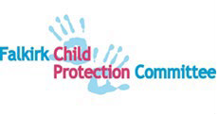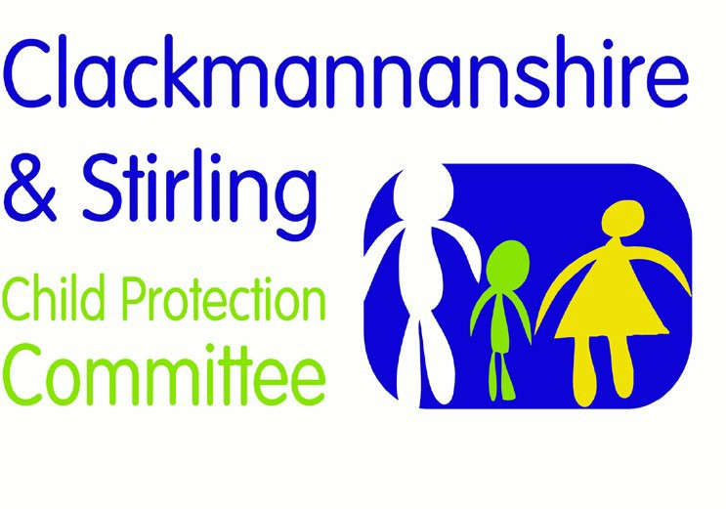

Forth Valley Multi-Agency Guidance Child Protection and Domestic Abuse

Version | Date | Author | Date Review Due | Changes/comments
1.0 | 02.08.2021 | FV PPP Group | 03.11.21

Page | 1

Definition
Domestic abuse is any form of physical, verbal, sexual, psychological or financial abuse which might amount to criminal conduct and which takes place within the context of a relationship. The relationship may be between partners (married, cohabiting, in a civil partnership or otherwise), or ex-partners. The abuse may be committed in the home or elsewhere, including online. Domestic abuse includes degrading, threatening and humiliating behaviour predominantly by men and predominantly towards women. It is a gendered crime and is underpinned by attitudes and inequalities between men and women that continue to be prevalent in society.
There is significant evidence of links between domestic abuse and emotional, physical and sexual abuse of children and children themselves can experience domestic abuse as ‘coercive control’ of the whole family environment, not just of their mother.
Violence against women and girls refers to a range of actions that harm, or cause suffering and indignity to women and children. These include but are not limited to physical, sexual and psychological violence in the family, general community or in institutions. This includes domestic abuse, rape, incest and child sexual abuse; sexual harassment and intimidation at work, online, at home or in public; commercial sexual exploitation including prostitution, pornography and trafficking; and so called ‘honour-based’ violence, including dowry-related violence, female genital mutilation, forced and child marriages, and ‘honour’ crimes.
The Scottish Government’s definition of violence against women and girls is based on the United Nations Declaration on the Elimination of Violence Against Women.
The criminal offence of Domestic Abuse is detailed in sections 1 and 2 of the Domestic Abuse (Scotland) Act 2018. Offences cover behaviour likely to cause a partner or ex-partner to suffer physical or psychological harm (including fear, alarm and distress). This can range from behaviour that is violent, threatening or intimidating or has effects such as dependency, isolation from friends or family, controlling, depriving or restricting freedom of action or which is frightening, humiliating, degrading or punishing.
Statutory aggravation of the offence in relation to a child is defined at section 5 of the 2018 Act. This applies if a child sees, hears, or is present during or is likely to be adversely affected by the offence of domestic abuse. There does not have to be evidence that the child is aware, understands or has been adversely affected by the domestic abuse and a single source of evidence is sufficient for the offence to be aggravated.
Domestic abuse is linked to emotional and psychological harm in children. Children are harmed by experiencing behaviour that is intimidating and degrading, threatening, exposing of intimate information, or accusing and blaming.

Coercive and controlling behaviour is also harmful. Examples of coercive and controlling behaviour include when the child and non-abusive parent are isolated from friends and family, or when abusers cut off the non-abusive parent’s access to a phone or a bank account.
Chronic trauma can disrupt attachment, achievement, concentration and wider relationships. The traumatic impact of domestic abuse is often masked and emerges indirectly in anxious or troubled behaviours in teenage years. A trauma- informed approach is required by all involved practitioners.
Young people may experience abuse and coercive control in their own relationships outside of the family home. As within adult domestic abuse, this can include physical, sexual and emotional abuse. This is often unrecognised, and victims may choose not to disclose. Social media and digital technology may be used to perpetrate abuse.

Responding to Domestic Abuse
Members of the public or non-statutory services concerned for the safety of a child or parent should contact Police Scotland or Social Work. As far as possible, taking into account the urgency of the situation, this should be in collaboration with the non- abusing parent/carer.
On all occasions when children are present during an incident that requires the police to attend, officers in attendance will consider all information, including previous incidents, to assess whether there is a child wellbeing or protection concern. Information about the incident will be considered for sharing by Divisional Concern Hubs with appropriate statutory and non-statutory agencies who have support, wellbeing or health responsibilities, or who provide domestic abuse advocacy services
The child protection response by statutory agencies will depend on professional judgement about the risk of harm and the urgency of the circumstances. Domestic abuse is always a wellbeing concern. It may be a child protection concern if there is evidence that significant harm has occurred or may occur.
Professional judgement involves consideration of key factors such as the child’s experience, needs and voice (and those of other children affected); the non-abusing parent’s views, choices, strengths and abilities to use available supports; the presence of other complicating factors such as parental alcohol and drug use; and the abuser’s pattern of coercive control.
Where professional judgement indicates the likelihood of risk of significant harm an IRD will be triggered. In some cases the risk from the perpetrator is very high.
Multi-agency planning and partnership with the non-abusive parent must protect the child. It can be difficult to achieve safe collaboration with a non-abusing parent/carer if they deny, or do not recognise, the risk posed by the perpetrator towards the child.

GP and hospital services must be alert to the needs of victims of abuse, and especially those who are pregnant and have mental health, drug and alcohol difficulties.
Domestic abuse may begin during pregnancy.
Third Sector organisations, such as Scottish Women’s Aid, play an essential role in developing and providing services for women.
A National Domestic Abuse and Forced Marriage Helpline is open 24/7, 365 days a year. This is available for professionals seeking advice as well as for individuals who are at risk of or experiencing domestic abuse. The helpline number is 0800 027 1234.
The Disclosure Scheme for Domestic Abuse Scotland (DSDAS) is facilitated by Police Scotland and aims to provide a way of sharing information about a partner’s abusive past with a potential victim. It gives people at risk of domestic abuse the information needed to make an informed decision on whether to continue the relationship. Disclosures are only made where it is lawful, proportionate and necessary to do so.
The Sex Offender Community Disclosure Scheme (Keeping Children Safe) was introduced across Scotland in 2011 and is managed by Police Scotland. The scheme enables parents, carers or guardians to make a formal request for information about a named person who may have contact with their child if they are concerned that he or she may be a risk to their child’s safety and wellbeing. A review was carried out in 2017, following which an online application form was developed to make the process more accessible. In cases where Police Scotland believes that an individual poses a risk to the child concerned, discussions will take place with partner agencies, and steps agreed and progressed to ensure the child’s safety. Where applicable, relevant information is provided to the child’s parent, carer or guardian. Police Scotland provides governance and co-ordination for the scheme to ensure it is publicised widely and embedded in national Police training.
Multi-Agency Risk Assessment Conferences (MARAC) are local meetings where representatives from statutory and non-statutory agencies meet to discuss individuals at high risk of serious harm or murder as a result of domestic abuse. A referral to a MARAC should be considered at the point this risk is identified.
MARACs can play a vital role in terms of safety planning for victims of domestic abuse and their children. Safelives, a UK-wide domestic abuse charity, has developed a suite of resources to help ensure that each MARAC keeps as many victims of domestic abuse as possible safe.
Multi-Agency Tasking and Co-ordination (MATAC) is a Police Scotland-led and chaired initiative to identify and manage the most harmful domestic abuse perpetrators. MATAC aims to effectively tackle offending by domestic abuse perpetrators who present the greatest risk of harm. It does this through:
- effective partnership working to identify those domestic abuse perpetrators who present the greatest risk of harm.

- multi–agency information sharing to support intelligence development and proactive enforcement action against identified perpetrators.
- using tasking and co-ordination to proactively investigate identified perpetrators, using relevant and legitimate tactics.
The Safe and Together Model is based on partnering with domestic abuse survivors and intervening with domestic abuse perpetrators in order to ensure the safety and wellbeing of children. The Safe and Together* approach includes principles and elements essential to safe practice. These are to:
- keep the child safe with the non-abusive parent • form a supportive partnership with the non-abusive parent
- hold the abusive parent accountable for their abuse
Within this approach, practitioners from statutory and non-statutory agencies work collaboratively and reach consensus to ensure the safety and wellbeing of children living with domestic abuse.
Practitioners will:
- locate responsibility for the abuse with the perpetrator and recognise their abuse is a parenting choice
- get as much information about fathering and father’s parenting choices as about mothering and find out about the pattern of abuse and how this affects choices available to the non-abusing parent
- explore the perpetrator’s pattern of coercive control to identify all forms of abuse and control in both current and previous relationships, rather than outlining singular incidents of physical violence
- assess how abuse has harmed the child, including descriptions of direct physical, emotional and sexual abuse from the perpetrator to the child, as well as the way in which the domestic abuse has harmed them
- assess wider wellbeing impact upon the child
- define how the non-abusing parent has promoted the safety, wellbeing, stability and nurture of their children
- assess the interaction of other factors like substance abuse, mental Health, culture, and how other socio-economic factors are considered and addressed’
The Caledonian System is implemented in Forth Valley. This is an integrated approach to address men’s domestic abuse and to improve the lives of women, children and men. It does this by working with men convicted of domestic abuse- related offences on a programme to reduce their re-offending while offering integrated services to women and children. The Men’s Service uses a challenging but trauma sensitive approach with cognitive behavioural techniques to encourage men to recognise their abuse and take responsibility for themselves and their relationship with their ex/partners and children. The Women’s and Children’s Services support women and children and advocate for their rights.
Men will be referred to the programme if they have been convicted of offences involving domestic abuse.

Learning from lived experience: bridges to safety
Safer practice in relation to Domestic Abuse includes:
- finding a safe way to talk to non-abusing parent in private (away from perpetrator)
- ensuring children’s experience and views are given due weight in decision- making, especially about contact
- recognising positive steps to protect the child
- responding early within universal services, including early referral to specialist domestic abuse services
- applying training, experience and supervision that generates an informed understanding of the dynamics of domestic abuse
- supporting the non-abusing parent, which in turn supports the child
- understanding when a non-abusing parent’s ability to effectively parent has been compromised by the perpetrator’s abuse, and providing support accordingly
- recognising and integrating protective factors in safety planning
- supporting children in finding an advocate who they trust
- being clear about confidentiality, and explaining to children and women what information will and will not be shared about them, why and with whom
- being aware of the consequences of sharing information with perpetrators, and taking heed of women’s and children’s fear of reprisal from a perpetrator.

Child abduction in the context of domestic abuse
Section 6 of the Child Abduction Act 1984 creates a criminal offence in Scotland for a person connected with a child under 16 to take or send the child out of the UK without appropriate consent where there is a UK court order in place awarding custody of the child to any person or which makes the child award of court or where there is a UK court order in place prohibiting the child’s removal.
Where no such court order is in place the parent or person with rights of custody can use civil law under the 1980 Hague Convention on the Civil Aspects of International Child Abduction to seek return of the child, or access rights.
Where the country to which the child has been abducted is not a party to the Hague convention, advice should be sought from the Foreign and Commonwealth Office.

Resources and References
National guidance for child protection in Scotland 2021 - gov.scot (www.gov.scot)
Practitioner Pages – These pages are for practitioners to support improving outcomes for Forth Valley Communities (glowscotland.org.uk)
Equally Safe Falkirk - Home

