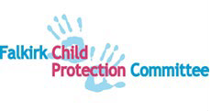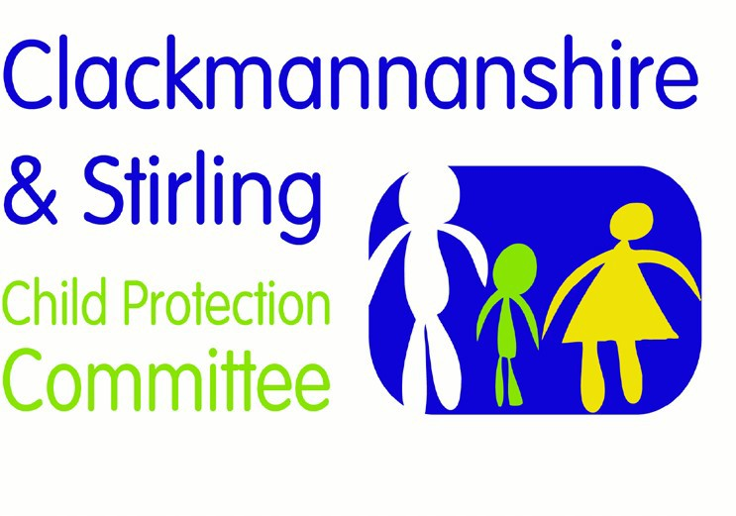

Forth Valley Multi-Agency Guidance

Child Trafficking and Child Criminal Exploitation

Version | Date | Author | Date Review Due | Changes/comments
1.0 | 02.08.2021

  - Purpose

This guidance is to inform staff on best practice in relation to Child Trafficking and Child Criminal Exploitation. Both are forms of child abuse and an immediate child protection response is required. An Inter-agency Referral Discussion (IRD) should be undertaken when there is reason to believe a child may have been trafficked or exploited.

2.1 Definition of Trafficking

The legal definition of the offence of human trafficking in Scotland is set out in the Human Trafficking and Exploitation (Scotland) Act 2015.

A person commits an offence of human trafficking if a ‘relevant action’ is taken with a view to another person being exploited.

The offence of human trafficking is aggravated by being committed against a child (as defined in the 2015 Act as a person under the age of 18-years-old).
Section 1(2) of the 2015 Act defines ‘relevant action’ as any of the following:
- recruiting another person
- transporting or transferring another person
- harbouring or receiving another person
- exchanging or transferring control over another person
- arranging or facilitating any of those actions.
It is irrelevant whether the person consents to any part of the action.
Travel between two places is not a requirement for an offence of human trafficking to have taken place.

The 2015 Act describes what constitutes exploitation for the purposes of the offence of human trafficking. Examples include:
- prostitution and sexual exploitation
- criminal exploitation
- slavery, servitude and forced or compulsory labour
- securing services and benefits
- financial exploitation/benefit fraud
- removal of organs
- debt bondage
- begging

2.2 Awareness and recognition

A child may not realise, divulge or agree that they have been trafficked or exploited. Trafficking is a largely hidden crime. It can be difficult to identify victims.
The child may be:
- at risk of being moved, especially when inquiries begin
- threatened with personal or family harm if they speak out
- unaware that they are a victim of trafficking.

2.3 Incidence

Trafficking occurs both within Scotland and between Scotland and other countries. UK children can be the victims of trafficking. It is estimated that around 40% of unaccompanied children have experienced trafficking and exploitation.

Current figures for the National Referral Mechanism (which is a UK-wide process for identifying and referring potential victims of trafficking and ensuring they receive the appropriate support) for England and Wales indicate that the highest number of referrals are for UK children who have been internally trafficked. The number of referrals from Scotland for UK children is lower but is growing.

Statistics are uncertain and incomplete. The numbers of children referred to the National Referral Mechanism across the UK has risen annually since 2009, and in 2016-2018 the number of children referred has increased significantly, partly due to referrals of UK national children in relation to child sexual exploitation and Child Criminal Exploitation.

In Scotland, between 2012-18 the majority of children known to have been trafficked have been from South East Asia (particularly Vietnam), East Asia, Africa and Eastern Europe. Across the UK as a whole, UK nationals accounted for the largest number of children known to have been trafficked in 2018.

3.1 Definition of Child Criminal Exploitation (CCE)

Child Criminal Exploitation is not defined in law but practitioners should be alert to the possibility that some children who are victims of trafficking may be exploited by gangs and organised criminal networks (CCE can be associated with the term, and can be known as “County Lines”).
Gangs which export illegal drugs into one or more importing areas (within the UK) may use dedicated mobile phone lines or other form of ‘deal line’. Such gangs are known to exploit children and vulnerable adults to move (and store) drugs and money. They will often use coercion, intimidation, violence (including sexual violence) and weapons.

Child criminal exploitation takes a variety of different forms. It can include children being forced to work in cannabis factories, being coerced into moving drugs or money across the country, forced to shoplift or pickpocket, or to threaten other young people. All forms of criminal exploitation have a detrimental impact on a child’s life. As such, any child being forced or coerced to commit crime must be seen as a victim of exploitation.

3.2 Awareness and Recognition

Child criminal exploitation is often unrecognised, and this can mean children are more likely to be prosecuted for offending behaviour rather than being recognised as victims of exploitation. It is critical for professionals to be aware of indicators of trafficking and exploitation, and to take appropriate safeguarding and procedural steps. This is particularly important because a prosecution against someone who has committed a criminal act as a result of being trafficked or exploited would in some circumstances be contrary to obligations imposed by European and national law. The 2015 Act requires the Lord Advocate to publish instructions about the prosecution of persons who are, or appear to be, victims of an offence of human trafficking. The Lord Advocate’s instructions for Prosecutors when considering Prosecution of Victims of Human Trafficking and Exploitation that there is “a strong presumption against prosecution” of a child victim of human trafficking or exploitation who has committed an offence in the course of, or as a consequence of, being the victim of human trafficking or exploitation. Too often children are criminalised rather than seen as victims of criminal exploitation and given the appropriate child protection response.

Being aware of the indicators and risks that may suggest children and young people are being exploited and abused in such a manner is the initial step that professionals need to take. Then, considering how this is being facilitated, by whom, and for what purpose, may evidence there is child criminal exploitation occurring, which should inform the agencies involved and the approach to be taken to protect and intervene.

Contextual safeguarding needs to be considered in managing the risks posed to and from the young person, as a traditional focus on solely the family rather than wider relationships may not suffice in managing presenting behaviours.

Practitioners should also be alert to reports which may indicate someone’s home has been taken over by intimidation or other means for the purpose of criminal activities. Signs of ‘cuckooing’ might include reports of:

- bags of clothing or bedding around the address
- increased visitors throughout the day or night
- increased vehicles outside the address, including taxis, new vehicles and hire cars
- increased anti-social behaviour in the area
- disengagement with support services
- drug paraphernalia around the address, and the smell of drugs such as cannabis
- barricades within and around the address, including weapons.

4.1 Initial assessment and response to trafficking and exploitation

An assessment should always be comprehensive and follow GIRFEC principles. There are no risk assessment tools that can predict the risk of trafficking or definitively identify those who have been trafficked.

However, an indicator matrix has been developed to assist the recognition of such abuse both within the UK and across borders. The indicators complement and do not replace child protection procedures. Indicators in use reflect those applied in international texts and trafficking practice handbooks (IOM 2009; UNODC 2018 and Operational Indicators of trafficking in human beings, 2009.
Operational Indicators of trafficking in human beings, 2009

If an agency or practitioner has concerns that a child may have been trafficked they should:
- always contact Social Work or Police Scotland but not contact carers initially or seek their consent
- follow inter-agency child protection procedures
- an Inter-agency Referral Discussion must follow.

Undertake Child Protection Investigation
Start
Provide assistance & support
Refer to the National Referral Mechanism (NRM) online
Notification of concern to Police or Social Work (referral to Police if risk of harm is immediate)
Undertake Inter-Agency Referral Discussion (IRD)

If trafficking, do not share concerns with carers or seek their consent
Concern about child trafficking or child criminal exploitation

Contact Scottish Guardianship Service to provide a Guardian for migrant, unaccompanied or young person under 18 years of age

Undertake Child Protection Planning meeting (case conference) if multi-agency Child Protection plan is required to prevent significant harm

5.1 National Referral Mechanism (NRM)

The UK has a responsibility to identify and record cases of child trafficking under The Council of Europe Convention on Action Against Trafficking in Human Beings. The NRM was set up by the Home Office to help victims of trafficking receive support, and to gather intelligence to help interrupt trafficking. Any child suspected of being a victim of trafficking should be referred to the NRM through the new digital platform. Best practice in Scotland is to ensure that referral to the NRM follows on from Child Protection processes, including an IRD, to ensure that the referral has captured all the relevant information pertaining to the child. authorities and police (in addition to the Home Office) are the first responders. Referral to the NRM is made online (National Referral Mechanism Toolkit for First Responders in Scotland).
Operational Indicators of trafficking in human beings, 2009

5.2 Independent Child Trafficking Guardians

The Scottish Guardianship Service provides a Guardian to migrant unaccompanied children and young people in Scotland. The Guardians provide assistance and support in navigating the complex welfare, care, immigration, asylum and trafficking systems, often in a foreign language. The Guardian can advocate for children in engaging with the various authorities and can speak on the child’s behalf to avoid the need for them to re-live their experiences through constant re-telling of their story to different authorities.

A new statutory service for an Independent Child Trafficking Guardian (ICTG) will be implemented in 2021 for a child under 18 years for whom a relevant authority has reasonable grounds to believe has been trafficked or is vulnerable to becoming a victim of trafficking, and for whom no-one in the UK has parental rights or responsibilities. This will put the role of the Guardian on statutory footing with other support services. International research has shown that unaccompanied and trafficked children benefit enormously from guardianship arrangements.

Effective response to child trafficking depends on a Child Protection response.
This requires:
- a central and immediate focus on the child’s safety, health and wellbeing
- practitioner awareness of indicators of potential abuse across agencies
- provision of a guardian for eligible children
- inter-agency systems that support identification and recording
- sufficient awareness of the legal framework within core agencies
- a prompt inter-agency referral discussion and response
- referral to the NRM following Scottish Child Protection processes (including IRD)
- consideration of the use of interpreters
- consideration of support needs of children who may be traumatised
- prevention and disruption of trafficking
- rigorous prosecution of offenders
- the provision of assistance and support for victims
- protecting victims’ rights in criminal proceedings

6.1 Trafficking and Exploitation Prevention Orders

The 2015 Act introduced Trafficking and Exploitation Prevention Orders (TEPOs) in June 2017, and Trafficking and Exploitation Risk Orders (TEROs) in October 2017. TEPOs can impose prohibitions or requirements on those who have committed a trafficking or exploitation offence, or who may commit such an offence, as well as those who in certain circumstances were acquitted of such an offence or who were found to be unfit for trial. TEROs may be imposed in respect of adults where there is a risk that the adult may commit a relevant trafficking or exploitation offence. TEPOs and TEROS could impose prohibitions or in relation to Scotland or elsewhere and could include other prohibitions e.g. on foreign travel.

