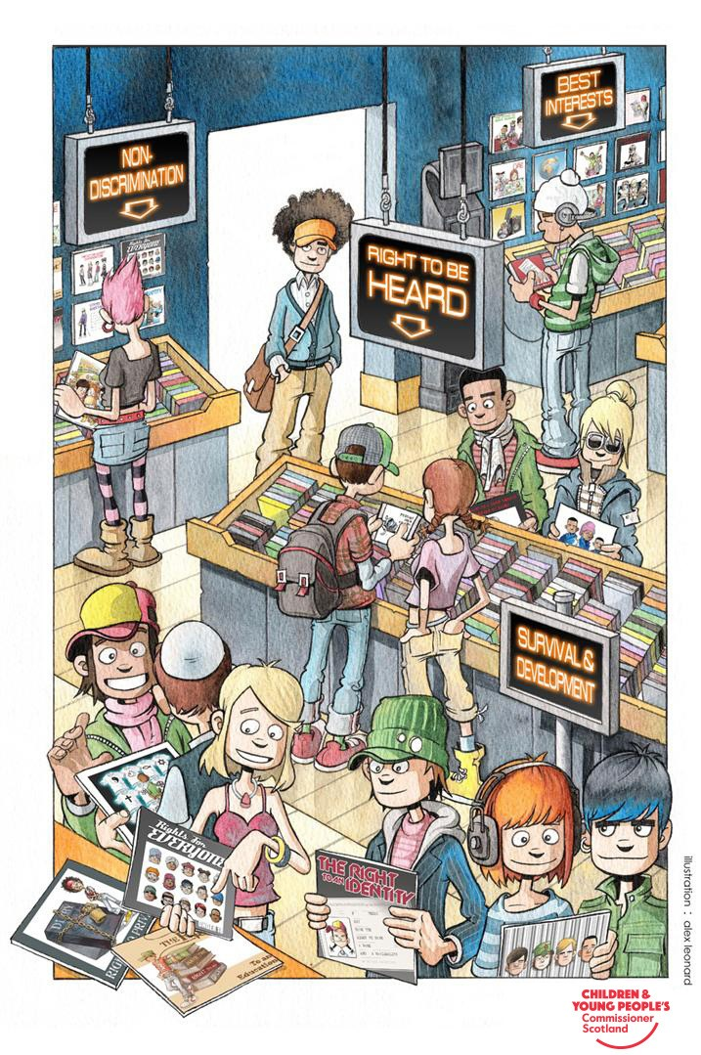
Plan

Clackmannanshire Children & Young Person GIRFEC Integrated Assessment & Care Plan

Section 1 – Core Information

Fields marked with an asterisk (*) are mandatory.
Meeting details
Type* | Date | Time | Venue
Choose an item.

Personal details

Forename* | Surname* | Known as

Gender* | Date of Birth/  Estimated date of delivery* | Place of Birth | Client I.D Number
Choose an item.

Home Address* | Contact telephone number(s)*
 | Home:
 | Mobile:
 | Work:

*** !! Non-Disclosure Request!! *** Report writers are responsible for making a non-disclosure request using the form which the reporter provides with the report request. If no non-disclosure request is made, the reporter will presume that providing the document or information in full to those entitled to receive it, will not be likely to cause significant harm to the child***. COMPLETE THE SCRA FORM IF YOU BELIEVE THE THRESHOLD FOR NON-DISCLOSURE IS MET. This is the Lead Professional’s (report writers) responsibility.

School / Early Learning Centre / Child Care

Additional support plan | Choose an item.

Current Placement* | Choose an item.
Is the address subject to a ’non-disclosure order’ ? | Choose an item.
Placement / Person Caring details* | Placement telephone number(s)*
 | Home:
 | Mobile:
 | Work:

Personal Details

Child Protection Register Dates*

Main Language* | Choose an item.
 | If ‘other’, please specify:
 | Interpreter Needed ? | Choose an item.
 | Translation requirements | Choose an item.

Religion* | Choose an item.
Ethnicity* | Choose an item.
Disability* | Choose an item. Choose an item.
Young Carer* | Choose an item.
 | If ‘Yes’, details of person cared for:
Legal Status* | Choose an item.
 | Please specify any conditions
Immigration status  (Please mark with ‘X’) | Not Applicable ☐
 | Child of a person with no resource to public funds ☐
 | Unaccompanied asylum-seeking child ☐
 | Home Office Identity Number:
 | Port Reference Number:
 | Documentation:

Parent’s Details*

 | Mother |  | Father
Forename
Surname
Birth surname (if different)
Other names (if any)
Date of Birth
Client ID No (if applicable)
Parental Responsibility – if ‘some’ please add details | Choose an item. |  | Choose an item.
Address (if different to child’s address)
Telephone
Main Language | Choose an item. |  | Choose an item.
 | If ‘Other’,  specify |  | If ‘Other’,  specify
 | Interpreter needed ? | Choose an item. | Interpreter needed ? | Choose an item.

Other Significant Children*

Also Referred | Relationship | Forename | Surname
 | Choose an item.
Gender | Ethnicity | Language | Date of Birth
Choose an item. | Choose an item.
Address (if different)
CFIS ID

Also Referred | Relationship | Forename | Surname
 | Choose an item.
Gender | Ethnicity | Language | Date of Birth
Choose an item. | Choose an item.
Address (if different)
CFIS ID

Also Referred | Relationship | Forename | Surname
 | Choose an item.
Gender | Ethnicity | Language | Date of Birth
Choose an item. | Choose an item.
Address (if different)
CFIS ID

Also Referred | Relationship | Forename | Surname
 | Choose an item.
Gender | Ethnicity | Language | Date of Birth
Choose an item. | Choose an item.
Address (if different)
CFIS ID

Also Referred | Relationship | Forename | Surname
 | Choose an item.
Gender | Ethnicity | Language | Date of Birth
Choose an item. | Choose an item.
Address (if different)
CFIS ID

Also Referred | Relationship | Forename | Surname
 | Choose an item.
Gender | Ethnicity | Language | Date of Birth
Choose an item. | Choose an item.
Address (if different)
CFIS ID

Other Significant Adults (including Kinship Carer, Foster Carer)*

Relationship |  | Forename | Surname
Choose an item.
Gender | Ethnicity | Language | Date of Birth
Choose an item. | Choose an item.
Address (if different)
Tel No.

Relationship |  | Forename | Surname
Choose an item.
Gender | Ethnicity | Language | Date of Birth
Choose an item. | Choose an item.
Address (if different)
Tel No.

Professionals / Agencies involved (including Named Person)*

Role / Agency |  | Child/Adult concerned | Name of Professional
Address
Tel No.

Role / Agency |  | Child/Adult concerned | Name of Professional
Address
Tel No.

Role / Agency |  | Child/Adult concerned | Name of Professional
Address
Tel No.

Family Background & History

Section 2 – Overview & Summary of Assessment

Purpose of Assessment

Sources used in assessment (tick all that apply)
Information provided by the child / young person ☐ Observations of baby / infant ☐
Information provided by parent(s) ☐
Observations of the parent(s) ☐
Information provided by family ☐
Information provided by carers ☐
Information shared by multi-agency partners ☐
Information from social work & multi-agency records ☐
Other ☐

Has this assessment been shared with the child / young person and their parent(s) / carer(s)*]

Has the child / young person been prepared for the meeting*

Have the parent(s) / carer(s) been prepared for the meeting*
see section 6

Analysis & summary of strengths needs and risk overview.

Progress summary and evaluation of child’s / young person’s plan.

Section 3 – Chronology of Significant Events

Personal Details

Forename* | Surname* | DOB/EDD | Client ID Number

(PLEASE ENSURE THAT THE ALERT LEVEL STATUS (R /A/ G) IS COMPLETED FOR EACH ENTRY)

Date | Source | Significant Event | Age | Impact | Action | Alert  Level

Visual Alert Codes:

Green – denoting visual pattern of positive & promising behaviours, attitudes & actions that could be
beneficial and promote positive outcomes for the child’s wellbeing. G

Amber – denoting emergent new and moderate risks incidents, behaviours, attitudes and actions that could be moderately detrimental to the child’s wellbeing particularly if pattern emerges. A

Red – denoting a high risk incident(s), behaviours, attitudes & actions that could be seriously detrimental to the child’s wellbeing. R

Section 4 – Assessment of Development & Wellbeing

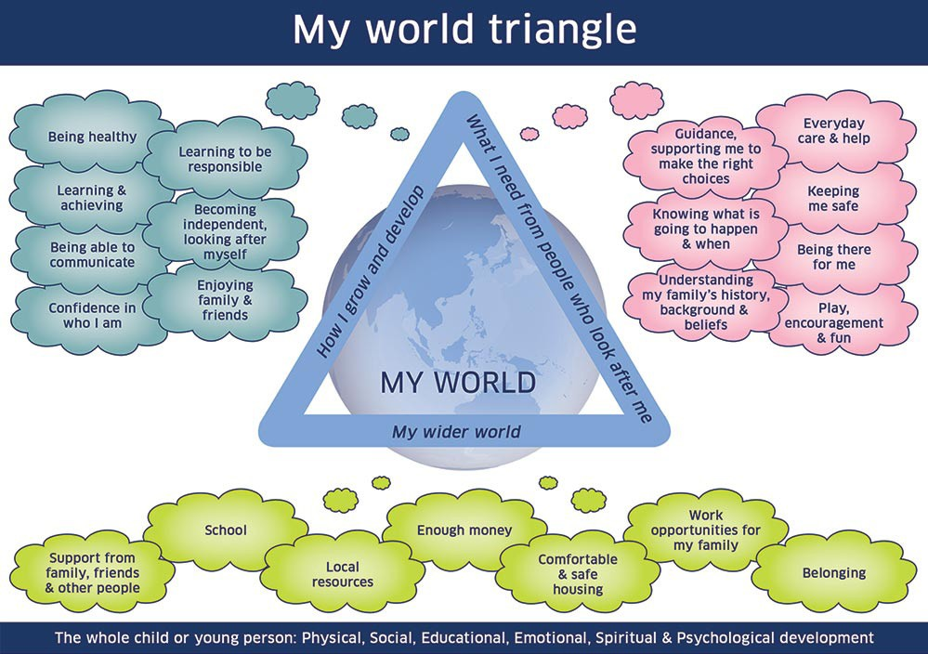
How well is the child / young person growing and developing ?

What does the child / young person need from the people who look after them ?

Detail any current / proposed contact arrangements and the impact of this on the child / young person? This must also include sibling contact. The views of the child regarding contact must also be clearly stated in this section.

What does the child / young person need from the wider environment ?

Section 5 – Risk Protection & Resilience

Resilience / Vulnerability Matrix

Resilient Child  High adversity | Resilience | Resilient Child  Protective  Environment
 | Good attachment, Good self esteem, Sociability, Intelligences, Flexible temperament, Problem solving skills, Positive parenting
Adversity |  | Protective Environment
Live events / crises, serious illness, loss / bereavement, Separation / Family breakdown, Domestic violence, Asylum seeking status, Serious \ parental difficulties - e.g. substance misuse, Parental mental illness, Poverty |  | Good school experience, One supportive adult, Special help with behavioral problems, Community networks, Leisure activities, Talents and interests
Vulnerable Child  High adversity | Vulnerability | Vulnerable Child  Protective  Environment
 | Poor attachment, Minority status, Young age, Disability, History of abuse, Innate characteristics in child / challenge development, A loner / isolation, Institutional care, Early childhood trauma, Communication differences, inconsistent, neglectful care
Variables  Timing and age, Multiple adversities, Cuculative protectors, Pathways, Turning points, A sense of belonging |  | Interventions  Strengthen protective factors and resilience, Reduce problems and address vulnerability, Achieve initial small improvements

What are the risks posed by the child / young person to themselves?

What are the risks posed by the child / young person to others?

What factors make the child / young person particularly vulnerable to risk?

What protective factors and strengths would increase the child’s / young person’s resilience and reduce adversity (what is working well)?

Section 6 – Participation, Rights & Views

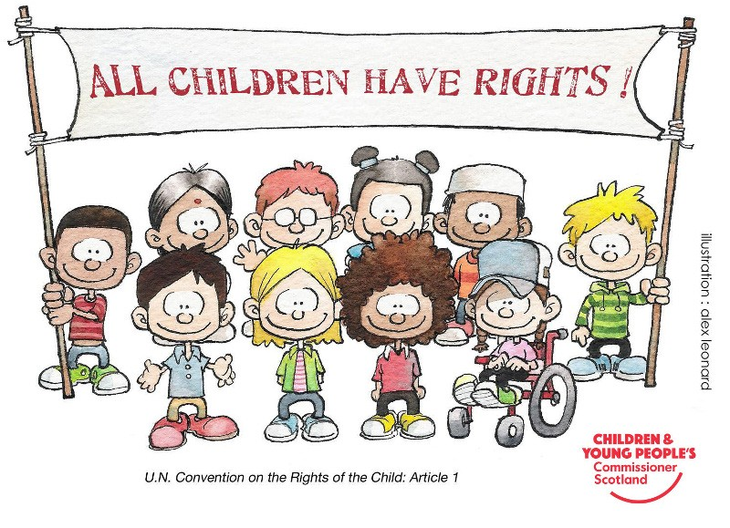

What are the child’s / young person’s views about their circumstances and wishes for the future? How were the child’s views captured? E.g. 3 houses ( include disagreement with any aspect of this assessment /plan). Is there an Advocacy Support Person who has promoted the child’s participation?

What are the parent’s / carer’s views about their circumstances and wishes for the future ? (Include disagreement with any aspect of this assessment & plan) ?

Prehearing panel request to be excused

Team around the child’s views. Is there agreement or disagreement regarding the care plan and recommendation? How has this been resolved?

Section 7 – Summary, Conclusions & Recommendations

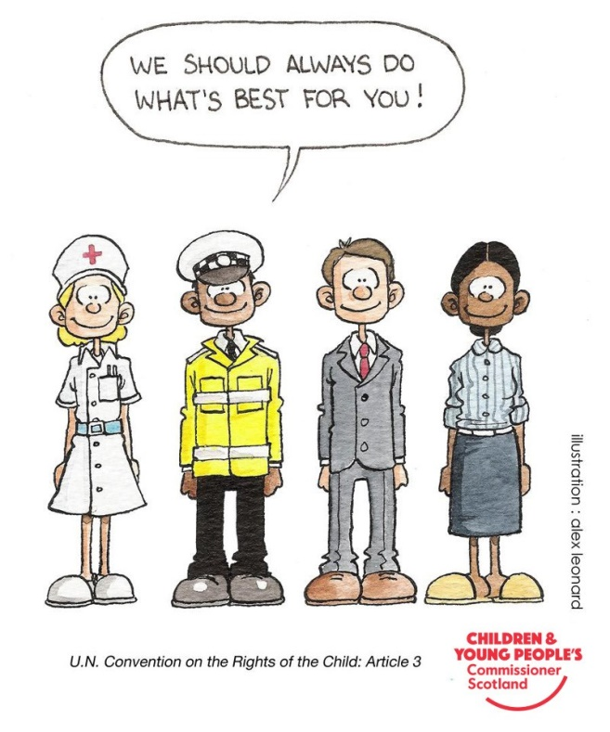

Summary
Summary & analysis of Strengths, Chronology, Needs, Risks and Views. Evaluation of early help and previous multi-agency interventions including Child & Adult Services. What difference did it make to the wellbeing of the child? What is the assessment of capacity for change?

Recommendations
Recommendations. Must flow from the assessment. (No new information should be introduced in this final section.

Section 7 (ii) Children’s Hearing (Scotland) Act 2011 – Compliance with Rule 80 Information for Children’s Hearings – Carer Information. *This information is mandatory and must be completed if there is a proposed placement with an alternative carer*
Name and Address of Carers:

Rule 80(a)(i) – Identified needs of the child

Rule 80(a)(ii) – Statement of suitability of place (s) to meet the child / young person

Rule 80(a)(iii) – Statement of suitability of the person who is to have “charge” or “control” of the child / young person to meet their needs.

Rule 80(b) – The Local Authority confirms that they have carried out the procedures and gathered the information described in Regulation 3 and 4 of the Looked After Children (Scotland) Regulations 2009.

Name of Lead Professional*
Job Title*
Agency*
Contact details – Address
Telephone Number*
E-mail Address*
Date*

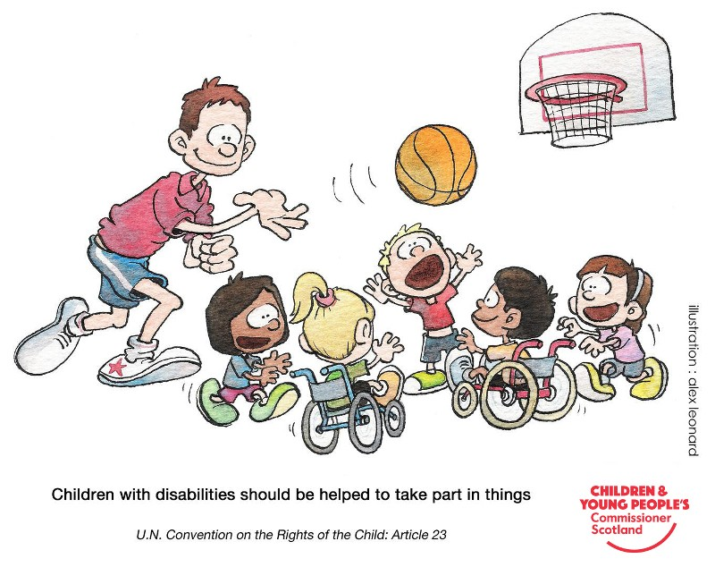
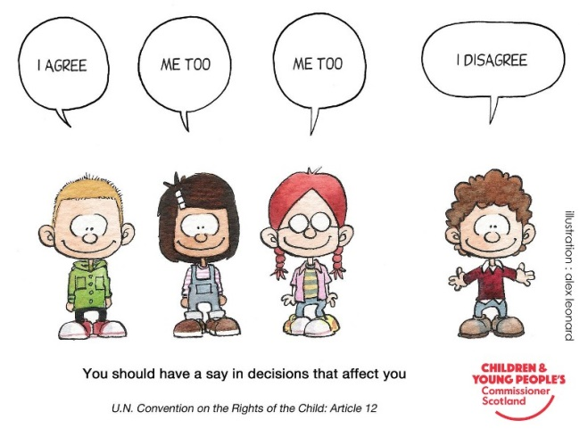
Child’s Wellbeing Plan
Child/Young Person’s Forename | Child/Young Person’s Surname |  | DOB/EDD
Child’s Young Persons Legal status | Choose an item.
Any Conditions:

Current Placement | Meeting Type
Choose an item. | Choose an item.
Date of Meeting | If review, date plan effective from | Venue

Plan Partners

Role / Relationship | Child / Adult Concerned | Name of Professional
Address
Tel. No.

Role / Relationship | Child / Adult Concerned | Name of Professional
Address
Tel. No.

What is the immediate plan for the child’s / young person’s wellbeing?

What is the longer term desired outcome for the child / young person?

Action

SAFE
Need / Risk | Desired Outcome | Action
What resources are required? | Who is responsible for this action? | By When?

HEALTHY
Need / Risk | Desired Outcome | Action
What resources are required? | Who is responsible for this action? | By When?

ACHIEVING
Need / Risk | Desired Outcome | Action
What resources are required? | Who is responsible for this action? | By When?

NURTURED
Need / Risk | Desired Outcome | Action
What resources are required? | Who is responsible for this action? | By When?

ACTIVE
Need / Risk | Desired Outcome | Action
What resources are required? | Who is responsible for this action? | By When?

RESPECTED
Need / Risk | Desired Outcome | Action
What resources are required? | Who is responsible for this action? | By When?

RESPONSIBLE
Need / Risk | Desired Outcome | Action
What resources are required? | Who is responsible for this action? | By When?

INCLUDED
Need / Risk | Desired Outcome | Action
What resources are required? | Who is responsible for this action? | By When?

Contingency

What action will be taken if outcomes or agreements are not reached within specified timescales or if there are increased concerns for the safety, care or wellbeing of the child / young person?

Monitoring and Reviewing of the Child / Young Person’s Plan

What arrangements are in place for monitoring and reviewing the Child / Young Person’s Wellbeing Plan?

What is the Child / Young Person’s View of their Plan?

What is the Parent / Carer’s View of the Child’s Plan?

Next Review Date

Date
Time
Venue

Lead Professional

Signature
Name
Job Title
Agency*
E-mail Address
Address
Tel. No*
Date

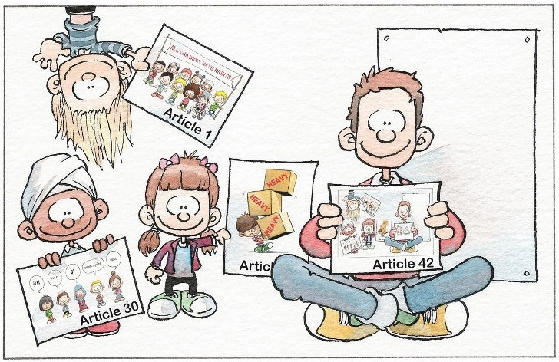

EVERYONE should know about the Convention on the Rights of the Child

U.N. Convention on the Rights of the Child: Article 42

