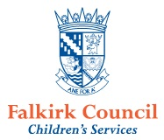
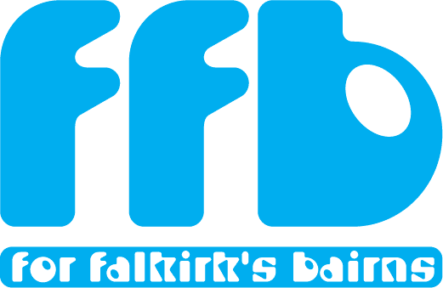
RCS: What next?

Falkirk schools took part in the Re-aligning Services Programme with Scottish Government in 2016/7. 4,147 primary school pupils from P4 – P7, and 4,448 secondary pupils from S1 – S4 took part.
The following publications about the findings have been produced:
- Health and Wellbeing among children and young people in Falkirk: Findings from the RCS wellbeing survey programme (full report – 140 pages).
- Key themes from the Realigning Children’s Services Wellbeing Surveys in Falkirk. (summary Report – 11 pages).
- Health and Wellbeing amongst P4-P7 pupils cluster primaries (each cluster has an individual report based on primary findings).
- Health and Wellbeing amongst S1 – S4 Pupils in High Schools (each school has an individual report).
Excel overviews have also been produced for the key themes in the reports.
So you have your data – what next?
- Identify your improvement theme what does the data tell you are the areas you need to focus on? Once you have interpreted the data you can identify your improvement areas. Using the model for improvement you can identify changes you think will lead to improvement and measure if your changes are working. The Falkirk Children and Young People Improvement Collaborative will be holding information sessions on the model for improvement and drop in sessions for people looking for some help with their change ideas.
Example: in Grangemouth Cluster there will be a focus on the theme of ‘place and wellbeing’. This will focus on young people and their responses about their community
- Who should be involved?
Who do you need to be involved in your improvement work? Who will lead?
Example: for the improvement project on ‘place and wellbeing’ young people will be joined by partners who may include; East Locality community planning partners, CLD, local businesses, Falkirk Community Trust, Friends of Zetland Park, Active Schools, Skills Development Scotland and any other partners who want to/ should be involved as the plan develops.
- Get people together.
Brainstorm Bring young people and partners together in a workshop to share the findings from RCS and any other relevant data.
Ask the group to look at the data and think about what that really means for them.
You could develop a driver diagram – what are the main things that have an impact on your improvement theme?
Use the Model for Improvement
Identify what the main improvement priorities are. Use the model for improvement tools on the practitioner pages.
Develop an aim. What are you going to do, by how much, by when and with what group of people?
Do we need to find out more information about some of our improvement ideas? Do we need more data? If so, allocate tasks to people.
How do I know my change is an improvement?
Get the group to think about the improvement ideas they have chosen and think about what ideas they have that could make things better.
Use the 3 questions and the Plan Do Study Act (PDSA) template.
Use the Test of Change Template
- Use the supports available via Children’s Services, RCS and CYPIC (Children’s Commission Group).
- RCS Steering Group
- Drop Ins to help you with your change ideas
- Introduction to the model for improvement
- National courses on using the model in certain projects you have.
- For support with improvement ideas contact;
Gayle Martin gayle.martin@falkirk.gov.uk
Jude Breslin jude.breslin@falkirk.gov.uk
Wendy Toner Wendy.Toner@gov.scot

