  - Student/team members’ names

  - Project title
  - Mentor name
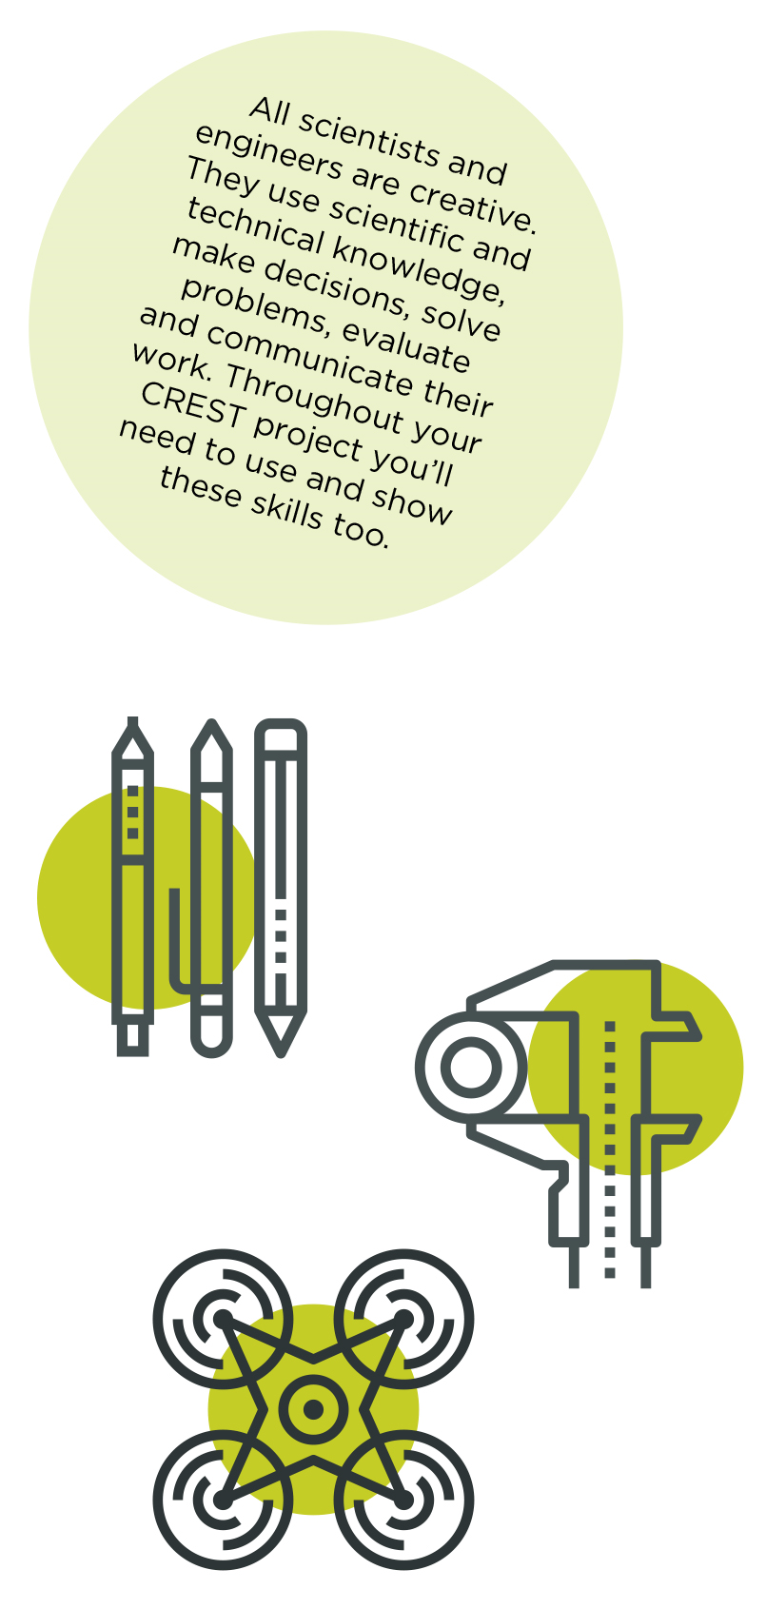
Before you start: Check the CREST Silver Award student guide for all the guidance and information you’ll need to complete your CREST Award.

During the project: Use the checklist on the next page to make sure your project is on track.

Completing your project: To complete your project, you should upload the following documents:
- A project report
- This student profile
- If you’re doing a team project, each team member should have a separate student profile.) Groups that have done separate project work should submit separately, so that each project is assessed on its own merits.

  - Tips for your project report:
- Use pictures, graphs, diagrams or photos to help explain things
- Include where you found the information for your background research
- Use the checklist on the next page to make sure you include everything you need to achieve your CREST Silver Award
- Number the pages in your report
- Do not upload documents or images that could be used to identify yourself e.g. photos of you or your classmates, personal contact details etc.

CREST Silver Award checklist
 | Where do you show this in your report or project record? | Your notes to the assessor (optional)

1 – Planning your project
Set a clear aim and break it down into smaller steps/objectives | Example: Page 2, paragraph 5
Explain the wider purpose of your project
Consider different ways to do your project
Describe your plan for how to complete your project and give reasons for the approach you chose
Explain how you planned your time and organised who would do what

2 – Throughout your project
Say who and what materials you needed to help you complete your project
Summarise the background research you did to help you understand your project and where you found the information

3 – Finalising your project
Make logical conclusions and explain the implications for the wider world
Describe how what you did affected the outcome of your project
Explain what you learned and how you would change your project if you did it again

4- Project-wide criteria
Show understanding of the science behind your project
Describe how you made sensible decisions about your project. Consider safety and risks
Show creativity in the way you carried out your project
Explain how you identified and overcame problems
Explain your project clearly in writing and/or conversation.

Personal reflections
Now that you’ve finished your project, use this space to add further thoughts on what you did and evaluate each stage of the project process. The CREST Silver Award student guide gives an example of what to include. You can continue on a separate sheet if necessary and use diagrams or pictures if you want to.
- How my project was successful/not successful
- What I learned
- What impact the results of my project might have on other people/the wider world
- What I would have done to improve my work
- What I’d do to develop the project in the future

My mentor
What role did your mentor have in your project?
Ask your mentor to confirm that this project is your work by signing below.
  - Signature of mentor
  - Date

  - Space for further notes/ drawings/ reflections (optional)...

