**Negotiating activity in groups**

Reflect on and discuss the choices you have made.

Allow each person time to speak by themselves without interruption and then as a group negotiate what your top 3 choices are, **important, very important or critical**

Place each criteria inside the rectangle –

* Critical to meeting the needs of each student.
* Middle rectangle if it is very important to meet the needs of each student.
* Outside if it is important to meet the needs of each student

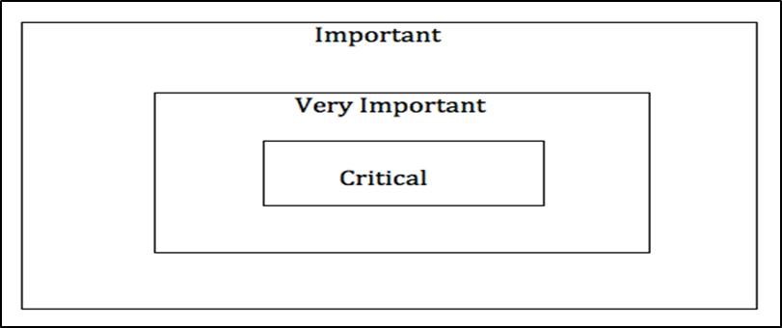

**Identify a spokesperson to share your group thoughts**