

Community Learning and Development (CLD): A professional learning analysis

September 2026

Contents
Community Learning and Development (CLD): A professional learning analysis 1
Contents 2
Introduction 3
Context 3
Existing professional learning offer 4
Education Scotland 4
Other organisations 5
Stakeholder Engagement feedback 6
CLD plans 7
Evidence from HMIE 8
Professional learning networks 9
South East and Central 9
Tayside and Fife 9
South West 10
North 11
West 11
CLD Workforce Survey 12
CLD Independent Review 13
Research on effective professional learning approaches 14
Summary and conclusion 14

Introduction
Education Scotland’s role is changing. Going forward the organisation will have a focus on curriculum and professional learning. In late 2024, a paper was presented to Education Scotland’s (ES) leadership team giving an overview of the context for our Education Scotland’s CLD officers’ support to the sector. A recommendation from that paper was to initiate an exploratory phase of work to develop ES’s potential role within the recommendations from the independent review of CLD, and within the refocussed work of ES.
To support this proposal, we undertook an appraisal of the current evidence on professional learning in Scotland, to assimilate the available data and draw out common themes. As part of that we want to reflect on the current Education Scotland CLD professional learning offer, drawing on evaluation data we hold, and engagement work we have carried out.

Context
Community Learning and Development is a sector at a crossroads. An independent review of CLD was carried out in 2024 with clear recommendations for Scottish Government, the CLD Standards Council (CLDSC) and others. At the same time HMI carried out progress visits in all 32 local authorities, resulting in a national report and local authorities published their most recent statutory CLD plans (2024 – 2027). All of this is situated in the context of ongoing education reform, and wider public service reform.
Evidence sources for this report include stakeholder engagement undertaken by Education Scotland; local authority CLD plans; HMIE progress reports; and findings from the independent review of CLD. It also draws on research carried out regularly by five regional professional learning networks across Scotland and a recent workforce survey undertaken by the CLD Standards Council.
The CLDSC’s Continuing Professional Development Strategy, Growing the Learning Culture in CLD (updated in 2025), sets out this vision:
‘We will nurture a culture of learning in our sector in order that individual engagement will contribute to the development of the whole profession; we will celebrate learning, relish challenge, and reflect critically on our practice. Our vision for all CLD practitioners is that their participation in continuous professional development activities will be a central and established part of their practice. Through this they will demonstrate and enhance their commitment to a culture of learning.’
Alongside this, the CLDSC has reviewed and developed a range of National Occupational Standards (NOS) relevant to CLD practice, including Adult Learning, Career Development, Community Development, Family Learning, Learning and Development, and Youth Work.
These specify the standards of performance required in the workplace, together with the knowledge and understanding required for roles, for most employment sectors. National Occupational Standards can be used to complement the CLD Competences in reflecting on, developing and strengthening practice.
Education Scotland and partners have also developed a national model of professional learning which is highly relevant to the CLD sector, providing a shared language and aspiration for meeting learners’ needs.

Existing professional learning offer

Education Scotland
Education Scotland’s CLD officers deliver a range of professional learning opportunities to the CLD sector, both online and face-to-face. Topics include:
- UNCRC and rights-based practice in CLD
- Racial literacy
- Self-Evaluation for Continuous Improvement (SECI)
- Community needs analysis
- Youth voice
Some programmes are delivered regularly, such as, UNCRC and rights-based practice in CLD, while others are provided on request from the sector. In 2025, the SECI programme was delivered using different models with five local authorities identified through CLD HMIE progress visits.
In 2025, 302 practitioners and leaders from seven local authorities, took part in SECI or Community Needs Analysis sessions. Evaluation findings indicate that participants found these sessions informative and engaging, particularly valuing opportunities for reflection and professional dialogue.
By mid-November 2025, a further 987 practitioners and leaders had engaged in professional learning opportunities delivered by CLD officers. This included sessions on stakeholder engagement, UNCRC, Challenge Poverty Week, youth voice, improving racial literacy and youth work partnerships.
CLD officers also co-ordinate national practitioner and leader networks, including Adult Literacy, ESOL, Digital, STEM, Numeracy and Learning for Sustainability. These networks support professional learning through knowledge sharing, reflection on practice and skills development. As of November 2025, 346 practitioners and leaders attended network events. Feedback from network participants highlighted the value of these sessions in providing updates, insights and opportunities to share practice,
Since 2020, work has been undertaken to improve CLD practitioners and leaders’ access to Education Scotland’s wider professional learning offer. These opportunities have been made more accessible by working to remove barriers such as needing a GLOW account to register on the website and working with colleagues to ensure content and language are relevant to CLD contexts. Professional Learning Activities (PLA’s) are now mapped to the CLD Standards alongside those of the General Teaching Council for Scotland (GTCS) and Scottish Social Services Council (SSSC). In 2026, 7 new PLA’s have been developed specifically for the CLD sector, including New Scots, Anti-Racism and STEM for CLD.
In response to a gap in the system for CLD leaders Education Scotland developed the Leading CLD programme, which ran between 2022 and 2024 involving a total of 55 participants from 26 local authorities, the third sector and further education. Evaluation findings from the programme subsequently led to a more flexible approach, focusing on PLA’s and greater promotion of existing Education Scotland leadership learning opportunities.
Education Scotland now shares relevant CLD professional learning opportunities on a landing page within the professional learning area of its website. Since late 2024, this content has been shared and promoted through ES’s sector networks, the CLDSC and CLD Managers Scotland.

Other organisations
A range of national organisations also provide professional learning and support to the CLD sector across the three main practice areas. (It's important to caveat that this list will not be exhaustive of all CLD-focused PL available).

Adult Learning
- Learning Link Scotland offers support and training to their members working in third sector adult learning organisations.

Youth Work
- Youth Scotland provides a wide range of professional learning and training for youth workers, volunteers and leaders.
- YouthLink Scotland offers training, resources, networks and guidance on a range of areas of youth work practice.

Community Development
- The Scottish Community Development Centre supports specific programmes and provides extensive resources on their website. It also hosts the Community Health Exchange (CHEX) which supports the Health Issues in the Community programme.

The CLD Standards Council (CLDSC)
- The CLD Standards Council for Scotland offer a range of opportunities that contribute to personal development: networks and members meet-ups across a variety of subjects.
- The CLDSC support five regional professional learning networks that co-ordinate and facilitate professional learning for practitioners.

Stakeholder Engagement feedback
CLD Officers facilitated five stakeholder engagement sessions in March and April 2025. Senior CLD leads in local authorities, national CLD organisations and a range of other stakeholders including universities delivering CLD professional courses were targeted by invitation. In total ninety-six senior CLD stakeholders, including representatives from twenty-seven local authorities and nine national CLD organisations, participated across three in-person and two online sessions.
A discussion paper was developed which sets out this exploratory work and the findings.
As part of the engagement the following question was posed:
How should a refocused Education Scotland use its curriculum improvement and professional learning (PL) roles to support community learning and development and the aims of the CLD Review?
And more specifically:
How should Education Scotland’s professional learning (PL) role support a CLD improvement cycle?
In summary:
- While the current PL offer is valued, a key theme across responses was the lack of clarity around ES’s current role in supporting CLD, with stakeholders expressing a need for better visibility, coherence and alignment with sector needs
- There was a call for ES to better align its PL offer with inspection findings and identified practitioner needs across Scotland
- Many stakeholders saw ES as having an important role as a connector i.e. bringing together practitioners across disciplines and sectors to share effective practice, build collective understanding and create joint solutions.
- There were also frequent calls to address barriers like geography, time and digital access to ES PL.
- Participants requested that any new or revised frameworks come with professional learning to support implementation.
- Additionally, participants requested that targeted professional learning is offered to support CLD practitioners in contributing to curriculum design and implementation.​
Stakeholders were also asked:
Looking ahead (e.g. to 2030) what are the top challenges and opportunities likely to be for CLD learners and groups?
The areas highlighted in response to this question give some insight into where practitioners may require upskilling in terms of professional learning.
Challenges highlighted were:
- Poverty/cost-of-living crisis
- Mental health and wellbeing
- Societal changes and demographic shifts
- Climate change
- Digital/AI
- Declining community cohesion
- Leadership, funding and sustainability of CLD.
The opportunities highlighted were:
- Collaboration and partnerships
- Digital tools and AI
- Aligning CLD practice with human rights and sustainability goals
- Alternative learning pathways for young people
- Shift towards more preventative and long-term approaches
- Raising the profile of CLD.

CLD plans
Thirty-one out of the thirty-two Local authority community learning and development plans mention workforce development and/or professional learning to some extent.
Within these plans, around half detail the priorities for the professional development of their staff. The two areas mentioned most by far are digital skills and mental health and wellbeing.
In addition, several other areas are mentioned including, but not limited to:
- CLD pathways
- Working with groups
- Community engagement and development
- Trauma-informed approaches
- Using data to demonstrate impact
- The Promise
- Accreditation for all
- Inclusive communication
- Climate change
- UN Convention on the Rights of the Child (UNCRC).

Evidence from HMIE
HMIE published an Evaluation of community learning and development in Scotland in 2024. This report summarised Inspectors key messages for the CLD sector following a year’s worth of visits to Scotland’s thirty-two local authorities in 2023/24.
Inspectors found that CLD practitioners were generally well supported through high-quality professional learning and increasingly effective workforce development approaches. There were significant inconsistencies in access to qualifications and development opportunities however, creating challenges for workforce recruitment and retention in some areas.
Inspectors found evidence of the positive impact that accredited learning opportunities have on developing practitioners’ knowledge, skills and confidence:
‘CLD staff support youth workers effectively to progress towards a personal development award in youth work. In addition, a few staff are achieving a Scottish Vocational Qualification in community development. Both qualifications are increasing staff knowledge and skills.’
Inspectors highlighted the value of multi-agency professional learning in building workforce capacity and strengthening practice across CLD services and partner organisations. They also highlighted how targeted workforce development can promote more consistent practice and strengthen CLD practitioners’ capacity to respond effectively to key priorities:
‘A well-developed workforce development programme is helping to inform more standardised and improved practice in key work areas. This includes trauma informed practice and employability mentoring support. Health promotion staff deliver training on poverty awareness and sensitivity to partners. As a result, partners have deepened their understanding of poverty and disadvantage.’
Finally, Inspectors found that comprehensive and well-connected professional learning offers were crucial in helping CLD practitioners and leaders to respond effectively to changing needs:
'Council staff, partners and volunteers are supported well with a comprehensive professional learning programme. Council staff take an active role in regional and national networks, which enhances the workforce development offer. Practitioners value highly the professional learning pathways, and a few staff are progressing to undergraduate and post graduate study. As a result, practitioners and leaders have increased capacity to respond and adapt to changing needs.’

Professional learning networks
There are five regional networks across the country who receive grant funding from the CLD Standards Council (CLDSC). Each looks slightly different and spends the money in various ways, for example, on in-person conferences. These groupings are responsible for the co-ordination of professional learning for the regions. Membership includes third sector and higher/further education. The sections below outline the analysis of professional learning needs undertaken by each regional network in recent months.

South East and Central
Network members carried out independent research in late 2024 to achieve a better understanding of CLD workforce development priorities across the nine-member authority areas and to allow the consortium to plan and deliver appropriate and responsive CLD professional learning opportunities.
Top professional learning needs were identified as mental health and wellbeing, using technology, building financial capacity of community organisations, leadership and management, using data and evaluation.
Four of these could be broken down further:
Using technology: Digital competence; social media to promote services; using the most of platforms such as MS Teams and using tools such as Padlet and sway; understanding AI.
Leadership and management: Leading and working in partnership in a challenging funding environment; refresher/ continuing development of leadership and management skills in a CLD context; confidence to describe what CLD is and articulate how it contributes to multi-agency strategies and agendas; practitioners developing leadership skills in a CLD context to prepare for leadership roles.
Using data: Management, gathering and use of; demonstrating impact; data and performance monitoring for service and partnership.
Evaluation: Evaluative writing; self-evaluation; evaluative language; demonstrating impact.

Tayside and Fife
Tayside and Fife carried out a practitioner survey in early 2024 which was followed up with an in-person conference where people were asked, ‘What are your current priority learning needs as a CLD practitioner or volunteer?’ with the following results:
Microsoft365/IT | 19 | Mental health | 19
Evaluation/data/impact | 16 | Community development/capacity building | 10
Digital CLD | 10 | Professional CLD training | 9
Practical tools/skills for group work | 8 | Governance | 7
Literacy and numeracy | 6 | Leadership | 5
Poverty and inequalities | 5 | Operating in political context | 4
CLD values | 4 | Reflective/reflexive practice | 3
Community engagement | 3 | SQA | 2
ESOL | 2 | Family learning | 2
Substance use | 2 | LGBTQi | 2
Working with volunteers | 2 | Employability | 2
Environment | 2 | Place-based CLD | 1

South West
No formal research was carried out by the South West grouping and based on local knowledge and evidence of need service leaders agreed to hold regional conferences on a top shared priority. In 2024 they focused on embedding the UNCRC in CLD practice, and staff health and wellbeing in 2025.

North
Learn North carried out research in the first quarter of 2024 through an online survey with 25 respondents working across all CLD disciplines. As part of this survey respondents were asked, ‘Thinking about yourself as a community learning and development practitioner, what do you think are your top three professional learning needs for the coming year?’
They were also asked to prioritise these. The top professional learning needs can be covered by the following themes:
- Adult learning
- Dealing with change
- Evaluation including self-evaluation
- Parental engagement
- Digital connectivity and use of IT
- Social media and comms
- Practice sharing opportunities
- Project management
- Effective report writing
- Youth voice and participation
- Reflective practice
- Community engagement.

West
The West PL Network (‘West Alliance’) hasn’t gathered any recent data on professional learning needs; however potential priorities were identified by West CLD leads in June 2025. These were:
- Anti-poverty work
- Youth violence
- Gender-based violence
- Family learning
- Digital/social media
- Youth voice
- Youth awards
- UNCRC.
While the regional research approaches varied across the five areas, several common professional learning themes emerged. The themes below were identified in at least two regions.
- Digital (both IT skills and the development of digital learning)
- Self-evaluation
- Use of data
- Mental health
- Youth voice.

CLD Workforce Survey
The 2025–26 CLD Workforce Survey Report 2025-2026 was commissioned by the CLD Standards Council and delivered by Rocket Science. It provides an updated picture of the size, shape and experiences of the CLD workforce in Scotland, including paid practitioners, volunteers, employers and key stakeholders.
The two images below, taken from the survey illustrate the development needs as reported by practitioners and volunteers working in the CLD sector, and as reported by employers.
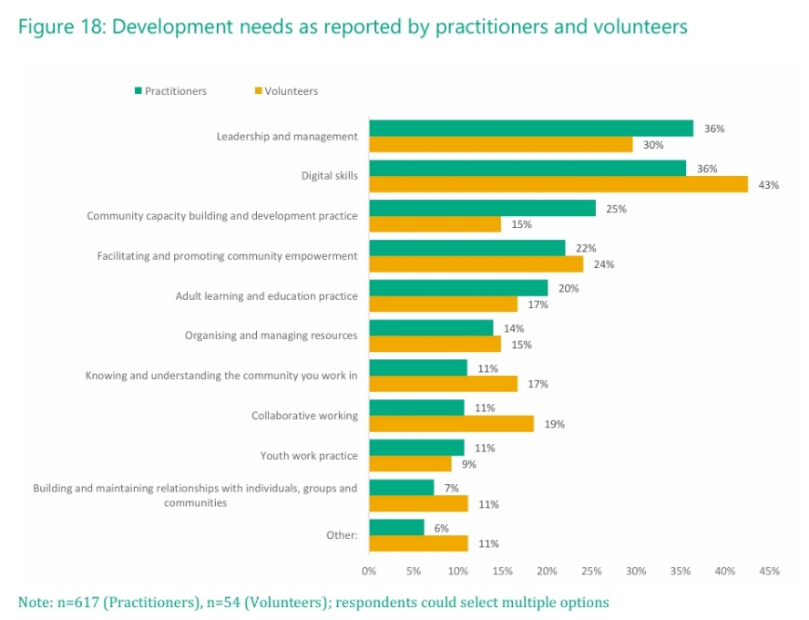
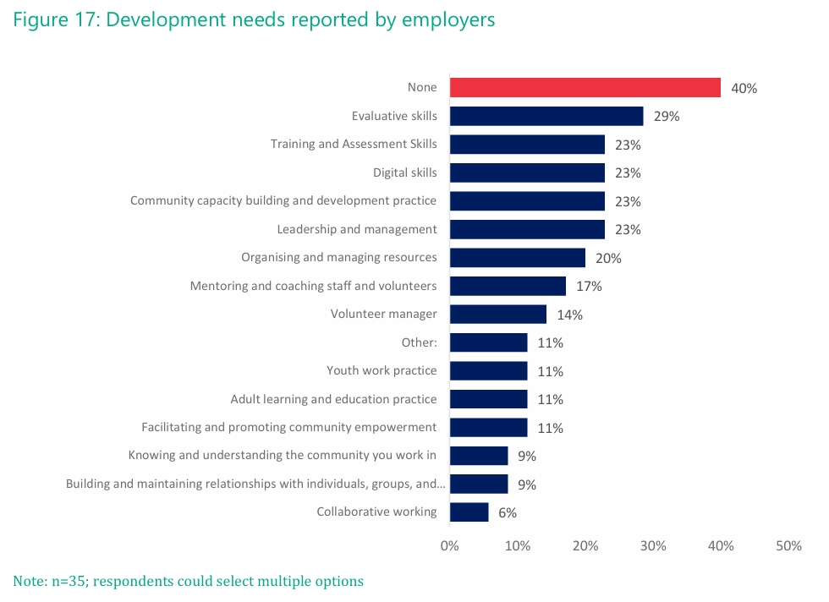
This tells us that the most cited development needs are digital skills (both practitioners and volunteers) and leadership/management (especially practitioners).

CLD Independent Review
Kate Still’s independent review of CLD, Learning: For All. For Life (2024) states that there is:
‘A role for the Standards Council in setting and monitoring minimum Continuous Professional Development (CPD) requirements for CLD professionals and volunteers;’
and
‘… the possibility of mutual learning exchanges being built into CPD requirements for CLD professionals, teachers and social workers.’
While the report does not explore practitioners’ professional learning in detail, it does identify several challenges affecting CLD learners and communities, including:
- Migration and integration
- Poverty
- Cost of living crisis
- Lack of digital skills
- Mental health
- Literacy, numeracy or digital skills.
Many of these overlap with the data available to us that outlines the professional learning needs of CLD practitioners and leaders.

Research on effective professional learning approaches
When designing any professional learning it is important to acknowledge what makes professional learning effective. As part of an active, networked learning community, effective professional learning should give learners the richness that comes from learning with and from others such as colleagues, partners and learners, through dialogue and working together to share experiences and solve problems.
The Three Fields of Knowledge (National College for School Leadership, 2006) can be a useful model for networked learning, bringing together what learners already know, the knowledge from theory, research and best practice, and the new knowledge gained from working collaboratively. This model heavily influenced the development of the Leading CLD programme to ensure participants knowledge and experience was considered.
Andragogy is defined as the art or science of teaching adults, emphasising self-directed and autonomous learning, where the teacher acts as a facilitator. Knowles' five assumptions of adult learners can be useful when exploring adult learning theory and how it differs from pedagogy (child-focused teaching).
Kolb's Learning Styles & Experiential Learning Cycle emphasizes a four-stage learning cycle: Concrete Experience, Reflective Observation, Abstract Conceptualization, and Active Experimentation, along with four distinct learning styles. These are based on how individuals prefer to process information and experiences.
This is all important when designing any professional learning, thinking about the pros and cons of self-directed learning verses face to face and the delivery method. This has been crucial over the last few years, in a post covid world as the majority of Education Scotland’s professional learning has moved online. These theories are also considered when tailoring and targeting professional learning at different audiences, for example strategic managers or a youth worker on the ground.

Summary and conclusion
The evidence set out in this report confirms that professional learning is highly valued across the CLD workforce and remains a key component of professional practice.
The evidence demonstrates a strong degree of consistency across national and local data sources regarding current professional learning priorities for the CLD workforce. The highest priorities are:
- Poverty/cost-of-living crisis
- Mental health and wellbeing
- Digital skills (of both practitioners and learners)
- Data and evaluation.
Other significant professional learning priorities are:
- Climate change
- Leadership
- UNCRC/Youth voice
- Community development/engagement
- Partnerships.
From the stakeholder engagement sessions and discussions with CLD Managers Scotland (CLDMS) it is also clear that as the Curriculum Improvement Cycle evolves and continues, an ongoing focus on professional learning will be important to ensure that the CLD sector remains engaged and supported. The CLD resources Professional Learning – Curriculum Improvement Cycle provide an important foundation for supporting sector understanding and engagement. While Education Scotland CLD Officers continue to connect practitioners to relevant developments and contribute CLD expertise to national discussions, practitioners report that the wider education reform landscape can be complex and difficult to navigate.
Across all the available evidence professional learning and development is valued as integral to high-quality leadership and practice across the CLD workforce. However, evidence also suggests that increasing pressures on the workforce is impacting on capacity to participate. Particularly since the Covid pandemic – professional learning models have increasingly moved to self-directed and online delivery. This may be suitable and beneficial in some situations, but practitioners and leaders continue to place a high value on in-person opportunities to learn collaboratively, share practice and address common challenges. ES CLD officers have established trusted relationships with the sector through our regional links, networks and our existing professional learning offer. Evidence suggests that this link should be maintained as it supports Education Scotland to respond to practitioner need and deliver PL using the method that works best, e.g. face-face versus online.
Taken together, the findings provide a clear evidence base for a refocussed Education Scotland to further develop its CLD professional learning offer. Future provision should focus on the identified priority themes above; supporting CLD engagement with national education reform; and building on the strengths of existing networks and relationships. In doing so, Education Scotland will make a significant contribution to strengthening CLD practice and improving outcomes for learners and communities across Scotland.

