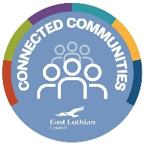

**Wellbeing Web**

|  |  |
| --- | --- |
| **Name** |  |

|  |  |  |
| --- | --- | --- |
| **Date of Completion** | | **Name of Worker** |
| **1** |  |  |
| **2** |  |  |
| **3** |  |  |

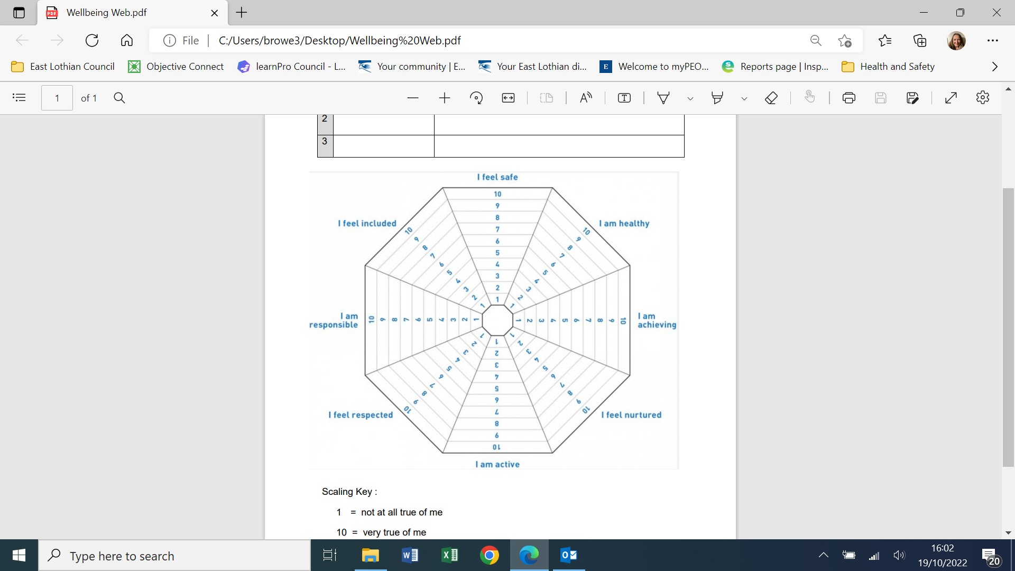

**Scaling Key**

**1 = Not true of me**

**10 = Very true of me**

***Significant acknowledgement to Angus Council for the development of this tool***



**Appendix 1 – Wellbeing Web Notes**

|  |
| --- |
| **Safe** |
| **Healthy** |
| **Achieving** |
| **Nurtured** |
| **Active** |
| **Respected** |
| **Responsible** |
| **Included** |

**Appendix Two Wellbeing Web Action Plan**

|  |  |  |  |  |  |
| --- | --- | --- | --- | --- | --- |
| **Please Tick** |  | **Desired Outcome**  ***What do you want to change?*** | **Priority Actions** | **By Whom?** | **When?** |
|  | **Safe** |  |  |  |  |
|  | **Healthy** |  |  |  |  |
|  | **Achieving** |  |  |  |  |
|  | **Nurtured** |  |  |  |  |
|  | **Active** |  |  |  |  |
|  | **Respected** |  |  |  |  |