- Visualise and speak about a group plan and agree a theme.  - Sketch out the plan onto the canvas using pencil each person can do a individual canvas  - Each person should then Paint / Spray paint onto the canvas before reassembling the canvas |   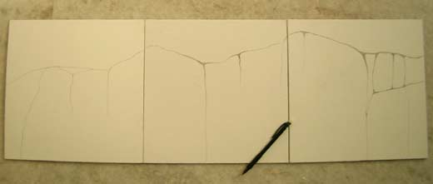  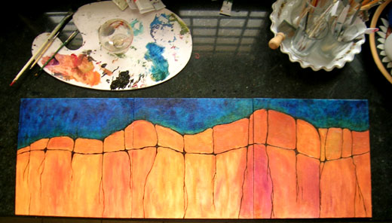

Summer arts 2024 – Garden
Spray/painting – Triptych canvas for croft street HUB
Purpose:
Participation and active leaning is at the centre of the project is designed to allow opportunities for young people to develop and grow by providing opportunities that they may not have access to in the community or educational settings. This can be therapeutic for young people by building,
- Self-confidence /esteem
- Self efficacy
- Group work
- Enabling young peoples voice and dedicated support
Spray/painting – Triptych canvas for croft street HUB
- This could be a banner for inside the building .
- The building itself .
- What our young people feel represent them.
Materials:
- Spray paint.
- Acrylic paints.
- Modge podge / plaster.
- Masking tape.

Examples of Triptych canvas process & step by step instructions:
- Guidance will be given to each person & each step through the process.
This will facilitate group discussion
team work and compromise when planning out and pre
each stage
- each young person will take responsibility for the canvas they work on this will would be inline with the agreed group theme, each person will be responsible for gather and returning materials and supplies.
- Visualise and speak about a group plan and agree a theme. Create frame using wire  - Apply Clay and sculpt, at this stage details would be applied  - Paint and apply clear coat to sculpture | 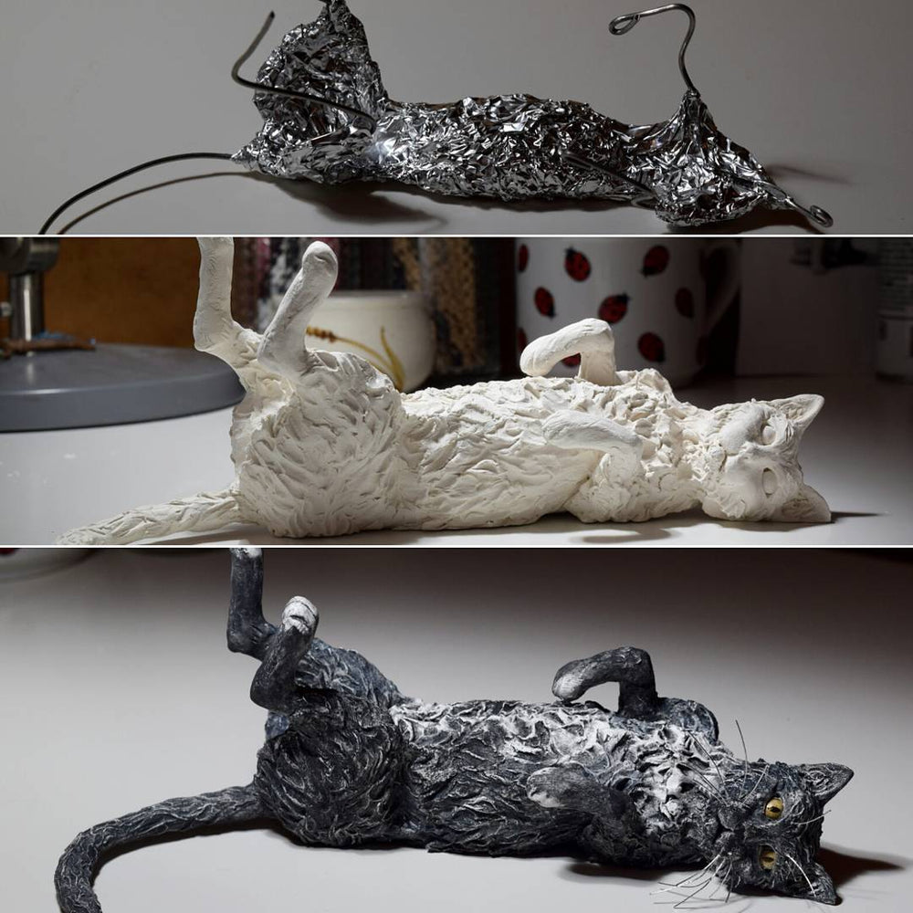
Air Dry Clay sculptures for Garden
Purpose:
Participation and active leaning is at the centre of the project is designed to allow opportunities for young people to develop and grow by providing opportunities that they may not have access to in the community or educational settings. This can be therapeutic for young people by building,
- Self-confidence /esteem
- Self efficacy
- Group work
- Contributing to a shared project / value in local community
Each young person should make a sculpture that represents them or something they value
For example a object or an animal.
Materials:
- Air Dry Clay.
- Acrylic paints.
- Wire mesh, Tinfoil.
- Spray clear gloss varnish.

Examples of Sculpting & step by step instructions:
- Guidance will be given to each person & each step through the process.
This will facilitate group discussion
team work and compromise when planning out and pre
each stage
- each young person will take responsibility for the sculpture they work on, each person will be responsible for gather and returning materials and supplies.

- Group decision about Charles Rennie macintosh and brief history of his work and significant impact on the world.  - Cut windows into wood  - Glue clear and coloured plastics to the wood itself | 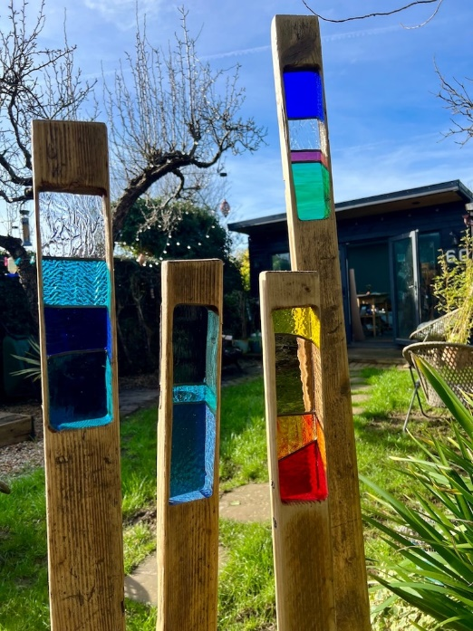
Garden post (Charles Rennie macintosh)

Purpose:
Participation and active leaning is at the centre of the project is designed to allow opportunities for young people to develop and grow by providing opportunities that they may not have access to in the community or educational settings. This can be therapeutic for young people by building,
- Self-confidence /esteem
- Learning about Scottish history
- Group work
- Contributing to a shared project / value in local community
Materials:
- Wooden Plank.
- Plastic sheets.
- Hot glue gun.
- Paint.

Examples of place markers & step by step instructions:
- Guidance will be given to each person & each step through the process.
This will facilitate group discussion
team work and compromise when planning out and pre
each stage
- each young person will take responsibility for the sculpture they work on, each person will be responsible for gather and returning materials and supplies.

- Design a light using Air dry clay or recycled materials such as pots etc.  - Remove solar panel from donor light  - Fix into place  - Reconnect wiring | 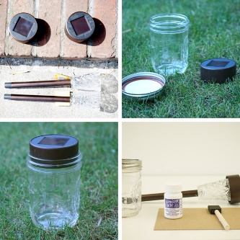
Create own Garden light
Purpose:
Participation and active leaning is at the centre of the project is designed to allow opportunities for young people to develop and grow by providing opportunities that they may not have access to in the community or educational settings. This can be therapeutic for young people by building,
- Self-confidence /esteem
- Self efficacy
- Group work
- Contributing to a shared project / value in local community
Each young person should make a solar powered light for the Garden
Materials:
- Solar powered light
- Acrylic paints.
- Container.

Examples of Light building process & step by step instructions:
- Guidance will be given to each person & each step through the process.
This will facilitate group discussion
team work and compromise when planning out and pre
each stage
- each young person will take responsibility for the sculpture they work on, each person will be responsible for gather and returning materials and supplies.
- recycle or upcycle solar gardens lights then repurpose them into a design that the young person as create
- basic safe wiring no risks from shocks

Photography

Purpose:
Participation and active leaning is at the centre of the project is designed to allow opportunities for young people to develop and grow by providing opportunities that they may not have access to in the community or educational settings. This can be therapeutic for young people by building,
- Self-confidence /esteem
- Self efficacy
- Group work
- Contributing to a shared project / value in local community
- Knowledge of digital media
- Basic introduction to photography principles and portraits
Materials:
- Young person’s phone / camera.

Examples Conversations and instructions:
- Guidance will be given to each person & each step through the process.
This will facilitate group discussion
- This may open up conversations around social media
each stage
- each young person will take responsibility for the sculpture they work on, each person will be responsible for gather and returning materials and supplies.

