Play pedagogy : A guide to Collaborative Practitioner Enquiry 2023-2024
School name: ............................................................

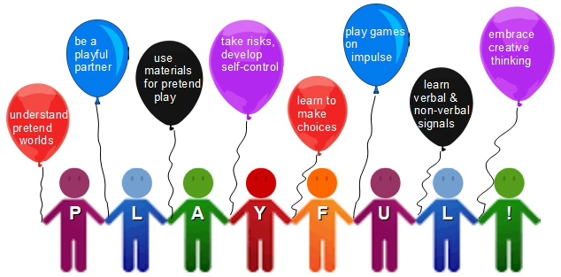
Attributes of playfulness (Inspired by Thomas and Harding, 2011)

Play pedagogy
As part of your preparation for introducing or further developing play pedagogy in your practice, it’s important to ensure you are embarking on something that is realistic and is the best fit for the needs of your school and community.
This document is intended to help you (class teacher(s) and Senior Management Team) begin to jointly plan to introduce or develop play pedagogy, with a focus on joined up working, making feasible/realistic plans, ensuring quality, measuring impact and considering long-term sustainability.
This document is supported by the accompanying Audit Toolkit (2023), which can be used to identify areas for change in and out with the classroom and to measure the changes made over a period of weeks or months.
The introduction or development of play pedagogy can be carried out using the Collaborative Practitioner Enquiry approach or CPE for short.
CPE- What is it?
It is any form of evaluation which uses the following model in a school or nursery setting, which involves at least two people working collaboratively to:
- identify an issue to be addressed
- look at other resources and/or research literature to identify possible reasons and solutions
- identify a strategy to attempt to improve the issue
- evaluate the changes made.
A model of the approach is set out below:

What other names mean the same thing?
You will come across lots of other names for research or evaluative activities that mean, more or less, the same thing. Other expressions used:
- Action research
- Professional inquiry or enquiry*
- Collaborative inquiry or enquiry*
- Teacher research/ classroom based research
- Spirals of enquiry or inquiry*
*Both spellings are used interchangeably in USA. In the UK the word inquiry is more likely to be used in relation to a formal inquest or investigation while enquiry is used to denote the act of questioning- although this is not an absolutely established distinction in terms of dictionary definitions.
CPE can be as simple as noting the outcomes of the discussions between a teacher and SMT, recording any changes made in the classroom or outdoors - no matter how small - and evaluating whether that change has achieved positive outcomes.
By recording (however briefly) this process the practitioner can then use this information to continue to develop their environment and teaching.
Collaborative Practitioner Enquiry therefore is a model of ‘study, plan, do, review’ which is carried out by practitioners within a specific setting. The other core principal underpinning CPE is that it should be carried out collaboratively at each stage of the evaluation process.
In summary CPE is:
- A collaborative process
- which identifies practical changes to be carried out by practitioners
- in a specific context
- and includes an evaluation of what worked and what could be developed further
By sticking to these core principles there is greater likelihood that changes in practice will be introduced that are embedded and sustainable as they will be fully understood by the practitioners responsible for carrying them out.
Following a model like this and adhering to the core principles is in line with the recommendations of the General Teaching Council of Scotland (GTCS):
Teachers engaging in practitioner enquiry offer a number of benefits to the teacher as an individual, the school and wider educational community. This is about promoting a process-led, capacity building, enquiring approach to professional learning and school development. It advocates practitioner enquiry as a key approach to addressing school, local authority and individuals' priorities and aims to improve practice and raise attainment. (Quote from GTCS website)
It is in line with the priority across the authority to develop improvement planning in all schools, which is driven by the key priorities in the National Improvement Framework:
- Improving attainment and achievement
- Closing the attainment gaps
- Improving children and young people’s health and wellbeing
- Improving employability skills and sustained positive school leaver destinations.

The development of play pedagogy should be embodied in the school improvement plan. Schools can develop play pedagogy at their own pace and according to their own specific needs.

This document sets out questions to consider at each stage of the Collaborative Practitioner Enquiry in the form of a series of checklists. The CPE framework can be used as a record of the evaluation of small or large changes, for example from introducing a new resource to the children and monitoring their responses to redesigning the morning timetable or classroom or outdoor environment. Each stage of the process will now be considered in turn.

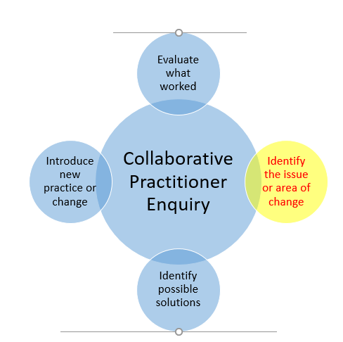
Step 1: Identify the issue or area of change
The people involved in identifying the area of change should always include the class teacher(s) and SMT – however you can consult as widely as you wish and ask the views of parents, children, the wider staff team and even the Pupil and Parent Council.
If you do decide to consult widely e.g. through questionnaires or focus groups, the ideas that are generated can be considered pre-data or a baseline, and a few months down the line you can evaluate the changes made by asking the same people (parents, children, the wider staff team, Pupil Council, Parent Council) about their views on the changes and the impact of these.
The accompanying Audit Toolkit (Play Pedagogy Audit Toolkit 2023) has been created to support each step of the collaborative practitioner enquiry process.
We would advise that the following measure is used before you begin to plan for changes to be made – as this will give you baseline or pre-intervention data which can then be followed up by repeating the measure at stage 4:
- Ferre Laevers’ scales of engagement and wellbeing (training is available on using Ferre Laevers’ scales if required)
For Step 1, the Audit Toolkit can support you to identify an issue or area for change. You can use the audit checklists to identify which area(s) of practice require development in your school (use columns titled ‘extent to which this is already happening’ and ‘level of priority’ to rate current practice) – the priorities can be recorded in the ‘summary of priorities’ table (Audit Toolkit).
Issues or areas of change that you identify might include:
- to better support the nursery-P1 transition
- to improve levels of pupil engagement in literacy or numeracy learning tasks
- to improve levels of pupil wellbeing particularly during transition periods (nursery-P1, Christmas, P1-P2)
- to increase children’s confidence in themselves as independent learners
- to decrease the use of worksheets
- to improve children’s cooperation with each other through play
- to increase the level of child-led play in the school week
- to decrease the amount of ‘settling time’ that is wasted across the school week e.g. settling back to tasks after break and lunch time
- to decrease the amount of ‘carpet time’ when all children are gathered around the teacher at the same time
- to be more flexible with the classroom layout e.g. fewer tables and chairs and more space to play
- to introduce learning ‘zones’ or discrete areas into the classroom
- to create a quieter/calmer space within the classroom to support children who become overstimulated/anxious
- to decrease the level of adult-led learning across the school week
- to challenge the most able learners
- to more effectively support the learners who struggle with the formal classroom setting
- to consider how a play pedagogy approach can support children with additional support needs
- to develop the homework programme by decreasing the amount of worksheets used
- to close the vocabulary gap
- to increase outdoor learning to support literacy or numeracy learning in the natural environment
- to raise attainment in reading, writing or spelling at early level
- to raise attainment in numeracy at early level
The following checklist suggests some questions to consider when you are at this first stage of the CPE. It is not exhaustive and you can add to the checklist as you work with the model.
Step 1 Checklist Questions
Have we consulted everyone who should be involved in the process of identifying the issue or area for change?
- Staff team including support staff?
- Parents/carers?
- Pupils?
- Pupil and Parent Councils?
- Other stakeholders e.g. Early Years Practitioners and link Educational Psychologist?
Are the SMT on board with the Play pedagogy approach?
- Is there support for the approach from SMT?
- Is time set aside for sharing information or carrying out the process of evaluation?
- Do you have all the resources or training you need to continue?
Are there different perspectives about introducing play pedagogy?
- Is there shared understanding of child development and evidence around learning?
- How will you incorporate different perspectives into the process of enquiry?
Are we clear about next steps and who will be involved in the next stage in the process of change?
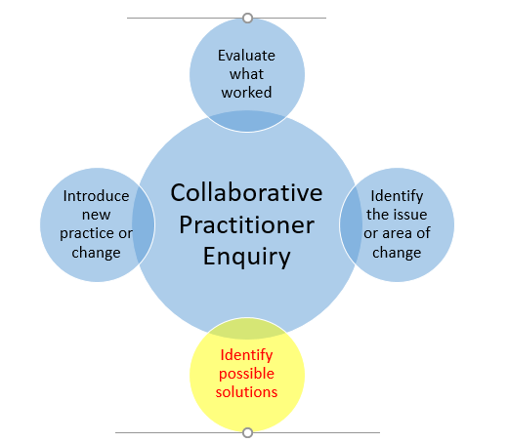
Step 2: Identify possible solutions
At the second stage of the CPE you have already established the issue or area of change (see Step 1 for examples). You are now looking at resources that may offer possible solutions. At this stage you may use a range of resources, e.g.
- Strategies suggested in the accompanying Audit Toolkit
- Messages from child development theory
- Messages from research on play and learning/child development within education settings
- Information gained from CPD
- Visits to schools who have already developed their model of practice
- Academic journals
You can use the audit checklists (Play Pedagogy Audit Toolkit 2023) to identify ideas and strategies and following them up with additional reading.
The important point here is that you are already absolutely clear about what question(s) or issues you want to answer (see Step 1 for examples) and you can identify research or resources that answer those questions or will help with this issue.
Example A: If the issue identified is that several Primary 1 children struggle emotionally each year with the transition from the nursery into the Primary 1 environment, then you could be looking to read research about successfully bringing the Early Years’-style environment into the Primary 1 class to address wellbeing, or visit another Primary 1 class who have had success in this area, and find one or more strategies that you could introduce.
Example B: If Primary 1 homework is an issue for children, parents or teachers in terms of content or pupil motivation, you could read the research on what impact different types of homework/home learning have and identify some changes that you could make.

Research articles can be used both to get ideas about an intervention but also you can look at how the researchers measured outcomes or gathered the views of participants.
There are lots of sources of information. Your GTCS membership entitles you to access about 1,700 online education journals through the EBSCO host:
http://www.gtcs.org.uk/professional-update/research-practitioner-enquiry/research/education-journals.aspx
Other sources include:
The Cochrane Library allows free access to systematic reviews on a range of issues related to health on:
http://www.cochranelibrary.com/cochrane-database-of-systematic-reviews/
Google and Google Scholar can also offer access to a range of free online journal articles.
The key to success at this stage is to make sure you are clear about what question(s) you want answered by the research.
For example, if you wanted to find out how you could improve levels of pupil engagement in learning tasks by using play pedagogy, you could investigate:
- Has another school in EDC already researched or aimed to address the area we are looking at?
- Can we identify interventions/strategies or changes to practice that seem to be effective?
- Does the research we’ve read help us identify the best way to introduce an intervention, how long it will take and how to evaluate the outcomes and impact?
Step 2 Checklist Questions
Are we clear about the question(s) we want answered by the research or resources we have found?
Can we identify a change or changes in practice or a specific intervention or strategy that could be a solution to the issue we want to address from Step 1?
Does the research help us by suggesting ways to measure change? E.g. observations, pre-post measures, asking the views of parents, pupils or practitioners?

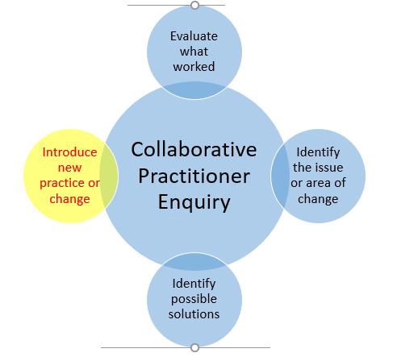
Step 3: Introduce new practice or change
At this stage of the Collaborative Practitioner Enquiry, you are implementing the new practice/strategies or changes that you identified at Step 2 – you have a plan and you are putting it into action.
You need to make sure at this stage that you have a clear plan for implementation. Is everyone clear about what they are doing, when and why? Do parents/carers and pupils know about the imminent changes and what they are trying to achieve?
Is there a clear goal and timeline for the start and end of the evaluation of the change?
Example A: If the change is to introduce nursery-style learning into the Primary 1 classroom to support Early Years’-school transitions, you would want to know what changes you are going to make and what you hope to achieve, make sure you have budget to buy additional resources if required, inform those affected about the nature and purpose of the changes, consider when you are going to make the changes (e.g. before the P1s begin school in August?) and plan how and when you are going to evaluate to the impact of the changes (e.g. parent and child questionnaires/focus groups at the end of the term/the end of the session and observations re: children’s wellbeing and engagement levels).
Example B: If the change is to adapt the homework programme to increase pupil engagement and motivation, presumably you would already have information which has informed the need for change (e.g. parent or child feedback). Before making the changes to the homework programme you would need to inform the parents/carers and pupils of the changes, what you are hoping to achieve by making changes, and ideally share some of the research findings on homework and impact (e.g. by John Hattie) in an information sheet. You would need time to develop the new homework programme and to put it in place. You would want to plan when and how you were going to evaluate the changes made e.g. follow up parent/carer and pupil questionnaires at the end of term/session.

At this stage, in terms of ensuring robust implementation, it can be helpful to consider the following aspects of information sharing to ensure everyone within the school’s community have a shared understanding play pedagogy:
Discussion and planning with SMT: Sharing key messages and negotiating the initial priorities for moving forward.
Whole staff awareness raising: Information sharing with staff team, including admin support and support staff re: the key messages.
Sharing information with children (Primary 1-Primary 7): Letting all of the school’s pupils know that some changes will be happening in Primary 1 and what you hope to come of these changes.
Sharing information with all parents and carers: Sharing the key messages and the school’s plans for taking play pedagogy forward through your usual communication channels – website, newsletter, Parent Council, social media, email, text, See-Saw, Teams etc. Parents/carers of Primary 1 pupils could be invited to an information event to hear in more detail about the plans and how they can get involved.
Pupil Support Group: Request that play pedagogy is included as discussion item on the PSG agenda once per term, thus providing a forum to discuss, plan and evaluate the implementation of the plan with SMT, link educational psychologist etc.
In addition to planning the intervention or change you must also make sure that you have planned how you are going to evaluate the intervention, who is going to do this and when it will take place. You will already have a range of methods of assessments and evaluations that you use to assess children’s progress against the CfE experiences and outcomes and Benchmarks and these would continue to be appropriate and valuable as measures of evaluations of learning.
If you want to use a pre-post measure of, for example, engagement, wellbeing, vocabulary or attainment in literacy or numeracy then you need to be clear about who is going to carry out these measures/assessments both pre and post changes, and what your timescales are. You might want to use the Audit Toolkit as a baseline and then again as a post-measure at the end of your implementation period.
Triangulation
It is best practice to gather enough sources of data to triangulate any findings. For example, if you were looking to measure the impact that your changes have made on closing the vocabulary gap, you could keep a teacher log or reflections on changes and your observations, evidence of benchmarks achieved in talking and listening and a pre-post measure of pupil vocabulary (e.g. the British Picture Vocabulary Scale). If all three offer similar outcomes then the data has been triangulated which strengthens the evaluation.

Checklist for Step 3
Is everyone clear about what intervention/strategies/changes are to take place?
Is everyone clear about their role? Does everyone have the resources/training/information that they need to proceed?
Is everyone clear about when the changes start and finish?
Is everyone clear about how the changes are to be evaluated?
If doing a pre and post evaluation do you have the time set aside and agreed in the plan for collecting data?
If doing a mid-point evaluation (e.g. observations or classroom visits) has time been set aside and have arrangements been made for someone to carry out that evaluation?

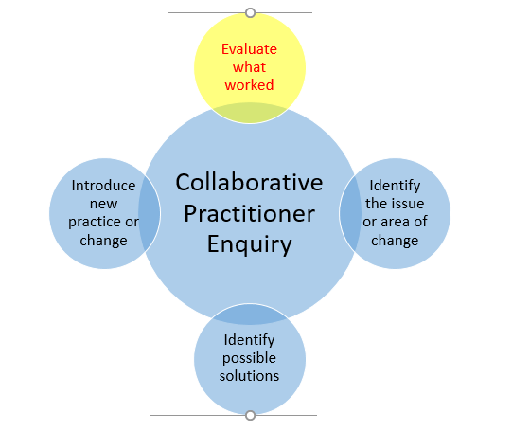
Step 4: evaluate what worked
At this stage in the process the intervention or changes will have been carried out and data gathered and the task now is to evaluate the results.
We would advise that the following measure is used post-intervention:
- Ferre Laevers’ scales of engagement and wellbeing
A measure of whole-class change you can use is the Audit Toolkit (Play Pedagogy Audit Toolkit 2023), which can be used a ‘post’ measure of change by revisiting the checklist headings ‘the extent to which this is happening’ to see if progress has been made in developing areas of practice. This type of evidence can be used to triangulate other forms of evidence.
In addition to information formally gathered, such as pre and post measures, observations, teacher’s logs, planners or information from the CfE benchmarks, there may also be useful information in the minutes of children’s planning meetings or reflective discussions at PSG on the impact on individual pupils.
There are a range of evaluations that can take place at this stage:
- Evaluations of the process itself- how were any changes or strategies planned for, introduced and communicated and what might you do differently next time in the light of your experience? (evidence here might include reflective discussions between those involved).

- Evaluations of the changes - what changed? Were changes made to the learning environment? Were changes made to the resources used to teach? Were changes made to the timetable/structure of the day? Were changes made to the homework programme? Are they sustainable and embedded? (evidence here might include a teacher’s reflective diary, observations, planners, homework diaries or photographs of the learning environment)

- Evaluation of the outcomes of the changes- what difference did it make for pupils and how do we know? (evidence here might include pre and post completion , pre and post measures of wellbeing, engagement or vocabulary, curriculum based assessments (including tracking and attainment against the CfE Early Level Benchmarks), parent/carer or pupil views).
It is very important at this stage to consider how you share your evidence e.g. with your staff team, parents/carers, pupils and the wider community and discuss what you plan to do next: more of the same or repeat the cycle and identify an additional issue or area for change that you want to address.
Checklist for step 4
- Has all the evidence been gathered?
- Is it clear how the evidence gathered should be analysed and presented or do we need support with this e.g. from the school’s link Educational Psychologist?
- Can any conclusions be drawn about the process, changes or outcomes of what we have done?
- Have decisions been made about sharing the evaluations with others? When will this happen? Who will be the target audience and how will this be shared?
In summary the Collaborative Practitioner Enquiry model involves identifying an issue which requires changes, identifying any resources or research that offers possible solutions, carrying out the changes and evaluating the impact. Start small and make your changes achievable!
You can also speak to your school’s link Educational Psychologist about research techniques and ask for support in designing and carrying out a Collaborative Practitioner Enquiry.
It is recognised that there can be challenges and barriers to introducing play pedagogy. Common barriers cited include:

- A practitioner (teacher, SMT or both) being unconvinced that play pedagogy is a more effective method of raising attainment that their current practice.
- The perspective that parents/carers prefer a more ‘traditional’ teaching approach.
- The school practitioner’s view that there are insufficient resources or budget for resources to full embrace play pedagogy.
- The view that the classroom or school environment is not suitable for play pedagogy.
- Staff lacking confidence or perceived lacking in skill to implement play pedagogy.
- An SMT view that the school already has many other priorities in their improvement plan.

It must be emphasised that small changes can make a significant difference to children’s learning and wellbeing.

For additional support and advice please contact:
Anne Dalziel, Quality Improvement Officer (anne.dalziel@eastdunbarton.gov.uk) Kate Spalding, EDC Educational Psychology Service (kate.spalding@eastdunbarton.gov.uk)

References
Bronfenbrenner U. (1986). Ecology of the Family as a Context for Human Development. Research Perspectives Developmental Psychology. 22: 723-742.
Bruner, J. S. (1971). The Relevance of Education, New York: Norton.
Erikson, E. H. (1950). Childhood and society. New York: Norton.
Froebel, F. (1887). The Education of Man. (Translated by Hailmann, W.N.) New York, London, D. Appleton Century.
Ginsburg, K.R. (2007). The importance of play in developing healthy child development and maintaining strong parent-child bonds. Paediatrics. 19(1).
Gray, P. (2011). The Decline of Play and the Rise of Psychopathology in Children and Adolescents. American Journal of Play. Volume 3 (4), p443-463.
Grogan, D., & Martlew, J. (2014). Exploring Creative Environments through the Child’s Lens. Creative Education, 5, 1528-1539.

Hattie, J.A.C. & Yates, G. (2014). Visible Learning and the Science of how we Learn. Routledge, UK.
Hattie, J.A.C. (2009). Visible learning: A synthesis of 800+ meta-analyses on achievement. Oxford, UK: Routledge.
Marcon, R.A. (2002). Moving up the Grades: Relationship between Preschool Model and Later School Success. Early Childhood Research and Practice. Volume 4 (1).
Melhuish, E., Quinn, L., Sylva, K., Sammons, P., Siraj-Blatchford, S. and Taggart, B. (2012). Preschool affects longer term literacy and numeracy: results from a general population longitudinal study in Northern Ireland. School Effectiveness and School Improvement: An International Journal of Research, Policy and Practice. Special Issue: Educational effectiveness approaches in early childhood research across Europe, 24 (2). 234-250.

Moyles, J. (2010). The Excellence of Play. McGraw-Hill Education.

Muir, E., Lojkasek, M., Cohen, N. (1999). Watch, Wait and Wonder: A manual describing a dyadic infant-led approach to problems in infancy and early childhood. Hincks-Dellcrest Institute.

Piaget, J.-P. (1952). The origins of intelligence in children. International Universities Press, New York.

Piaget, J.-P. (1962). Play, dreams, and imitation in childhood. Norton, New York.
Sammons, P., Elliot, K., Sylva, K., Melhuish, M., Siraj-Blatchford, I., & Taggart, B. (2004). The impact of pre-school on young children’s cognitive attainments at entry to reception. British Education Research Journal, 30, 691-712.
Suggate, S.P., Scaughency, E.A., & Reese, E. (2013). Children learning to read later catch up to children reading earlier. Early Childhood Research Quarterly. Volume 28, Issue 1 (p33-48).
Sylva, K., Grabbe, Y., Hunt, S., & Barreau, S. (2004). Effective pre-school and primary education: a longitudinal study funded by the DfES.
The Scottish Government. (2014). Building the Ambition: National Practice Guidance on Early Learning and Childcare Children and Young People (Scotland) Act 2014.
Thomas F. and Harding, S. (2011) The role of play: play outdoors as the medium and mechanism for wellbeing, learning and development. In J. White (ed.) Outdoor Provision in the Early Years. London: Paul Chapman (pp.13-14).
Vygotsky, L. S. (1978). Mind in society: The development of higher psychological processes. Cambridge, Mass.: Harvard University Press.
United Nations Convention on the Rights of the Child. (1989). (UNCRC).

