Play Pedagogy: Collaborative Practitioner Enquiry
2023-2024
School name ............................................................
Practitioner names…………………………………………………..

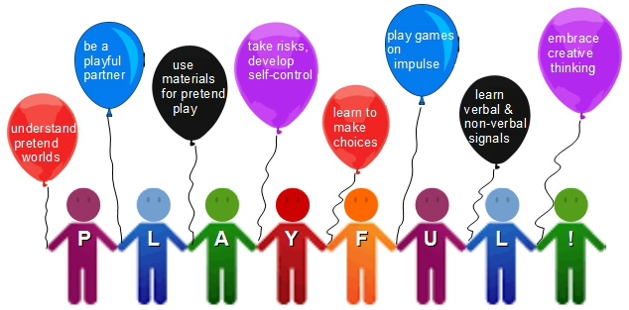
Attributes of playfulness (Inspired by Thomas and Harding, 2011)

Step 1: Identify the issue or area of change (August – early September 2023)
What is the issue/need for change that you have identified and want to address through CPE?

How did you identify this issue/need for change (e.g. consulting with colleagues or the Team around the Child, your own observations?)

Who else is in agreement that this is an issue/need for change? (E.g. colleagues, parents/carers?)

Are your Senior Management Team ‘on board’ with this?

Are there alternative viewpoints about the issue/area for change within your school? (e.g. colleagues, parents?)

Step 2: Identify possible solutions (September – early October 2023)
Which resources have you explored in order to find solutions to the identified issue/need for change? (e.g. personal reading, discussion with colleagues, a training course or CPD)

What is your change(s) in practice going to be in order to address your identified issue/need for change? – What is your proposed solution?

How will you let everyone affected know about the changes? (e.g. colleagues, parents/carers, pupils)

Have you considered any means of measuring the changes (pre-post)? E.g. use of the Audit Toolkit (2023), or observational tools such as Ferre Laevers’ scales?

Step 3: Introduce new practice or change (October 2023-January 2024)
At this stage of the Collaborative Practitioner Enquiry you are implementing the new practice/strategies or changes that you identified at Step 2 – you have a plan and you are putting it into action!
You need to make sure at this stage that you have a clear plan for implementation. Is everyone clear about what they are doing, when and why? Do parents/carers and the rest of the Team around the Child know about the imminent changes and what they are trying to achieve?
Is there a clear goal and timeline for the start and end of the evaluation of the change?
Please provide details of the changes you are putting in place below. You could highlight practical and pedagogical changes as well as anticipated challenges or barriers:
Your plan of action:

Step 4: evaluate what worked (Spring 2024)
Has all the pre-post evidence been gathered?

Do we know how the evidence gathered should be analysed and presented or do we need support with this e.g. from the school’s link Educational Psychologist?

Can any conclusions be drawn about the process, changes or outcomes of what we have done?

Have decisions been made about sharing the evaluations with others? When will this happen? Who will be the target audience and how will this be shared?

