West Partnership

EP Wellbeing and Practice Survey 2025

Summary Report
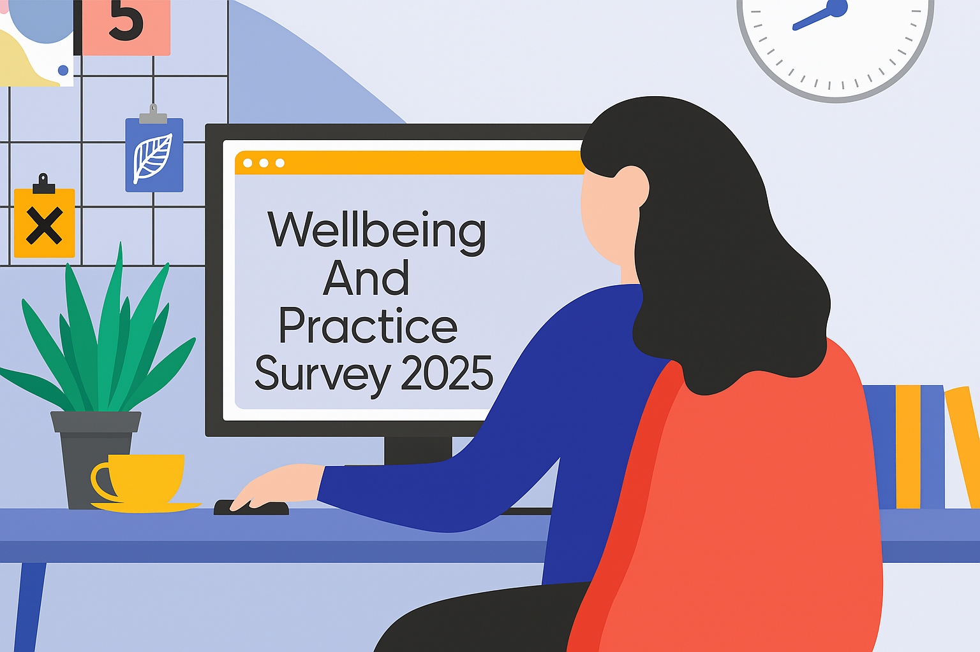

The ‘Wellbeing and Practice Survey 2025’ was developed by the West Partnership Educational Psychology Practitioner Network to gather Educational Psychologists’ views on their wellbeing and practice 4 years on since the previous report ‘Wellbeing and Practice Survey 2021’. It is the hope that the themes identified in this report will help inform future service delivery planning and considerations.

Table of Contents
Introduction 2
Resilience 2
Wellbeing and Work 3
Productivity 3
Stress 4
Self-care 4
Relationships 4
Positive Impact 4
Wellbeing supports 6
How to improve EP Wellbeing? 6
Working Model 8
Blended Working Model 8
Post Covid Changes 9
Conclusion 10

Introduction
The ‘Wellbeing and Practice 2025 Survey’ gathered the views and experiences of Educational Psychologist’s within the West Partnership 4 years on from the initial survey and 5 years on from the start of the COVID pandemic to compare the experience of Educational Psychologists. The survey was carried out in Summer 2025 and received 52 responses across the eight authorities.
The survey results are presented in three sections: Resilience, Wellbeing at Work, and Working Models since COVID. The term ‘EP’ is used throughout and refers to all respondents including trainees, main grades and senior posts.

Resilience
To look at resilience with regards to wellbeing, EP’s were asked to reflect on the last 6 months and rate how well they use each of Karen Reivich’s seven skills of resilience to support their own resilience. Results indicate that EPs make use of the seven skills of resilience to support their own resilience, with almost all respondents stating they use each of all of skills extremely well, very well, or well enough. However, it was also noted that the use of all resilience skills except ‘Emotional Awareness and Control’ were used less when compared to the previous survey. Although it is concerning that six of seven skills have decreased since the previous survey, it is possible in 2021 EP’s were more aware of the need to be resilient at that time than they are currently, and it is likely that everyone was more consciously utilising these skills at that time due to the challenging circumstances.

The most well used skills of the seven skills were ‘Empathy’ and ‘Emotional Awareness and Control’. This had changed from the 2021 results as ‘Flexible thinking’ was one of the most used skills in the previous survey. The results showed that the least well-used skills were ‘Realistic Optimism’ and ‘Reaching out’, these skills were similarly less used in the previous survey. The full results are in Figure 1 below.

Figure 1. Reivich’s seven skills for resilience: EP ratings
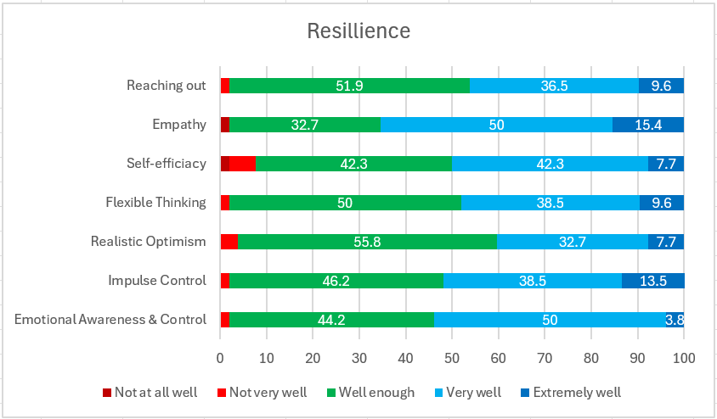

Wellbeing and Work
EPs were asked to reflect on their experiences over the last 6 months by rating levels of agreement on 16 statements. They were also asked about the current wellbeing supports in place in their service and if there was anything their service could do to improve EP wellbeing.
82.2%
76.7%
8.3%
8.3%
10.9%
11%
19.2%
41.1%
79.5%
78.1%
63%
45.2%
Results of the statements are presented below in Figure 2. When comparing these results to those from 2021, almost all of the measures have increased demonstrating that EPs overall are feeling more positive than they were straight after the pandemic. Below is a more in-depth comparison of different areas.

Productivity
Productivity was an area which saw an increase in scores when comparing to the previous survey. The results showed that when asked if they were feeling productive at work 89% agreed or strongly agreed, compared with 77% in the previous survey.

Stress
When comparing questions around stress levels, these scored have improved. The current survey showed that 71% of respondents strongly agreed or agreed that their stress levels feel manageable compared to 63% in the 2021.

Self-care
Self-care is another area that has seen significant improvements when comparing to the previous survey. 78% of respondents strongly agreed or agreed that they are able to switch off effectively from work and focus on self-care compared to 48% in the 2021 survey.

Relationships
Relationships is an area which has remained positive across both surveys. The question around having good relationships within their schools has increased since 2021, before it was 90.4% but increased to 94.2%. Also, in the current survey 100% of responses agreed that they benefit from informal support from my EP colleagues which shows the strength of relationships within departments.

Positive Impact
Positive impact is an area that has decreased since the previous survey. In 2021, 74% of EPs strongly agreed or agreed that the could see the how the work they were doing was, directly or indirectly, making a positive difference and improving outcomes for children, young people and their families, but this had decreased to 67.3% in the current survey.

Figure 2. Level of Agreement with Wellbeing and Work Questionnaire Statements
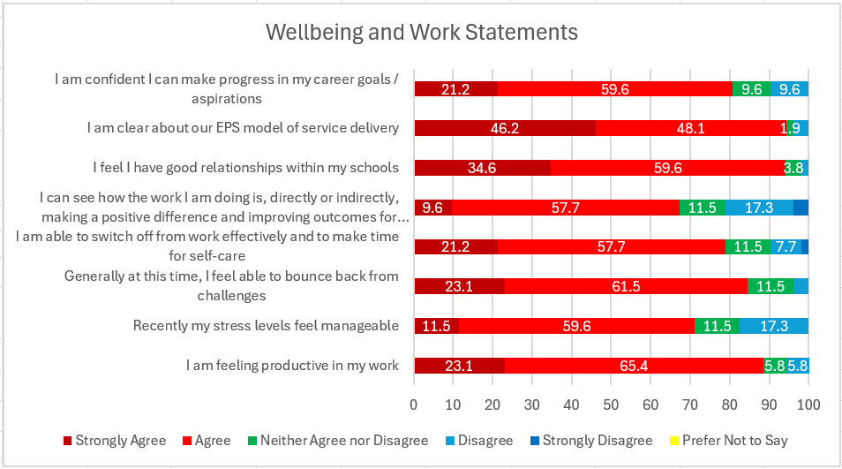
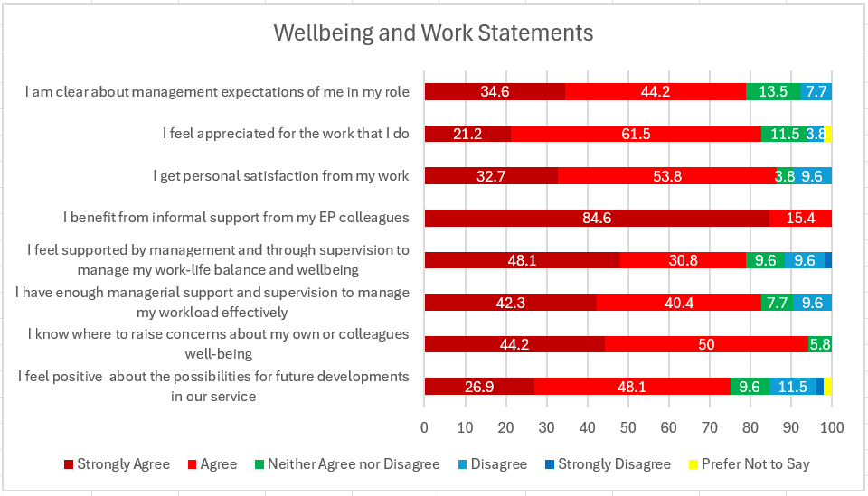

Wellbeing supports
EPs were asked about the current wellbeing supports in place in their service. Figure 3 demonstrates the common responses to this question. Peer support was the most popular response with 71% of respondents highlighting this as a current wellbeing support in place in their service. Another common wellbeing support was social events, which was highlighted by 63% of respondents. Additionally, 23% of respondents noted peer supervision as a current wellbeing support.
Figure 3: Responses to current wellbeing supports in place in your service.
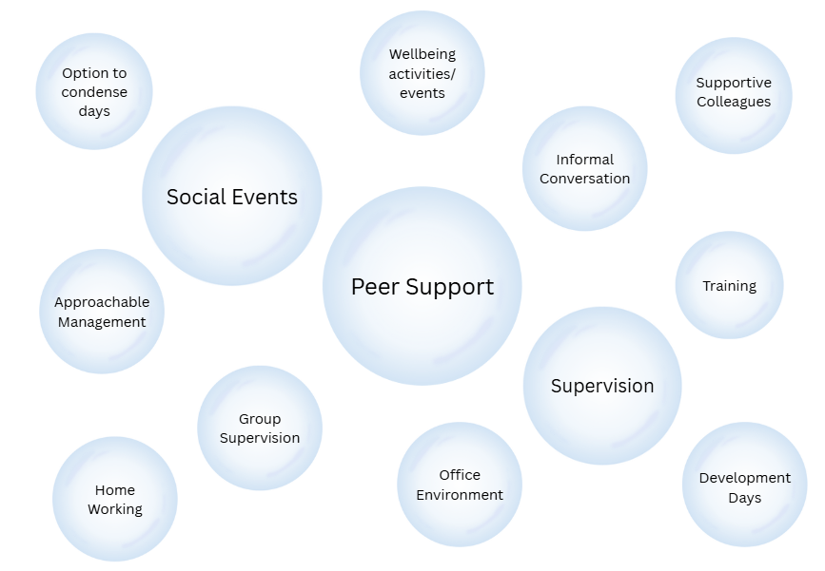

How to improve EP Wellbeing?
EPs were asked if there was anything their service could do to improve EP Wellbeing. 38% of respondents said there wasn’t or did not answer this question suggesting that they are happy with the services offering to support EP wellbeing. Additionally, a range of suggestions were made such as manage workload, hybrid working, and management focus on EP Wellbeing. Figure 4 demonstrates the responses.

Figure 4: Suggestions of what EP’s feel their service
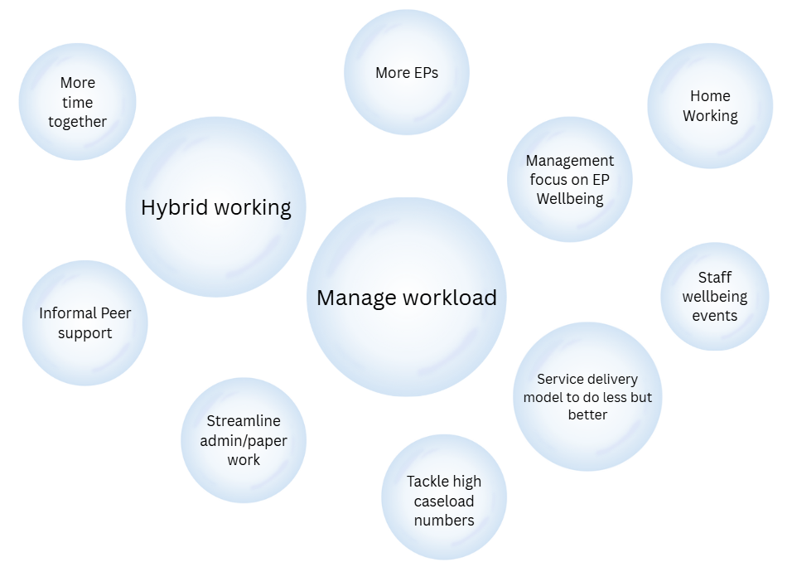

Working Model
When looking at working models across the West Partnership, EPs were asked whether their service has a blended model of working between home and in person. In response to this question 73% said yes they have a blended working model, and 27% answered no they did not. Those who answered yes to having a blended working model answered some additional questions on their opinion on the blended working model.

Blended Working Model
The response of the additional questions can be found below in Figure 5. The results demonstrate that almost EP’s who work in a blended model are able to work effectively in this way (93%) and are happy to work in a blended way between home, office and ELC/ Schools (93.2%).

Figure 5: Additional questions on the blended working model
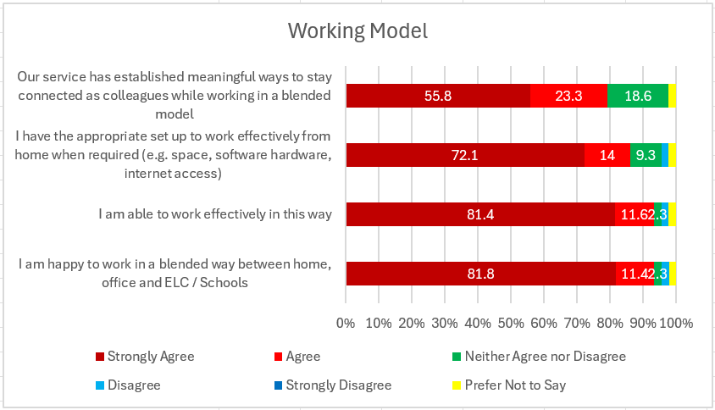

Post Covid Changes
Additionally, EPs were asked about the positive and negative changes that have been in place since working during the coronavirus pandemic.
EPs were asked if there are changes that have been maintained or developed further which have enhanced service delivery in your context. One of the most common answers was having a blended home/office model. Most people said that having the option to work from home allowed them to be more flexible, more productive with time, and reduced travel time across the day. Many EPs noted that this has improved their work/life balance, and their wellbeing.
The use of online meetings and online CLPL was also mentioned a lot as a change since COVID. Online meetings were noted to make coordinating diary dates with other professionals easier due to reduced travel time, online meetings were mentioned to be useful for multi-agency and cross-authority working and they also said this allows them to fit more meetings into their day.
In terms of negative changes, the most common answer was that there weren’t any negatives, some EPs noted that they feel having a blended working model has allowed for flexibility and enhanced wellbeing, and that they feel there is a good model of blended working. However, one of the key negatives mentioned was increased expectations on EPs to respond quickly to emails or always being on call which increases workload and can increase stress levels. Another negative noted was the office being quiet which lessens the opportunity for peer support.

Conclusion
This report has assessed EP wellbeing by surveying on resilience, wellbeing and work, and wellbeing supports. Carrying out the survey 4 years on from the initial survey allowed for comparisons to be made to see how things have progressed throughout this time. This survey differed from the previous one as the impact of having a blended working model was examined as this is a key area which has seen development in the majority of local authorities since the pandemic.
When looking at how well EP’s use Karen Reivich’s seven skills of resilience to support their own resilience it was found that almost all EP’s use all of the skills of resilience extremely well, very well, or well enough. When comparing these findings to the previous survey it was noted that the use of all resilience skills except ‘Emotional Awareness and Control’ were used less than they were in 2021. This finding may be due to the post pandemic circumstances everyone was facing in 2021, and hopefully the skills are currently less used due to not having to actively use our resilience in 2025.
When looking at Wellbeing and Work, the results showed that almost all measures had increased since the previous survey, which demonstrates that overall EP’s are feeling more positive with regards to wellbeing and work than they were post-pandemic. These improvements were evident when looking at productivity, stress, self-care, and relationships. However, it was highlighted that positive impact was an area which has seen a decrease since the previous survey.
The survey also asked EP’s about current wellbeing supports in place in their services, the most common responses were peer support, social events, and supervision. Additionally, when asked if there was anything their service could do to improve EP Wellbeing, many people did not respond to this question, while others provided suggestions such as manage workload, hybrid working, and management focus on EP Wellbeing.
The current working model for EP’s across the West Partnership was also analysed as this is an area which has changed for most local authorities since the pandemic. When asked if their service has a blended model of working between home and in person, the majority of respondents said yes they do and the minority said they did not. Those who work in a blended model were then asked more questions with regards to this working arrangement. These findings were all very positive about working in this way. The results found that almost EP’s who work in a blended model are able to work effectively in this way and are happy to work in a blended way between home, office and ELC/ Schools.
EPs were asked if there are changes that have been maintained or developed further which have enhanced service delivery in your context. One of the most common answers was having a blended home/office model noting that this has improved their work/life balance, and their wellbeing. Additionally, use of online meetings and online CLPL was also mentioned a lot as a change since COVID.
In terms of negative changes, the most common answer was that there weren’t any negatives, and some EPs noted that they feel it has allowed for flexibility and enhanced wellbeing, and that they feel there is a good model of blended working. However, one of the key negatives mentioned was increased expectations on EPs to respond quickly to emails or always being on call which increases workload and can increase stress levels.
In conclusion, this report has shown that overall EP wellbeing has improved since the previous survey in 2021. This report has exhibited a range of wellbeing supports that are in place across the West Partnership and are having a positive impact on EP wellbeing. The positive changes that have been implemented and remained in place across various local authorities since the pandemic have been demonstrated. The report highlighted that those who are working in a blended working model rate this positively and it is working well.

