West Partnership

EP Wellbeing and Practice Survey 2021
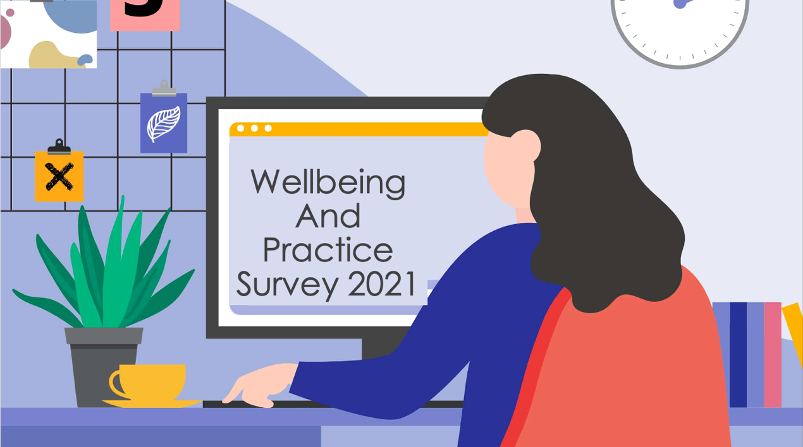

The ‘Wellbeing and Practice Survey 2021’ was developed by the West Partnership Educational Psychology Practitioner Network in order to gather Educational Psychologists’ views on their wellbeing and practice this past year. It is the hope that the themes identified in this report will help inform future service delivery planning and considerations.

Table of Contents
Introduction 2
Section 1 – Resilience 3
Section 2 - Wellbeing and Work 4
Working from home context (including challenges) 4
Wellbeing 7
Working within Covid restrictions 8
Future goals and service provision 8
What staff wellbeing supports should continue? 9
Service/Team Focus on Wellbeing 9
Acknowledgement and Transparency 9
Assessment of Wellbeing 9
Prioritising Informal / Flexible Support 10
One-to-one or Small Group Support 10
Service Culture and Values 10
Management Support 11
Support Blended Pattern of Working 11
Information Sharing and Training 11
What do you think services could do better to support staff wellbeing in the coming months? 12
Continued Wellbeing Support 12
Improved Workload Management 13
Improved Blended Model of Working 13
Review Aspects of Service Provision 14
Improved IT & Working Environment 14
What could your authority do to support staff wellbeing during this time? 15
Section 3 – Future Models of Service Delivery 15
Examples of effective remote working 15
What have we learned from remote working? 18
What could be embedded? 19
Costs and benefits of remote working 19
Conclusion 21

Introduction
The ‘Wellbeing and Practice 2021 Survey’ was created by EPs within the West Partnership to gather the views and experiences of EPs over the past year. The survey was created in May 2021 and sent out with the deadline of June 30th, 2021. The survey received 73 responded from EPs across the eight authorities.
There was representation from; Trainees (1st and 2nd year), EPs in Training (3rd year), EPs, Senior EPs, Depute Principal EPs and Principal EPs across; East Dunbartonshire, East Renfrewshire, Glasgow, Inverclyde, North Lanarkshire, Renfrewshire, South Lanarkshire and West Dunbartonshire.
The Survey consisted of 13 questions in 4 sections: Demographics, Resilience, Wellbeing at Work, Reflecting, and Planning. All responses were treated sensitively and some questions included the option ‘prefer not to say’. See Figure 1. This report brings together the results and main themes of the survey in three sections: Resilience, Wellbeing at Work and Future Models of Service Delivery. The term ‘EP’ is used throughout and refers to all respondents including trainees, main grades and senior posts.
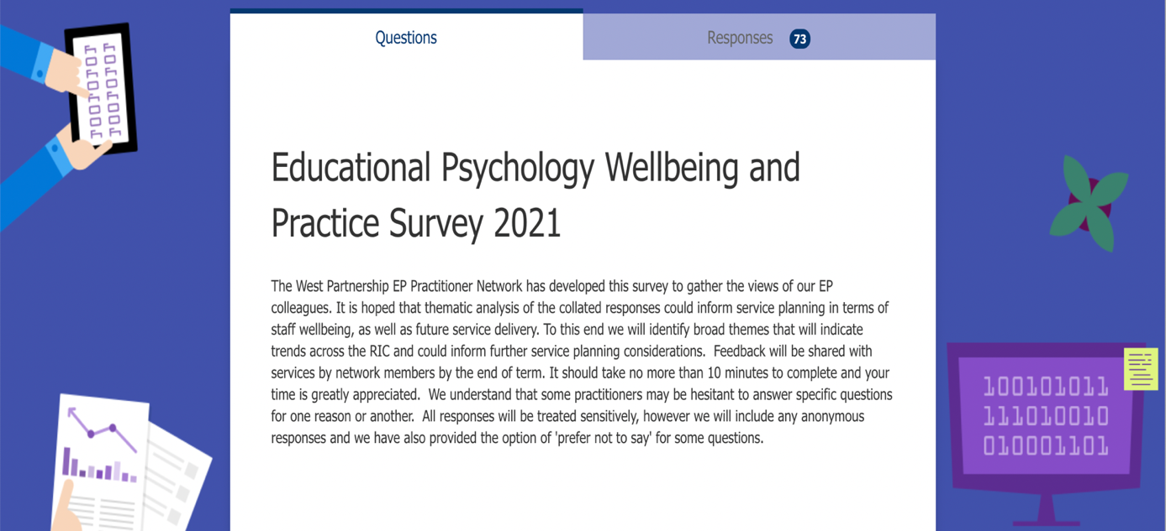
Figure 1. Purpose of Survey

Section 1 – Resilience
From a positive psychology perspective, Karen Reivich identifies seven factors or skills that promote resilience in times of adversity: emotion awareness and control, impulse control, realistic optimism, flexible thinking, self-efficacy, empathy, and reaching out. EPs reported the extent to which they felt they had effectively used these skills, on a five point scale from ‘not at all well’ to ‘extremely well’, during this challenging time. Overall, results indicate that EPs were able to deploy these skills relatively successfully to support their resilience, with few EPs reporting ‘not very well’ and none reporting ‘not at all well’. See Figure 2.
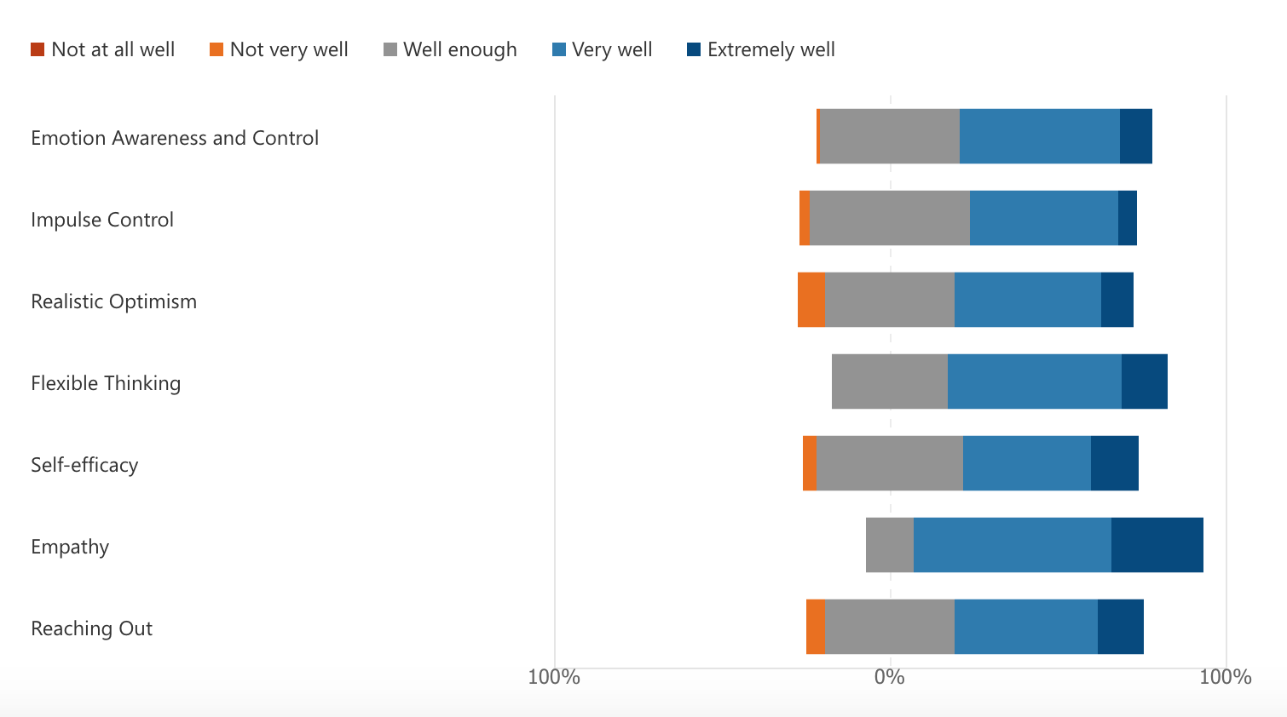
Figure 2. Reivich’s seven skills for resilience: EP ratings
Very well (47.9%)
Well enough (47.9%)
Very well (43.8%)
Very well (51.4%)
Well enough (43.7%)
Very well (58.9%)
Very well (42.5%)
Empathy received the most positive response rate followed by flexible thinking. Impulse control, realistic optimism, self-efficacy and reaching out were more likely to receive the midpoint rating of ‘well enough’ and in a number of cases ‘not very well’. In particular, remaining optimistic was challenging for some individuals.
Some of the issues EPs felt had a negative impact on feelings of resilience included personal circumstances, feelings of ‘being spread too thinly’, isolation, difficulties with work/life boundaries and not being able to access the usual de-stressors at this time (e.g. meeting up with friends). However, for some, the benefits of home working helped offset some of these feelings. For example, it was reported, “although difficult situations can be harder to bounce back from with the increased isolation, this is offset by the increased flexibility of timetable”. It is considered that responses to realistic optimism and reaching out may have been more sensitive to the effects of differing life circumstances and experiences of individual Eps, and the impact of restrictions during this time, compared to, for example, flexible thinking and empathy.

Section 2 - Wellbeing and Work
EPs were asked to reflect on their experiences over the last 6 months by rating levels of agreement on 19 statements. Ratings for ‘strongly agree / agree’ and ‘strongly disagree / disagree’ were combined to provide a clear understanding of results. These are red and blue, respectively, in Figure 3 below. An open-ended option (please elaborate on any of the above responses if you wish to) was also included to develop further understanding of EPs’ experiences. Responses are discussed below in four themes: working from home context, wellbeing, working with Covid restrictions and, future goals and service provision. Responses to three open-ended questions about wellbeing at work are also discussed.
82.2%
76.7%
8.3%
8.3%
10.9%
11%
19.2%
41.1%
79.5%
78.1%
63%
45.2%

Working from home context (including challenges)
EPs identified that working from home had improved their productivity and efficiency. Working in a quieter environment, fewer opportunities for distraction, time saved through less commuting, and flexibility of hours led to feelings of enhanced productivity and, for some, a better work life balance. Some EP’s indicated that there were good opportunities for creative work although others found it more difficult to be creative. There was a good level of agreement (76.7%) among EPs that they felt productive during the pandemic.
However, some of the key factors that were reported to reduce productivity pre-covid (driving, chatting to colleagues) were also factors that improved EP wellbeing (connection and reflection). Driving, for example, was cited as offering useful time for reflection and mental preparation.
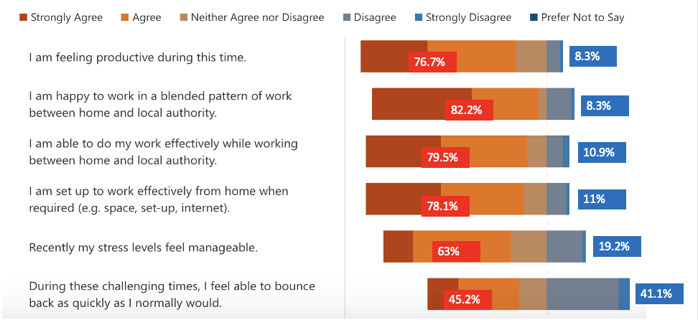
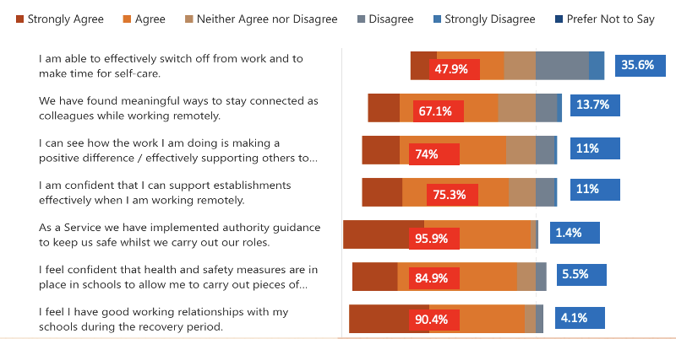
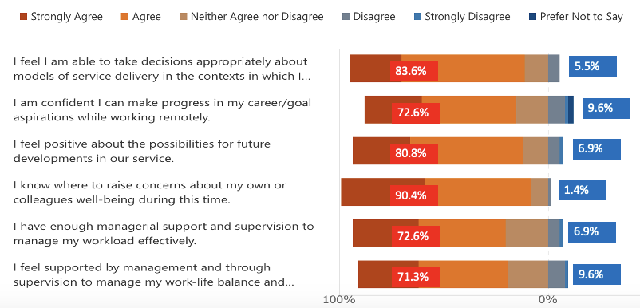
Figure 3. Level of Agreement with Wellbeing and Work Questionnaire Statements
Productivity was affected by people’s home circumstances, ranging from no physical work space available or set up within the home (which led many EPs to spend their own money on office equipment), home-schooling children and the home environment making it difficult to focus on work. Working at home also brought ‘secondary trauma’ into private, family living spaces. Some EPs unfortunately experienced loss and bereavement at this time.
The majority of meetings / interactions were task focused with no downtime together, and not having colleagues around meant fewer opportunities to ask questions. Similarly, there was less opportunity to ‘repair’ following challenging online meetings. Working through complex problems without respite or balance offered by colleagues, either through softer conversations or seeing the positive elements of children and young people returning to school, created feelings of isolation.
New EPs faced difficulties as they did not have pre-established relationships with schools or families, and making connections within the team was more challenging.
ICT problems were prevalent and additional time was spent by EPs to navigate ICT issues, including:
- WiFi challenges, for example, making, joining and staying in calls
- Difficulties reaching schools and families that live in rural areas
- Adapting to no printer, case files and typing up notes
- Use of personal phone to make calls caused difficulty filtering / switching off from this on non-working days
- Knowing how to use the various digital platforms
- Insufficient IT support
Additionally, it was reported that working from home led to an increase in back-to-back meetings, therefore workload also affected how productive EPs felt they could be with little to no time for follow up admin work and agreed actions.

Wellbeing
For some, working at home had reduced stress levels as they felt better able to work productively and flexibly to fit in with their own or family plans. For others, being in the same environment for work and home made it difficult to ‘switch off’ and de-stress after work. Wellbeing was affected by several factors including the “unmanageable” workload, the merging of home and work, and IT problems. Although EPs felt productive (82.2%) and were managing to work effectively from home (79%) this may have come at a cost for some as only 63% agreed that their stress had been manageable lately, and 19.2% disagreed that they were able to manage stress. In addition 41.1% disagreed/strongly disagreed that they could ‘bounce back as quickly as normal’.
Many EPs reported feeling supported by management and colleagues, and understood the importance of self-care, however, struggling with home/work balance, not being able to socialise, lack of physical/mental head space to work from home, not being in the office and having a sense of “home time” made it difficult to make time for self-care (35.6%).
Almost two thirds (67.1%) “had found meaningful ways to stay connected” reporting use of weekly and daily check ins, various media platforms, and strong informal and formal support processes within the service. Although EPs worked hard to remain connected, many reported feelings of isolation and missing the informal feeling of connection that being in the office brings and how small questions or comments felt silly going into an email and so were left unsaid.
Almost all EP’s (90.4%) indicated that they knew where to raise concerns about their own or someone else’s wellbeing, and felt there was enough support from management and through supervision to manage work load (72.6%) and, work-life balance and wellbeing (71.3%) effectively; (1.4%, 6.9% and 9.6% disagreed, respectively). Support from management during this time was viewed very positively with EPs saying that they felt supported in practical and compassionate ways, although as noted above this did not always fully resolve issues.

Working within Covid restrictions
Around 74% of respondents agreed, and 11% disagreed, that the work they were doing was “making a positive difference / effectively supporting others to make a positive difference to children, young people and their families” and, similarly, felt that they could “confidently support establishments when working remotely”. Comments indicated EPs felt there was a greater ability to stay in touch with establishments online and there had been greater involvement of teaching staff (in addition to senior management) in online meetings. EP's felt they had spent more time empowering those around the child as they had been less able to be physically present. EPs agreed (90.4%) that they had good relationships with schools over the recovery period, one responded “the virtual context has allowed an increased regularity of purposeful contact with schools and class teachers.” Some individuals, however, felt that it was difficult to navigate relationships with schools whilst managing expectations online.
A number of EPs commented that they felt lower confidence in making appropriate decisions about models of service delivery in this context though the majority (83.6%) did not indicate difficulty with this.
In terms of safety measures, 95.9% agreed that “as a service we have implemented authority guidance to keep us safe whilst we carry out our roles.” However, fewer (84.9%) agreed “that health and safety measures were in place in schools to allow me to carry out pieces of work which cannot be done remotely”. Additional comments suggest EPs would have liked more concrete and consistent guidance about what constitutes “essential” work rather than being told “no more than one school visit a day”.

Future goals and service provision
It was felt that the pandemic had had a positive influence on potential future service developments (80.8%), particularly around a blended model of working from home / the office. Over 80% (82.2%) of respondents agreed that a blended model of working between home and the local authority was working well, and this was something that they would like to keep in the future. While there were many positives of working at home (concentration, work/life balance, purposeful contact with schools) there was a need for the physical space of the office to help with work/life balance and boundaries, connection and creativity with colleagues and to develop relationships with schools.
In regards to personal development, 72.6% of EPs felt confident they were “making progress in their career/goal aspirations while working remotely.”

What staff wellbeing supports should continue?
The questionnaire asked EPs to consider what support they had received from services that would be beneficial to continue or develop further. These are outlined in bullet points in the themes below.

Service/Team Focus on Wellbeing
- Regular team meetings
- Wellbeing should remain part of team meeting agendas and development days. This is something that is hoped to be developed in the future with more content and procedures.
- A health and wellbeing whole staff morning which allowed one hour at the start of the day to personally engage in something HWB related.

Acknowledgement and Transparency
- Recognition of the importance of EP wellbeing and how EP mental health is important in providing a sustainable service to children, young people, families and schools.

Assessment of Wellbeing
- Conducting health and wellbeing staff surveys and feedback of results
- Using SAMH wellbeing indicators to promote positive staff wellbeing during COVID-19. This involved discussing how we will address each indicator over a certain period of time, then reviewing and reflecting on our experiences in meeting these.

Prioritising Informal / Flexible Support
- Breaks were encouraged to reconnect. This has taken many forms: WhatsApp group chats, virtual tea breaks, remote social events, book clubs, quizzes
- Protected time for wellbeing
- Colleagues meeting up for walks out with work
- Prioritising connection and time to be together without a work focus

One-to-one or Small Group Support
- Wellbeing reflective discussions
- Collegiate support e.g. providing buddies for new members of staff
- Using peer support to focus on wellbeing and talk about cases
- Formal supervision as protected time with more structure e.g., the CAMHS supervision model
- Peer support session after team meetings
- Service Improvement Groups have allowed and enabled small group support to develop.

Service Culture and Values
- “There is a general ethos of empathy and support within the team and a feeling of mutual awareness and responsibility for each other's wellbeing.”
- Members of the team being more mindful of different people’s experiences during covid-19, and recognition that some have been more isolated than others. It is hoped that the regular contact/support will continue post pandemic.
- Awareness in meetings that people have different personal circumstances.
- A friendly and welcoming service with supportive colleagues has made challenging work easier.
- Acceptance and acknowledgement that this is a very challenging time has helped to normalise some of the negative feelings.

Management Support
- ‘Open door’ policy and regular availability to discuss queries
- Check ins with members of management team (formal and informal)
- Encouragement to protect time and energy
- Encouragement of work/life balance
- Clear, consistent communication from Senior Management Team while working from home
- Offering to provide support and guidance if EPs felt pressured to attend schools

Support Blended Pattern of Working
- Flexibility of work/life balance - opportunities to work hours to balance home life and personal circumstances (e.g. caring duties) with meeting the needs of the service/schools/CYP
- Increased ability to independently make professional judgements

Information Sharing and Training
- CPD opportunities
- Regular updates and information sharing opportunities to ensure that key information is shared, and everyone is kept informed while working remotely.

What do you think services could do better to support staff wellbeing in the coming months?
EPs were asked to comment on areas for improvement in relation to staff wellbeing. These are outlined in several themes below: continued wellbeing support, improved workload management, improved blended working,

Continued Wellbeing Support
Format and Structure of Support
- A preference for regular check in’s instead of one off events
- Wellbeing remaining on meeting agendas
- Supports and guidance specific to EP’s (including a secure and confidential EP support forum across different local authorities)
- Develop an organisational approach to support staff wellbeing
- More frequent organised supervision sessions or opportunities for peer support
- Opportunities for connection (in person and online)

Type / purpose of support
- Fun/relaxing wellbeing activities as well as work focussed activities
- Sharing effective wellbeing strategies with each other and increased focus on 'play' for adults/ having fun
- Give all EPs the opportunity to talk through how things are going for them. Bring awareness and have open conversations about what is happening in a person's life so that they can be supported
- Build in more peer learning/support sessions

Targeted Support
- More support for people who have been off during this time and new staff, including trainees

Principles of Support
- Place more emphasis on EP mental health, wellbeing and recovery to mitigate against burnout and ensure that we can support others during challenging times
- Ensure there is not an increase in expectations of the rate of recovery from covid-19

Improved Workload Management
- Realistic allocation of time for development work, rather than the expectation that this is carried out in EPs own time - evenings, weekends etc.
- Realistic expectations regarding workload, particularly at a time of crisis
- Provide safe discussion spaces regarding workload
- Maintain a clearer overview of and monitor EP workloads, including monitoring expectations of EPs to ensure staff continue to have a sense of job satisfaction
- More guidance about dealing with / prioritising the many competing demands on EP time (service level and individual)
- Team meetings should be less ‘top-down’ – this does not provide enough time to process or absorb the information discussed
Positive examples of support for workload management included management taking a strong lead in supporting EPs by helping them to protect their diary commitments, ensure equity of casework distribution across services, and by ensuring a return to a better balance of casework and strategic development.

Improved Blended Model of Working
The aim would be to introduce a system, based on regular discussion and review, that has a focus on connection, collaboration, creativity and that has taken stock of what has worked well during the pandemic.
- Implement the positive changes that have been made to service delivery over covid-19 on a more permanent basis
- Continue to offer flexibility and allow for a higher level of autonomy
- Ensure EPs are brought back together in a meaningful way to support effective collaboration and connection
- Work to develop plans that allow EPs to access shared office space for even some of the week to allow for informal peer support and learning opportunities for trainees
- More structured opportunities for discussions across the team to make sure everyone stays fully informed and involved
- Develop a robust remote working policy, which may include recognition that everything virtual is not the norm; consistent, clear communication with definite decisions around what a blended approach will look like; support for EPs to manage expectations and external pressures relating to working from an office

Review Aspects of Service Provision
- Facilitate more in-person events to discuss service developments – some respondents reported the pandemic has caused a feeling of being instructed rather than co-creation at times.
- Revisit time allocation models given increased working from home leads to an increased workload.
- Consistency of approach across services as well as within services.
- Discussion and recognition of new pressures which require more time following the pandemic, and perhaps do not fit service priorities.
- Moderate expectations around normal reporting processes, including Practice Level Agreement (PLA) dates and reviews, to take the current context into account.
- Collaboration to develop high quality resources/materials/training

Improved IT & Working Environment
- Receive appropriate working from home supplies
- Training in how to use different forms of ICT

What could your authority do to support staff wellbeing during this time?
There was a general feeling of being well supported by the authority, many EPs commented on the thanks they had received for work they had carried out. EPs felt that the authority could provide support in similar ways to the EPS, including communicating an ethos of positive wellbeing and work-life balance, supporting a blended model of working and improved IT support. In addition, several further points were raised:
- More ‘informal’ communication and connection – sharing what's happening within the EPS with different services
- Ensuring EPs views are sought and genuinely desired to inform implementation planning
- Value children and young people’s wellbeing first and foremost, over and above attainment

Section 3 – Future Models of Service Delivery

Examples of effective remote working

Online meetings were thought to be effective and this included planning and review meetings (e.g. TAC meetings, multiagency meetings), assessment (e.g. dyslexia, developmental checklists), national gatherings / events (e.g. ASPEP, SDEP), school meetings (e.g. Locality Inclusion Support Networks – LISNs, staff consultation, regular check-ins).
Reasons outlined for effectiveness included:
Improved structure and focus
- Some multiagency allocation meetings have more focus and benefited from a structured approach.
- Online meetings with establishments to support solution focussed working and consultation have been more effective over teams enabling more dedicated time spent on consultation and effective multiagency working.

Increased attendance / availability of staff, for example:

- LAC reviews for young people have been very effective as it has enabled attendance at meetings without having to travel long distances. This has been more efficient.
- More teachers and education staff are able to attend online meetings, including after school consultations
- Review meetings with parents/school have worked well on most occasions and more often two parents attend online. “I think it's been easier for parents to access and if they haven't managed to make the meeting you can continue with your work without the unnecessary travel.”
- Facilitating solution-oriented multi-agency meetings has been very effective. All partner agencies (health / SW) attended and participated for different pupils which was invaluable to the planning process.

Online working with children, young people and parents was also considered effective and took the form of virtual parent groups (including intensive parent support programmes), regular remote support and one-to-one sessions:
- Regular remote support to parents, during face-to-face work do not normally have this level of flexibility to be as responsive to family needs.
- Better able to reach children who are current non-attenders. Progress is seen due to the meetings with EPs being online and not in school.
- One to one work remotely with YP experiencing anxiety - able to meet weekly online for sessions remotely and this wouldn’t have been the case if we were stuck to a school visiting pattern.

Opportunities to engage in multiagency working and collaboration had improved during the pandemic, with an increased number of agencies able to participate in dialogue and discussion without the need to travel. Examples included:
- Online meetings with out of authority schools have had more attendance by other agencies.
- Multi-agency meetings have worked well, particularly if there is a time limit to the meeting - this encourages all to be concise and stick to the timeframe.
- Developing materials for staff, working with staff from other areas effectively using Teams.
- Reaching remote areas of the country and work with another authority to deliver training that would have been logistically very difficult if not online

Virtual training was considered effective because it opened up new opportunities and methods of sharing information and resources:
- Ability to deliver training to large groups at once. For example, providing parent information sessions about the impact of Covid on the mental health and wellbeing of children and young people. “We were able to provide this for a much bigger audience than we would normally.” “Very high turnout at online training which works well when the aim is to share information rather than network/have a workshop.”
- Knowledge and use of additional IT functions – recording sessions, chat functions, mentimeter etc.
- Creating resources and online delivery models that will be sustainable long-term, post-covid (e.g. transferring a two-day face-to-face training programme to online delivery; online recordings and creating support guidance for schools around emotionally based school refusal).
- Some online training participants reported that using Teams gave them an opportunity to participate in discussions when they wouldn't have had the confidence to do so in person.

Administrative benefits were also mentioned such as easier organisation of national events due to geographical location not being an issue (e.g. ASPEP, SDEP) and being able to fit in more meetings because of the reduction in travel time. Methods of information gathering and sharing had changed for some over the pandemic with greater use of Microsoft forms to gather information, and increased use of EPS website and twitter to disseminate information widely.
Some EPs highlighted that they had been able to complete work which had not previously been possible due to time limitations, for example, whole service initiatives, a secondary transition skills profiling and planning tool (developed with school staff via online meetings), and an in-depth cross authority needs analysis.

What have we learned from remote working?
We have learned that the EP does not always have to be physically present in order to work effectively and efficiently. I think we have empowered stakeholders more so than ever this year.
We can have a work from home policy in tandem with office working and still very effectively deliver on our priorities and commitments to children, families and schools.
That we can adapt effectively to new models of service delivery. We are flexible and responsive, we can identify and meet local needs, we are creative and good at sharing practice.
Working remotely can facilitate what we do but it can also be restrictive and detrimental to staff/EP mental health and wellbeing
A blended model of online and face-to-face working can work well.
The importance of the EP role in consultation in schools – we do not always need to be working directly with CYP to have an impact.
The importance of relationships and incidental, informal or spontaneous discussion.

What could be embedded?
- Continued emphasis on EP wellbeing
- Blended approach to working - benefits of being online and benefits of being in the office
- Sharing resources and information online - having a better online presence e.g. short YouTube videos, resources, signposts, materials, resources, offer online training packages
- Using I.T. more widely to gain stakeholder views
- Using Teams to ensure EPs come together from across the whole country and share good practice
- The creativity that has been achieved during this time
- Continued reduction of ‘paperwork’ and move to electronic ways of working
- Investigate the long-term potential of working directly with young people over social platforms and the impact of this way of working

Costs and benefits of remote working
Many comments emphasised how well EP service delivery has adapted over the pandemic, and that going forward, having the flexibility to use a blended approach and decide what is best for personal and organisational circumstances would work effectively. To achieve a balanced approach, the advantages and disadvantages of blended working must be taken into consideration. Table 1 below highlights the costs and benefits of remote working raised in the survey, and these can be used as a starting point to consider the best approach.

Table 1. Benefits and costs of remote working
Benefit | Cost
More efficient use of time being at home:
- Save time on the commute  - Able to be productive if cancelled meetings  - Less distractions  - No travelling between schools  - More flexibility | - Lack of time for reflection  - Hard to connect with others  - Face-to-face is essential for building relationships  - Informal conversations missed  - Feeling isolated  - Missed informal learning  - Missed peer support
Development work can be completed online:
- Able to work with more agencies  - Able to give this more time | - Difficulty collaborating with colleagues  - Feeling less creative at home if not set up to work effectively  - IT issues
Greater attendance at online meetings:
- Parents feeling less overwhelmed  - Teachers and parents more able to attend  - Some children/young people may prefer to contribute using ‘remote’ means  - Great for big meetings  - Contact with parents and professionals – deciphering the meetings where it is more appropriate to meet online and when you are more likely to have parental/different services engagement. Especially for out of authority cases, saving on the travel time but still being present. | - Schools struggled not having the informal reassurance/containment that comes with being physically there  - Difficult to console parent/young person if they are upset  - Overfilling diary with meetings
Fewer observations and direct work:
- Able to complete observations online  - More time for advice and consultation | - Feeling in person assessments and observations are necessary
Delivering online training:
- Able to reach wider audiences  - Participants using the chat option feel more able to join in  - Able to access training after it has been delivered | - Not good for EPs to deliver training with little feedback  - Distractable online  - Less engagement from participants  - Unsure how much information is obtained online
Offering EPs flexibility and autonomy
- Retain a model of blended service delivery  - Able to make decisions on what is more appropriate | - Ensure consistent within service and across authorities  - Wellbeing and check ins must be a priority in the future  - Need clear and consistent guidelines around this

Conclusion
The pandemic created many challenges for service delivery and this survey has shown that the majority of EPs were able to cope with these challenges. Extensive use was made of empathy and flexible thinking to support resilience. However, even with the use of these skills around 40% of EPs found it difficult to bounce back the way they normally did and about a third of EPs found it difficult to make time for self-care.
The survey highlighted the commitment EPs had at this time, ensuring positive relationships with schools, families and children continued, persisting through IT difficulties, developing new resources to support others and making time to support each other.
The report also highlights the many benefits of remote working, including more efficient use of time, better engagement with some children, young people and families, improved multiagency working, and development of new collaborations. Challenges included difficulties building relationships, maintaining a good work-life balance and isolation.
Suggestions for future working and service delivery models were provided, including a continued and regular focus on staff wellbeing, improved workload management support and strategies, a more permanent / embedded blended working model, increased opportunities for collaborative development work and greater IT support and training.

