West Partnership

EP Wellbeing and Practice Survey 2021

Summary Report
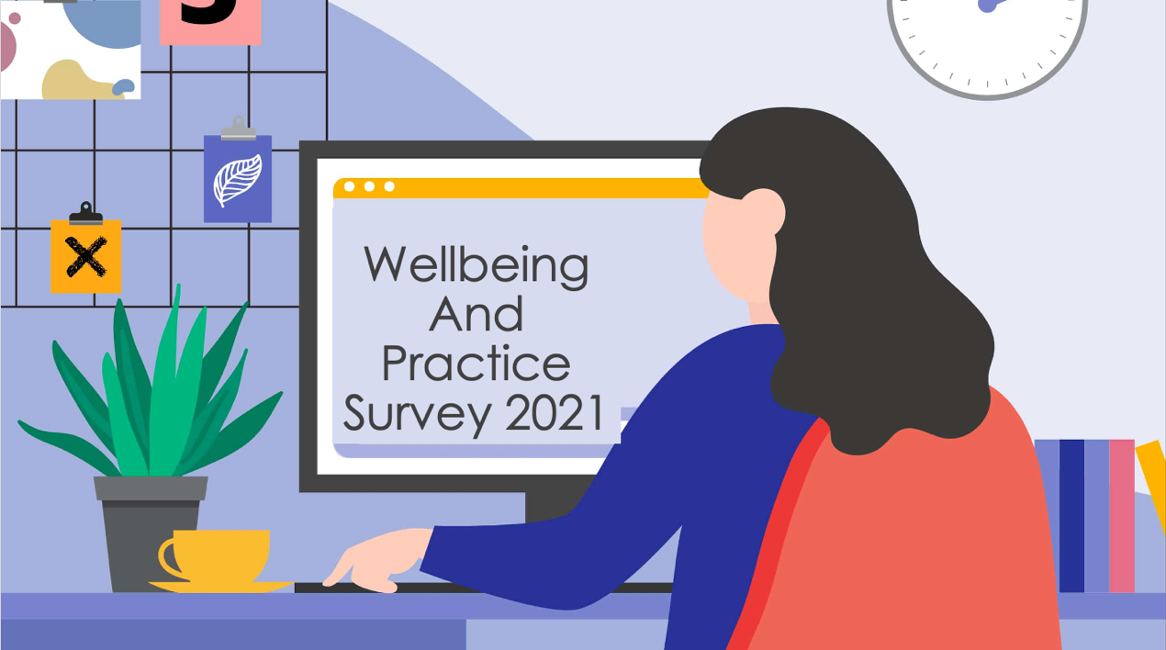

The ‘Wellbeing and Practice Survey 2021’ was developed by the West Partnership Educational Psychology Practitioner Network in order to gather Educational Psychologists’ views on their wellbeing and practice during the past year. It is the hope that the themes identified in this report will help inform future service delivery planning and considerations.

Table of Contents
Introduction 2
Resilience 2
Wellbeing and Work 3
Working from home 3
Wellbeing 3
Working within Covid restrictions 5
Effective staff wellbeing supports 5
Future Models of Service Delivery 6
Examples of effective remote working 6
What have we learned from remote working? 7
What could be taken forward? 8
Conclusion 9

Introduction
The ‘Wellbeing and Practice 2021 Survey’ gathered the views and experiences of EPs within the West Partnership over the past year. The survey was carried out in June 2021 and received 73 responses across the eight authorities.
The survey results are presented in three sections: Resilience, Wellbeing at Work, and Future Models of Service Delivery. The term ‘EP’ is used throughout and refers to all respondents including trainees, main grades and senior posts.

Resilience
Results indicate that EPs made use of Karen Reivich’s seven skills of resilience to support their own resilience during this time of adversity. ‘Empathy’ and ‘flexible thinking’ were considered to be the most effectively used of the seven skills.
Remaining optimistic was challenging for some individuals. It is likely that this reflects the differing life circumstances and experiences of individual EPs during this time. See Figure 1 for results.
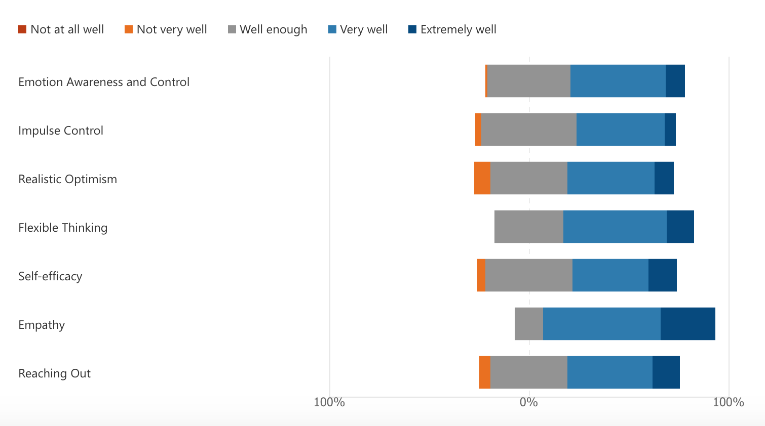
Figure 1. Reivich’s seven skills for resilience: EP ratings
Very well (47.9%)
Well enough (47.9%)
Very well (43.8%)
Very well (51.4%)
Well enough (43.7%)
Very well (58.9%)
Very well (42.5%)

Wellbeing and Work
EPs were asked to reflect on their experiences over the last 6 months by rating levels of agreement on 19 statements and by responding to open ended questions. Results of the statements are presented below in Figure 2 and qualitative responses are outlined in three themes: working from home, wellbeing, and working within covid restrictions. A second sub-section considers what supports were effective for EP wellbeing and what could be continued or improved going forward.
82.2%
76.7%
8.3%
8.3%
10.9%
11%
19.2%
41.1%
79.5%
78.1%
63%
45.2%

Working from home
Overall, 76.7% EPs agreed that they felt productive during the pandemic. Many EPs identified that their productivity and efficiency had improved because of a quieter working environment at home and less time spent commuting. Flexible hours had created a better work life balance for many. However, some of the factors that reduced productivity, such as driving (downtime) and chatting to colleagues (connection and reflection) were factors that improved EP wellbeing.
Home circumstances including home-schooling, no physical work space within the home, and loss and bereavement created difficulties for EPs. Work related features also caused strain including an increase in back-to-back meetings, task-focused only meetings, no pre-existing relationships with schools, and IT issues.

Wellbeing
Although EPs felt productive (76.7%) and were managing to work effectively from home (79.5%) this may have come at a cost for some as only 63% agreed that their stress had been manageable lately, and 19.2% disagreed that they were able to manage stress. In addition 41.1% disagreed/strongly disagreed that they could ‘bounce back as quickly as normal’.
Although EPs worked hard to remain connected (67.1%), many reported feelings of isolation and missing the informal feeling of connection that being in the office brings. Similarly, EPs understood the importance of self-care, however, home/work life balance, not being able to socialise, lack of physical/mental head space made it difficult to make time for self-care (35.6%).
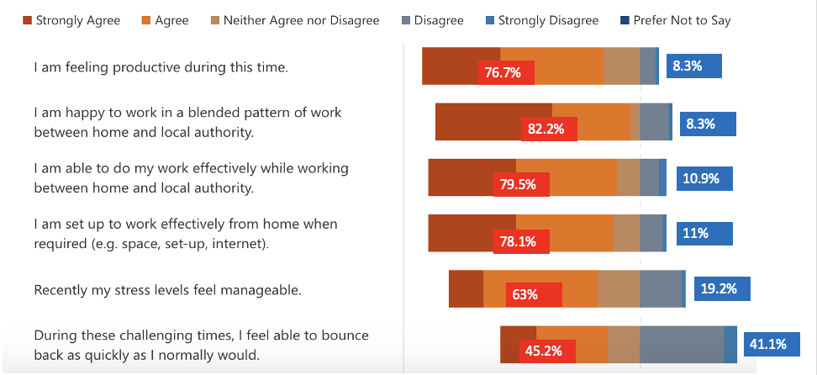
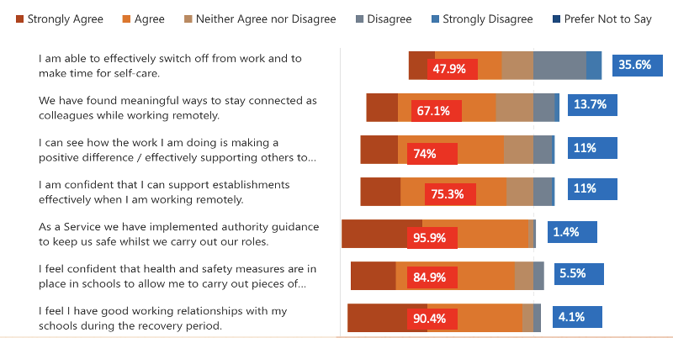
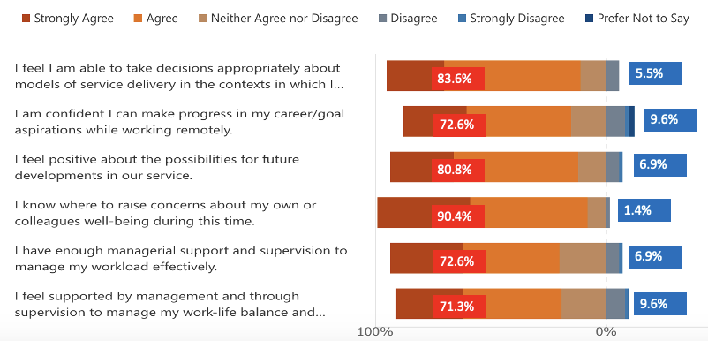
Figure 2. Level of Agreement with Wellbeing and Work Questionnaire Statements

Working within Covid restrictions
Around 74% of respondents agreed that the work they were doing was “making a positive difference / effectively supporting others to make a positive difference to children, young people and their families” and, similarly, EPs felt that they could “confidently support establishments when working remotely”. EPs (90.4%) felt they had good relationships with schools over this time.
In terms of safety measures, 95.9% agreed that “as a service we have implemented authority guidance to keep us safe whilst we carry out our roles.”
Fewer EPs (84.9%) agreed “that health and safety measures were in place in schools to allow me to carry out pieces of work which cannot be done remotely”.

Effective staff wellbeing supports
EPs were asked to consider what EPS support would be beneficial to continue and develop further. These are outlined below.
Service/Team Focus on Wellbeing e.g. regular focus on health and wellbeing during team meetings, health and wellbeing mornings
Acknowledgement and Transparency e.g. recognition of the importance of EP wellbeing and how EP mental health is important in providing a sustainable service to children, young people, families and schools, acceptance and acknowledgement has helped to normalise some of the negative feelings during the course of the pandemic
Assessment of EP Wellbeing e.g. staff surveys, use of SAMH wellbeing indicators
Prioritising Informal / Flexible Support e.g. breaks to reconnect, protected time for wellbeing, meeting with colleagues for walks outside work
One-to-one or Small Group Support e.g. wellbeing reflective discussions, peer support including buddies for new staff, formal supervision
Service Culture and Values e.g. general ethos of empathy and support within the team, friendly and welcoming service, mindful of different people’s experiences during covid-19, recognition that some EPs have been more isolated than others
Management Support e.g. Many EPs felt supported by management and colleagues to manage workload (72.6%) and work-life balance and wellbeing (71.3%), although as noted above this did not always reduce stress. The ‘open door’ policy and regular availability to discuss queries and provide support when needed, and consistent communication from senior management team while working from home were valued.
Support a Blended Pattern of Working e.g. flexible working to suit home / work life, although improved workload management and support to prioritise will be required in the future
Information Sharing and Training e.g. CLPL opportunities, regular updates and information sharing opportunities while working remotely
Overall it was felt that there should be an improved focus on health and wellbeing, building on the support already provided. This includes a focus on avoiding burnout, supporting others and maintaining realistic expectations about recovery from covid-19.

Future Models of Service Delivery
It was felt that the pandemic had had a positive influence on potential future service developments (80.8%), particularly around a blended model of working from home / the office (82.2%). In this section are examples of effective remote working, suggestions and key areas of learning from the pandemic that can be used to inform future models of service delivery.

Examples of effective remote working

Online meetings (including planning and review meetings, assessment, national gatherings / events) were considered successful because of the improved structure and focus and increased attendance / availability of staff e.g. teachers, parents and partner agencies.
Online working with children, young people and parents (including one-to-one sessions, virtual parent groups and regular remote support) were effective because of greater flexibility and responsiveness, and better attendance of children who were anxious and / or did not attend school.
Opportunities to engage in multiagency working and collaboration had improved during the pandemic as there was no or a reduced need to travel. This included joint work with EPS to develop materials and deliver joint training.
Virtual training opened up new opportunities and methods of sharing information and resources, including delivering training to large groups, improved knowledge and use of additional IT functions.
Administrative benefits such as easier organisation of national events (e.g. ASPEP, SDEP) (no geographical considerations), fitting in more meetings because of the reduction in travel time, increased use of EPS website and twitter to disseminate information.

What have we learned from remote working?
We have learned that the EP does not always have to be physically present in order to work effectively and efficiently. I think we have empowered stakeholders more so than ever this year.
We can have a work from home policy in tandem with office working and still very effectively deliver on our priorities and commitments to children, families and schools.
We can adapt effectively to new models of service delivery. We are flexible and responsive, we can identify and meet local needs, we are creative and good at sharing practice.
Working remotely can facilitate what we do but it can also be restrictive and detrimental to staff/EP mental health and wellbeing
A blended model of online and face-to-face working can work well.
The role of consultation with schools is key – we do not always need to work directly with CYP to have an impact.
We have learned the importance of relationships and incidental, informal or spontaneous discussion.

What could be taken forward?
- Sharing resources and information online, having a better online presence e.g. short YouTube videos, resources, signposts, materials, resources, offer online training packages
- The creativity that has been achieved during this time, although recognising that some EPs found it more difficult to be creative during the pandemic
- Exploring further opportunities for collaboration across EPS to develop high quality resources, materials and training.
- Using Teams to ensure EPs come together from across the whole country and share good practice
- Using I.T. more extensively to gather stakeholders views
- Investigate the long-term potential of working directly with young people over social platforms and the impact of this way of working
- Balancing the benefits of working from home (concentration, work/life balance) with the use of physical office space / in-person meetings to help maintain work/life balance and boundaries, connection and creativity with colleagues and to develop relationships with schools
- Development of specific wellbeing guidance for EPs which may include managing school expectations and managing workload
- Revisit time allocation models
- Returning to the principle of co-creation - some EPs had felt ‘instructed’ during the pandemic
- Improved I.T, including training and continued reduction of ‘paperwork’ and move towards electronic ways of working
- A better home working environment (receiving appropriate home working supplies)

Conclusion
This survey has shown that the majority of EPs were able to cope with the challenges associated with the pandemic and had high levels of commitment at this time, for example, ensuring positive relationships with schools, families and children continued. However, around 40% of EPs found it difficult to bounce back the way they normally did and about a third of EPs found it difficult to make time for self-care.
The report highlighted the many benefits of remote working, including more efficient use of time, better engagement with some children, young people and families, improved multiagency working, and development of new collaborations. Challenges included difficulties building relationships, maintaining a good work-life balance and isolation.
Many suggestions for future working and service delivery models were provided, including a continued and regular focus on staff wellbeing, improved workload management support and strategies, a permanent move towards blended working, increased opportunities for collaborative development work and greater IT support and training.

