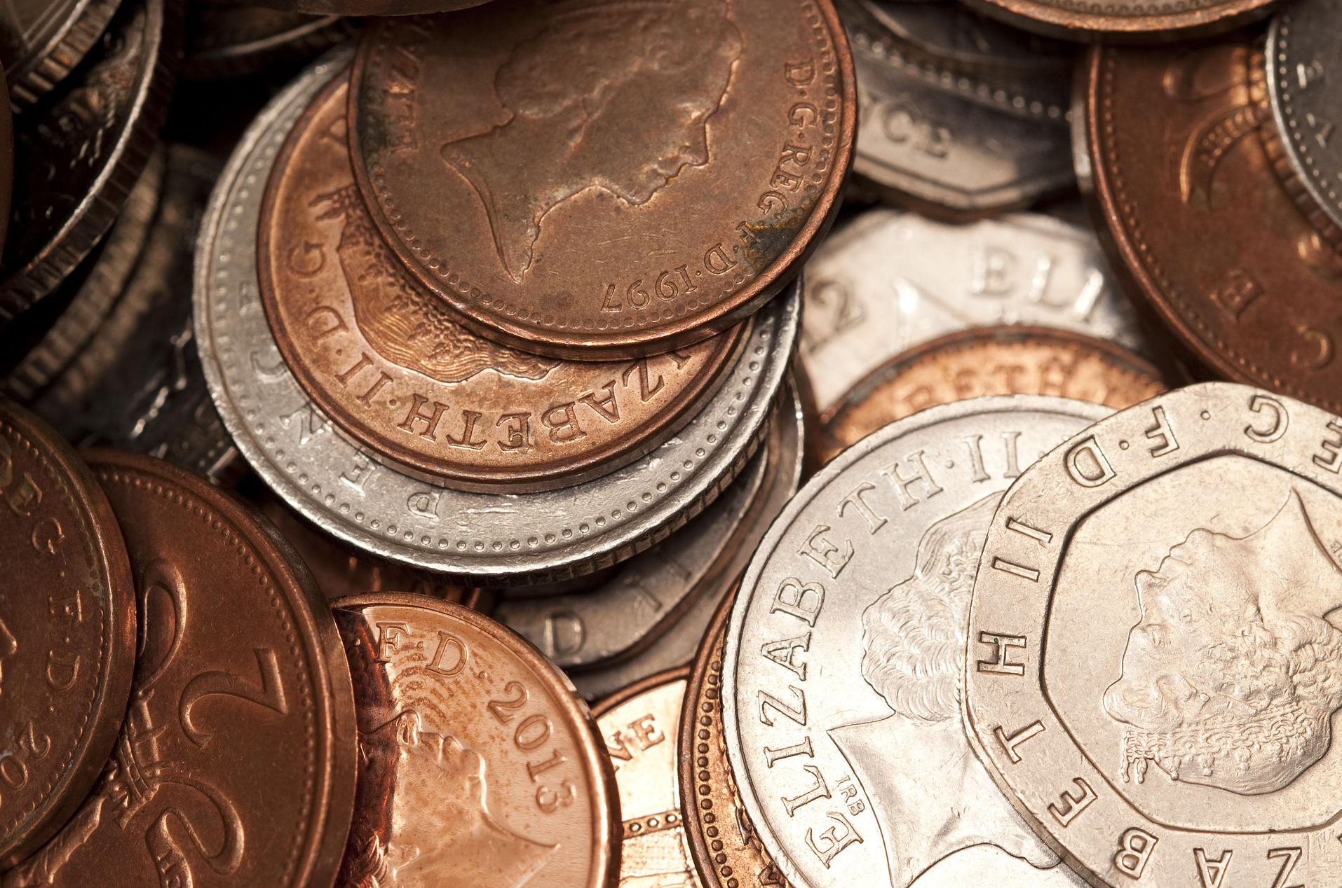
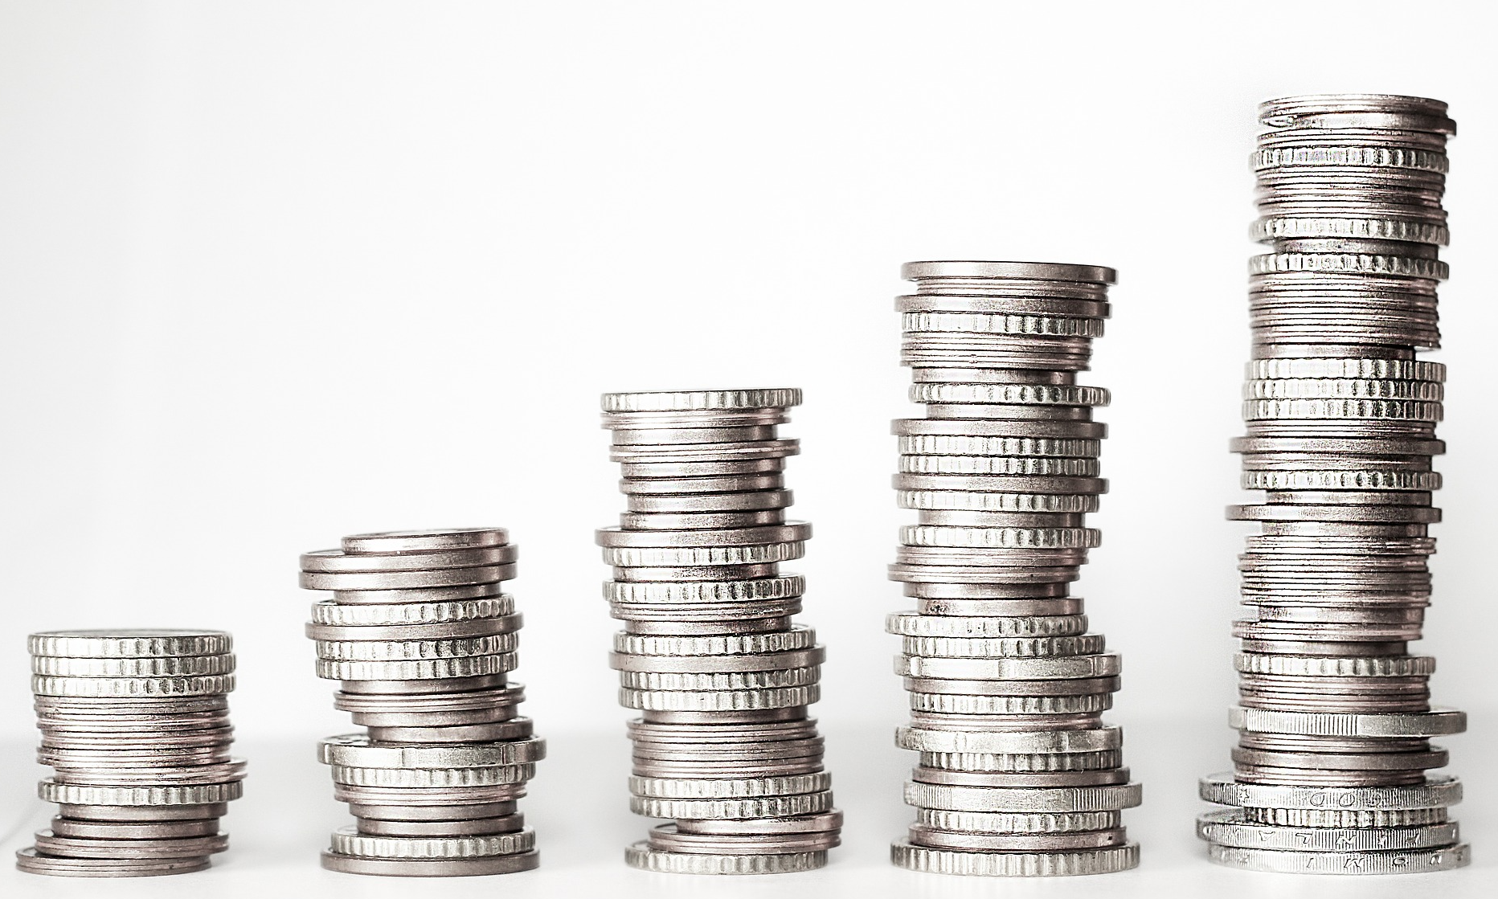

Money

1. The cake costs 20p. You have £1 how much change would you receive.

80p – C
60p – A

2. The pencil costs 50p. You have 70p, how much change would you receive?

35p – S
20p – O

3. The ruler costs 70p. You have £1, how much change would you receive?

45p – d
30p – I

4. The muffin costs £1, you have a £2 coin how much change would you receive?

£1 – N
£1.10 – B

FINALLY

What word can you make up from your answers?

___ ___ ___ ___

