North Lanarkshire Schools
Winter Leavers’ Conference
23-26th November 2015
This event took place from 23rd to 26th November 2015 at 101 Park Street, New College Lanarkshire and was aimed at S4-S6 pupils from all 23 secondary schools who are Christmas leavers in December 2015 or who are in their Senior Phase of Learning and looking to obtain a positive leaving destination but unsure of what direction to take.

Aim
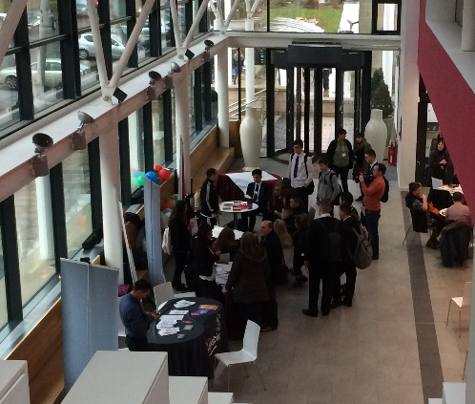
Schools were invited to send along a maximum of five young people who fell into this category and during the course of the four days the young people were exposed to a broad range of learning and employability experiences outwith the norm of the school environment. The aim and focus was to ensure young people felt valued and invested in, whilst giving them vital and current knowledge of the local labour market from partner agencies and current employers. The format varied with some sessions delivered as a conference, and others through workshops or taster sessions. 101 Park Street proved to be an ideal venue, due to the wide range of top class facilities and breakout space. The overall conduct of the young people is to be commended as they engaged both formally and informally with partner organisations and employers to gain more information for themselves and developing skills for life and work in the process.
Young people engaging with Street league during breakout session.

Partners Involved
LAGTA (Employer)
Amey (Employer)
Mears (Employer)
CMS Windows (Employer)
Voluntary Action NL
CLD - Activity Agreements
Skills Development Scotland
Street League
The Prince’s Trust
SkillForce
Regeneration Services
Routes to Work
Citizens Advice
New College Lanarkshire
Schools Involved
Airdrie Academy
Bellshill HS
Braidhurst HS
Caldervale HS
Chryston HS
Clyde Valley HS
Coatbridge HS
Cumbernauld Academy
Greenfaulds HS
Kilsyth Academy
Our Lady’s HS (Motherwell)
St Aidan’s HS
St Ambrose HS
St Andrew’s HS
Taylor HS
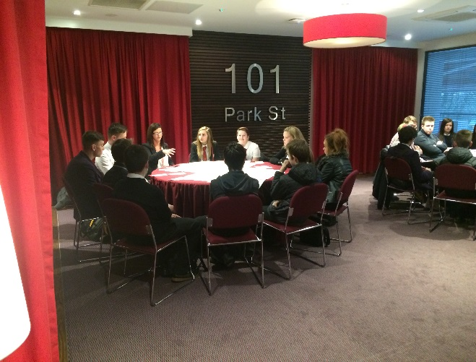
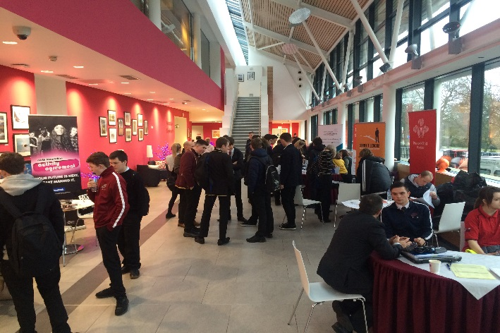
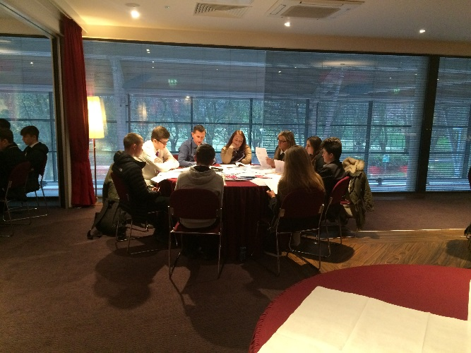
Over the four days pupils received inputs from partner organisations such as Regeneration Services, Skills Development Scotland, Routes to Work, Activity
Speed networking session with New College Lanarkshire.
Agreement Staff, Citizens Advice and Voluntary Action North Lanarkshire alongside organisations such as The Prince’s Trust and Street League as well as talks from New College Lanarkshire regarding entry routes and courses starting in January 2015. At times this was performed in the manner of speed networking to provide pupils with some information regarding these organisations, and then allowing further knowledge to be gained in smaller groups with an employability focus. Alongside these talks and workshops, the young people were offered tasters in Dentistry, Accounting & Administration, tours of the New College Lanarkshire Coatbridge Campus and were also able to opt into an Emergency First Aid award SCQF Level 5, provided by SkillForce. All 24 pupils who under took this course successfully obtained a certificate which lasts for 3 years.
Pupils enquiring about Activity Agreements and waiting to speak one to one with a local employer.

Linking in with local businesses, the young people heard from representatives from LAGTA, CMS Windows, Mears and AMEY regarding how they work with young people and the wide range of opportunities available highlighting the benefits of becoming a modern apprentice and gaining an insight into what employers look for currently from young people.
Gaining information about North Lanarkshire’s job portal.

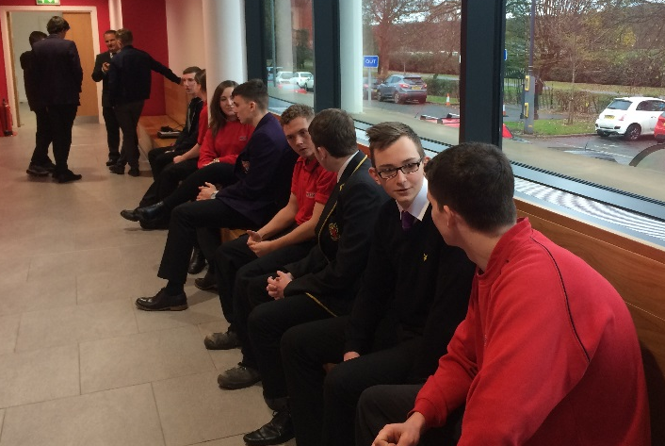
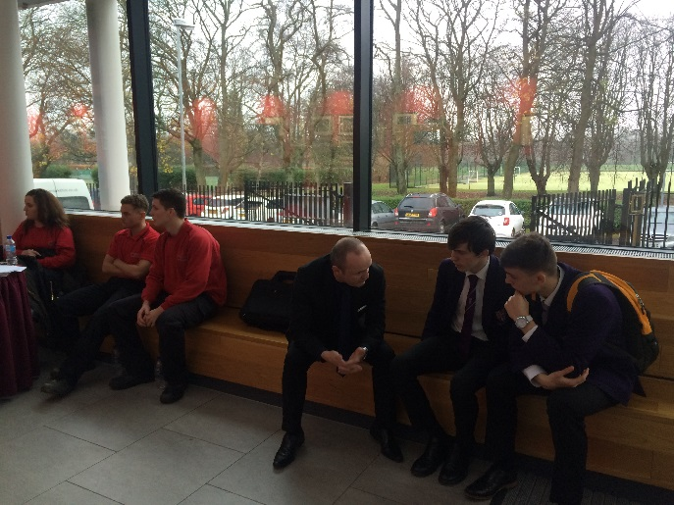
After each session the young people were encouraged to take part in a question and answer session to gain more information about each company and current employment opportunities, with further opportunities being made to allow pupils to access these companies on a one to one basis. On the last day, Mears presented four modern apprentices from a range of sectors and at various stages of their employment journey to allow our young people to gain further useful insight into the world of work. A young female plumbing apprentice was a positive role model, supporting the gender equalities agenda. In the afternoon pupils were afforded the opportunity to sign up for the portal to view current vacancies within North Lanarkshire, to obtain further experience writing CVs or to take part in mock interviews, gleaning feedback from the partner agencies. By the end of the week, young people felt better informed and more confident in following pathways outwith school.
Chatting with some Modern Apprentices from MEARS.
Meeting Business Development Manager from Amey.

Statistics

Out of the 23 mainstream schools invited, 15 schools sent young people along. A total of 59 young people attended on the first day and 51 attended on the last day. Of that number: 18 young people indicated they were looking to leave at Christmas 2015. 22 indicated they intended to leave in summer 2016; 1 intends to leave in June 2017; 3 at the end of S6; and 7 did not respond to this question. Of the pupils questioned: 7 are looking to become electricians; 6 non-specific college courses; 5 non-specific trades or apprenticeships; 7 Childcare; 2 joiners; 1 paramedic; 1 police; 1 army; 2 construction; 1 welding; 1 marine Engineer; 1 wants a job; 2 hairdressing; 1 make-up artist; 1 air hostess;1 computing course at College; 1 Street League and 10 did not answer.

Equalities

Of the 59 young people, 38 were male and 21 female. Information provided by schools prior to event indicated only one pupil had general learning difficulties with significant dyslexic tendencies.

Feedback

Feedback from young people indicated they enjoyed the event, and felt the venue was ideal for the event. In terms of timing, the majority of young people felt four days was good with sessions times being just right in terms of timing and length. The teambuilding sessions were seen as favourable and enjoyable, however for some youngsters day 1 was too inactive, although as the week progressed the presentations became more practical, interactive and enjoyable.

“It was very suitable, held us all and plenty of space to sit at lunch and breaks.” Pupil

“The length of the event was good as we learned a lot of information that will help us once we leave school.” Pupil

The majority of pupils enjoyed the tasters especially the dentistry.

“Dentistry was good and interesting.” Pupil

Overall the event was enjoyed by the young people and they felt it useful in developing their knowledge and would want to do it again.

“Mears talk– very interesting, made me feel more confident about going into an interview.” Pupil

“MA talks with mock interviews – it was useful information.” Pupil

During the de brief session it was noted by partners that there was a marked improvement from the young people in their confidence levels throughout the week. Partners also enjoyed the opportunity to work together with each other and find out more about other services, whilst getting the opportunity to see them in action too.

“The event made it real for the young people, this is your future, these are positions and jobs within North Lanarkshire for North Lanarkshire youngsters” Regeneration Services

“An enjoyable programme to be involved with and the young people worked hard to ensure they gained maximum benefit from the training on offer.” Skillforce instructors

Feedback from a careers advisor within one school suggested that some of the pupils who attended had already become non-attenders at the school and that communication between themselves and these young people since the event had improved and that they were exactly the correct pupil to have the opportunity to attend the event.

Positives Outcomes

- To date seven young people have obtained interviews for Modern Apprenticeships as a result of contact made during this week.
- Attendance and active participation in sessions remained consistently high throughout the week.
- Positive interactions between young people and all staff involved.
- Broad range of relevant employability activities on offer and young engagement in them.
- Staff from schools, businesses and partners networking too to gain knowledge of each other.
- 101 Park Street staff were as always very flexible and accommodating to changing needs and ensured rooms were set up as required.

Areas for Consideration

ICT was an issue as the Library had been double booked which meant the portal sessions on the Tuesday could not go ahead as planned.

More information to speakers with a clearer focus and possibility of presentations been shown beforehand to avoid repetition of information.

Having a team building session earlier on the Monday to allow young people to get to know each other so that in group session or talks they felt able to talk out or ask relevant questions for themselves.

Access to more training providers so there is a wider range of partners on display along with more access to local business in a variety of different fields so more areas of interest made available to young people.

The possibility of a general registration form for young people to complete at the start of day 1 to ensure partners could link in further with their individual needs and interests.

Next Steps

All in all the event was a huge success. Future proposals include:

- A summer leavers’ event over 5 days, with day 5 being an optional elective for hands-on sessions either with college at one of the three campuses, and hands-on sessions in the place of work

- Talks from college students regarding their journey
- More visits to different faculties within college
- More input from local businesses
- More team-building sessions especially on day one at beginning of day
- Taking into account equalities and seeking further information from schools regarding this
- ½ Day event for school staff to meet partner agencies so that there is a better understanding of what there is available within North Lanarkshire.

North Lanarkshire’s future workforce!

