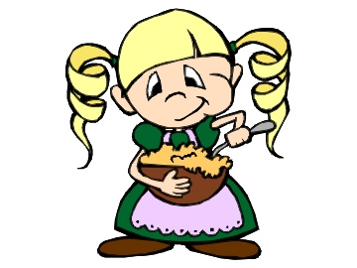
Insulating Porridge
Poor Goldilocks thinks the temperature of Baby Bear's porridge is perfect, but she is exhausted. Goldilocks is looking for a way to keep her porridge at the same temperature while she goes for a nap, can you help her?

Materials | Starting Temperature | Temperature after 15 minutes | Temperature after 30 minutes | Temperature after 45 minutes | Temperature after 60 minutes
What materials do you require? | What temperature was your porridge to begin with? | What temperature was your porridge after 15 minutes? | What temperature was your porridge after 30 minutes? | What temperature was your porridge after 45 minutes? | What temperature was your porridge after 60 minutes?
Page Break
Can you draw a graph that clearly shows Goldilocks how well your insulator did? Don't forget to add your title and labels.

