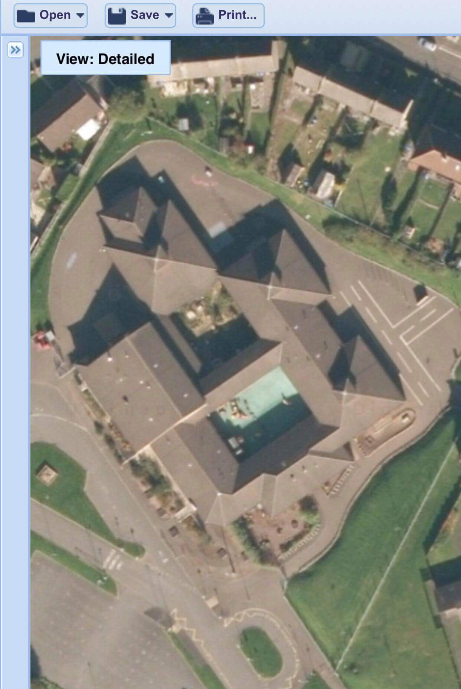

Housing Development

Fencing around the perimeter

Nursery play space

School garden

Staff car park

Entrance to school grounds