**Adobe Express for Education**

Launching for Perth and Kinross Council Education on Wednesday 18th September

We are delighted to let you know that launch Adobe Express for Education will be available to PKC education staff and learners within Glow.

From Wednesday 18th September, all PKC Glow users will have access to Adobe Express for Education for free.

[Adobe Express for Education](https://www.adobe.com/education/express/) is a web-based and mobile app suite that provides students and practitioners with tools to create and share engaging visual content such as

* **Eye-catching graphics and social media posts**
* **Informative presentations and videos**
* **Websites and web stories**
* **Collages and photo edits**

**Why would I use it?**

* **Ease of use:** The interface is simple and intuitive, even for young students. No need to be a design pro to create something awesome.
* **Templates and inspiration:** There are tons of pre-made templates and design elements to get you started, plus access to Adobe Stock photos and royalty-free music.
* **Collaboration:** Work on projects together with classmates or colleagues in real time.
* **Free for Education:** Adobe Express for Education is completely free to use.
* **Ease of access:** Single sign on experience within Glow

**Potential benefits of using Adobe Express for Education**

* **Boosts creativity and engagement:** Students can bring their ideas to life in a visually appealing way, which can make learning more fun and effective.
* **Develops essential skills:** Students learn valuable skills like digital literacy, communication, and collaboration.
* **Enhances presentations and projects:** Students can create presentations and projects that are more visually interesting and impactful.
* **Promotes teamwork and communication:** Students can work together on projects, which can help them develop teamwork and communication skills.

**How do I get Started?**

From Wednesday 18th September, an Adobe tile will appear on all PCK Child Establishment dashboards. (If you cannot see this, search the app library for ‘adobe express.’)

When clicking this tile, you will be automatically logged in to adobe express.

On your first log in, it will ask you if you are a student or educator. (This can be changed.)

You will then be directed to your launch pad where you will be able to access a wealth of features to use with your learners. As you have selected ‘educator’ you will see an area of educator resources here which are full of lesson plans, editable templates and professional learning opportunities.

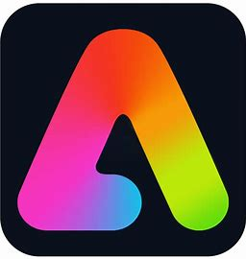**For iPad use:**

Navigate to Adobe Express App.

Choose ‘sign in’ and log in with your Glow Credentials.

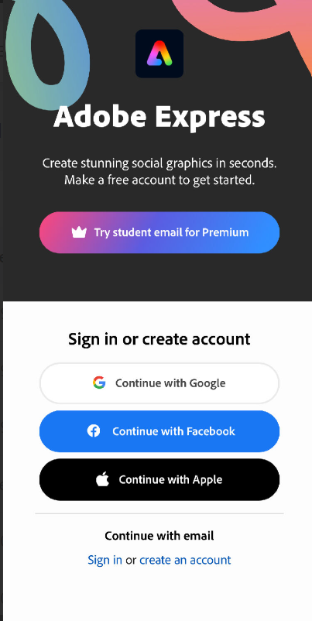

**Where can I find support?**

**Practical Support**

##### What can I Create? Selection of ideas outlining what you can create in Adobe Express [Click here to find out more](https://glowconnect.org.uk/docs/adobe-express-for-education/what-can-i-create-using-adobe-express-for-education/)

##### Self-paced Learning - Search and filter the selection of self-paced professional learning content [Click here to find out more](https://edex.adobe.com/search?type=professional-learning&template=showAll&product=Adobe%20Express)

##### Teacher Professional Learning Events - Learn how to use Adobe Express to bring creativity into your classroom [Click here to find out more](https://docs.google.com/forms/d/e/1FAIpQLScFGmYDJmJbuTyqAthMg7DNClE6yXZ3yjrcF_eeS-SpmqPftg/viewform)

* Glow Connect link**:** [Adobe Express for Education Glow Connect Knowledge Hub Article](https://glowconnect.org.uk/docs/adobe-express-for-education/adobe-express-for-education/)

**Lesson Content**

* Lesson Plans - Download UK lesson plans with video tutorials and supporting resources - [Click here to find out more](https://edex.adobe.com/uk-resources)

##### Live Lessons - Join weekly live lessons on important calendar themes which will talk your learners through how to create themed projects. [Click here to find out more](https://docs.google.com/forms/d/e/1FAIpQLSc0jcxfYZhHq7ClUXvvUOVVBUVxAMELJVNmaOuh2cXzfooyqQ/viewform)

##### Youtube lessons - [Lesson Plans - Adobe Express - YouTube](https://www.youtube.com/playlist?list=PLRzO12Ny6FC7u6GdcIIOHyYF64-sDl3V1)

##### Drawing lessons = [Drawing With Kyle Webster - Adobe Express - YouTube](https://www.youtube.com/playlist?list=PLRzO12Ny6FC6yZBkgpV8JtF1wG_0A2jE8)

Although we will be providing support within the DigiLearnPKC team, keep an eye on @GlowScot and @adobeforedu on X (Twitter) for updates on all of the above.

See following posters for events on in Terms 1 & 2.

