


Digital
Skills

for
Scottish Educators

September 2026 (updated)

Contents
Introduction 3
Cyber resilience and data security 4
Device and account security 4
Data sharing and security 4
Social media 4
Device and app essentials 5
Devices 5
Apps 5
Physical health (Health and Safety Executive Guidance) 5
Communicating 6
Accessing and sending emails 6
Online messaging and video-calling platforms 6
Families and learners 6
Online services and accounts 7
Work systems 7
Web content, media and services 7
Cloud storage 7
Finding and checking information 8
Reliable sources of information 8
Search engines and generative AI, such as Google Search or ChatGPT 8
Misinformation and disinformation 8

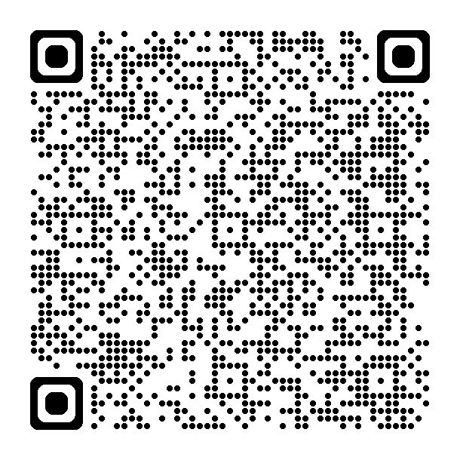
Use the link, or scan the QR, to take the survey and check your skills and knowledge:

https://forms.cloud.microsoft/e/Mc94uLy9Uf

Introduction

Context

This document is an evolution of the Teacher Digital Skills Toolkit (2023) and is designed to be suitable for all educators, whether early learning, schools or community based. It aims to provide guidance on the essential digital skills that can be required for day-to-day work in education and learning. The guidance is based on the UK Government Essential digital skills framework (UKEDS) and would align with the proposed Scottish Government Minimum Digital Living Standard (MDLS).
Defining these skills allows educators to judge their basic digital skills and for education or learning providers, such as local authorities, to measure the development and improvement of such skills.
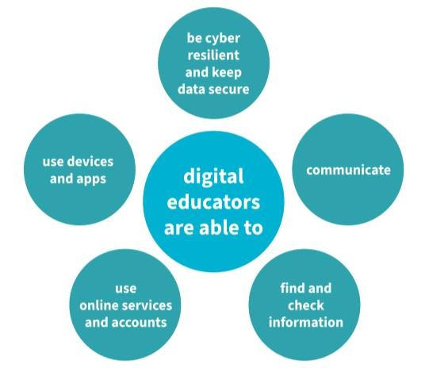

Educators

This guidance is suitable for all educators in Scotland. These are the basic skills that underpin education and learning in any sector and there are additional toolkits for early learning and childcare, primary, secondary and community learning and development. These additional toolkits provide advice and examples on using digital skills in sector-specific learning contexts, such as ‘accessibility tools in a primary school’.

Educators and employers can use it to underpin professional learning and to support staff to develop their digital skills. More confident educators might use this to evaluate their own skills and identify next steps for professional development.

Education Scotland will provide training and professional learning to further develop skills, knowledge and confidence with digital skills. Due to the autonomy of education and learning providers, and how they manage devices, networks and platforms, we would recommend that those organisations provide training that covers such skills and knowledge that are specific to them.

Cyber resilience and data security

Educators should be able manage their accounts and devices to keep them secure. Throughout this document purple text and the label [cyber] is used to highlight skills and knowledge which require some consideration of cyber resilience and data security.

Device and account security
Although it is an employer’s responsibility to set up devices and install apps in most cases, educators should be able to use these systems securely, including:
- allowing devices to update when prompted
- securely login to accounts, such as email with a username and password
- report suspicious emails, such as phishing, to IT staff in your organisation
- create passwords using three random words and any other requirements, such as using lower- and upper-case letters, numbers and symbols
- use a second device or account to receive codes when a website provides 2-factor authentication (2fa) and input the code to access the associated account
- reset a password when required, such as when forgetting it

Data sharing and security
Every employer will have rules designed to keep sensitive data secure and educators should follow these rules to ensure that they:
- know employer rules on handling sensitive data, especially about educational establishments and learners
- only share other people’s data online with their consent, including on social media
- understand that online content, such as images and documents, belong to others and using them without their permission is subject to copyright and intellectual property legislation
- can use apps’ media libraries and search engines to find open-source images and videos that are copyright free and can be used by others

Social media
There are no rules forbidding educators from using social media but each registration body (Scottish Social Services Council (SSSC), The General Teaching Council for
Scotland (GTCS), Community Learning and Development Standards Council (CLDSC)) provides guidance on how they might be used. When using these platforms to post and share content and messages publicly educators should:
- apply privacy settings to personal social media to ensure only friends can see posts and shared content
- ensure posts on social media are not offensive or inappropriate, considering how it may reflect on their position or profession, and be mindful of unintended consequences in using it
- seriously consider the use of social media for ‘work’ and regulate who likes, follows and shares content – this should focus on reaching the intended audience

Device and app essentials

Educators should be able to use devices and apps that are common to their setting and role, such as:

Devices
When using devices, educators should be able to
- turn on the device and enter any account information as required
- use a mouse and keyboard on a computer, use a touch screen on a smart phone or tablet
- use settings menus to change device display to make content easier to read, such as increasing text size, changing background colour or adjusting screen brightness
- use additional accessibility features, such as screen readers, speech-to-text typing and captioning of videos
- find applications by choosing the correct icons on the home screen, including the web browser icon
- connect a device to the internet using the Wi-Fi settings, and insert the password when required [cyber]
- keep login information for a device and any websites secure, not shared with anyone or written down and left prominently near the device [cyber]

Apps
Educators should be able to use a range of apps:
- to create a document with text and images, such as Word or PowerPoint
- to edit media, such as photos and videos, using in-app tools like trim, crop and filters
- to send photographs and other documents, such as a Word doc, as an email attachment [cyber]
- to share and edit a document in collaboration with colleagues, such as Word or OneDrive [cyber]
- to manipulate and analyse data or plan the cost of a project, such as in Excel
- to use ‘AI assistants’ to analyse, change, review and generate text and content
- including in-app ‘AI assistants’ to summarise emails, transcribe calls and meetings or review text and suggest changes

Physical health (Health and Safety Executive Guidance)
Educators who may use devices for an extended period should consider their physical wellbeing and ensure they have regular breaks. This knowledge should also be shared with learners in the context of their health and wellbeing:
- eye breaks
- movement breaks
- stretching at desk
- seating position

Communicating

Educators should be able to communicate and collaborate with colleagues by:

Accessing and sending emails
Email, such as Outlook, is still used to communicate with colleagues and external partners and educators should be able to:
- use a shared calendar to view schedules, arrange meetings and schedule video calls (Teams)
- use the email address book of the organisation to send emails to colleagues
- take care with who emails are sent to, such as reply all, BCC and CC fields
- send or share photographs and other documents, such as a Word doc, as an email attachment or cloud link [cyber]

Online messaging and video-calling platforms
Workplace apps, such as Teams, are becoming more common to message and call colleagues and external partners, and educators should be able to:
- set up a meeting for a video call and invite others to join
- join and manage a Team, including adding and removing members or changing their permissions
- post messages, media and links to group spaces [cyber]
- be able to use screen sharing to present information to others
- use translation or transcription tools to make calls more accessible

Families and learners
Where required, these skills may be applied to communicate with learners or families but should follow employer guidance on why, how and what to communicate, such as:
- preferred/official platforms and channels, not personal devices, platforms or time
- agreed expectations on frequency of, and suitable times for, contact to ensure there is no ‘out of work hours’ burden on individuals
- safe and legal communications and sharing of content

Online services and accounts

Educators should be able to register and apply for and manage services online, such as:

Work systems
Educators should be able to use employer systems to:
- set up online accounts for services provided by employer, organisation or a registered body
- access salary and expenses information digitally including password-protected payslips
- submit requests for annual leave, record absence from work or submit expenses claims online

Web content, media and services
Educators should be able to use a range of websites to find information, access media and make bookings, including:
- use the internet to legally access content including films, music, games and books
- using tabs and windows to view multiple webpages at the same time
- use bookmarks to save and retrieve information on a web browser
- use web browsers to access different accounts associated with services, especially on employer-managed devices
- using private browsing to access different accounts when signed in to the web browser on an employer-managed device
- use the help, FAQ section or chat facility of a website to work out how to fix an issue with a device
- find out how to do something by using a tutorial video, such as those found on YouTube
- use websites and apps to book tickets and make reservations
- complete online forms, such as an evaluation or to apply for funding

Cloud storage
Educators should be able to use online storage apps, known as the cloud, such as OneDrive, to:
- organise the information and content, on their device or the cloud, using files and folders
- create and share documents though web-based applications, such as Word or OneDrive [cyber]
- access, edit and save online document in collaboration with colleagues [cyber]

Finding and checking information

This guidance has been developed in partnership with the Chartered Institute of Library and Information Professionals in Scotland (CILIPS). Educators should be able to access online services and content, manage online storage and find and check information, including:

Reliable sources of information
Educators should understand that anyone can put information online and that they should use reliable and verifiable sources when seeking information, and that they should:
- go to a reliable and trusted source of information from relevant sites, such as news from the BBC or Associated Press, health from the NHS or statistical data from the Scottish Government
- use peer-reviewed research, including from journals, which can be accessed using libraries, such as the National Library for Scotland
- understand that Wikipedia is a source where valuable information is robustly scrutinised and fact-checked, or sites like it, but it is expected that sources of information are checked using links to external sites

Search engines and generative AI
When unsure of the best place to find information on a subject, educators may choose to use a search engine, such as Google, to search the web but should be:
- aware search engines informed by advertising, trending use of sites and can point to unreliable and inaccurate information as well as reliable sources
- aware that most search engines provide an ‘AI overview’ in the search returns and this may not be accurate or verified information

Misinformation and disinformation
Unfortunately, information on the web, just as in the physical world, can be wrong by accident or on purpose and educators should:
- understand that the web and social media contain misleading information that may be incorrect (misinformation) and contain deliberately misleading or false information designed to cause harm (disinformation)
- contact a librarian or similarly trusted professional if they are unsure of the online information


Education Scotland

Denholm House
Almondvale Business Park
Almondvale Way
Livingston
EH54 6GA

T +44 (0)131 244 4330
E enquiries@educationscotland.gov.scot

www.education.gov.scot

© Crown Copyright, 2026

You may re-use this information (excluding images and logos) free of charge in any format or medium, under the terms of the Open Government Licence providing that it is reproduced accurately and not in a misleading context. The material must be acknowledged as Education Scotland copyright and the document title specified.

To view this licence, visit http://nationalarchives.gov.uk/doc/open-government-licence or e-mail: psi@nationalarchives.gsi.gov.uk
Where we have identified any third party copyright information you will need to obtain permission from the copyright holders concerned.

