Cyber resilience and internet safety  (QR code to Support and examples) |  | What am I doing? | How well am I doing it? | What should I do next?
Protecting devices
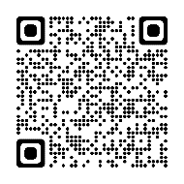 | To protect devices and digital content, and to understand risks and threats in digital environments.  To understand safety and security measures and to have due regard to reliability and privacy.
Protecting personal data and privacy
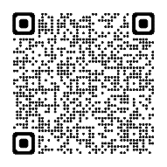 | To protect personal data and privacy in digital environments.  To understand how to use and share personally identifiable information while being able to protect oneself and others from damages.  To understand that digital services use a “Privacy policy” to inform how personal data is used.
Managing digital identity
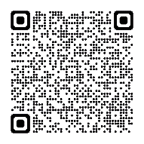 | To create and manage one or multiple digital identities(separate work and personal), to be able to protect one's own reputation, to deal with the data that one produces through several digital tools, environments and services.
Resilience
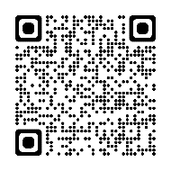 | To know how to recognise, react and recover appropriately to incidents involving devices, data, wellbeing and identity in relation to yourself and others.

Information and Data Literacy  (QR code to Support and examples) |  | What am I doing? | How well am I doing it? | What should I do next?
Browsing, searching and filtering data, information and digital content
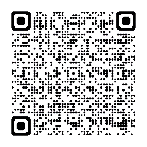 | To articulate information needs, to search for data, information and content in digital environments, to access them and to navigate between them.  To create and update personal search strategies.  To be able to evaluate content to understand whether you have the right to use it and how to search for free to use content.
Evaluating data, information and digital content
To analyse, compare and critically evaluate the credibility and reliability of sources of data, information and digital content.
To analyse, interpret and critically evaluate the data, information and digital content and the impact of algorithms/systems on this.

Managing data, information and digital content
 | To organise, store and retrieve data, information and content in digital environments. To organise and process them in a structured environment.

Communication and collaboration  (QR code to Support and examples) |  | What am I doing? | How well am I doing it? | What should I do next?
Interact through digital technologies
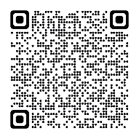 | To interact through a variety of digital technologies and to understand appropriate digital communication means for a given context, for example with learners, other teaching staff and/or parents/careers.
Share through digital technologies
 | To share data, information and digital content with others through appropriate digital technologies, for example with learners, other teaching staff and/or parents/carers. To act as an intermediary, to know about referencing and attribution practices.
Collaborating through digital technologies
 | To use digital tools and technologies for collaborative processes, and for co-construction and co-creation of resources and knowledge with learners, other staff and parents /carers.

Pedagogy in a digitally enabled learning in environment (QR code to Support and examples) |  | What am I doing? | How well am I doing it? | What should I do next?
Planning. teaching, learning and assessment
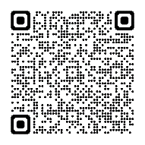 | To have the skills, knowledge and confidence set out in the Features of highly effective digital learning and teaching document to use digital technology to, plan teach and assess learning.
Developing digital content
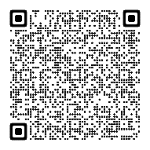 | To create and edit digital content in different formats. To be aware of how copyright and licences apply to data, information and digital content, including whether you have the right to use digital information. How to find free to use content and the importance of referencing and attribution.
Integrating and re-elaborating digital content
 | To modify, refine, improve and integrate information and content into an existing body of knowledge to create new, original and relevant content and knowledge.
Digital Resilience
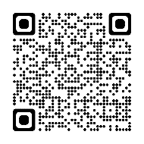 | To have the skills, knowledge and confidence to prepare digital technology for use with learners. To react, respond and recover to problems when operating devices and using digital environments.
Digitally enabled learning environments
To make effective use of digital environments in order to increase access to the curriculum.
To provide, and continue to develop, simple and streamlined processes to engage with learners and peers.
To make use of automation when appropriate to process and manage data and repetitive tasks
Identifying needs and technological responses
 | To assess the needs of all learners and to identify, evaluate, select and use digital tools and possibly assistive technology to support these. To adjust and customise digital environments to personal needs (e.g. accessibility).

Career long professional learning and leadership (QR code to Support and examples) |  | What am I doing? | How well am I doing it? | What should I do next?
Identifying digital competence gaps
To understand where one’s own digital competence needs to be improved or updated.
To be able to support others with their digital competence development and be able to advise how to improve.
To seek opportunities for self-development and to keep up-to-date with the digital evolution.
Research and evidence informed practice
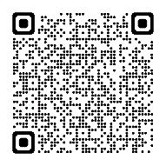 | Engage with the main theoretical perspectives and research in the digital learning domain.  Be critically aware of the evidence and impact that digital tools, spaces and cultures can have on childhood and society and how digital learning and teaching can adapt to meet the needs’ of learners.
Practitioner enquiry
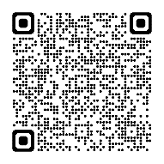 | To engage in self and collaborative review to measure the impact of digital tools and technologies.  To produce and share practitioner enquiry into the use of digital tools and technologies.

