Use Case 1: Departmental Trios/Groups Across LAs/RICs

Quality Assurance using Teams and OneNote

- Form trios of subject departments from different schools in a local authority or regional improvement collaborative.
- One person from each department uploads learner evidence to OneNote.
- All members of the departments join the team to access the OneNote
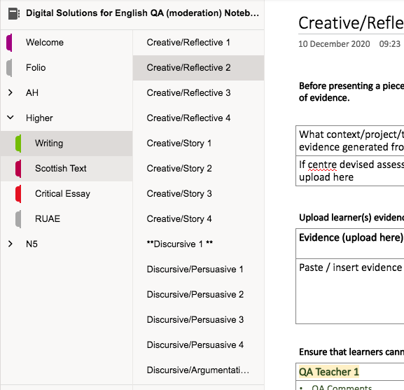
School A department
School B department

School C department

Arrange who will quality assure what evidence. This can be done asynchronously or live. Use the meeting functions within teams to enable peer discussion.

Asynchronous Example
Identify who from each department will quality assure what evidence

Teacher QA Trios | Pages to Quality Assure
Teacher 1 (School A)  Teacher 1 (School B)  Teacher 1 (School C) | Higher Writing Creative Story 1  Higher Writing Creative Story 3
Teacher 2 (School A)  Teacher 2 (School B)  Teacher 2 (School C) | Higher Writing Creative Story 2  Higher Writing Creative Story 4

Live Example
All members of the departments arrange a live meeting.
Use breakout rooms to group teachers into trios

Specify what breakout room will look at what pages eg
Breakout Room | Pages to Quality Assure
1 | Higher Writing Creative Story 1  Higher Writing Creative Story 2
2 | Higher Writing Creative Story 3  Higher Writing Creative Story 4
3 | Higher Writing Discursive / Argumentative 1  Higher Writing Discursive / Argumentative 2

All teacher comments and discussion recorded on appropriate OneNote page

Use Case 2: Single Person departments across LAs/RICs

Quality Assurance using Teams and OneNote

In smaller local authorities or single person departments in local authorities / regional improvement collaboratives, each person would be responsible for joining the team and uploading evidence

Teacher A
Teacher B
Teacher C
Teacher D

Arrange who will quality assure what evidence. This can be done asynchronously or live. Use the meeting functions within teams to enable peer discussion.

Asynchronous Example
Identify who from each department will QA what evidence

Teacher Groups | Pages to Quality Assure
Teacher A  Teacher B | Higher Writing Creative Story 1  Higher Writing Creative Story 3
Teacher C  Teacher D | Higher Writing Creative Story 2  Higher Writing Creative Story 4

Live Example
All members of the team arrange to a live meeting.
Use breakout rooms to group teachers into trios/duos

Specify what breakout room will look at what pages eg
Breakout Room | Pages to Quality Assure
1 | Higher Writing Creative Story 1  Higher Writing Creative Story 2
2 | Higher Writing Creative Story 3  Higher Writing Creative Story 4
3 | Higher Writing Discursive / Argumentative 1  Higher Writing Discursive / Argumentative 2

All teacher comments and discussion recorded on appropriate OneNote page

Use Case 3: Whole School

Quality Assurance using Teams and OneNote

Create a PLC Team, with all staff as members. Set up the PLC Notebook as follows:

- Create Section Groups for each subject. (must be done via OneNote desktop app)
- Within each Section Group, create appropriate sections for courses

Each staff member/department uploads learner evidence to an appropriate page within the subject section

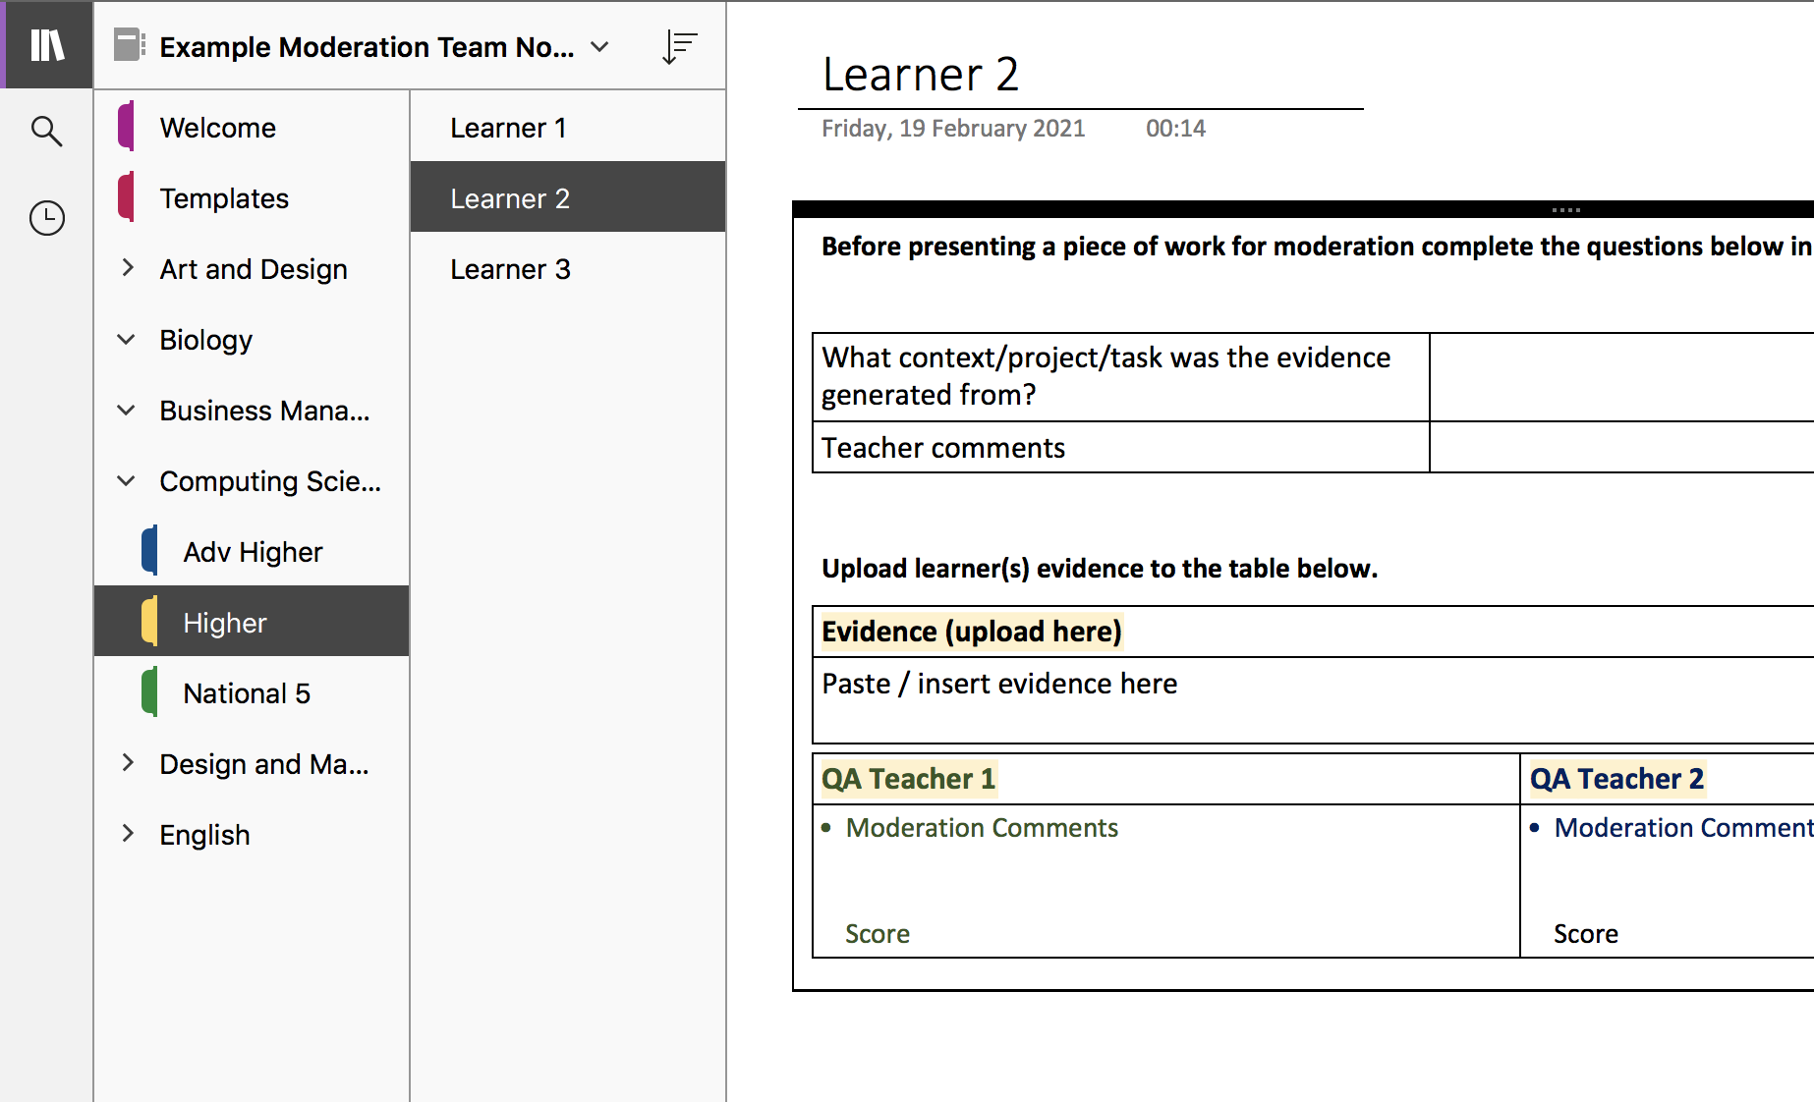
Upload
Art staff
Biology staff

Business Management staff

Computing Science staff

- Learner evidence uploaded to an appropriately named page within te appropraote subject and section. Any quality assurance comments/discussions done between staff members can be recorded on that page

- Staff who engage with quality assurance work involving other schools/local authorities can also record evidence of that in here.

