Video Reflection Exercise: Responsive Interactions

This video reflection tool can support reflection on your interactions with babies or children

Do
Make a short (under three minute) video clip of yourself interacting with a child or group of children in your setting. Ensure this is a child-led activity and you have been invited to join the play (indirectly or directly). It is more difficult to be responsive during adult-led tasks which build language skills in a different way e.g. baking or reading a story to a group of children.

Watch
Watch the video twice

The first time reflect on the following:
- What did you like about the video?
- What did you notice about the interaction?
- How did the child/ren respond to your interaction style?
- How do you think the child/ren felt during the interaction?

Write your observations here:
________________________________________________________________________________________________________________________________________________________________________________________________________________________________________________________________________________________________________________________________________________________________________________________________________________________________________________________________________________________________________________________________________________________________________________________________________________________________________________________________________________________________________________________________________________________________________________________________________________________________________________________________________________________________________________________________________

The second time notice Chatting Together behaviours in the interaction.

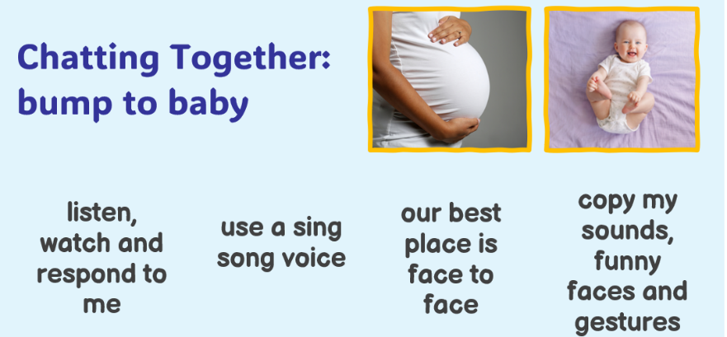
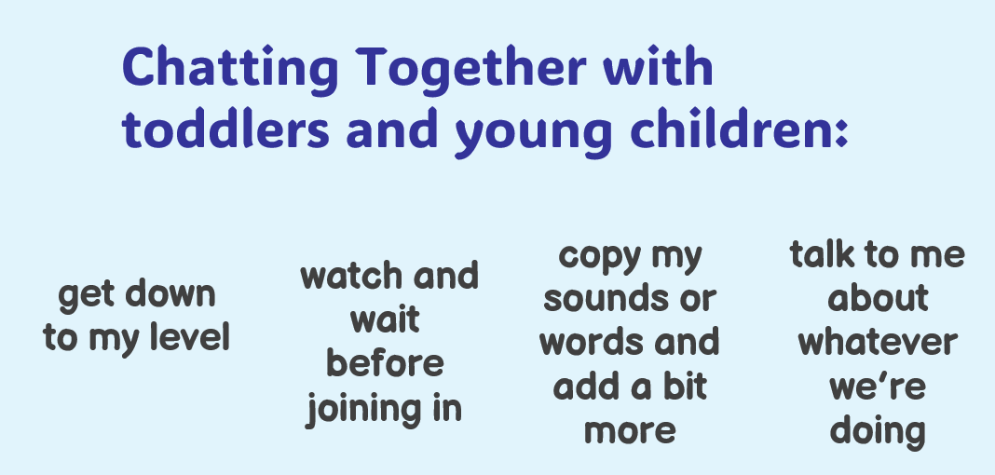

Write your observations here:
______________________________________________________________________________________________________________________________________________________________________________________________________________________________________________________________________________________________________________________________________________________________________________________________________________________________________________________________________________________________________________________________________________________________________________________________________________________________________________________________________________________________________

Reflect
What strengths have you identified in your interaction that support babies and child/ren’s language and communication development?
Are there any Chatting Together ideas you want to use more? What could you do differently next time?
__________________________________________________________________________________________________________________________________________________________________________________________________________________________________

