Speech, language and communication development in 0-3 year olds - Parental engagement.
June 2025

- Background

In the 2025 to 2026 Programme for Government, the Scottish Government has committed to reducing developmental concerns at 27-30 months by a quarter by 2030, with a particular focus on addressing inequality.

Speech, Language and Communication (SLC) forms the essential foundation of every child’s development. These skills influence a child’s ability to learn, build relationships and support their mental and emotional wellbeing. However, in Scotland, too many children, particularly those growing up in disadvantaged communities, experience preventable delays in SLC. These delays often contribute to a range of lifelong challenges, including poorer educational attainment, social isolation and increased risk of mental health difficulties.

To help achieve the Government’s aims, the National Early Language and Communication Team at Education Scotland are currently developing a National Speech, Language and Communication Action Plan. The Plan will support the early communication of all children in Scotland from prebirth to school entry, with a particular focus on those who may be at risk of speech, language and communication (SLC) needs due to social or environmental factors.

- Engagement aims

The Strategy & Insight Team, part of the Communications Division at the Scottish Government, undertook engagement with parents and carers to help inform the development of the Scottish Government’s National Speech, Language and Communication Action Plan, utilising qualitative research techniques. This explored parents’ knowledge about and attitudes towards the development of their child’s speech, language and communication skills, focusing on the following four areas:

- Parents’ understanding of their role in developing their child’s speech, language and communication (SLC) skills
- Parents’ views on whether the early years workforce understand families’ circumstances that may impact SLC development.
- Understanding when, how and what SLC development information has been shared with parents and identifying any gaps.
- Parents’ views on how they receive information and support on SLC development.

- Methodology and sample frame

The engagement consisted of five focus groups and one paired depth interview with parents and carers (both men and women), from low-income households in areas of social deprivation in Kilmarnock, Glasgow and Arbroath.
Location | Type | Number of respondents
Kilmarnock | 3 x focus groups | 18
Arbroath | 1 x focus group  1 x paired depth interview | 9
Glasgow | 1 x focus group | 7
Total number of respondents |  | 34

Respondent postcodes were used to determine level of deprivation.

SIMD quintile | Number of respondents
1 (most deprived) | 14
2 | 7
3 | 4
4 | 0
5 (least deprived) | 0
Unknown | 9
Total number of respondents | 34

All 34 respondents were caring for at least one child aged between 0 and 3 years. For some this was their only child, while other participants had additional children in and/or older than this age group. The focus groups and interview were conducted in person.

- Scope and limitations
Participants for the engagement were recruited through local authority nurseries, Five to Thrive and PEEP groups in NHS boards where speech, language and communication concerns are higher than the national average. Recruitment of respondents was achieved by contacting group leaders at venues to provide the research background, objectives and methodology, and to ask if they could arrange a focus group at the venue itself. Respondents were therefore more likely to have children with SLC development delays and to already be receiving support from the early years workforce.
Although this document will use the term parents throughout, it is important to recognise that other family members or foster carers can sometimes be the primary carer of a child. The sample for this research included a foster carer and this report aims to be inclusive of all family circumstances
Qualitative research techniques were utilised to ensure a range of different views and experiences were captured, however this approach does not provide conclusions about the number of particular views or experiences. As such, we have tried to avoid quantifying language, as quantitative research would be needed to understand prevalence.

- Key learnings

- Health visitors are key
Health visitors are largely viewed as trusted and respected figures, who are knowledgeable about speech, language and communication development. They are the first point of call for SLC help or questions, particularly when the relationship is good and the family believes the health visitor understands their circumstances.

“My health visitor can walk in and sit in the kitchen, be like, are you OK? Because she knows I'm not OK. She's built that relationship, so they should be seeing you. You almost don't have to tell her, she knows you well enough to see.”

- Stigma can be paralysing
A fear of being judged by professionals and peers on their ability to parent is a barrier to families accessing support for SLC development. Potential fears are expressed through opinions such as groups like Five to Thrive and PEEP being only for bad parents or early years professionals potentially thinking their children are not as good as other kids.

“If I go and say I'm needing help then you'll maybe see me as weak.”

- Communication is seen as a ‘natural thing’ parents don’t necessarily have to make a conscious effort to support
The importance of speech, language and communication development throughout a child’s first year needs to emphasised to new parents. There is an opportunity to help parents unpick the difference between what a baby does naturally and what they as parents need to do to help their children grow their SLC skills.

“My child is fine – they pick up all the communication stuff at nursery from the other kids.”

- Parents in areas of social deprivation have varying degrees of self-efficacy and agency to support speech, language and communication development.

Awareness of and attitudes towards supporting speech, language and communication development differ depending on individual circumstances. However, commonalities enable respondents to be classified into three groups: ‘keen’, ‘do what I can’ and ‘not a priority’.

- Speech, language and communication resources need to stand out in a crowded communications space.

Resources on speech, language and communication are being lost amongst other information for parents. Dedicated resources should be created in a variety of formats to suit all learners.

- Make things fun
Fun, interactive, visual, musical or colourful SLC resources will increase engagement and memorability.

“It's making it just fun - so it doesn't feel like homework. It doesn't feel like a chore. If it's fun, it keeps the kids entertained.”

- Parents’ understanding of their role in developing their child’s speech, language and communication skills
Communication messages (Appendix A) were shared with respondents to gauge parents understanding and reactions to these. They included messages describing the different forms communication can take, the reasons why communication is important and the benefits of this communication to both the parent and child. The sample was asked for their initial reactions, followed by their views on the importance of children developing speech, language and communication (SLC) skills and the role of parents in supporting their child’s development.
Parents were positive in their reactions to the communications phrases. There was general agreement that effective communication and speech is essential from a young age to successfully interact with others. However, some parents were unsure how to react to the phrases as they had not thought about speech, language and communication development before.
Many parents felt strongly that it was an important area for their child’s development. Some stated that SLC was as or more important than other developmental milestones, the ‘cornerstone’ or ‘foundation’ from which ‘everything else flows’. Despite that, few parents were able to immediately share examples of what they do with their child to specifically develop their speech, language and communication skills. When prompted with possible activities, some parents were able to share examples such as including mimicking facial expressions and reading books. Others said that SLC is something they should think more about and take more action with.
“You always try and get down to their level. They will mimic back.. you know when they're trying to formulate their speech...”

Many parents believed that they are responsible for their child’s speech, language and communication development. However, others, including those for whom English is a second language, mentioned that their child benefited from interactions with other children, in particular their siblings or children at nursery. Some with work commitments also acknowledged their reliance on nursery staff.

Although parental responsibility was widely recognised, across all groups parents shared the view that speech, language and communication skills come naturally to children. Many thought that SLC only requires intentional support from parents when developmental stages are not met or for parents with older children when phonics are taught. For some there was a sense their child is at an appropriate level of communication for their age, so no further support is required. A minority of parents felt that society is trying ‘too hard’ to force children to say words.

"If you have a child that’s very receptive to your natural instincts and communications, that everyday communication happens through your daily routine. You don't process or think about it until you've got to learn a wee bit more about it."

“You naturally speak to your child anyway, so you communicate with your child. I think as they develop you then start to look at things like the phonics pronunciation or saying things properly.”

Through their responses it was apparent that parents might not consider speech, language and communication until it becomes a development milestone. Parents found it difficult to assess their child’s SLC development before 12 months, and easier to prioritise other developmental areas such as physical movement and eating solids. Very few of the parents had sought SLC information online, unless a developmental issue had been considered or identified past the first year.

There were some parents who had been actively and consciously supporting their child’s SLC development in the first year. They were motivated by the knowledge of how fast a baby’s brain grows in those months. Others were aware of communications signs before the first word, such as mimicking, babbling and pointing.

For some communicating with their child could be frustrating and challenging. They described communicating with their children as like ‘learning a foreign language’ as they struggle to understand what their child is saying or the noises they are making. For parents, frustration on both sides resulted in poor behaviour from their child, including tantrums. Many were unaware that this behaviour is itself a form of communication. Some parents said they find it difficult to know if what they are doing is making a difference, as there are no immediate results.

“It can be quite frustrating sometimes to pick up on the signals, especially at that young age, about what they're trying to signal. And he was getting really frustrated by that. So as I get it is quite important to try and help them as much as you can, as you can get quite frustrated. Then they end up getting angry and annoyed.”

- Parent’s views on whether the early years workforce understand families' circumstances that may impact SLC development

Health visitors and nursery professionals were praised by parents for taking the time to really understand the families they were supporting. For many parents, positive and trusting relationships with health visitors and nursery staff were built through ongoing face-to-face relationships with individual professionals over time.

Some parents with children in nursery described the nursery professionals as an extended part of the family, that understood the children in their care almost as well as the parent.

Health visitors were praised for being available outside of the expected timeslots/required visits by extending appointments or sharing their phone number. They were also praised for recognising when extra support was needed, especially if it wasn’t directly asked for.

“She understands you and she's got good information. Sometimes she's in my house for two hours, so she must be late to the other people.”

“Was about 12:00 when my health visitor had an appointment. And I never had a shower or even a chance to wash myself because she [the baby] was up all night. (I said) would you mind taking her for 5-10 minutes so I can have my shower or even a wash. And, you know, my health visitor stayed.”

However, there were mixed experiences. A number of parents expressed disappointment at not having a consistent health visitor, with a different person arriving at every appointment. Others described their relationship with health visitors and midwives as a tick box exercise, which met the minimal expectation in terms of visits and checks but nothing more.

For some parents trust in the professional had to be earnt, particularly if there was a sensitivity to their parenting ability or their child’s development being judged by others. While there was a variety of experiences across the groups, those from minority ethnic groups were more likely to have experienced problems.

“I think it's so wrong that not all health visitors are on the same level. I think it should be. They need to be.”

“Come into my house and you ought to be someone I would actually be OK with.”

Not all professionals were prioritising speech, language and communication development. While some parents thought their health visitor or nursery was providing support and knowledge about SLC development, others described how their health visitor was prioritising physical development.

“They wanted the walking and things like that first before the communications, it wasn't like number one. And that came from the health visitor. Basically, they wanted to make sure that he was walking first.”

- Understanding when, how and what SLC development information has been shared with parents and identifying any gaps.

The table below is a timeline of the collated answers to the questions on when, how and what information parents receive about supporting their child’s SLC development.

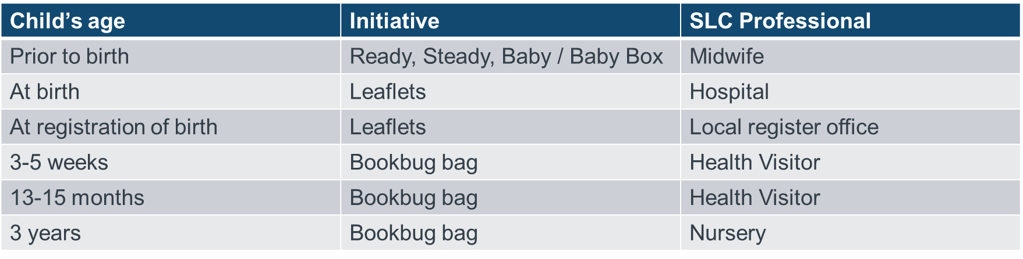
Parents also referenced the following websites as useful resources for general guidance on speech, language and communication development:
- NHS websites (including NHS Inform, local NHS boards and NHS.uk)
- Tiny, Happy People (BBC)
- Bookbug
- Parent Club
- YouTube.

However, not all parents had access to a laptop or desktop, highlighting the importance of creating content accessible on phones.

The following services and groups were identified by parents as providing additional support for speech, language and communication development in their community:
- Sparks
- NEST
- Five to Thrive
- Incredible Years
- PEEP Programme
- Speech therapists
The answers above illustrate that standard information provision relies heavily on successful interactions with early years professionals. However, as already noted, parents’ experiences of health visitors, midwifes and nurseries were inconsistent. Access to the three Bookbug bags received between 0-3 also varied, with some parents having the expected amount for their child’s age and others reporting less or none.

Parents initially struggled to answer the questions about when, how and what speech, language and communication information they had received, suggesting resources can be hidden and/or not obviously about SLC development and/or not memorable. After further probing, parents described how SLC information is provided at times when a lot of information is shared, often in resources about several different topics. Parents explained how the time straight after birth and the first six months can be an overwhelming period of adjustment, learning and new information.

Parents described discarding or overlooking leaflets or other literature (books) if they felt overwhelmed. Respondents who had literacy challenges were also likely to ignore leaflets or information provided in large amounts of text.

When asked about their families’ current SLC activities, parents predominantly shared examples of passive observation and listening, such as the child watching family members talk to each other, listening to a story or watching a video. A minority involved interaction between the parent and child. This suggests that not all parents understand the importance of interaction to develop successful speech, language and communication skills and for many, there is a belief that these necessary skills will happen through passive observation and listening.

Parental engagement with SLC information

Successful engagement with information and resources also relies on the self-efficacy and agency of parents. For example, while for many online SLC content is perceived to be plentiful and easy to access, it requires interest, willingness and the ability to seek and find trustworthy information.

The self-efficacy and agency of parents in the sample varied hugely due to individual circumstances. However, commonalities enable us to create three groups of respondents based on their self-efficacy and agency to support speech, language and communication development. These groups are titled ‘keen’, ‘do what I can’ and ‘not a priority’ in the diagram below, which describes their mindset, attitudes, challenges/drivers towards SLC support.

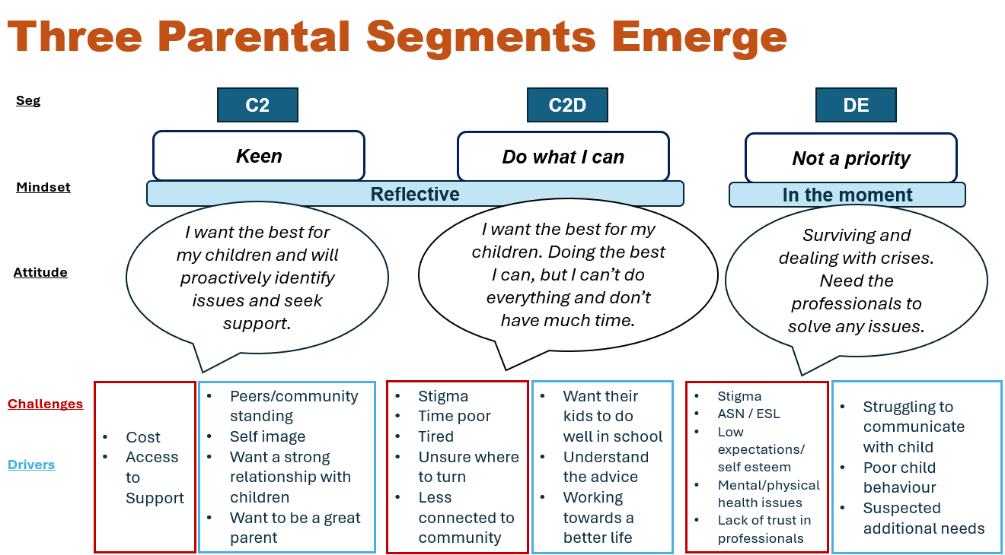

Consideration should be given in the Action Plan as to how best to target each group.

- Parents’ views on how they receive information and support on SLC development

How parents want to receive information
When asked how they want to receive information and resources about SLC development, parents had a clear preference for face-to-face delivery, suggesting parent and baby groups, or through health visitors or nurseries as effective channels. However, time poor working parents were looking for resources or communications that required little additional effort and could be accessed digitally.

“I'd be looking for resource that can be used within the community when and if needed. And that is like a drop in clinic that you talk about support and guidance”

“Delivered for each community, like via the nursery.”

“Baby massage, things like that, where you go and you attend. There's a social aspect not only for you, but for your baby as well, I think. Also what it does is it prompts the parent to be out so that then improves their mood that they're engaging their socialising.”

“For me it would be an e-mail sent to my phone like that is how I best receive information in an e-mail, because that's what I'm on every day. If that's not in front of me, I'm not logging on. You get a lot of text messages and things, GP surgeries. You know. How hard would it be? (Working mum)”

The majority of parents thought health visitors are in the best position to share SLC advice due to the trust and respect generated through an ongoing relationship with families. They are also perceived to be the most knowledgeable about speech, language and communication development. However, a minority of parents did not trust their health visitor, viewing their relationship as transactional or functional.

Other preferences for receiving speech, language and communication development information included social workers, friends and relatives, midwives, primary care teams (GPs and practice nurses), and nurseries, and were dependent on each parent’s individual circumstances.

Some found videos on YouTube very helpful, particularly those for whom English is their second language. However, a minority noted that online videos only provide passive support rather than the reciprocal interaction required in everyday communications. Others had found SLC content was often from America, resulting in their children picking up American words, phrases and pronunciation.

"Like my husband, is not talking in English. So ... my first one [son] is [going] to the nursery and he's seeing the ...YouTube Kids and he [is learning] many sentences."

"I know a lot of like the TV things you get on YouTube. It's all free, but you lose the reciprocal conversation.”

"So we use things like that with them, and then she was getting American accent, aye. But there's nothing British like."

Parents suggested that any recommended SLC development activities should be fun, as this is more enjoyable for families, more memorable and feels less like additional work. Other suggestions to make activities more memorable and engaging were including sign language, using characters from TV shows, creating a song and having a theme.

- Barriers to seeking and using SLC information and support

Stigma was the biggest barrier to parents seeking out or accessing speech, language or communication support across all groups and interviews. Some parents expressed anger or anxiety at the thought of early years or SLC professionals making negative judgements about their parenting skills or viewing the development of their child as inadequate. Some parents had concerns that being invited to a course or support group reflected badly on their ability to parent their child. There was evidence this could be overcome if support was suggested or provided by a trusted professional who understood their family’s circumstances.

“People can be quite judgy because he wasn't talking. So I don't feel that there was any help to not make me not feel that way.”

“You know if I go and say I'm needing help then you'll maybe see me as weak.”

"A lot of people put too much pressure on where the kids should be. My mom does. My mom compares my niece."

Additional barriers to providing, seeking and engaging with speech, language and communication support can be divided into personal circumstances and information available. As part of the former, mental bandwidth was a challenge for many in the group who were struggling with additional challenges such as overcoming addiction, job loss, lack of sleep and relationship breakdowns.

Parents also described having little time to focus on developing their children’s speech, language and communication skills. This was most frequently expressed by working parents, parents with three or more children, and parents looking after older relatives or family with a long-term health condition/disability.

"So it's like you [the nursery] can pick up the slack a lot.. stuff that we can't do because you look after our kids quite a lot. So I think the scope of what nurseries now do, and what parents do have kind of switched and changed and you [the nursery] take on more of an education, extended family role.”

“I don't think parents, any parents, really get to spend as much time as they like with their third child.”

"I was literally plumbing pipes backward. ...I just don't get any sleep. I'd come back on from work and I'll sit outside. I need to sleep for now or something so that I can just have a bit of a recharge and I can spend time with her.”

Access to information was challenging for some parents who were neurodiverse or for whom English was a second language. These parents (particularly those who shared a dyslexia or ADHD diagnosis) were unlikely to read leaflets, brochures or large amounts of information online about speech, language and communication. They were also less likely to engage with the books provided through the Bookbug programme.

“I'm dyslexic, that's why I like songs. If need to go for information, I'll go for something that catches my attention or I might type in in Google and then go to an image. And then from the image I'll go maybe watch a video, because then somebody's talking to me and I don't need to sit and try and read it.”

Some felt there was too much information and advice for parents, with information and resources currently too dispersed across multiple sources and experts. They found this hard to navigate and were uncertain about what to trust, particularly when looking at online information. Parents expressed a preference for a one-stop, trusted place to go.

Some parents thought technology could be a barrier to helping their children’s SLC development. Many parents use technology to occupy children while they complete household tasks or to keep them entertained. Some struggle to get their children to pay attention if they are engrossed in online activities. Parents described how they also spend a lot of time online as admin tasks, banking, shopping and socialising are often done on laptops, iPads or phones.

"I'm calling them and they [do] not listen because they are playing in their games and sometimes in YouTube."

Some parents felt that not all information and support was accessible. Support groups like Five to Thrive were understood to be selective and not open to all. Low cost community groups had been largely replaced by commercial baby and toddler classes.

"I think there is a lot of excessive information because there's so much more because of the internet, social platforms and stuff."

“I'm a bit scared of online because you've been to go into one form. It says one thing and then you want another one and it says something completely different.”

"These other franchises have kicked in and they're like, oh, bring your baby here for eight weeks. It's going to be blah blah... that's kind of taken over from what used to be community. Initially you were going to take a pound a week and you would put in for your term... ”

"There's no kind of accessible (service) that's open to anybody... It seems that if you want to access support in this area, you have to meet certain criteria at the current time and that needs to come away.”

- Conclusions and recommendations

This engagement with parents demonstrated that they understand the importance of their child developing speech, language and communication skills, and acknowledge their responsibility in supporting their child to do so.

However, for some this is not considered an area that needs active intervention until around 12 months when babies are expected to say their first words. This is due to views such as:
- SLC development happens naturally and/or through passive observation or listening
- Other developmental areas are more important in the first year
- It is only something that needs conscious effort if milestones are not met
- SLC activities make no immediate difference.

Stigma is also a barrier to seeking and engaging with SLC support. Parents fear negative judgements about their parenting skills and their child. Support groups like Five to Thrive and PEEP are sometimes perceived to only be for parents who need help or aren’t doing well.

To overcome these views and potential stigma, health visitors and other early years professionals have an essential role in supporting parents as providers of information, resource and advice on SLC development. This is most effective when trust and respect has been built through an ongoing relationship with a professional, and time has been taken to understand a family’s individual circumstances.

It is essential that both parents and early years professionals have dedicated resources that emphasise the importance of speech, language and communication development from birth. The importance of interactive activities should also be clear.

Materials and resources that appear fun and enjoyable are more likely to stand out amongst the significant volume of information to parents, especially in the first year.

Based on these conclusions, below are some recommendations for creating SLC development resources for parents and early years professionals:

- Dedicated speech, language and communication development resources should be clearly labelled as such to increase standout and memorability.

- Emphasise the importance of interaction with the child. Interaction should be demonstrated and modelled by health visitors and other members of the early years workforce.

- Give parents reasons to care about SLC in the first 12 months. These could include speech, language and communications milestones before the first word and increasing awareness of the speed at which a baby's brain develops in the first year.

- A variety of resources should be created to cater for all types of learner. These could include video prompts, products for change and picture boards. The resources should be fun and enjoyable to increase stand out and engagement in a crowded communications space.

- Find space for SLC communications so they don’t get lost in a potential information overload in the first six months. There is an opportunity to plant the seed prebirth through midwives.

- Ensure there are multiple opportunities to hear consistent messages through trusted professionals: health visitors, midwifes, GPs and nurseries.

Below is a diagram with a suggested timeline for speech, language and communication development communications.

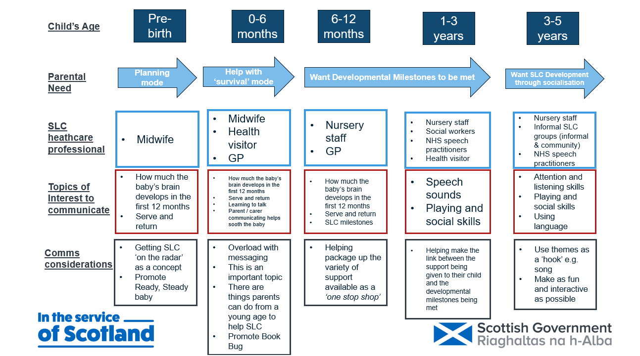

Appendix A: Communication Messages

Communication is the way we share messages about all kinds of things.

There are many ways of communicating. This includes using words but also using facial expressions, gestures, sounds, and your tone of voice.

We all communicate for different reasons across the day. This includes getting things that we need and want, to tell people how we feel or share information and ideas.

Communication starts early. Babies can communicate their own messages without words - for instance, crying from hunger or wriggling when in an uncomfortable position. When babies realise that these signals get a response, they soon begin to communicate on purpose using cries, laughs, babbling and looking. These interactions are the first conversations parents have with their babies before words develop.

Communicating with your baby and wee one is important because it helps their brains to grow and develop.

Communicating with your baby and wee one helps you to feel connected and in tune with each other.

Appendix B: Discussion guide

Discussion Guide – Speech, Language & Communication Qualitative Research
April 2025 – 60 minutes / 90 minutes
Text highlighted in yellow to be excluded for 60 minute focus group
- Moderator introduction and housekeeping (5 mins)
- Many thanks for attending this focus group - will last 60 minutes
- Highlight complete impartiality.
- No right or wrong answers and everyone’s views are important.
- Please give your honest thoughts about what YOU think, not what you think someone else would think or say – we want to hear your thoughts
- Reassurance over confidentiality, GDPR and MRS Code of Conduct:
- We will not disclose any of your details
- We will anonymise our reports
- We will only use the information you provide for the purpose of this research.
- Explanation of recording and request permission.
Consent Form – ask respondents to sign printouts

- Background (5 mins)
Health visitors will discuss your child’s development with you at their child health review appointments (this is when the health visitor visits you at home) . The information Health Visitors record about how babies and young children are developing helps us understand what is happening across Scotland. Since COVID, they are finding more children have trouble with talking and communication.’ The government is making a plan to help young children with communication and they want to hear from families to find out what would help them.
We’re not here today to talk about any issues you have about your child. We want to understand more about the information you might have received (or would have liked to have received) about speech, language and communication (talking and words), and how you would have liked to have received it. Again, there are no right or wrong answers.

- Introduction (5 mins)
Please can we go around the room and share the following one by one:
- Name, your age, how many children you have, the age of your youngest child.
Moderator to turn on recorder after introductions

- Parents role in SLC development and how much of a priority it is (20 mins)
I am going to read out a description about communication:
Communication is the way we share messages about all kinds of things.
There are many ways of communicating. This includes using words but also using facial expressions, gestures, sounds, and your tone of voice.
We all communicate for different reasons across the day. This includes getting things that we need and want, to tell people how we feel or share information and ideas.
Communication starts early. Babies can communicate their own messages without words - for instance, crying from hunger or wriggling when in an uncomfortable position. When babies realise that these signals get a response, they soon begin to communicate on purpose using cries, laughs, babbling and looking. These interactions are the first conversations parents have with their babies before words develop.
Communicating with your baby and wee one is important because it helps their brains to grow and develop.
Communicating with your baby and wee one helps you to feel connected and in tune with each other.
- Initial reactions to description:
  - How does this sound? How does this make you feel?
  - What does this mean? How would you say this in your own words?
  - Was there anything new or surprising? Or anything that makes you think differently? If so, which bits and why?
- What do you think your role is in this?
  - Describe in own words your role.
  - Is this something you do consciously or unconsciously? Are there times when you are more or less aware of it? Why?
  - When do you do this? Are there times you do this more or less? Times of day, days of week, age of baby / child?
- How important do you think your wee one’s communication development is?
  - Overall? Why?
  - Compared with other development (like walking, kicking a ball, problem solving etc)? Why?
  - Compared with other parts of raising a child? Why?
  - Compared with other aspects of daily life? Why?
  - What things (if any) get in the way of this (like having to do the weekly shop, laundry, life admin)?
- Information and support (15 mins)
We’re now going to chat about where, when and how you get information and advice about raising your wee one…
- Do you ever look for or ask anyone for information or advice about raising your child? Why/ why not?
  - Who or where do you get that from?
  - What sort of things?
  - Always the same place? Why?
- What about if you wanted information or advice about their development generally? What about their communication development? Where would you go? Why there?
- Have you ever looked for any info / advice on your wee one’s communication? Why/ why not?
  - When? Why then?
  - Where did you go for info / advice?
  - Was it helpful? Why / why not?
- Have you ever been given any information or advice about your wee one’s communication development by a professional at any point? Probe for details: What? When? How? What format?
  - What was good / less good about it?
  - Was it helpful? Why / why not?
  - What was missing? What could have been better?
- People that help with their communication (Practitioners) (15 mins)
Moving on to talk about the professionals who help families…
- Thinking about any people that help you and your wee ones (like health visitors, midwifes, social workers, support workers), how well do they seem to ‘get you’ as a family and the parenting challenges you face? Explore
  - How supportive are they?
  - Do they ‘get’ parenting? Do they understand the things that make parenting harder or easier? How well to they understand your situation? Why do you say that?
- Did anyone talk to you about communication before your baby was born or before they were a year old? Probe:
  - How did they share information with you? What was the format of information?
  - Can you remember much about it? Did you use it? Why / why not?
  - How well did they explain things to you about your wee one developing their communication? Did you understand their advice?
  - Was their advice useful? Was it practical? Why / why not?
- What could they do better when it comes to helping you develop your wee one’s communication?
  - Walk me through what would be good for you? What is the best way they could help you? Probe - Who, where, when, how, format?
- Supporting communication development (20 mins)
Now, I’d like us to think about how things could be done better to help parents support their wee one’s communication development
- Thinking about before your child was born, in what way would you like information about helping your wee one’s communication development? Probe who, what, where, when, how.
- In an ideal world, how could things be better in the way that you’re given information to help you support your wee one with their communication development?
  - Who’s the best person to give you useful information on developing your wee one’s communication? Why them?
  - Where (what organisation) would you like to get information from about your child developing their communication? Why?
  - What would you expect this to look like? Probe: Format, stage of development etc
- If you were worried about your wee one’s communication, what would be the best way to get the support you need?
  - Can you describe what this would be like for you? Probe: Where? What? How?
  - Probe for: at home individually, drop-in, stay and play, online such as Parent Club/social media
  - What would make this better than other ways of getting support?
- Overall, thinking about getting information or support, what things are important to help you feel confident in supporting your wee one’s communication development?
  - What things help you to feel confident in what you are doing?
  - What helps you feel like a good parent?
- Final summary (5 min)

- What’s the most important one thing we should take away from this group?
Thanks and close.

The Scottish Government, Programme for Government 2025 to 2026, 6th May 2025
The National Early Language and Communication Team, ‘Early Speech, Language and Communication Development: Which Factors are Associated with Better or Poorer Outcomes?’ Education Scotland, January 2025
Throughout the rest of the report the term ‘parents’ is used as shorthand to refer to anyone who has primary parental responsibilities
SIMD is the Scottish Government's standard approach to identify areas of multiple deprivation in Scotland. Further information can be found: Scottish Index of Multiple Deprivation 2020 - gov.scot
Postcode not provided, not complete or illegible

