Video Reflection Exercise: Responsive Interactions

This video reflection tool can support reflection of your own interactions with children

Do

Make a short (under three minute) video clip of yourself interacting with a child or group of children in your setting. Please ensure that this is a child-led task and you have been invited to join the play (indirectly or directly). It is more difficult to be responsive during adult-led tasks which build language skills in a different way e.g. baking or reading a story to a group of children.

Watch
Watch the video back twice.

The first time you watch the video, reflect on the following:
- What did you like about the video?
- What did you notice about the interaction?
- How did the child/ren respond to your interaction style?
- How do you think the child/ren felt during the interaction?

Write a summary of your observations here:
____________________________________________________________________________________________________________________________________________________________________________________________________________________________________________________________________________________________________________________________________________________________________________________________________________________________________________________________________________________________________________________________________________________________________________________________________________________________________________________________________________________________________________________________________________________________________________________________________________________________________________________________________________________________________________________________________________________________________________________________________________________________________________________________

The second time you watch the video, make a note of the Chatting Together ideas you observe in the interaction.
Consider the ideas that align best with the child’s developmental stage:
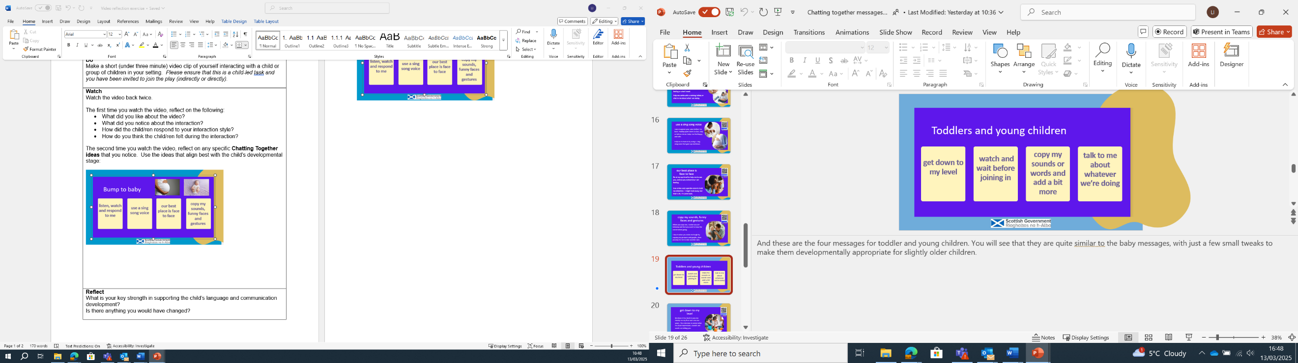
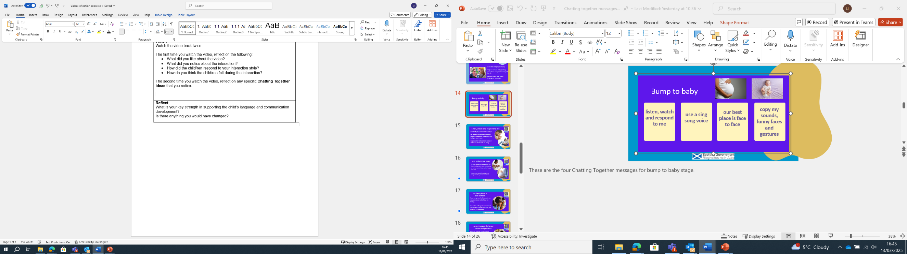

Write a summary of your observations here:
________________________________________________________________________________________________________________________________________________________________________________________________________________________________________________________________________________________________________________________________________________________________________________________________________________________________________________________________________________________________________________________________________________________________________________________________________________________________________________________________________________________________________________________________________________________________________________________________________________________________________________

Reflect
What strengths have you identified in your interaction that support the child/ren’s language and communication development?
Are there any Chatting Together ideas you want to use more? __________________________________________________________________________________________________________________________________________________________________________________________________________________________________________________________________________________________________________________

