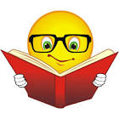
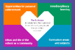
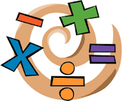
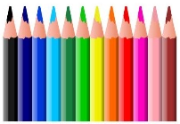
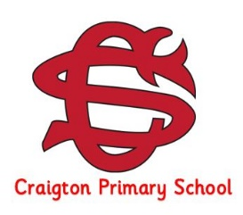
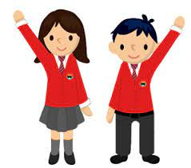
Our Literacy Learning
We would like to encourage our children to read for enjoyment every day. In Primary 6 we have ERIC (Everybody Reading in Class) time every day after break. Pupils are welcome choose a book from our class or school library or if they would prefer they can bring in a book they are enjoying from home.
This term we will be using a new resource called ‘Write on Track’ to further develop our writing skills. This resource teaches pupils how to uplevel their writing through a deeper understanding of sentence structure and grammar.

PE days
PE days for P6 are on: Mondays and Thursdays.
On PE days, children should come to school in their PE kit. Children are encouraged to wear school colours for their PE days. No football tops should be worn.
Earrings must be taken out to take part in PE. Children are required to do this independently.
Homework
Spelling words are uploaded to Seesaw on a Monday.
Pupils should complete activities from the spelling grid to practise their words.
Primary 6 will also be working on a personal project this term on a subject of their choice. This will form part of their homework and details will follow.

Our IDL learning (Interdisciplinary)
This term we are learning about Exploring Space in preparation for our school science fair which will take place in June. We will also be learning about the World Cup and Commonwealth Games both of which are exciting events taking place this summer.

Other Class Information
Please make sure your child brings a water bottle to school every day.
It is helpful if pupils bring their iPad to school fully charged and ready to use each day.
Please encourage your child to share any achievements from outside school with us, either on Seesaw or by bringing in certificates, medals etc. to show.

Our Numeracy and Mathematics Learning
Our Maths focus this term will be measurement. We will also be reinforcing our learning on place value and the four operations as well as practising the times tables and learning about fractions and decimals.

Curriculum News
Primary 6 – Term 4
Other Areas of the Curriculum
R.M.E. – We are learning about Islam; daily life for Muslims including how they worship and celebrate.
P.E. – We will be focussing on developing badminton and rounders skills this term.
H.W.B. – This term we are learning about anti-racism, as well as digital safety and RSHP (Relationships, Sexual Health and Parenthood).

Dear Families of P6,
We hope you all had a fantastic spring holiday. We are looking forward to a term full of learning and fun with Primary 6! Pupils who have applied to be buddies are already busy supporting our new Primary 1s and I’m sure they will make fantastic role models for our new pupils.

