


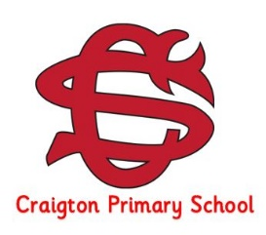
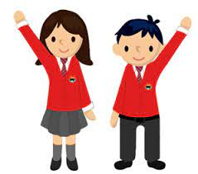
Our IDL learning (Interdisciplinary)
Africa - Our topic this term will take us on an exciting journey to explore the diverse continent of Africa. Pupils will learn about the lives of African people, including those living in tribes and will have the opportunity to compare their daily lives with our own. Through this, children will develop a deeper understanding of different cultures and ways of life.
We will get creative by designing and making our own tribal masks and jewellery inspired by African art, as well as exploring African music. Pupils will listen to, compare and create rhythms, and even learn some traditional dances.across expressive arts.

As part of our topic, we will also discover fascinating African animals and the environments they live in. We will explore how climate change is affecting the continent’s landscapes, people and wildlife, helping pupils to develop an awareness of global issues in an engaging and age-appropriate way.

This topic offers a rich blend of creativity, curiosity and learning, encouraging pupils to make connections, ask questions and develop a broader understanding of the world around them. their actions can make a positive, protecting the planet and making the world fairer. Through discussion, creativity and investigation, they will explore real-life issues and learn how their actions can make a people’s lives, protecting the planet and making the world fairer. Through discussion, creativity and investigation, they will explore real-life issues and learn how their actions can make a actions can make a positive difference.

Other Areas of the Curriculum
HWB– We will be exploring how we are all unique, learning how friendships are formed, and discovering how living things grow and are nurtured.

R.M.E - We will be learning about artefacts and stories from Christianity.

French - We will be developing our speaking and listening skills by greeting others, taking part in daily routines, following instructions and celebrating special events like birthdays.

Our Literacy Learning
Pupils continue to work through the Jolly Literacy spelling programme, which equips them with essential spelling skills, with lots of consolidation opportunities provided.
In writing, we will be developing our writing skills through the Write on Track programme, where children will learn and practise the key building blocks of writing, to help them become more confident and independent writers.
In reading, we will identify the main idea of a text and continue to reinforce our understanding of a variety of
before, during, and after-reading strategies.

As we embark on the final term of this academic year, I want to express my deepest gratitude for your unwavering support throughout this journey. As we look ahead to the upcoming term, my focus will be on further nurturing the confidence and independent working skills the children have cultivated thus far. Together, we will navigate this transitional period, preparing them with the necessary tools and resilience as they embark on the exciting next chapter of their Craigton journey into P5.

Other Class Information

Please continue to make sure that your child’s initials are on ALL items of clothing and packed lunch bags.

Please encourage your child to leave toys at home. Having them in school causes distractions to learning and upset when they get lost.

Our Numeracy and Mathematics Learning
Within numeracy we will be exploring a range of strategies when solving problems involving:
- Algebra (Tidying up like terms and working with expressions).
- Data handling (Collecting, presenting and
displaying data using charts, diagrams, tables and graphs).
Our mathematics topic for this term will be time. Pupils will learn to read, write and tell the time using analogue and digital clocks, understand durations, and apply their knowledge of time to real-life situations.

Homework

Numeracy homework will be issued weekly. This will take the form of a mental maths challenge that revisits previous learning.

Literacy homework will continue to be uploaded to Seesaw on a Monday, to be completed by Thursday.

All log in details have already been sent home but can be sent home again if required.

PE days
PE days for P4 are on: Tuesday & Wednesday this term.

On PE days, children should come to school in their PE kit. Children are encouraged to wear school colours for their PE days. No football tops should be worn.

Earrings must be taken out to take part in PE. Children are required to do this independently.

Curriculum News
Primary 4 – Term 4

