
Corpus Christi Primary School
Anti-Bullying Policy 2025–2026
Approved: August 2025
Review Date: August 2026
“We Try Our Best To Be The Best”

1. Rationale & School Vision
Corpus Christi Primary School is a welcoming Catholic community where every child is known, valued and loved. Bullying in any form is contrary to our Gospel values and our school values of Happiness, Kindness, Respect, Honesty and Friendship. We commit to ensuring every child feels safe, included and protected from harm.

2. Statement of Intent
We believe every child has the right to feel happy, safe and respected. All concerns will be listened to, believed and acted upon. Children, staff and parents are partners in preventing and responding to bullying.
We believe it is important that:
• All children feel safe whilst learning to work, play with and relate to others
• All children are treated fairly, with respect and dignity.
• We listen carefully to what all children have to say.
• We treat reports from all children seriously and take appropriate action

3. What Is Bullying?
We recognise that many children and young people will experience conflict in their relationships with other children and young people and as a school we are committed to developing empathy and the skills to manage relationships in a peaceful way that does not harm others. In Corpus Christi Primary School, our definition of bullying is:
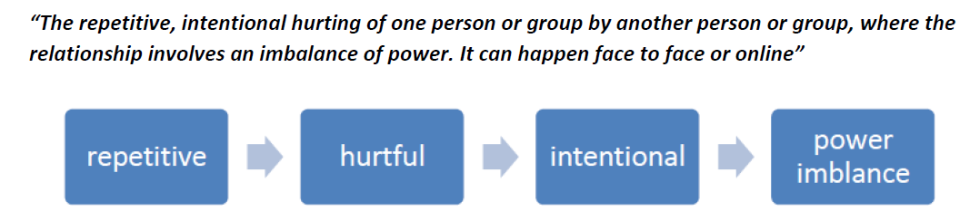

4. Types of Bullying

Bullying can take many forms:

• Emotional - being unfriendly, excluding, tormenting, threatening behaviour

• Verbal - name calling, sarcasm, spreading rumours, teasing, use of derogatory language

• Physical - pushing, kicking, hitting, punching or any use of violence

• Extortion - demanding money/goods with threats

• Online – use of social media, messaging and calls. Misuse of associated technology e.g photos and videos.

• Racist - racial taunts, graffiti, gestures

• Sexual - unwanted physical contact, sexually abusive comments

• Homophobic or biphobic - bullying because of sexuality or perceived sexuality

5. Aims of This Policy
- Prevent bullying through culture, curriculum and relationships.
- Ensure all incidents are taken seriously and recorded.
- Support pupils affected by bullying.
- Encourage restorative and positive relationships.

6. Prevention

Preventing Bullying We foster a clear understanding that bullying, in any form, is unacceptable. We believe that preventing bullying is the responsibility of our whole school community and when there are incidents of bullying we will work together to deal with the situation and to learn from what has happened. In our school we do this by:

• Involving the school community in developing our policy including a child/ pupil friendly version of our policy.

• Using assemblies and circle time in class to ensure that pupils understand the differences between relational conflict and bullying.

• Building a positive ethos based on respecting and celebrating all types of difference in our school.

• Creating a safe and happy environment, with consequent positive relationships that have an impact on learning and achievement.

• Having a positive ethos that all pupils, staff and parents understand.

• Work in school which develops empathy, social skills and emotional understanding e.g. PSHE, Citizenship, social and emotional learning programmes, circle time, peer mediation and playground buddies.

• Secure the safety of the target of bullying Take actions to stop the bullying from happening again Whole school learning - reflection on what we have learnt

• Think about any safeguarding concern and report concerns to Designated Safeguarding Lead.

• Provide assurances to child that concerns have been listened to and action will be taken.

• Consider who else is involved and what roles they have taken.

• Send clear message that the bullying must stop.

• Work with both parties to find solutions. Identify the most effective way of preventing reoccurrence and any consequences.

• Reflect and learn from bullying episodes –consider what needs to happen next to prevent future bullying e.g. PSHE, training etc.

• Raising awareness of online bullying through regular e-safety lessons.

• Adopting a social model approach to bullying. Diversity is valued and everyone is included in our school.

• Ensuring playground and midday staff are trained and we have a range of activities at lunchtime to promote positive play.

• Offering training to all school staff around bullying, including specific guidance on those groups who are most likely to be bullied.

7. Reporting Bullying

In our school pupils are encouraged to talk to staff when they are unhappy or have concerns. Pupils in our school understand that they have a right to feel and be safe and a responsibility to support others to feel and be safe. Pupils are encouraged to report bullying to:

• A trusted adult

• Their class teacher/SFLW

• Class has a ‘worry box’ where children can report their concerns if they do not feel confident speaking to an adult.

Children are taught that it is important to talk to a trusted adult if bullying is taking place outside of school. Parents are also encouraged to report concerns and bullying to SLT. When pupils report their concerns our staff are trained to LISTEN and to BELIEVE. We involve children as far as possible in finding solutions.

8. Responding to Bullying Incidents

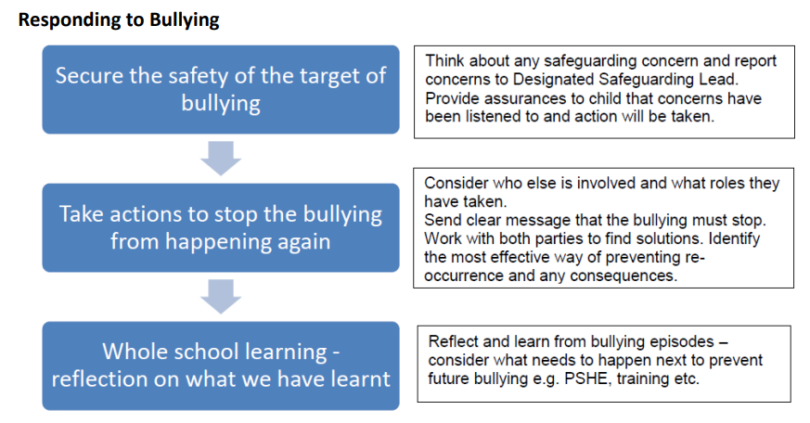
We monitor and review all bullying incidents to determine any patterns or trends that may require further action. On a regular basis we give pupils the opportunity to feedback on how safe and happy they feel at school, we do this through pupil questionnaires and School Council meetings. All staff are required to complete a bullying and prejudice-based incident reporting and monitoring form when dealing with incidents of bullying. This should be completed as soon as possible and given to the Designated Safeguarding Lead.
Dealing with Bullying
We encourage children to report any incidents of bullying to any member of staff in the setting. We strive to create an environment where all students can discuss any concerns with staff and feel listened to and supported. Staff will deal with the incident as promptly and sensitively as possible. The following list of actions might be used by staff depending on the perceived seriousness of the incident:
- Staff to record all incidents.

• Meet with the victim and remain calm, using patience and understanding.
• Encourage to talk about incidents, issues and feelings.
• Try to establish what type of bullying is taking place and where, how often the bullying is occurring.
• Identify the alleged bully/bullies. Obtain witnesses if possible.
• Advise the victim not to hit out at the bully or bullies as they themselves may end up being accused of bullying.
• Discuss options to resolve the situation, agree actions advise the victim of what happens next.
• Meet with the child/ren alleged to have been involved in bullying behaviour and encourage them to talk about reported incidents. Listen carefully to their perception of the incidents, accurately recording their words.
• If bullying behaviour has taken place explain that it is totally unacceptable and encourage child to acknowledge that the behaviour is wrong and needs to stop.
• Arrange a programme of support for both children where appropriate, including exploring motives or reasons for the behaviour and to ensure that there is no reoccurrence. Mediation will be used between culprit(s) and victim(s) where appropriate to support the right choices being made and good friendships rather than retaliation and to ensure that the victim’s voice is heard. However, in serious cases this may not be suitable.
• The key phase leader will ensure that parents are informed of the incident on the day it has happened. Children will be offered the opportunity of having their parents involved to support the process throughout.
• Should any incidents of bullying behaviour be deemed of a particularly serious nature the Head will inform parents immediately of the possibility of exclusion.
• The Head may take the decision to exclude a child immediately for serious bullying behaviour. Parents have a right of appeal to the Governing Body and the LA.
• Inform the relevant staff in the appropriate phase (eg lunchtime organisers and other relevant staff who work with both victim or culprit).
• Complete the Individual Bullying Incident Form
• Arrange to meet the parents/carers of all of those involved in the incident(s) and any subsequent follow up meetings. Discuss relevant documentation and resulting action with parents/carers and what they can do to reinforce and support the school action.
• Think ahead about supporting both victim and bully and make regular checks to ensure the bullying has ceased.

9. Procedures for Parents
•If a parent has any concerns about their child they should speak to the class teacher immediately. If a parent thinks bullying is the issue, the matter will be referred to the headteacher. The headteacher is always informed of any bullying concerns at Corpus Christi and monitors the situation carefully.
•If a parent feels unable to talk to the class teacher, they can make an appointment to speak directly with the Headteacher.
•The school will work with both the child and the parents to ensure that any bullying is stopped and that support is given where needed.
•Parents should not confront the bully or their parents. This can complicate the situation and distress the pupil.
•The school will deal directly with all children involved and their parents directly. Parents will be kept informed of any actions the school is taking.
•If parents feel that their concern has not been dealt with appropriately they should follow the schools complaints policy. All members of the school community, including pupils, staff, parents and governors, are expected to treat everyone with dignity respect at all times. This includes both face-to-face contact and online.

9. Support for Pupils
Children affected by bullying receive reassurance, check-ins, nurture support and a safety plan. Children displaying bullying behaviour receive guidance, reflection time and support to change behaviour.

10. Partnership with Parents/Carers
We communicate openly with families, share factual information, and work together to support all children involved.

11. Online & Cyberbullying
Pupils are taught safe digital behaviour. Cyberbullying inside or outside school is treated seriously and may involve Police Scotland if required.

12. Equalities
We uphold the Equality Act 2010. Prejudice-based bullying is recorded and addressed as a serious incident.

13. Staff Responsibilities

Staff Code of Conduct (Staff Responsibility) We recognise that all adults in the school are in effect role models for the students. The way in which we behave towards each other and to students is particularly important in terms of providing positive role models. Therefore, as adults we must:

• show respect for every child and other colleagues within the school community as individuals

• be aware of vulnerable pupils

• criticise the behaviour rather than the child

• avoid favouritism

• be seen to be fair

• avoid labelling

• have high expectations of pupils

• never give children ammunition to use against each other

• actively seek to develop a praise culture within the school. Supervision We ensure that key areas of the school are adequately supervised and staff are vigilant. Children are given opportunities to take responsibilities and demonstrate initiative (peer mentors, prefects). The school regularly asks students via a map of the grounds and vicinity where vulnerable places might be and act upon this appropriately.

14. Monitoring & Review
SLT reviews incident trends termly. The policy is reviewed annually with input from pupils, staff and parents.

