A Story Map

Level - Early Level

Subject area/s - Computing Science/Literacy

Experiences and Outcomes –
Understanding and analysing computing technology
- I understand that sequences of instructions are used to control computing technology. TCH 0-14a
Designing, building and testing computing solutions
- I can develop a sequence of instructions and run them using programmable devices or equivalent. TCH 0-15a

Benchmarks –
Understanding and analysing computing technology
- Demonstrates an understanding of how symbols can represent process and information
Designing, building and testing computing solutions
- Designs a simple sequence of instructions/algorithm for programmable device to carry out a task for example, directional instructions: forwards/backwards
- Identifies and corrects errors in a set of instructions.

Duration of time –
This can be introduced to an individual, small group or whole nursery. The time taken for this activity will vary depending on the interest of the learners involved. This could develop over a number of days or weeks.

Computing Science Concepts and Approaches –
Tinkering
Algorithms
Programming
Debugging

Overview of learning

This lesson is based around using a story which has elements of a journey. E.G. The Gruffalo, We’re Going on a Bear Hunt etc. whilst introducing learners to computing science vocabulary. The children will learn how to use computing science terminology within the context of recreating the story journey. After creating their own story mat, they will create algorithms to journey round the story. These algorithms can be used with or without programmable devices. They will learn to evaluate and debug their algorithms if they encounter any problems.

Pupil Objectives

- I can sequence the main parts of a familiar story
- I can create a simple algorithm
- I can program a device to follow a simple algorithm
- I can evaluate and debug a simple algorithm

Introduction

Prior Knowledge – It would be expected that you would initially read the story to the learners a number of times so they had a good understanding of the story journey and are able to retell the story with some confidence.

You may wish to introduce new computing science vocabulary to the learners. Introducing new words using the whole environment allows learners to have a better understanding of these words and how they can be used.

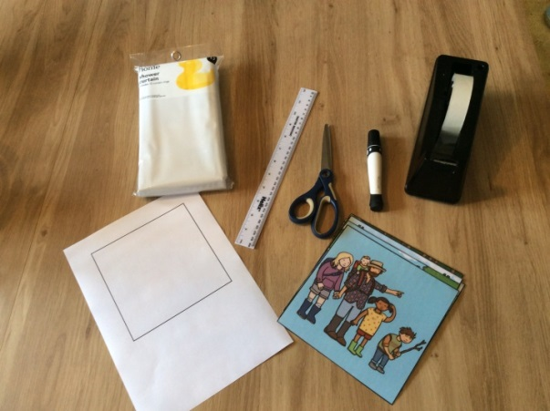

Introduce the word Tinkering – Explain to the learners that you are going to let them explore programmable devices, EG. Beebot, within free play opportunities. Observe and listen for language used to have an idea of prior learning. Once they have had the opporuntity to be exposed to this then introduce sequence cards, either by creating your own or printing off the sequence cards from resources. This will give the learners the opportunity to explore the Beebot/programmable device with the cards in a less formal way. You may want to visit the Barefoot Computing Science resource – Bee-Bots Tinkering - http://barefootcas.org.uk/barefoot-primary-computing-resources/computational-thinking-approaches/tinkering/ks1-bee-bots-tinkering/

Possible Lines of Development (PLOD) – Create a mind map with the children about their understanding of the story and what they have learned about the Beebot/progammable resource. This will be the basis for designing their own story mat. You can use the mind map in resources or create your own.

Create a story mat – Use the downloadable 15cm x 15cm blank square in resources or cut blank squares 15cm x 15cm. Learners can design and create their own squares based on the story you are using as the stimulus. This could be an activity that is a free choice activity during free play, with the book used as a provocation. These mats can be designed using any materials, understanding that they should be flat if using with a programmable device. Alternatively, you could print off already created downloadable resources from other websites.

Watch the video to create the mat before the main activity. This video shows how to create a more durable story mat. You can also cut out the 15cm x 15cm squares and tape them together to create a mat that the Beebot/programmable device can move on.

Introduce the word Algorithm – Explain that this means making steps and rules. That it is a sequence of instructions. Give them instructions E.G. stand up, walk to the table, sit down, pick up a pencil, draw a picture. Explain that this is an Algorithm. Explain you can also give their Beebot/programmable device an algorithm to follow. Use the sequence cards to program the Beebot, input the instructions and see that the Beebot follows the instructions.

Main Activity

Start by recapping the story with your learners, getting them to retell the story in their own words, using the story map as support.

Initially, use the arrow cards with the mat, without any programmable device. Encourage the learners to place the cards onto the story mat retelling the story. Remember to use computer science terminology. Remind the learners that they are creating an algorithm. Give learners the opportunitiy to create an algorithm for each other to help them move from one point on the story map to another. E.G. Move from the fox, to the owl on the Gruffalo Map, or move from the long wavy grass, to the deep cold river in We’re Going on a Bear Hunt. Give learners cooperative learning roles which will support them to collaborate with each other. One person can be the planner and the other the programmer. Learners can use the small sequence cards to plan their algorithm using the algorithm sequencer. If things go wrong take this opportunity to introduce the word Debugging.

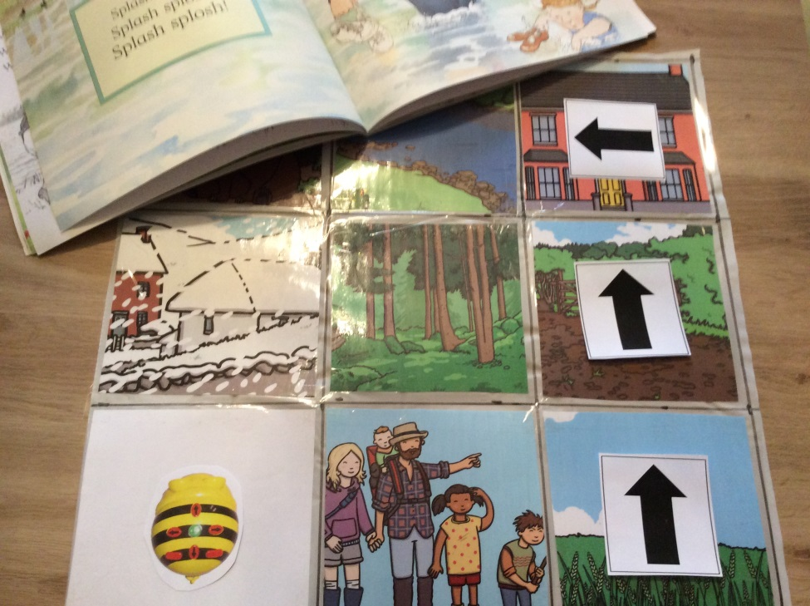

Introduce the word Debugging – Explain that sometimes there are errors in an algorithm and these are called bugs. Therefore we need to debug the algorithm. Encourage learners to use these words when they are creating and trying out their algorithm.

Plenary

At the end of each session with these activities it would be useful to discuss their learning. Possible questions may include:
- What have you learned about using programmable devices (Beebot)?
- What does tinkering mean and what did we learn when we tinkered?
- What is an algorithm?
- What do we understand about the story journey?
- What happened if things went wrong?

Differentiation

Practitioners can support learners if needed.

Learners can be encouraged to create their own algorithms by drawing arrows to show which direction they want the Beebot to move in, rather than use the sequence cards. The algorithm sequencer, in resources, can be printed off, laminated and used with a whiteboard pen to create algorithms.

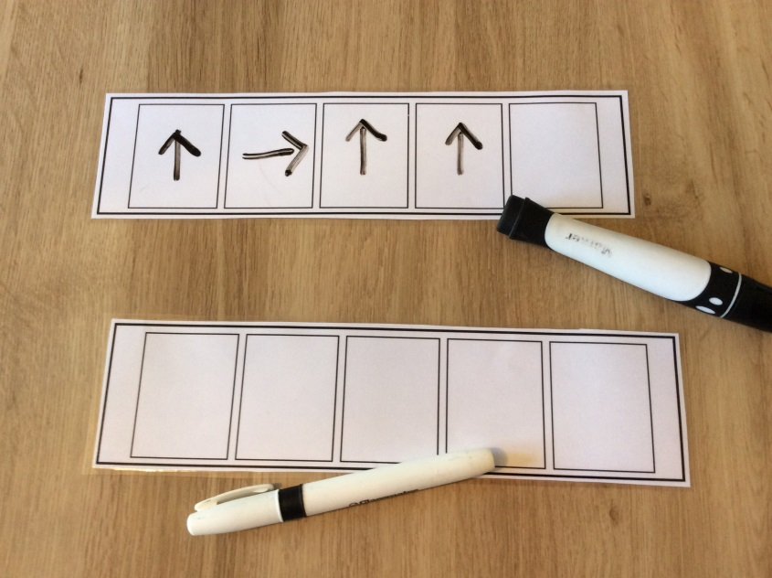

Assessment Oportunities

- Observe if learners have an understanding of the symbols used.
- Observe if learners can use the arrow symbols to create a simple algorithm. E.G. move forwards, move backwards, turn left, turn right.
- Observe if learners can debug an algorithm.
- Take digital photographs as evidence of learning. These can be used in an individual learning journey or in a floor book.
- Gather learners thoughts throughout the process and write these down with any mark making E.G. algorithm sequencer.

Teaching Notes

Tinkering – trying things out.
Algorithm – a sequence of instructions or a set of rules.
Programming – is creating a set of instructions to input into a device.
Debugging – solving an error in an algorithm.
Programmable device – a remote controlled device that can be programmed. E.G. Beebot
More information about this can be found on the Barefoot Computing Science website.
http://barefootcas.org.uk/barefoot-primary-computing-resources/concepts/

Curriculum Links

I enjoy exploring events and characters in stories and other text, sharing my thoughts in different ways (LIT 0-01c / LIT 0-19a)

I can create a range of visual information through observing and recording from my experiences across the curriculum (EXA 0-04a)

Key Vocabulary

Tinkering, Algorithm, sequence, Debugging, Debug, Beebot, programmable, forward, backward, left, right, pause, clear, go, turn, device.

Resources required

- Arrow Cards
- Beebot Sequence Cards
- http://barefootcas.org.uk/barefoot-primary-computing-resources/computational-thinking-approaches/tinkering/ks1-bee-bots-tinkering/
- Mind Map for Programmable Toy/Story
- 15cm x 15cm Blank Square
- Video on How to Make a Beebot Mat - https://youtu.be/WxHr82UaKio
- Beebot Sequence Cards Small
- Beebot Algorithm Sequence

