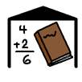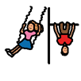

My Nursery to

Primary   
Booklet

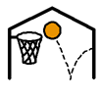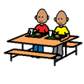

**FOR PARENTS AND CARERS**

Look through this booklet and complete with your child.

You can draw the pictures in the boxes to help.

This information will help your child’s class teacher get to know them better.

**This is Me**

Draw a picture of yourself.

My name is _________________

I am ____ years old.

**Nursery**

I went to ________________________ Nursery.

Here are some of the things I like best about nursery.

Please draw or write in the box.

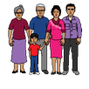**My Family and Friends**

This is my family.

This is my friends and I.

**I want you to know that:**

Ask an adult to write or you can draw anything you want your teacher to know. It might be things you are excited about or things you are nervous about. It might be something that you think is really important.

**Anything Else?**

This is a space for parents and carers to add anything else you want the school to know that is important for you.