This is Anne. Anne loves colouring and painting. Her favourite colour is blue. She loves going on long walks with her family and their dog. Her favourite film is Toy Story and she has seen it over a gazillion times. Anne is in Primary 6 and likes to play with her friends at school.
When Anne was younger, she had visits to a special doctor and worked with other adults who wore name badges and pretty pictures. When she was 6, the doctor told Anne that her brain works differently from some of her friends at school. This is because Anne is autistic.
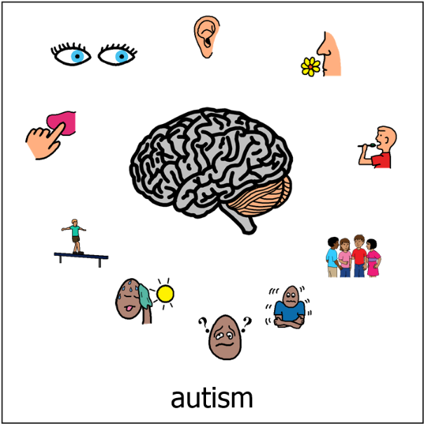

Anne likes listening to loud music but gets quite upset when people are shouting or screaming. She gets quite nervous in busy crowds in case someone starts to shout.

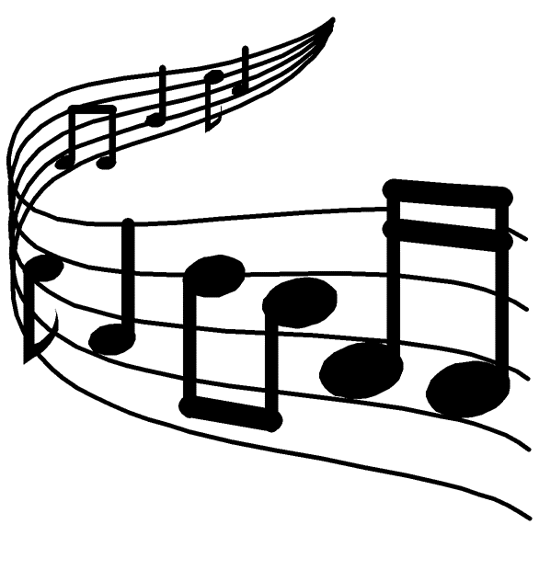

Her favourite song is Shotgun and she knows all the words to it. Sometimes when someone says “hot sun” or time flies by” she will start to sing Shotgun. When Shotgun starts to play her brain, it can take a few days to stop.

Anne needs to be reminded to eat her lunch because sometimes the message from her stomach gets distracted and forgets to travel to her brain so she doesn’t realise she may be hungry.
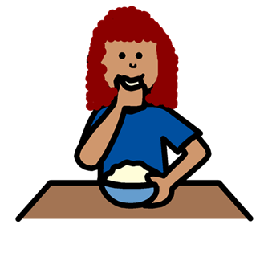
Anne sometimes needs to be reminded when to stop eating because her brain gets distracted and forgets to read the message from her stomach to say she’s full.

Anne loves to read but sometimes has to read the same sentence a few times before her brain recognises the meaning of all the words in the sentence and is able to put them together.
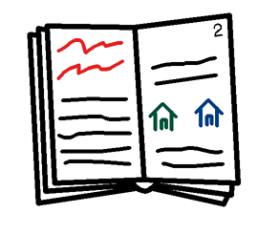
This is because Anne’s brain is so busy trying to remember the instructions in the class, block out other people talking, ignore the itchy label on her shirt, trying to understand if the poster on the window is inside or outside and recognise what time it is and whether she might be hungry.
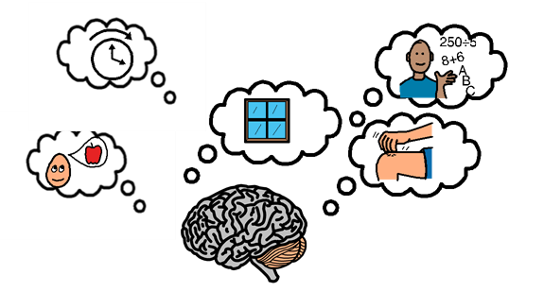

Anne really enjoys making up stories. She has a great imagination and can create the most exciting adventures for her characters.
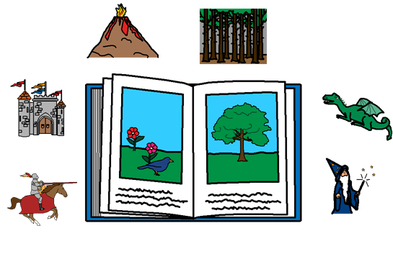
Unfortunately Anne never has time to finish her stories at school. This is because Anne can see the story in her head and can see how it is written. If her handwriting is not exactly the same as how she sees it in her imagination, she needs to fix it. This can take a long time.
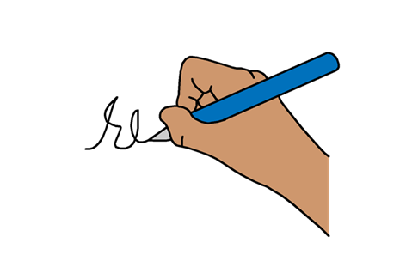
Sometimes Anne feels stupid because she cannot finish her work. When Anne feels stupid, it can be hard for her to focus on anything else. She needs a break to allow her brain to relax. Anne has fidget toys that can help her.
Sometimes Anne will sit under the table. This helps her feel better because when she is closer to the ground, her body relaxes. She would like to lie down on the floor but she worries that other people might say something to her.
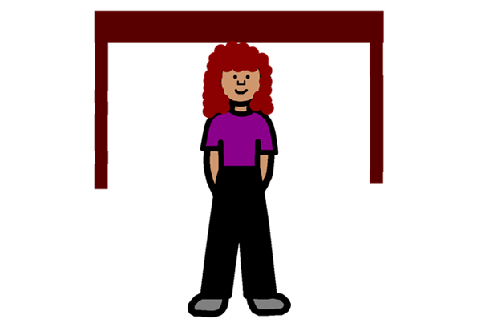

When Anne feels worried, her brain starts to send messages to other parts of her body to help her get ready to run. Her brain is so busy doing this, it forgets to send words to her mouth to allow her to say how she is feeling.
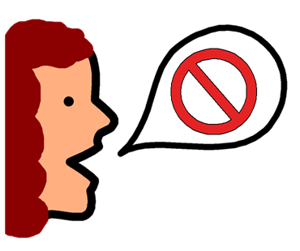
Sometimes Anne can find it hard to speak when she is excited or happy. This is because of how busy her brain is. Sometimes adults use Makaton or visuals to help her to communicate when she can’t speak. This helps her brain to relax a bit. Anne would like her friends to do this too but doesn’t know how to tell them.
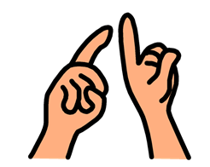
Most of the time Anne is a happy person and loves the fact that she is autistic. She knows that because she is autistic, sometimes it means she can see things other people miss. It also means that Anne, sometimes feels things more strongly than some other people. Sometimes though, Anne wishes that other people could be more understanding. Anne has to adapt and change so much of herself already in order to make sense of her world. Sometimes it would help if other people changed how they say or did things to make sure that Anne and others like her, are not left out.
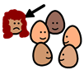

It can also be confusing because autism is also called a spectrum. This means that some days Anne is able to do, understand and focus more. On other days, more things or activities may be difficult. Sometimes this can happen on the same day!

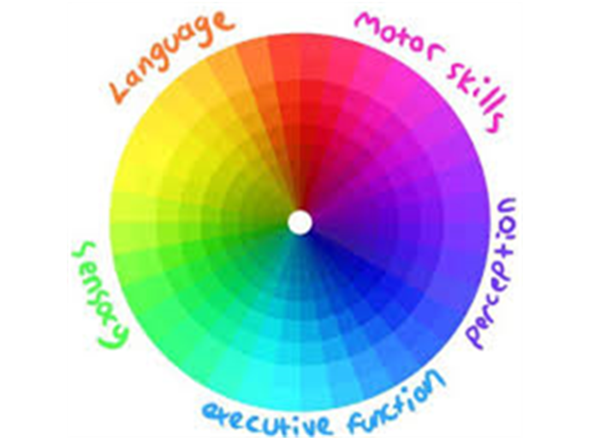

Anne is proud to be autistic and if you know someone who is autistic help them to feel proud of who they are. If you are autistic yourself, be proud of who you are because you matter and you should be proud.

