Lesson Title: Values of Visuals

You will need: Copy of Activity 2a-d.
Timer as appropriate
Colouring pencils/pens/crayons
Activity 2a:
- This can be completed on smartboard, in groups or printed and given to each pupil.
- Pupils have to name as many as they can in a set amount of time. (Teacher decides)
- Feedback as appropriate.

Activity 2b:
- Print off Activity 2B.
- Use visuals around class and from activity 2a to help.
Allow pupils to create own symbols.
Activity 2c:
- This can be completed in a jotter or a whiteboard.
Think about road signs, badge on uniform etc.

Activity 2d:
This is about where pupils would use or put them in school if they were in charge.
It can be done as a whole class lesson on the Smartboard or on Activity 2D sheet.
This is about encouraging using symbols in a variety of situations.

Quote to use “Language can be confusing for me.”
Discussion: When an autistic brain is stressed, the brain can find it difficult to follow words. Using visuals can help and can prevent the person being overloaded.

Answersto 2a: Minecraft, superman, aldi, pepsi, lego, Wikipedia, lidl, roblox, Burger King, Instagram, KFC, Firefox, tesco, asda, google chrome, facebook, batman, domino’s, apple, McDonalds

Activity 2a

Our brains recognise pictures (visuals) quicker than words. How many of these pictures can you name?

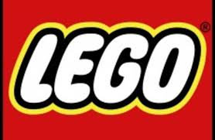

Activity 2b

Can you make up some symbols for your partner to work out?

Activity 2c
Can you create a list of visuals that you see on your way to school and around school?

Activity 2d

Where would you use these visuals in your school?

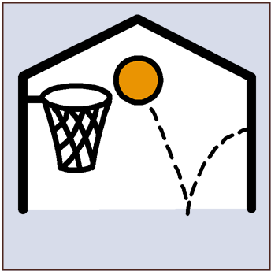 | 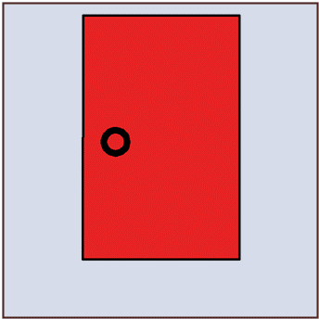
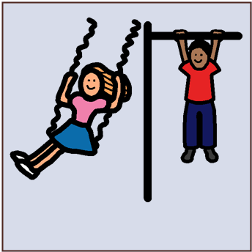 |  | 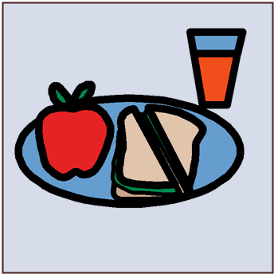
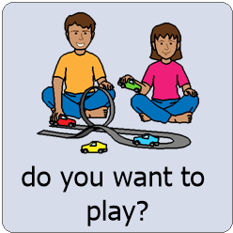 | 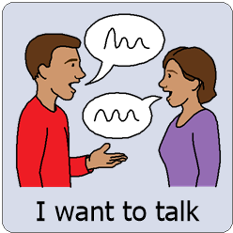 | 