Lesson Title: Everyone is Different

You will need: Copy of Activity 1.
Activity:
- Give everyone a copy of Activity one.
- Ask them to complete the “I like” column from Activity 1A. Once completed move onto step 3.
- Ask pupils to swap with partner and partner will complete “My shoulder partner likes”.
- When all pupils are ready, teacher will write up his/her answers on board and pupils will copy into “my teacher likes”.
- Share answers as appropriate. Compare similarities and differences.
- Complete Activity 1B.
- Share answers and compare similarities and difference.

Quote to use “If you know one person with autism, you know one person with autism.”
Discussion: Autism is a spectrum which means that ever autistic person is different. We may be similar but we are different. . See the examples below to help.

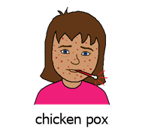
Someone has spots and most people feel unwell.
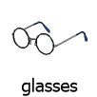

If someone needs help to see better, they wear glasses.

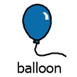
If you blow into a balloon,
It changes shape and grows.

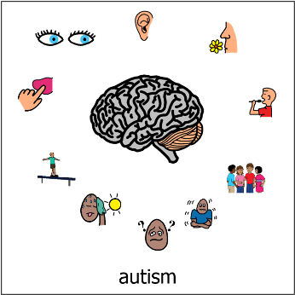
Autism is not the same. It is different
for each person.
 | My favourite | My shoulder partner’s favourite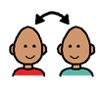 | My teacher’s favourite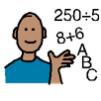
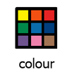
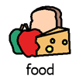
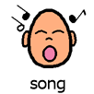
Activity 1A Everyone is different

Activity 1B Everyone is Different
 | I look like | My shoulder partner looks like | My teacher looks like
