Transition to Primary __
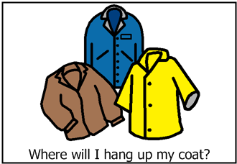
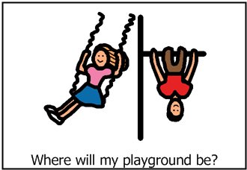
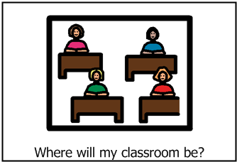
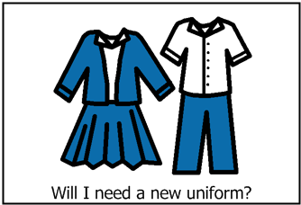
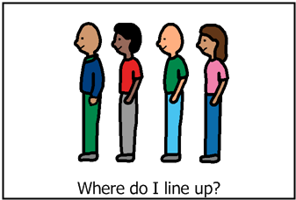 |  | 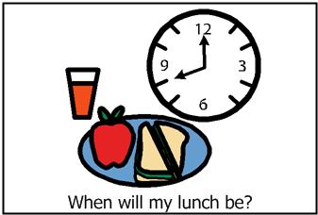
Transition to Primary 6 example
In the corridor next to the nursery. | The lines might be a bit smaller. | We don’t know yet, but the school will tell me when they can. | The same one as this year.
The same playground. | In the playground with my class. | Some of the boys and girls from this year. | Any other questions?  Who will I be in a group with? My teacher will tell me in August.
It will be next door to my class from this year. | We don’t know yet, but the school will tell me when they can. | At the end of the year, I might be a mentor to the nursery boys and girls.
My parent/carer might get me a bigger uniform as I might grow over the holidays. | The row behind P5. | I can speak to Mrs PT or your class teacher or Mr DHT or Ms HT or Miss ASNA.
Next to the senior toilets. | The tables will be the blue tables which are a wee bit bigger. | Between 12:15-12:45
Transition to Primary 2 example
√ | no | ? | √
√ | √ | √ | Where will the toilets be?  At the junior area.
√ | ? | yes
yes | √ | √
√ | no | 12:00

This could be used to support transition between Primary classes.
It is suitable for use with all pupils and can be printed out in black and white.
This could be done as a whole class, group or 1:1 activity.
Pupils can write or draw their own answers. A tick can be used for pupils who require it to show they have seen where they will hang up their coats for example.
It is okay to say that we don’t know yet, but will let them know when we do. It is also okay to leave a space blank until the information can be given.
The blank spaces at the end, can be used for pupils to ask their own questions.
If you have any further concerns about individual pupils using this resource e.g. you feel they need more support or if you have any questions about how to use this resource, please feel free to contact the ELCaT Team.

