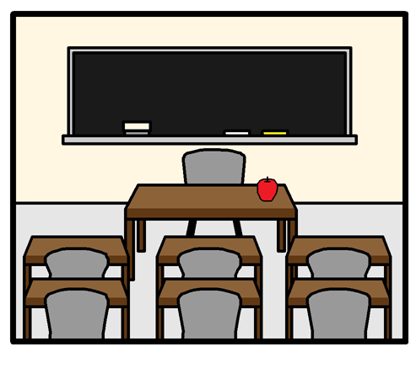

What happens when I change class?
I will be changing class after the summer holidays.
I may have the same classroom or my classroom may be somewhere else in the school.

I may have a different teacher or the same teacher.

I may have new friends in class with me.

I have lots of questions about my new class.
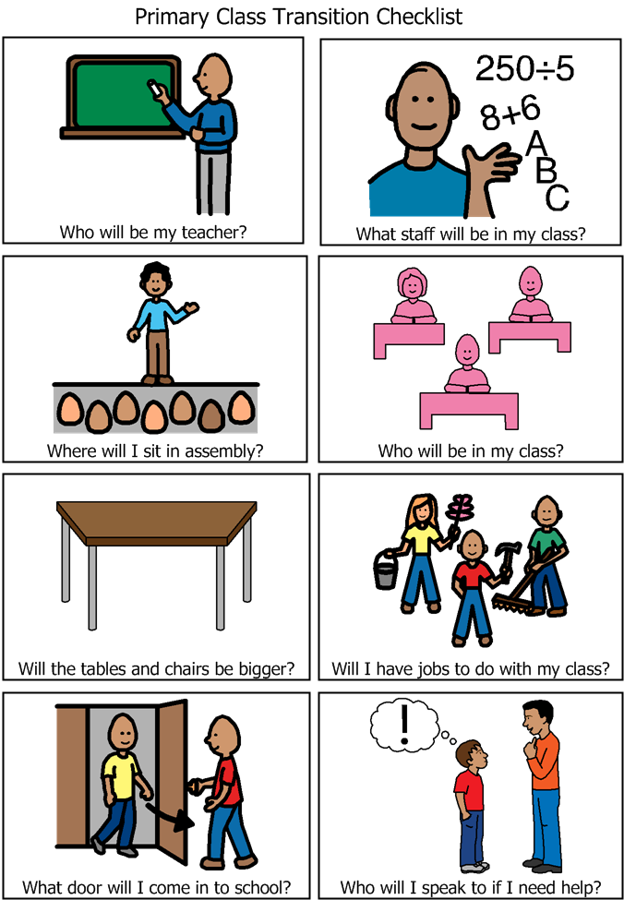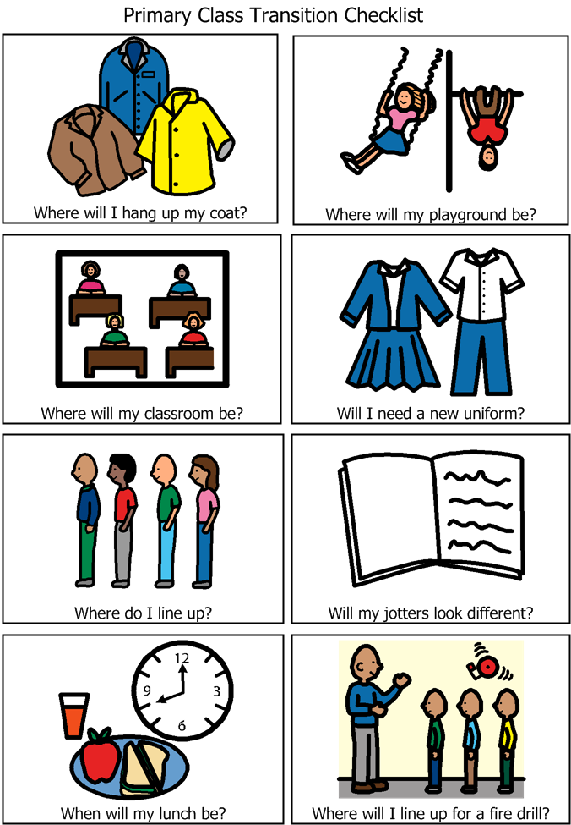
This book will help me give me answers to questions I may have.

The school will give me as many answers as they can, but some questions they may not have an answer for yet. This is okay because I know they will tell me when they know.
Starting a New School Year.
